Economics 102 Name ______________________________________
Summer 2015
Answers to Quiz #1
Thursday, June 25, 2015

Please write your answers neatly and legibly.

1. Consider Bob, Jane, and Marco, three individuals who produce zippers (Z) and radios (R). All three of these individuals have linear PPFs for these two goods. Bob knows that he is able to produce (R, Z) = (10, 10) and (15, 5) given his PPF. Jane knows that she can produce (R, Z) = (20, 5) and (15, 10) given her PPF. Marco knows that he can produce (R, Z) = (0, 20) and (5, 10) given his PPF. Use this information to answer this set of questions.
a. (1.5 points) In the space below draw three graphs. In the first graph depict Bob’s PPF measuring Zippers (Z) on the vertical axis and Radios (R) on the horizontal axis: label this graph “Bob’s PPF”. Make sure you fully label this graph and the numeric values for the X and Y intercepts. In the second graph depict Jane’s PPF using the same labeling conventions. In the third graph depict Marco’s PPF using the same labeling conventions.
Answer:
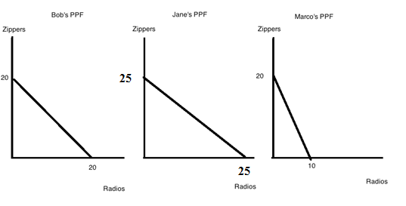
b. (1 point) Given the above information:
i. Who has the comparative advantage in the production of radios? _____________________
ii. Who has the absolute advantage in the production of radios? ________________________
iii. Who has the comparative advantage in the production of zippers? ______________________
iv. What is Marco’s opportunity cost of producing one zipper? _________________________
Workspace:
Answer:
Bob’s opportunity cost of producing 1 radio is 1 zipper; Jane’s opportunity cost of producing 1 radio is 1 zipper; and Marco’s opportunity cost of producing 1 radio is 2 zippers. Bob and Jane have the lowest opportunity cost of producing radios, so Bob and Jane have the comparative advantage in the production of radios.
Bob can produce a maximum of 20 radios; Jane can produce a maximum of 25 radios; and Marco can produce a maximum of 10 radios. Jane has the absolute advantage in the production of radios since she can absolutely produce more radios.
Bob’s opportunity cost of producing 1 zipper is 1 radio; Jane’s opportunity cost of producing 1 zipper is 1 radio; and Marco’s opportunity cost of producing 1 zipper is ½ radio. Marco has the lowest opportunity cost of producing zippers, so Marco has the comparative advantage in the production of zippers.
To recap the answers:
i. Who has the comparative advantage in the production of radios? __Bob and Jane______
ii. Who has the absolute advantage in the production of radios? ___Jane________
iii. Who has the comparative advantage in the production of zippers? ____Marco__________
iv. What is Marco’s opportunity cost of producing one zipper? _____1/2 radio_______
c. (3 points) In the space below draw the joint PPF for Bob, Jane, and Marion given the above information. Measure zippers on the vertical axis and radios on the horizontal axis. Identify all numeric values for intercepts as well as numeric values for any “kink points” that are in your graph.
Answer:
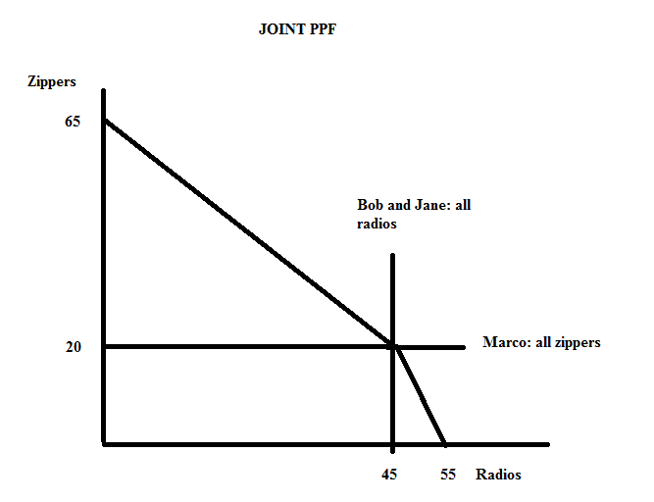

d. (2 points) Given the above information write the set of equations that describes the joint PPF. For each equation provide the range of zippers for which this equation is true. For full credit show your work.
Answer:
For the top segment of the joint PPF, the equation is easy to write since can see the y-intercept and can easily calculate the slope of this segment of the PPF:
Z = 65 – R for 20 ≤ Z ≤ 65.
The bottom segment of the joint PPF will take more work. From our graph we can compute the slope of this segment: m = slope – rise/run = -20/10 = -2. We also know that the point (R, Z) = (45, 20) sits on this segment of the joint PPF. So, use this point and the general slope-intercept form to write the equation:
Y = mX + b
Z = (-2)R + b
20 = (-2)(45) + b
20 = -90 + b
b = 110
So, the equation for this segment is Z = 110 – (2)R for 0 ≤ Z ≤ 20.

e. (1.5 points) Given the above information determine if Bob, Jane and Marco can produce the following levels of zippers and radios. Then, determine if the overall level of production described is efficient, inefficient, or not feasible provided that these three individuals specialize according to comparative advantage and trade with one another.

- Bob produces 10 zippers, Jane produces 10 zippers, and Marco produces 10 zippers. Bob produces 10 radios, Jane produces 10 radios, and Marco produces 5 radios.

This combination is _________________

- Bob produces 20 radios and 0 zippers; Jane produces 0 radios and 20 zippers; and Marco produces 5 radios and 10 zippers.

This combination is _________________

- Bob produces 20 radios and 0 zippers; Jane produces 25 radios and 5 zippers; and Marco produces 0 radios and 20 zippers.

This combination is _________________

Answer:
- This level of production is inefficient. From the joint PPF we know that if 30 Zippers are produced then through specialization according to comparative advantage and trade this group of individuals have the capacity to produce 35 radios which is more than the 25 radios that are produced in the scenario.

- This level of production is inefficient. If 25 radios are produced, then this group of individuals have the capacity to produce 30 zippers if they are on their joint PPF.

- This point is not feasible: we know that the kink point has (R, Z) = (45, 20) so the point (R, Z) = (45, 25) lies beyond the PPF.

f. (1 point) Given the above information, provide a number line as discussed in class to show the acceptable range of trading prices in terms of radios for 10 zippers from the point of view of Bob and Marco. (Essentially assume that Jane has dropped out of the picture.) In your diagram provide arrows that indicate Bob’s and Marco’s perspectives on this issue.

Answer:
