Economics 390 Name ______________________________
Fall 2019
November 19, 2019

Version 1

There are multiple versions of this exam. You will be given a scantron to fill out. It is important that you:
- Fill out this scantron accurately and completely using a #2 pencil
- In “Special Codes” put your exam version number in column “A”

During the exam it is expected that you will always keep your answers for the exam covered. A failure to cover your answers may be grounds for an academic misconduct violation.

During the exam it is expected that you will always keeps your eyes solely on your own exam. Violation of this expectation may be grounds for academic misconduct violation.

This exam is 15 pages long!

Binary Choice Questions (20 points) __________________

Multiple Choice Questions (60 points) __________________

Short Response (10 points) __________________

Problem Two (10 points) __________________

TOTAL out of 100 points __________________

I. Binary Choice Questions (10 questions with each question worth 2 points)

1. Suppose you are provided the following information about the production costs for a good:

Average total cost: ATC = 20q + 10 + (2000/q)
Marginal cost based on this average total cost information: MC = 40q + 10

where q is the number of units of the good. You are also told that this market can be characterized as a natural monopoly over the relevant region of production. Given this information and holding everything else constant, which of the following statements is true?

a. The maximum amount of good that will be demanded in this market is 10 units of the good.
b. This market experiences increasing returns to scale for quantities less than or equal to 100 units.

2. Consider the provision of a public good in a community. If some members of the community decide to free ride on the provision of this good since the good is non-rival and non-excludable, then:

a. the market will produce too much of the public good, but there will be no deadweight loss.
b. the market will produce too little of the public good and there will be a deadweight loss.

3. If a market is characterized as having increasing returns to scale this tells you that:

a. The firm’s average total cost decreases as the firm’s level of output increases.
b. The firm’s average total cost increases as the firm’s level of output increases.

4. When we compare health insurance coverage in the United States to the health insurance coverage that is available in other high-income countries like Norway, Sweden, Germany we find that:

a. The other high-income countries cover 99% to 100% of their population while the United States has health insurance coverage for less than 60% of their population.
b. The other high-income countries cover 99% to 100% of their population while the United States has health insurance coverage for approximately 90% of its population.

5. Bus service for a large, densely populated city likely has increasing returns to scale due to:

a. the bus service having high variable costs of production.
b. the bus service having high fixed costs of production.

6. Consider the production of a good that generates positive social benefits. If the market does not include these positive social benefits, the market will produce too:

a. little of the good.
b. much of the good.

7. A Dutch-style auction starts:

a. with low prices for the auctioned good and then as bidding occurs, the price for that good rises until the highest bidder wins the good at that price.
b. with a high price for the auctioned good and when the price falls sufficiently to encourage one bidder to bid, that bidder wins the good at that price.

8. According to the CIA World Factbook infant mortality in the United States is the highest among developed countries.

a. True
b. False

9. Consider a city that has a metropolitan bus system. The marginal cost of an additional rider to this system will be:

a. $0 provided that the bus system is not operating with all buses at full capacity.
b. equal to the current bus fare in the city.

10. The administrative costs as a percentage of all health care spending in the United States is:

a. about the same as the administrative costs as a percentage of all health care spending in other developed countries.
b. 8% of all health care spending in the United States and 1% to 3% of all health care spending in other developed countries.

II. Multiple Choice Questions (15 questions with each question worth 4 points)

11. Consider the following graph which depicts the long run average cost curve (LRAC) for the production of a good. Use this graph to answer this question and assume that all firms that produce this good have the same long run average cost curve.

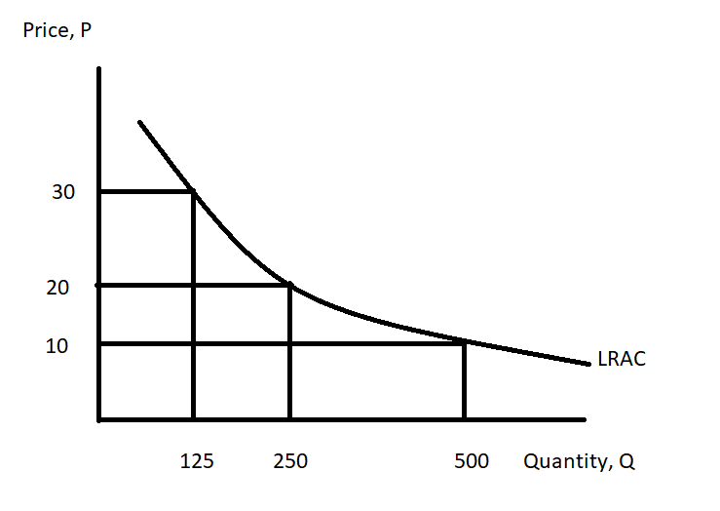
Given this information and holding everything else constant, how many of the following statements is true?
- If 500 units are produced in this market, the lowest cost of producing this quantity can be achieved by one firm producing all 500 units for a total cost of $5000.
- If 500 units are produced in this market, the total cost of having five identical firms each produce one fifth of this total quantity will be equal to no more than $15,000.
- If 500 units are produced in this market by two firms each producing 250 units of the good, the total cost of production will be twice the total cost of having a single firm produce all 500 units of the good.
- Perfect competition teaches us that it is always cheaper for a market to be served by multiple firms: in this market this is still true.

a. One statement is true.
b. Two statements are true.
c. Three statements are true.
d. Four statements are true.

12. Consider a bus system for a large metropolitan city. Which of the following statements is true?

a. The bus system will find that its average total cost of providing the service decreases as the number of rides taken increases.
b. The bus system will find that its total cost is constant for the entire system whether there is one firm providing the service or four firms providing the service.
c. If the bus system prices each bus ticket so that the price is greater than the marginal cost of providing the last ride, then the bus system will need a subsidy from the city in order to be able to cover its operating costs.
d. If the price of a ride on the bus is equal to the average total cost of a ride, then the buses in this community will be so full that some people will not be able to get on the bus.

13. Medicare is funded by:

a. FICA taxes paid by employees and employers.
b. general tax revenues.
c. a small amount of payments made by states.
d. All of the above help to fund Medicare.

14. When a good is non-rejectable this means that:

a. Everyone can consume the good without any one person’s consumption of the good diminishing the amount of the good available to someone else in the community.
b. Everyone has access to the same amount of the good no matter what their preferences for the good.
c. Everyone is required to pay for the good since it is not possible to reject the good.
d. Anyone can enjoy the consumption of the good even if they have not paid for the good.

15. Consider a city with a metropolitan bus system. If this bus system provides the socially optimal amount of bus rides then:

a. it is likely that the bus system will earn a positive economic profit.
b. it is likely that the bus system will charge very low fares to ride the bus and that the bus system will need to be subsidized by the community.
c. the bus system will earn zero economic profit.
d. no one in the city will drive cars.

16. Medicare and Medicaid are two health care programs financed by the government. Medicare:

a. provides coverage to people aged 65 and older as well as some younger people with disabilities and to people with end-stage renal disease.
b. provides coverage solely to people aged 65 and older.
c. provides coverage solely to people aged 65 and older and to people with end-stage renal disease.
d. provides coverage to low income people.

Use the following information to answer the next two (2) questions.

Consider a market that can be described by the following information:

Marginal Social Benefit from consuming the good: MSB = 250 – (1/2)Q
Marginal Private Cost of producing the good: MPC = 25 + (1/16)Q
Externality Cost of Producing the good = $45 per unit of the good produced

17. Given this information and holding everything else constant, the socially optimal amount of the good is:

a. 80 units more than the market quantity where the market quantity is the amount that will be produced if the externality is not internalized.
b. 80 units less than the market quantity where the market quantity is the amount that will be produced if the externality is not internalized.
c. 120 units more than the market quantity where the market quantity is the amount that will be produced if the externality is not internalized.
d. 120 units less than the market quantity where the market quantity is the amount that will be produced if the externality is not internalized.

18. If this externality is not internalized than the total surplus in this market can be written as:

a. (1/2)(250 – 25)(400) + (45)(400)
b. (1/2)(250 – 25)(400)
c. (1/2)(250 – 70)(320) – 45(320)
d. (1/2)(250-25)(400) – (45)(400)

19. Consider a market for health care services where there are non-poor consumers of the good and poor consumers of the good. Assume there is a health care program implemented in this market to provide health care services for free to the poor. The demand curves for these two types of consumers are given below where Q is the quantity of health care services provided and P is the price of these health care services. (To make the math simpler the problem uses a small dollar amount for the price of these health care services.)

Demand for Health Care Services from Poor Consumers: P = 40 – (1/2)Q
Demand for Health Care Services from Non-poor Consumers: P = 100 – Q

The supply curve for health care services is given by the following equation:

Supply of Health Care Services: P = (1/2)Q

Given this information and holding everything else constant, how many of the following statements are true?

- The total equilibrium quantity in this health care services market is 120 units of health care services.
- The non-poor will receive 20 units of health care services in this market.
- The poor will receive 80 units of health care services in this market.
- The non-poor will demand fewer health care services in this market since the provision of free health care services to the poor effectively increases the price of health care services to the non-poor.

a. One statement is true.
b. Two statements are true.
c. Three statements are true.
d. Four statements are true.

Use the following information to answer the next two (2) questions.

You are provided the following information about a market where Q is the quantity of the good:

Marginal private cost of producing the good: MPC = 50 + 4Q
Marginal social benefit from consuming the good: MSB = 1000 – 6Q
Externality cost per unit of the good = $10 per unit

20. If the externality in this market is not internalized then the total surplus, TS, in this market is equal to:

a. TS = (950)(95)
b. TS = (1/2)(950)(95)
c. TS = (950)(95) + (10)(95)
d. TS = (1/2)(950)(95) - (10)(95)

21. In this market the deadweight loss due to the externality is equal to:

a. $0
b. $950
c. $10
d. $5

22. Susie and Joe are the only residents in a community. Susie and Joe are debating the installation of streetlights in their community. They both know each other’s preferences for streetlights and Susie knows that Joe values having more streetlights than does Susie. Both Joe and Susie have linear demand curves for streetlights. The graph below depicts the marginal social benefit of streetlights for these two individuals:

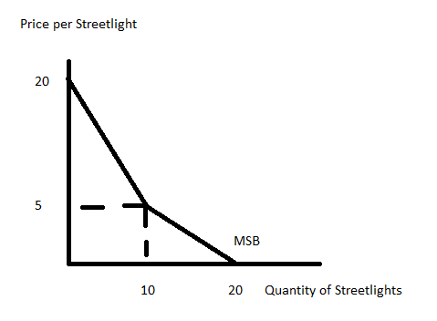

Suppose you are also told that the marginal social cost of producing a streetlight is given by the equation:

Marginal Social Cost of Streetlight: MSC = 4 + (5/2)Q

Assume that neither of these individuals free ride. Given this information and holding everything else constant, then:

a. the socially optimal amount of the good is 4 units and Joe will pay $8 per streetlight.
b. the socially optimal amount of the good is 2 units and Susie will pay $6 per streetlight.
c. the socially optimal amount of the good is 4 units and Joe will pay $14 per streetlight.
d. the socially optimal amount of the good is 2 units and the price per streetlight will be $14.

23. How many of the following statements about Medicaid are true?

- Medicaid provides health insurance and health care for 1 out of 5 Americans.
- is the United States public health insurance program for people with low income.
- Medicaid is a federal-state partnership program where the federal government provides a financial match of at least 50% of the cost of the medical care provided by Medicaid to each state.
- Medicaid provides health insurance to 76% of the nation’s poor children and 48% of children with special needs.

a. One statement is true.
b. Two statements are true.
c. Three statements are true.
d. Four statements are true.

24. If everyone free rides with regard to the provision of a public good, then:

a. the market supply curve for the public good will be further to the left than it would be if no one was free riding.
b. the market demand curve for the public good will not reflect the true marginal social benefit from the public good.
c. the market supply curve for the public good will not reflect the true marginal social cost of providing the public good.
d. the market will provide too much of the public good.

25. Consider a market for health care services where there are non-poor consumers of the good and poor consumers of the good. Assume there is no program implemented to provide health care services to the poor. The demand curves for these two types of consumers are given below where Q is the quantity of health care services provided and P is the price of these health care services. (To make the math simpler the problem uses a small dollar amount for the price of these health care services.)

Demand for Health Care Services from Poor Consumers: P = 50 – (1/2)Q
Demand for Health Care Services from Non-poor Consumers: P = 100 – Q

The supply curve for health care services is given by the following equation:

Supply of Health Care Services: P = (1/2)Q

Given this information and holding everything else constant, the quantity of health care services that poor people will receive in this market will be:

a. Greater than the quantity of health care services received by non-poor people.
b. Equal to 20 units of health care.
c. Will be one third fewer units of health care services than the amount of health care services received by the non-poor.
d. Equal to the quantity of health care services received by non-poor people.

Extra Worksheet: Do NOT Remove from Exam!

EXAM CONTINUES!
III. Problems and Short Responses (two questions worth 10 points each)

1. This is a short answer question. Your answers should be written in standard English with punctuation, capitalization, and the use of complete sentences. Before you write, take a moment to compose your answer.

a. (4 points) There are three properties associated with a public good. What are the two of these three properties of a public good? In your answer explain what each of these properties mean.

b. (6 points) It is difficult to get public goods to be provided by the market. Why is it that the market fails to provide the optimal amount of the public good? In your answer identify the sources of the market failure and why this market failure occurs.

2. Consider the market for streetlights in Elm Lawn. Elm Lawn has three citizens: Peter, Paul and Mary. All three citizens view streetlights as a public good. All three citizens are willing to reveal their preferences and they all three agree that they will not free ride on the provision of streetlights in their community. You are provided the following information where P is the price per streetlight and Q is the quantity of streetlights:

Peter’s Demand for the Public Good: Q = 10 – P
Paul’s Demand for the Public Good: Q = 20 – 4P
Mary’s Demand for the Public Good: Q = 16 – 2P
Marginal Social Cost of Providing a Streetlight: MSC = (9/8)Q

a. (6 points) In the space below draw a graph of the marginal social benefit (MSB) curve and the marginal social cost curve (MSC) for streetlights in Elm Lawn. Provide the numeric values for the y-intercepts and x-intercepts of these two curves. In addition, provide the coordinates for all “kink points” that you find in your graph. Also, provide the values for the equilibrium price per streetlight and equilibrium quantity of streetlights in this market. Make sure your graph also has a label for the x-axis and a label for the y-axis.

b. (3 points) Given the above information and holding everything else constant, how much will Peter contribute per streetlight? How much will Paul contribute per streetlight? How much will Mary contribute per streetlight? Show how you found your answers.

Peter will contribute ________ per streetlight.

Paul will contribute ________ per streetlight.

Mary will contribute ________ per streetlight.

c. (1 point) Suppose the MSC curve changes to MSC = 2.50. Holding everything else constant, who will free ride on this public good with this change in the MSC curve? Explain your answer.

