Econ 390 Name ________________________________
Fall 2021
First Midterm

I understand that this is a closed book, and no calculator exam.
I understand that providing help to another student or seeking help from another human being on this exam will be considered academic misconduct and that if I engage in this conduct I will get a zero on this exam.
Signature ____________________________________

Grade:
Essay #1 ___________________
Essay #2 ___________________
BC and MC Score ___________________
TOTAL SCORE ___________________

Binary Choice: 10 Questions worth 2 points each

1. "Altruistic punishment" refers to:

a. A punishment that is costly to the individual who engages in the punishment and where the individual who is doing the punishing does not gain any reward from inflicting the punishment.
b. A punishment rendered in such a way as to benefit the individual or party being punished.

2. Consider a firm that practices perfect price discrimination. This firm will:

a. Capture all of the consumer surplus when the firm engages in perfect price discrimination.
b. Result in a positive amount of deadweight loss, but the deadweight loss will be smaller than the deadweight loss if the firm acts as a single price monopolist.

3. A market for a product is such that the average total cost curve declines throughout the relevant range of production. This implies that throughout the relevant region of production:

a. For a given level of output, the marginal cost of producing the good is less than the average total cost of producing the good.
b. The marginal cost of producing the good is decreasing as the level of output increases.

4. The "Tragedy of the Commons" occurs when a good is:

a. Non-excludable and rival.
b. Non-rival and excludable.

Use the following information to answer the next three (3) questions.

Consider a monopoly that can be described by the following equations where P is the price per unit and Q is the number of units that the firm produces:

Market Demand Curve: P = 110 – 2Q
Marginal Cost: MC = 20 + 2Q
Fixed Cost: FC = 20

5. If this monopoly acts as a single price monopoly it will produce:

a. 22.5 units of the good and earn positive economic profit.
b. 15 units of the good and earn profits of $655.

6. If this monopoly acts as a single price monopoly it will generate a deadweight loss equal to:

a. $112.50
b. $56.25

7. Suppose this monopolist practices first degree price discrimination. Given this information and holding everything else constant, which of the following statements is true?

a. Profits are greater than producer surplus by the amount of fixed costs.
b. Producer surplus is greater than profits by the amount of fixed costs.

8. Hans Rosling discusses what happens when we divide issues into two distinct categories. He writes "Dividing the world into two distinct sides is simple and intuitive, and also dramatic because it implies conflict, and we do it without thinking, all the time." Rosling calls this instinct the:

a. Gap Instinct.
b. Size Instinct.

9. Prairie View Avenue is a five block long avenue located in a housing sub-division called Stone View. Rarely are there any cars on Prairie View Avenue and anyone who wishes to drive on Prairie View Avenue is welcome to drive there. Prairie View Avenue is an example of a:

a. Public good.
b. Private good.

10. A firm finds that its average total cost of producing 10 units of the good is $2.50 per unit and that its average total cost of producing 20 units of the good is $1.75 per unit. Given this information and holding everything else constant, if we determine that the market for this good needs to supply 20 units of the good, then:

a. It will be cheaper if a single firm supplies the whole market.
b. It will be cheaper if two or more firms supply the market.

Multiple Choice: 20 questions worth 3 points each

Use the following information to answer the next two (2) questions.

Consider a monopoly that can be described by the following equations where P is the price per unit and Q is the number of units of the good:

Market Demand Curve: P = 200 – 4Q
Marginal Cost: MC = 20 + 4Q
Fixed Cost: FC = 100

Suppose this monopolist decides to practice second degree price discrimination where the monopoly will sell the first five units it produces at a price of $180/unit, the second five units it produces at a price of $160/unit, and a final five units it produces at a price of $140/unit.
11. Given the above information and holding everything else constant, how many of the following statements are true?
I. In this example there are three triangles that represent consumer surplus.
II. In this example there is no deadweight loss since the second degree price discriminator in this example is producing the socially optimal amount of the good.
III. In this example the value of producer surplus exceeds the value of profit for the firm by the amount of the fixed cost.
IV. In this example the monopolist “captures” more of the consumer surplus than if the monopolist is just a single price monopolist.
- One statement is true.
- Two statements are true.
- Three statements are true.
- Four statements are true.

12. Given the above information and holding everything else constant, the value of producer surplus is:
a. $2100
b. $1550
c.$1750
d. $1650

13. Consider a public good. The market is unlikely to provide the socially optimal amount of the public good because:

a. When people consider a public good they know that the government will provide plenty of the good even if they do not demand the public good.
b. When a good is non-rival no one has an incentive to demand the good.
c. When people free ride this means that the market demand curve does not reflect the true demand curve for the good.
d. When a good is non-excludable people have an incentive to demand too much of the good at every price.

14. Passenger pigeons went extinct in the United States in 1914. The extinction of this bird was primarily due to the fact that these birds were:

a. A common resource which meant that no one could be excluded from consuming the resource and yet each individual consuming the resource was a rival to every other individual wanting to consume the resource.
b. A public nuisance creating all sorts of problems in urban areas necessitating the killing of large numbers of these birds.
c. A common resource which means that each individual could consume as much of the resource as they wanted since the resource was non-excludable and this consumption would not impact other individuals' consumption of the resource.
d. A public good and thus the passenger pigeon was both non-rival and non-excludable.

15. How many of the following statements are true about the socially optimal amount of the good?
I. The market always provides the socially optimal amount of the good since markets work well.
II. The socially optimal amount of the good is that amount where the marginal social benefit from consuming the good is equal to the marginal cost of producing the good.
III. To produce the socially optimal amount of the good it is necessary that the marginal social benefit from consuming the good is equal to the marginal social cost of producing the good.
IV. Since people recognize the importance of goods like national defense and lighthouses, the socially optimal amount of these goods will typically be produced without any real effort.

a. Four statements are true.
b. Three statements are true.
c. One statement is true.
d. Two statements are true.

16. Consider a natural monopoly. How many of the following statements are true about natural monopoly?
I. Over the relevant region of production the long run marginal cost of producing an additional unit of output is greater than the long run average cost of producing an additional unit of output.
II. With a natural monopoly the total cost of producing the total market quantity is always less the greater the number of firms serving this market.
III. Over the relevant region of production the long run average total cost is decreasing as output increases.
IV. Over the relevant region of production the long run average total cost is greater than the long run marginal cost at every level of output.

a. Four statements are true.
b. One statement is true.
c. Three statements are true.
d. Two statements are true.

17. Consider a firm that experiences increasing returns to scale over the relevant range of production. From this you conclude that:

a. As the level of output increases this firm experiences decreasing costs per unit of production.
b. As the level of output increases this firm finds that its cost per unit for producing this good increases.
c. As the level of output increases the firm has decreasing average total costs and decreasing total costs.
d. The firm will have lower costs per unit at a relatively small scale of operation than it will have at a relatively large scale of operation.

Use the following information to answer the next two (2) questions.

Consider a monopolist that sells their product to two distinct classes of buyers. The monopolist knows the following where P is the price per unit and Q is the number of units of the good:

Demand for the good from Class One Buyers: P = 20 – Q
Demand for the good from Class Two Buyers: P = 16 – Q
Marginal Cost for the Monopolist: MC = Q
Total Cost for the Monopolist: TC = (1/2)Q² + 20

18. Given this information and holding everything else constant, which of the following bests represents this monopolist’s total market demand curve for the good?
a. P = 16 – Q for quantities less than or equal to 4 units; P = 18 – (1/2)Q for prices less than or equal to 16
b. P = 36 – 2Q for quantities less than or equal to 4 units; P = 20 – Q for prices less than or equal to 16
c. P = 20 – Q for prices greater than or equal to 16; P = 18 – (1/2)Q for quantities greater than or equal to 4
d. P = 20 – Q for prices greater than or equal to 16; P = 36 – 2Q for prices less than or equal to 16

19. Suppose this monopolist decides to practice third degree price discrimination. Given this information and holding everything else constant, how many of the following statements are true?
I. Class One buyers will buy 5.5 units of the good at a price that is greater than the price that Class Two pays for the units consumed by Class Two.
II. The profit maximizing quantity this firm should produce if it practices third degree price discrimination is smaller than the quantity this firm should produce if it acts as a profit maximizing single price monopolist.
III. The total revenue for the two classes this monopolist earns when it practices third degree price discrimination is equal to $123.50.
IV. The total profit this monopolist earns when it practices third degree price discrimination is equal to $63.
- One statement is true.
- Two statements are true.
- Three statements are true.
- Four statements are true.

Workspace: Do NOT Remove This Page From Your Exam

20. Consider the firm depicted in the following graph where LRATC is the firm's long run average total cost curve, LRMC is the firm's long run marginal cost curve, D is the firm's demand curve, and MR is the firm's marginal revenue curve.

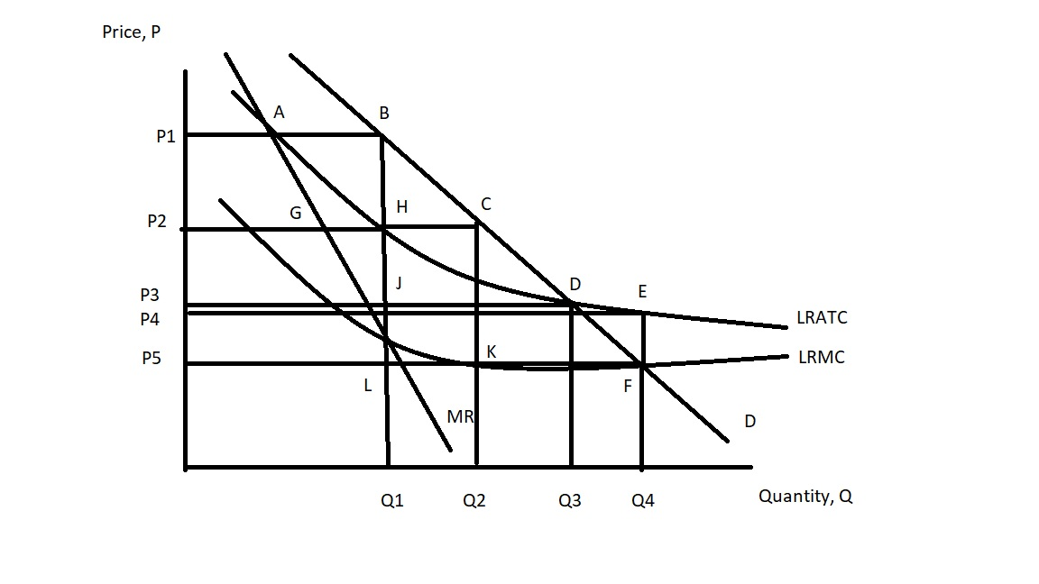

Suppose this firm is regulated so that it produces the socially optimal amount of the good. Given this information and holding everything else constant, what is the subsidy per unit that the government must pay the firm in order for the firm to be willing to produce this level of output?

a. (C- K) dollars per unit of output
b. (H - J) dollars per unit of output
c. (E - F) dollars per unit of output
d. (P4 - P5)(Q4) dollars

21. Consider the firm depicted in the following graph where LRATC is the firm's long run average total cost curve, LRMC is the firm's long run marginal cost curve, D is the firm's demand curve, and MR is the firm's marginal revenue curve.

Suppose this firm is regulated to produce where the firm breaks even. Given this information and holding everything else constant, then the firm will produce:

a. Q3 units of the good and charge P5 per unit of the good.
b. Q3 units of the good and charge P3 per unit of the good.
c. Q4 units of the good and charge P4 per unit of the good.
d. Q1 units of the good and charge P2 per unit of the good.

Use the following information to answer the next two (2) questions.

Consider a city bus system. Currently the buses are operating at 30% capacity and a single ride on the bus costs $2.00 per ticket. The total operating cost for the entire bus system is $500,000 for the year and 500,000 rides are taken each year.

22. Given this information and holding everything else constant, what is the marginal cost of one additional ride for this city bus system?

a. Less than $1.00 and greater than $0
b. $0
c. $1.00
d. $2.00

23. Given this information and holding everything else constant, is this bus system operating with positive, negative or zero economic profits?
a. The city bus system is earning zero economic profits since its total revenue is equal to its total cost.
b. The city bus system is earning positive economic profits since its total costs are greater than its average costs.
c. Since average total cost is $1 per ride and the bus system is charging $2 per ride, the bus system is earning positive economic profit.
d. The city bus system is earning negative economic profits which is typically of urban mass transit systems.

24. Consider a good where the long run total cost for producing the good is described by the following equation where TC is the total cost and Q is the number of units of the good:
TC = 10(Q)(Q) + 20Q + 1000
Suppose that we only need 8 units of this good. If one firm produces this good, then the average total cost of producing this level of output is ____; and if four firms produce this good (so that each firm produces 2 units of the good) then the average total cost of producing this level of output for each firm is ______.

a. $225 per unit; $540 per unit
b. $225 per unit; $135 per unit
c. $1800 per unit; $1080 per unit
d. $225 per unit; $56.25 per unit

25. Consider a natural monopoly. Over the relevant region of production for this natural monopoly which of the following statements is true?

a. The profit maximizing level of output for the natural monopolist is also the socially optimal level of production for this monopolist.
b. The natural monopoly's long run average total cost decreases as output increases.
c. The natural monopoly's long run marginal cost decreases as output increases.
d. The profit maximizing level of output for the natural monopolist results in the firm earning negative economic profit.

26. In one of our readings the author discussed a number of terms. Which of the following statements best describes the "overconfidence effect"?

a. People, in general, prefer immediate gratification of their desires since they are confident that immediate gratification will all work out fine in the long run.
b. People, in general, with confidence feel the pain of a loss more strongly than the benefit of a gain.
c. People, in general, evaluate their own skills as better than what a third-party observer might think of those same skills.
d. People, in general, find that the context within which they are make a decision can have a very big influence: for example, if you make a decision when you feel over-confident then there is a higher probability that it was a good decision.

27. Consider a natural monopoly that is regulated. How many of the following statements are true?
I. If the natural monopoly is regulated to produce the socially optimal amount of output, the firm will be unwilling to produce this level of output unless it also receives a subsidy.
II. If the natural monopoly is regulated to breakeven then the level of output the firm produces will be less than the socially optimal level of output.
III. If the natural monopoly is regulated to produce the socially optimal amount of output, the firm's average total cost of production will be greater than its regulated price for the good.
IV. If the natural monopoly is regulated to breakeven then its price per unit is equal to its average total cost.

a. One statement is true.
b. Four statements are true.
c. Two statements are true.
d. Three statements are true.

28. Schumpeter wrote about "creative destruction". His use of this term implied that:

a. All business are inherently destructive since they create new products that lead to destabilization of markets for existent producers of similar goods.
b. The existence of monopolies with their market power and positive economic profits served as an incentive for innovation and the inevitable destruction of the monopolist's power in the market.
c. The pursuit of maximum profits by perfectly competitive firms would result in the optimal provision of the good since the firms would act in a creatively destructive way towards their fellow competitors.
d. All monopolies, no matter what they produce, are both a creative force in the world and a destructive force in the world.

29. Bob walked into Costco last Thursday and the first thing he saw was an immense TV on sale for $2849.00. His first thought was "Wow, that's a huge TV-who has a living room big enough for that! And, that's a lot to pay for a TV!" He walked a few more steps into Costco and saw a large TV (still quite big but not as big as that first one) for sale for $1432.00. He decided to buy it reasoning that it was a really good deal. This story illustrates:

a. Temporal Discounting.
b. Anchoring and Framing.
c. Loss Aversion.
d. The Overconfidence Effect.

30. Angel Perez, the Director of Admissions at Trinity College, had two primary missions. They were:

a. To decrease the number of less qualified affluent students and replace them with more highly qualified affluent students.
b. To reduce Trinity College's expenses from hiring a consulting firm to help analyze their admission decisions and to diversity the student body at the school beyond its narrow prep school demographic.
c. To increase the total number of students receiving a free education while limiting the number of less qualified affluent students.
d. To help balance the school's budget through the admissions decisions that were made and to diversify the student body at Trinity College.

Essay Questions: 2 Questions at 10 points each

1. Hans Rosling writes about the rate of population growth in the world in his book Factfulness. He provides three reasons for why the average number of babies per woman is falling across the world. Briefly enumerate and explain these three reasons in an organized essay.
Grading Rubric:
3 points for each reason up to a maximum of 9 points
1 point for clarity, grammar, and quality of essay

2. Economists talk a lot about free riders. What is a free rider? Provide a definition of this term and then three examples of a free rider.
Grading rubric:
2 points for definition of free rider
2 points for each example up to a maximum of 6 points
2 points for clarity, grammar, and quality of essay

