Economics 390
Spring 2022
Homework #3
Due 3/24/2022

Homework is due by midnight Central Standard Time on its due date. Homework is to be submitted to the CANVAS course site: follow the directions for submission that are provided on the CANVAS page. The professor reserves the right to not accept homework if it is late. The expectation is that the homework will be done in a professional manner: it should be neat, well organized, and complete. You cannot receive full credit if you omit questions and do not follow the provided instructions. You will not be able to get full credit for the homework if you do not show your work in an organized, easy-to-follow manner. Illegible answers will not get full credit.

Natural Monopoly: The Bus Problem:

1. In this exercise you are charged with making a “bid” stating what price you must get paid to provide bus service to your community. Your service must meet certain criteria specified by the local authorities.

Here are the criteria for the bus system you will be providing:

i. The community is five miles wide and six miles long. The diagram below depicts this community of 30 square miles.
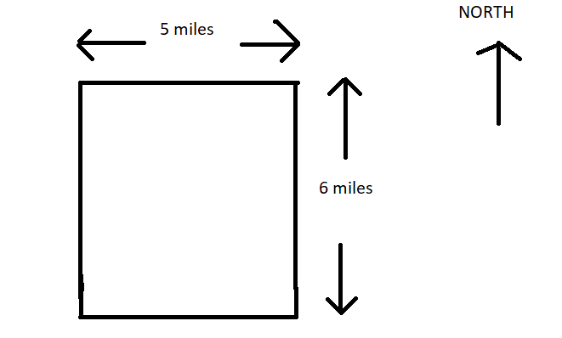
ii. The city will have 3 bus routes (Routes 1, 2, and 3) that run in a rectangular pattern as shown in the diagram below. For each of these 3 routes there is a bus stop every ½ mile.
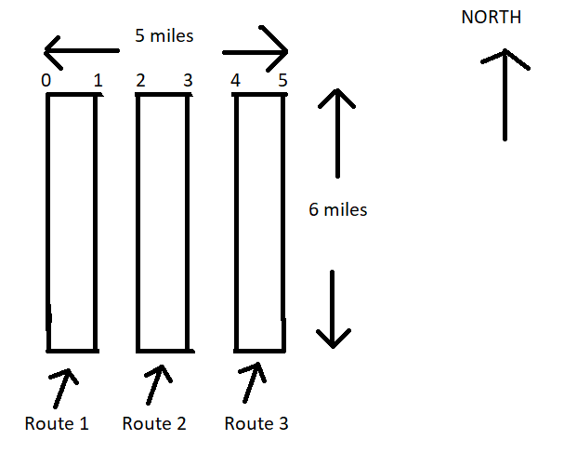
iii. The city will have 1 bus route (Route 4) that runs in a rectangular pattern as shown in the diagram below. This route will have bus stops that are ¼ mile apart.
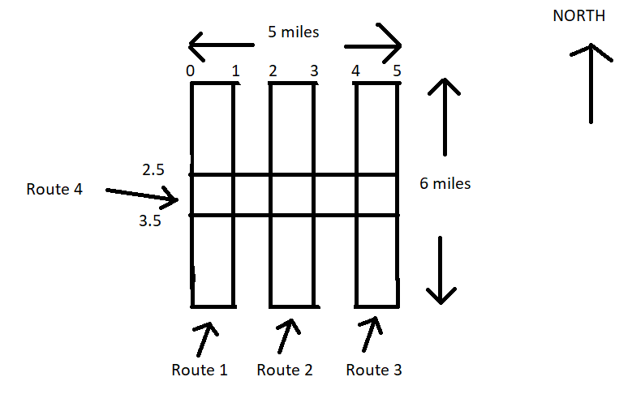
iv. Bus service in the city is only provided during the week (i.e., no Saturday or Sunday service). Each weekday rush hour lasts four hours and the city wants a bus at each stop on Routes 1, 2, and 3 every 10 minutes during this high demand part of the day. For Route 4 the city specifies that there must be a bus at every stop every 12 minutes during this high demand part of the day.

v. Bus service in the city will be provided a total of 16 hours a day on each weekday. (Four of the sixteen hours are during rush hour and the remaining 12 hours are non-rush hour.) The city specifies that a bus must be at each stop on Routes 1, 2, and 3 every thirty-five minutes during the non-rush hour part of the day. For Route 4 the city specifies that there must be a bus at every stop every 36 minutes during the non-rush hour part of the day.
vi. The bus company can lease buses from a long-term leasing company for $100 per hour for each hour the bus is operating. This fee includes all fuel and maintenance costs for the bus fleet.

vii. The bus company must also hire labor to operate the buses and the labor cost per hour of bus operation is $40.

viii. Assume that the time between the arrival at the first stop and the arrival at the second stop is 5 minutes if the stops are ½ mile apart. The time between the arrival at the first stop and the arrival at the second stop is 3 minutes if the stops are ¼ mile apart.

Revenue Information:

- Each bus when filled-to-capacity can transport 60 passengers.
- Average length of bus ride per passenger is 30 minutes.
- When fares are set at $1.00 per ride bus capacity is at 70%. When fares are set at $2.00 per ride bus capacity drops to 50%. Assume these are the only two pricing options you can offer for your service.
- The government provides this community a transportation subsidy of $5 million per year to help finance the provision of bus service. This subsidy reflects the fact that without mass transit there will be significant congestion costs, pollution costs, the need to construct expensive parking structures to accommodate single person transportation, and military costs associated with insuring that oil prices stay at low levels. The government estimates that these externality costs would be at least $10 million per year for the community.

Here are the questions you must answer:

- What is the long run total cost of operating this bus system for a 52-week year?
- How many bus-hours per week (a bus-hour is one bus operating for one hour) will you be operating buses?
- How many bus-hours per year will you be operating buses?
- How many buses will you need in your fleet to provide the service?
- What is the LRATC for your company if 5 million rides are taken each year? Round your answer to the closest whole dollar amount.
- What is the LRATC for your company if 10 million rides are taken each year? Round your answer to the closest whole dollar amount.
- What is the LRATC for your company if 20 million rides are taken each year? Round your answer to the closest whole dollar amount.
- What is the maximum number of passenger rides per year that this bus system can provide given its specifications? What do you project will be the number of passenger rides you provide each year if you choose the $1 fare? What do you project will be the number of passenger rides you provide each year if you choose the $2 fare?
- What do you project your profits to be if you charge $1 per fare? What do you project your profits to be if you charge $2 per fare?
- Which fare option do you plan to propose to the city authorities?
- What do you estimate your profits will be given the bus fare option you are choosing? (This just reiterates the answer you provided in #9.)

For your “bid” fill in the following table (this is just to help the grader access your data more swiftly!).

Bus Fare Option Chosen
Cost of Operating Bus System
 | Fare of $2 per passenger ride | Fare of $1 per passenger ride
Revenue from fares
Gross revenue (fares plus subsidy)
Profit

Externalities

Externalities:

2. Consider the production of a good. At the market provided quantity of the good you are told that the marginal social benefit from consuming this good is greater than the marginal social cost of producing this good.

a. Draw a graph that represents this provided information. In your graph be sure to include the marginal private benefit (MPB) curve, the marginal social benefit curve (MSB), and the marginal social cost (MSC) curve. Assume that the MSC curve is the same as the MPC (marginal private cost) curve in this market. Label the market quantity, Qmarket, as well as the socially optimal quantity, Qsocial optimum, in your graph. If there is an area of deadweight loss label this area as well.

b. Given the above information, does the market left to itself, produce too much or too little of the good? Explain your answer.

c. Provide an example of a good where the MSB at the market quantity is greater than the MSC at that market quantity.

3. The marginal social cost of providing a good is given by the following equation where Q is the market quantity and P is the price per unit:

Marginal Social Cost: MSC = 10 + 2Q

The marginal private benefit of providing this good is given by the following equation:

Marginal Private Benefit: MPB = 130 – Q
You are also told that this good generates positive consumption benefits of $9 per unit of the good consumed.

a. Given this information what is the quantity produced by the market?

b. Given this information what is the socially optimum amount of the good? Show how you found your answer.

c. What is the deadweight loss when this market fails to internalize (to correct for) the externality? Show how you found your answer.

4. We live in a world confronted with a large array of challenges. One current challenge is the COVID-19 pandemic. Discuss the issue of this pandemic and how it represents an externality that the market is failing to identify and correct. Then suggest some options that might be implemented to help remedy this problem. (You might find it helpful to read Paul Krugman’s article in the New York Times article “Republicans Keep Flunking Microbe Economics” found at the following site: https://www.nytimes.com/2020/07/18/opinion/republicans-keep-flunking-microbe-economics.html before you answer this question.)

5. Consider the market for plastic in the country of Seaview. The market for plastic in this country is currently described by the following demand and supply equations:

Demand: Q = 100,000 – 10000P
Supply: Q = 40,000P

where P is the price per unit of plastic and Q is units of plastic. Although the good citizens of Seaview are aware that consuming plastic creates externality costs on their society the current plastic market does not incorporate any of these externalities.

a. Describe at least four possible externality costs associated with the consumption of plastic.

b. Given the externality costs you delineated in (a), where do you think the marginal social cost of plastic curve is relative to the given supply curve? That is, are the two curves the same, is the marginal social cost of plastic curve to the right of the market supply curve, or is the marginal social cost of plastic curve to the left of the market supply curve?

c. Given the above information, what is the current market equilibrium quantity and price?

d. Suppose that the government analyzes the externality costs in this market and concludes that the market should ideally result in 40,000 units of plastic being consumed if all the externalities associated with plastic consumption were internalized in the market. Assuming the externality costs are per unit of usage of plastic and are constant, what is the externality cost per unit of plastic consumed?
e. Suppose the government elects to impose a tax to internalize the externality. How big an excise tax would the government need to impose in order to address the externality that you measured in (d)?

Public Goods:

6. Imagine a community that has only two residents: George and Mariah. George and Mariah both realize that their community would benefit from the installation of streetlights, and they are trying to figure out the optimal number of streetlights for their community. George and Mariah are both willing to reveal their preferences for streetlights:

George’s preferences for streetlights are given by the equation: MPB = 10 – 2Q
Mariah’s preferences for streetlights are given by the equation: MPB = 14 – 2Q

where MPB is the marginal private benefit for the individual and Q is the number of streetlights. Both George and Mariah know that the marginal social cost of installing a streetlight is given by the equation:

Cost of installing streetlights: MSC = 4Q

a. Given this information, start by constructing three graphs that are vertically drawn one under the other. In the top graph depict the MPB for George; in the second stacked graph depict the MPB for Mariah; and in the final stacked graph depict the MSB (marginal social benefit) from streetlights assuming that George and Mariah are the only two individuals in this community. Label all axis, and any “kink” points clearly and completely.

b. Given your graphs in (a), write an equation(s) for the MSB curve you found. Make sure you also indicate any relevant range for the MSB equation(s) you provide.

c. Calculate the optimal number of streetlights in this community and then determine the total price per streetlight and the amount of this price that will be paid by George and the amount that will be paid by Mariah. Show your work and explain how you found your answers.

7. Consider a community that has two residents, Janine and Scott. Janine and Scott would both like to have some public parks in their community and they are trying to decide on the optimal number of parks to build, and what price they should each contribute for each park. Luckily, they are both willing to reveal their preferences and so we do not have to worry about the free rider problem. You are provided the following equations describing these individual’s demand curves for public parks where P is the price per park and Q is the quantity of parks:

Janine’s demand for parks: Q = 12 – 2P
Scott’s demand for parks: P = 10 – (1/2)Q.

You are also told that the marginal social cost of providing a park is given by the equations:

Marginal Social Cost: MSC = 3Q

a. On your homework paper draw three graphs vertically one above the other. The first graph should be labeled “Janine’s demand”; the second graph should be labeled “Scott’s demand”; and the third graph should be labeled “Market demand”. On each graph the horizontal axis should be labeled “Quantity of Parks” while the vertical axis should be labeled “Price of Parks”. Now in each graph draw in the demand curve corresponding to your label. Remember that the market demand curve will be a vertical summation of the individual demand curves since a public good is non-rival.

b. Write an equation for the market demand curve for the public good.

c. Given the above information, what is the optimal number of parks for the community? Show how you found this number.

d. Since Janine and Scott each get benefits from the parks, they will each contribute towards the cost. Given her demand, how much will Janine contribute per park? How much will Scott contribute per park? Why do Janine and Scott contribute different amounts?

e. Now think about what would happen if Janine decides to free ride and not reveal her preferences. How many parks will be provided with this scenario (it’s okay if you get a fraction) and how much will Scott pay per park and how much will Janine pay per park?

8. Trudy and Stanley are the only residents in a community. Trudy and Stanley are debating the number of firework displays to have in their community for the coming year. They both know each other’s preferences for firework displays and Trudy knows that Stanley values having more fireworks than does Trudy. Both Stanley and Trudy have linear demand curves for fireworks. The graph below depicts the marginal social benefit of firework displays for these two individuals:

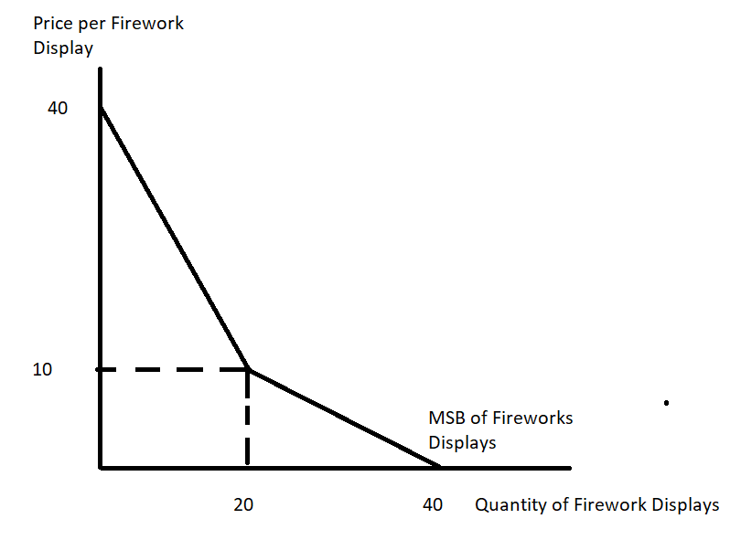

Suppose you are also told that the marginal social cost of producing a firework display is given by the equation:

Marginal Social Cost of Firework Displays: MSC = 5 + 2Q

Assume that neither of these individuals free ride. Given this information and holding everything else constant, answer the following questions. Provide your reasoning behind your answers to get full credit.

a. Trudy’s demand curve for firework displays.

b. Stanley’s demand curve for firework displays.

c. The socially optimal amount of firework displays given the above information.

d. The amount that Stanley will contribute per firework displays if the socially optimal amount of firework displays is produced.

e. The amount that Trudy will contribute per firework displays if the socially optimal amount of firework displays is produced.

