Economics 390
Spring 2022
Homework #2
Due 2/24/2022

Homework is due by midnight Central Standard Time on its due date. Homework is to be submitted to the CANVAS course site: follow the directions for submission that are provided on the CANVAS page. The professor reserves the right to not accept homework if it is late. The expectation is that the homework will be done in a professional manner: it should be neat, well organized, and complete. You cannot receive full credit if you omit questions and do not follow the provided instructions. You will not be able to get full credit for the homework if you do not show your work in an organized, easy-to-follow manner. Illegible answers will not get full credit.

Perfect Competition (these two questions are very similar, but my historical experience suggests that students need to practice this analysis!)

1. Consider a perfectly competitive market that is comprised of ten identical firms. This market is currently in short run equilibrium. You are provided the following information about this market:

Market Demand: P = 122- 2Q
Total Cost for the Representative Firm: TC = 250 + 2q + 10q²
Marginal Cost for the Representative Firm: MC = 20q + 2

where Q is the market quantity, q is the firm quantity, and P is the price per unit.

a. Given this information find the equation for the short run market supply curve. Show how you found this equation.

b. Given this information and the supply curve you found in (a), find the short run market price (P), the short run market quantity (Q), and the short run quantity produced by the representative firm (q), and the short run profits earned by the representative firm. Show how you found your answers in order to get full credit.

c. Given this information and the work you have done, what is your prediction for what will happen in the long run in this market? Assume that there are no changes to market demand. Be specific here: give a prediction on any shifts of curves that will occur, any entry or exit of firms, the market price, the market quantity, the level of profits for the representative firm and the representative firm’s level of production.

d. Assume there are no changes to the market demand curve. Find the long run equilibrium. Identify what the new supply curve will be, what the market price (P’) will be, the market quantity (Q’), the representative firm’s level of production (q’), the representative firm’s level of profit will be, and the number of firms in the industry will be. Show your work and your reasoning to get full credit.

2. Consider a perfectly competitive market that is comprised of four identical firms. This market is currently in short run equilibrium. You are provided the following information about this market:

Market Demand: P = 101 – (1/2)Q
Total Cost for the Representative Firm: TC = 90 + 2q + 10q²
Marginal Cost for the Representative Firm: MC = 2 + 20q

where Q is the market quantity, q is the firm quantity, and P is the price per unit.

a. Given this information find the equation for the short run market supply curve. Show how you found this equation.

b. Given this information and the supply curve you found in (a), find the short run market price (P), the short run market quantity (Q), and the short run quantity produced by the representative firm (q), and the short run profits earned by the representative firm. Show how you found your answers in order to get full credit.

c. Given this information and the work you have done, what is your prediction for what will happen in the long run in this market? Assume that there are no changes to market demand. Be specific here: give a prediction on any shifts of curves that will occur, any entry or exit of firms, the market price, the market quantity, the level of profits for the representative firm and the representative firm’s level of production.

d. Assume there are no changes to the market demand curve. Find the long run equilibrium. Identify what the new supply curve will be, what the market price (P’) will be, the market quantity (Q’), the representative firm’s level of production (q’), the representative firm’s level of profit will be, and the number of firms in the industry will be. Show your work and your reasoning to get full credit.

Monopoly and Price Discrimination

3. Consider a monopoly described by the following equations:

Market Demand: P = 200 – Q
Monopoly’s Total Cost: TC = 20 + 20Q + (1/2)Q²
Monopoly’s Marginal Cost: MC = 20 + Q

a. Suppose this is a single price monopolist. Using the above information find the following:

i. Market Quantity, Q = __________________________
ii. Market Price, P = _________________________________
iii. Profit for the Single Price Monopolist = _______________________
iv. Consumer Surplus for the Single Price Monopolist, CS = ________________
v. Producer Surplus for the Single Price Monopolist, PS = _____________
vi. Deadweight Loss due to the Single Price Monopolist, DWL = _________________

Show your work to get full credit.

b. Draw a graph and label it clearly and carefully to illustrate your answers in (a).

c. Suppose this same monopoly decides to practice first degree price discrimination instead of being a single price monopolist. Using the above information and assuming that the firm possesses the needed information that it must have to be a perfect price discriminator, determine the following values:

i. Market Quantity, Q = __________________________
ii. Profit for the First Degree Price Discriminator = _______________________
iii. Consumer Surplus for the First Degree Price Discriminator, CS’ = ________________
iv. Producer Surplus for the First Degree Price Discriminator, PS’ = _____________
v. Deadweight Loss due to the First Degree Price Discriminator, DWL’ = _________________

Show your work to get full credit.

d. Why is PS’ not equal to profits in (c)? Explain your answer.

e. Provide a graph that illustrates the first degree price discriminator. In your graph indicate any relevant values and areas. Label your graph clearly and completely to get full credit.

f. Suppose this firm decides to act as a second degree price discriminator. The firm plans to sell the first 30 units of the good for $170 per unit, the next additional 30 units at $140 per unit, and a final 30 units of the good for $110 per unit. (The monopolist arrives at these quantities and their associated prices by using the demand curve: for example, if Q = 20 then the price customers will pay is $180 per unit.) Given the above information and the decision to practice second degree price discrimination, find the following:

i. Total revenue for the second degree price discriminator = _______________
ii. Total cost for the second degree price discriminator = ______________
iii. Profit for the second degree price discriminator = ______________
iv. Producer Surplus, PS”, for the second degree price discriminator = _________________
v. Consumer Surplus, CS”, for the second degree price discriminator = _______________
vi. Deadweight Loss, DWL”, for the second degree price discriminator = ___________

Show your work to get full credit.

g. Provide a graph illustrating fully your work in (f). Label it clearly and completely.

4. Consider a monopolist that sells their product to two different types of buyers: buyers in class one and buyers in class two. This is the information you are given about this monopolist:

Demand of Class One Buyers: P = 20 – Q
Demand of Class Two Buyers: P = 15 – (3/2)Q
Marginal Cost for the monopolist: MC = 4
Fixed Costs: FC = 0

a. Suppose that this monopolist decides to sell to the two classes of buyers without distinguishing whether the buyer is in Class One or Class Two. That is, the monopolist decides to be a single price monopolist. Given this decision, find the following values:

i. Quantity of the good the monopolist sells = _______
ii. Price of the good = _________
iii. Total revenue from selling the good as a single price monopolist = __________
iv. Total cost of producing the good as a single price monopolist = __________
v. Profits for the single price monopolist = __________
vi. CS for the single price monopolist = __________
vii. PS for the single price monopolist = _________
viii. DWL due to the single price monopolist = ____________

Show your work to get full credit for this problem. And, provide a graph to illustrate your answers! Make sure it is well labeled and complete!

b. Suppose that this monopolist decides to practice third degree price discrimination by separating these two classes of buyers and treating each of them as separate monopolies. Given this information and the information you were originally provided determine the following:

i. Total quantity of the good the third degree price discriminating monopolist sells = _______
ii. Quantity of the good sold to Class One = ______
iii. Quantity of the good sold to Class Two = ______
iv. Price of the good to Class One Buyers = _____
v. Price of the good to Class Two Buyers = ______
vi. TR from Class One Buyers = ______
vii. TR from Class Two Buyers = ______
viii. TC of producing the good for both classes = _______
ix. Total Profit for the third degree price discriminating monopolist = ________
x. CS for the third degree price discriminating monopolist = _______
xi. PS for the third degree price discriminating monopolist = _______
xii. DWL for the third degree price discriminating monopolist = _____

Show your work to get full credit for this problem. And, provide a graph to illustrate your answers! Make sure it is well labeled and complete!

5. Consider a monopolist that sells their product to two different types of buyers: buyers in class one and buyers in class two. This is the information you are given about this monopolist:

Demand of Class One Buyers: P = 20 – Q
Demand of Class Two Buyers: P = 16 - Q
Marginal Cost for the monopolist: MC = (1/2)Q
Total Cost for the monopolist: TC = (1/4)Q² + 10

a. Suppose that this monopolist decides to sell to the two classes of buyers without distinguishing whether the buyer is in Class One or Class Two. That is, the monopolist decides to be a single price monopolist. Given this decision, find the following values (round your answers to two places past the decimal):

i. Quantity of the good the monopolist sells = _______
ii. Price of the good = _________
iii. Total revenue from selling the good as a single price monopolist = __________
iv. Total cost of producing the good as a single price monopolist = __________
v. Profits for the single price monopolist = __________

Show your work to get full credit for this problem.

b. Suppose that this monopolist decides to practice third degree price discrimination by separating these two classes of buyers and treating each of them as separate monopolies. Given this information and the information you were originally provided determine the following (round your answers to two places past the decimal):

i. Total quantity of the good the third degree price discriminating monopolist sells = _______
ii. Quantity of the good sold to Class One = ______
iii. Quantity of the good sold to Class Two = ______
iv. Price of the good to Class One Buyers = _____
v. Price of the good to Class Two Buyers = ______
vi. TR from Class One Buyers = ______
vii. TR from Class Two Buyers = ______
viii. TC of producing the good for both classes = _______
ix. Total Profit for the third degree price discriminating monopolist = ________

Show your work to get full credit for this problem.

Natural Monopoly

6. Consider a monopoly described by the following equations:

Total Cost for the Monopolist: TC = 640,000 + 550Q + (1/4)Q²
Marginal Cost for the Monopolist: MC = 550 + (1/2)Q
Market Demand for the Monopolist: P = 10,000 – 10Q

a. Examine the data you have been provided. What is variable cost, VC, for this monopoly? What is fixed cost, FC, for this monopoly?

b. Suppose the monopoly produces 200 units of the good, what is the average fixed cost for this level of production? Suppose the monopoly produces 2000 units of the good, what is the average fixed cost for this level of production? Show your work for this question.

c. At what level of output is the average total cost minimized? Show how you found your answer.

d. Suppose this monopolist acts as a single price monopolist. Find the following given this assumption. For all calculations, calculate to two places past the decimal. You will find it helpful to use a calculator or spreadsheet like Excel for this part of the problem.

i. Market price of the good = _____
ii. Market quantity of the good = _____ (calculate this to two places past the decimal)
iii. Profit for the single price monopolist = _____
iv. DWL when this firm acts as a single price monopolist = _____ (round all calculations to two places past the decimal) Hint: this will be a very big number!

e. Suppose that this monopoly is regulated so that it produces the socially optimal amount of the good. This quantity will be where the MC intersects the demand curve. Given this regulation determine the values of the following:

i. The price of the good with MC regulation = ____
ii. The quantity of the good produced with MC regulation = ______
iii. The profit for the firm if it is regulated with MC regulation = ____
iv. The amount of the total subsidy payment the firm must receive in order to produce the socially optimal amount of the good = _____
v. DWL when this firm is regulated with MC regulation = _____

7. Use the following graph of a natural monopoly to answer this set of questions.

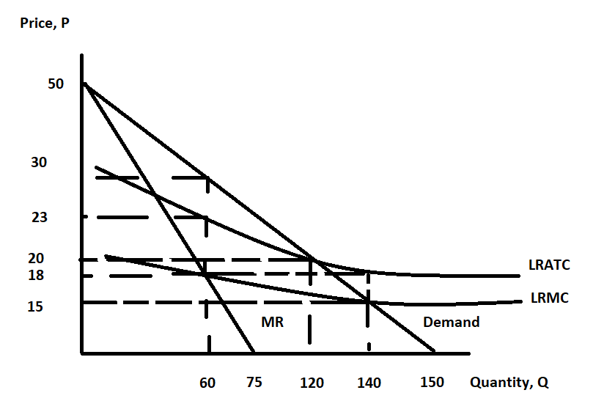
a. Suppose this natural monopoly is allowed to act as a single price monopoly. What level of output and what price will result under this assumption? Explain how you found your answer.
What will be the natural monopoly’s level of economic profit if it acts as a single price monopolist? Show how you found your answer.

b. Suppose that this natural monopoly is regulated so that it produces that level of output where its economic profit is equal to zero. Identify the price and the level of output the firm will produce with this form of regulation. Explain how you found your answer. If the natural monopoly is regulated so that it earns zero economic profit what must be true?

c. Suppose that this natural monopoly is regulated so that it produces the socially optimal amount of the good. What is the socially optimal amount of the good given the above graph? How big a subsidy per unit will the natural monopoly need if it is regulated to produce the socially optimal amount of the good? What will be the value of the total amount the regulatory authority will pay as a subsidy if this form of regulation is implemented. Explain and show how you found your answers.

