Economics 390
Fall 2019
Homework #2
Due on Thursday, November 14, 2019

Homework is due at the beginning of lecture. The professor reserves the right to not accept homework if it is late. The expectation is that the homework will be done in a professional manner: it should be stapled, it should be neat, well organized, and complete. You cannot receive full credit if you omit questions and do not follow the provided instructions. There is no need to submit the questions: you need to simply submit your answers. You will not be able to get full credit for the homework if you do not show your work in an organized, easy-to-follow manner. Make sure your name is clearly and legibly written on the homework. Illegible answers will not get full credit.

1. Consider the market for gasoline in the country of Xerbia. The market for gasoline in this country is currently described by the following demand and supply equations:

Demand: Q = 50,000 – 5000P
Supply: Q = 20,000P

where P is the price per gallon of gasoline and Q is gallons of gasoline. Although the good citizens of Xerbia are aware that consuming gasoline creates externality costs on their society the current gasoline market does not incorporate any of these externalities.

a. Describe at least four possible externality costs associated with the consumption of gasoline.

b. Given the externality costs you delineated in (a), where do you think the marginal social cost of gasoline curve is relative to the given supply curve? That is, are the two curves the same, is the marginal social cost of gasoline curve to the right of the market supply curve, or is the marginal social cost of gasoline curve to the left of the market supply curve?

c. Given the above information, what is the current market equilibrium quantity and price?

d. Suppose that the government analyzes the externality costs in this market and concludes that the market should ideally result in 20,000 gallons of gasoline being consumed if all the externalities associated with gasoline consumption were internalized in the market. Assuming the externality costs are per unit of usage of gasoline and are constant, what is the externality cost per gallon of gasoline consumed?

e. Suppose the government elects to impose a tax to internalize the externality. How big an excise tax would the government need to impose in order to address the externality that you measured in (d)?

2. Paul and Jonette are the only residents in their community. They are currently trying to decide how many streetlights should be installed in their community. Paul and Jonette both recognize that streetlights once they are installed are non-rival: that is, once the streetlight is installed and lit, everyone can enjoy consuming the benefits of the streetlight without affecting the level of consumption benefits available to other individuals in the community. They also recognize that streetlights are non-exclusive: that is, streetlights are apt to be under demanded as each individual in the community realizes that even if they do not pay for the streetlight they will still be able to enjoy consuming the benefits from the streetlight once it is installed and lit. Paul and Jonette have both decided to not free ride and take advantage of the non-exclusivity of the streetlight: they each are willing to fully reveal their willingness to pay for streetlights. Paul and Jonette’s demands for streetlights are given in the equations below where Q is the quantity of streetlights and P is the amount per streetlight, they are willing to pay.

Paul’s Demand for Streetlights: P = 10 – (1/2) Q
Jonette’s Demand for Streetlights: P = 10 – Q

You also know that the MC of providing an additional streetlight is $4 per streetlight. Assume that this MC curve reflects the marginal social cost of providing streetlights.

a. In a diagram with the graphs vertically “stacked” on top of one another draw three graphs: in the top graph draw Marty’s demand curve, in the middle graph draw Palmer’s demand curve, and in the bottom graph draw the market demand curve for streetlights. Remember that these streetlights are public goods: this implies that you will need to vertically sum the individual demand curves to get the market demand curve. That is, select a quantity and ask how much Paul and Jonette will each pay to install this amount of streetlights-remember that the streetlights are non-rival so the critical thing here is that each of these individuals will contribute together for the purchase of this quantity of streetlights since they can both consume the benefits from this level of streetlights simultaneously.

b. In your graph draw in the MC curve for streetlights.

c. Mark the socially optimum amount of streetlights on your graph. Then determine how much Paul will pay per streetlight and how much Jonette will pay per streetlight.

Now, suppose that the MC of providing a streetlight increases and is now $8 per streetlight.

d. Given this new MC of providing a streetlight, what is the socially optimum amount of streetlights? How much will Paul pay per streetlight and how much will Jonette pay per streetlight?

3. Suppose you are given the following graph of a monopoly.
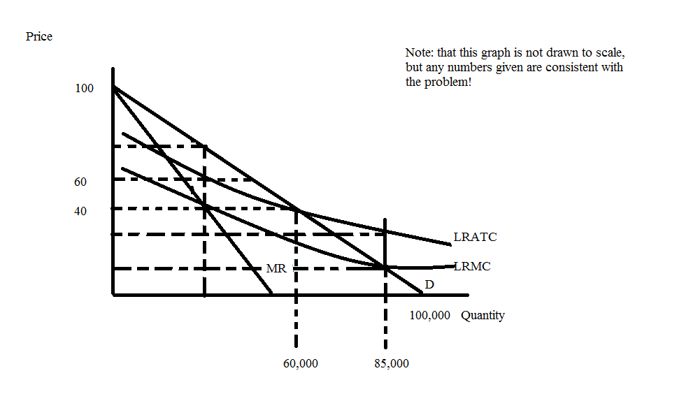

a. Given this graph, write an equation for this monopolist’s marginal revenue curve (MR).

b. If this monopolist is a single price monopolist, what price and output will this monopolist produce? What will be the monopolist’s profits at this price and output combination? Show how you found your answers.

c. If this monopolist is instead regulated to produce the socially optimal amount of the good, what price and output will the monopolist produce? What will the regulatory authority need to do in order to get the monopolist to produce at this price and output level? Explain your answer fully.

d. If this monopolist is instead regulated to produce at an output level where the firm breaks even, what price and output will the monopolist produce? Is there a deadweight loss associated with this level of production? Explain your answer verbally and then provide a mathematical calculation of this area of deadweight loss.

4. Suppose Sarah and Matthew are running for an elected position and are busy campaigning. Prior to the election the two candidates will debate several times and each candidate is considering what strategy they plan to take when their positions are questioned. One strategy is to respond with an aggressive rebuttal that defends the position that the candidate holds while a second strategy is to redirect the conversation and debate toward a new topic without addressing the issue. Both candidates have done research on the impact of these two strategies on likely voting outcomes and this is what they find. If Sarah takes the aggressive rebuttal strategy while Matthew simultaneously adheres to the same strategy, Sarah sees her votes increase by 10 votes while Matthew sees his votes increase by 8 votes. If Sarah adheres to the redirect strategy while Matthew adheres to the aggressive rebuttal strategy, Sarah sees her votes increase by 6 votes while Matthew sees his votes increase by 6 votes. If Sarah adheres to the aggressive strategy while Matthew adheres to the redirect strategy, Sarah sees her votes increase by 7 votes while Matthew sees his votes increase by 5 votes. If both candidates adhere to the redirect strategy, then both candidates see their votes increase by 5 votes each.

a) Given the above information fill in the following payoff matrix where each entry indicates the number of points won (a positive numeric value) or points lost (a negative numeric value).
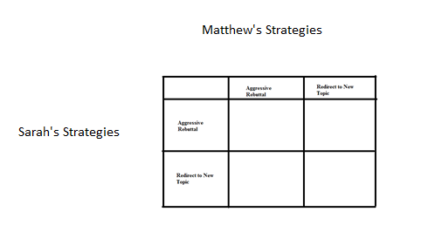
b) Examine the payoff matrix you created in (a). Does Sarah have a dominant strategy? Explain your answer.

c) Examine the payoff matrix you created in (a). Does Matthew have a dominant strategy? Explain your answer.

d) Suppose Sarah follows her dominant strategy; can you predict what Matthew will do given the above information? Explain your answer.

e) You plan to watch Sarah and Matthew debate each other this weekend. Describe the debate you anticipate seeing. Who do you predict will win the election given this analysis?

5. Sam, Megan, and Josie live in the same community (they are the only residents) and they are debating installing some lighthouses. Thankfully each of these individuals is willing to reveal their preferences and demand for lighthouses, but the community is still trying to decide how many lighthouses they should buy. Here is the relevant information that they have gathered:

Sam’s demand for lighthouses: Q = 10 – 2P
Megan’s demand for lighthouses: Q = 40 – 4P
Josie’s demand for lighthouses: Q = 10 – P
Marginal social cost of a lighthouse: MSC = $18

a) Given the above information draw an illustration of these three demand curves plus the market demand curve for lighthouses. In your illustration provide four different graphs that are vertically stacked with the market demand curve the bottom graph in the stack. Make sure all your graphs are clearly and completely labeled. Describe verbally how you found the market demand curve.

b) Write the equation(s) for the market demand curve and provide a range or domain for any segments of the demand curve. Show how you found these equations.

c) What is the socially optimal amount of lighthouses for this community? Explain how you found your answer. How much will Sam pay per lighthouse? How much will Megan pay per lighthouse? How much will Josie pay per lighthouse?

6. Consider the market for college education in the economy of Kernersville. The market demand curve for a year of college education is given by P = 50,000 – 2Q where P is the price per year of college and Q is the quantity of students attending college per year. This market demand curve expresses the marginal private benefit of going to college but does not include the social benefits derived from this education. The market supply curve for a year of college education is given by P = 2Q. This market supply curve expresses the marginal social cost of going to college. The social benefit of going to college for a year is equal to $10,000 per year per student, in addition to the private benefit that goes to the student directly.

a) Given the above description is there a negative or positive externality in this market? Explain your answer.

b) Given the above description, is this a consumption or a production externality? Explain your answer.

c) What quantity of students will attend college this year and what price will they pay given the above information? Show your work.

d) Suppose that the described externality is internalized in this market. Write the new equations we will need in order to find the socially optimal amount of college education to provide this year. Explain how you got these equations.

e) What is the socially optimal amount of college education to provide this year given the above information? What is the “right” (the one that corresponds to the socially optimal amount of the good) price for a year of college? Explain your answer.

f) What is the deadweight loss that occurs when the externality is not internalized in this market? Show your work.

7. Suppose you are the President of a small country and you have decided to provide health insurance to all the residents of your country. You plan to provide this health insurance by first assessing how much money you will need to set aside per year to cover the health costs of your citizens; second, figuring out what each person would need to contribute if everyone contributed the same amount to insure that all would get health insurance coverage; third, figuring out how big a subsidy per person would need to be paid by the government in order that all could afford the health insurance; and fourth, figuring out how much more needs to be collected from the affluent in order to cover the costs of these subsidies for the lower income individuals.

Luckily you do have some information:
- The population of your country is 20 people; this population is constant over time.
- 5% of your population in any given year will have significant healthcare costs of $100,000 per person; 40% of your population in any given year will have some healthcare costs of $20,000 per person; and 55% of your population in any given year will have low healthcare costs of $2000 per person. No one in the population knows with certainty whether they will have significant healthcare costs, some health care costs, or low healthcare costs each year.
- You also have the following information about everyone in your country:

Individual | Income Available to be spent on health insurance (this is related to total gross income of the individual)
Joe | $8,000
Amber | $8,000
Jose | $8,000
Mary | $9,000
Sue | $10,000
Mabel | $10,000
Maria | $12,000
Clyde | $12,000
Lee | $12,000
Zhihao | $13,000
Jaeho | $13,000
Josephine | $13,000
Sylvester | $14,000
Yoshi | $14,000
Moshi | $16,000
Gwen | $18,000
Owen | $20,000
Abigail | $20,000
Samantha | $30,000
Cletus | $30,000

a. Given the above information calculate the amount of money you will need to collect in order to cover this year’s health care costs in your country. Use the following table to help you calculate these costs.

% of population with health issue | Number of people with particular health issue | Cost per person of this particular health issue | Total cost for this health issue
5% of population have significant health costs
40% of population have some health costs
55% of population have low health costs
TOTAL COST OF COVERING ALL HEALTH ISSUES | ----- | -----

b. If everyone in the country is required to pay an equal amount for health insurance and the President wishes to collect enough funds to cover all health costs for the year, what payment will each individual be required to make?

c. Now that you have calculated the amount of money per person (the healthcare insurance premium) you will need to collect to cover the costs of the year’s health care, take the time to calculate how much additional money you will need to collect from the affluent in order to subsidize the lower income individuals when they go to purchase their health insurance. You will find it helpful to use the following table. Note: lest you think that this is an all-together dumb plan (against the Affordable Care Act) recall that in the U.S. our policy has been to provide healthcare even if you do not have insurance-and this healthcare cost does get past on to someone who has to pay in the form of a combination of higher taxes and higher medical costs.

Individual | Income Available to be spent on health insurance (this is related to total gross income of the individual) | Amount of subsidy required for the individual to be able to afford the healthcare insurance premium for the year
Joe | $8,000
Amber | $8,000
Jose | $8,000
Mary | $9,000
Sue | $10,000
Mabel | $10,000
Maria | $12,000
Clyde | $12,000
Lee | $12,000
Zhihao | $13,000
Jaeho | $13,000
Josephine | $13,000
Sylvester | $14,000
Yoshi | $14,000
Moshi | $16,000
Gwen | $18,000
Owen | $20,000
Abigail | $20,000
Samantha | $30,000
Cletus | $30,000
 | TOTAL ADDITIONAL AMOUNT OF MONEY THAT MUST BE COLLECTED TO COVER SUBSIDY TO LOWER INCOME INDIVIDUALS

d. Suppose the cost of the healthcare insurance subsidy is divided among those who have more income available for health insurance than the amount of required premium. Start by divvying up the healthcare insurance premium so that no one supports the subsidy beyond the level of income they have available for health insurance; and then divide any remaining subsidy needed evenly among those individuals who still have funds available (you will need to think carefully here). Show how you found your answer. Also fill in the following table to consolidate your work in this problem. Remember that each individual cannot spend more than the amount of their income they have available for health insurance: this implies that you may have to do some thinking about the amount of subsidy that is being paid by lower income individuals.

Individual | Income Available to be spent on health insurance (this is related to total gross income of the individual) | Amount of subsidy required for the individual to be able to afford the healthcare insurance premium for the year | Healthcare Insurance Premium (what the individual paid for their healthcare insurance) | Additional charge per person to cover healthcare subsidy costs | Total Payment per person for Healthcare Insurance (includes premium plus subsidy)
Joe | $8,000
Amber | $8,000
Jose | $8,000
Mary | $9,000
Sue | $10,000
Mabel | $10,000
Maria | $12,000
Clyde | $12,000
Lee | $12,000
Zhihao | $13,000
Jaeho | $13,000
Josephine | $13,000
Sylvester | $14,000
Yoshi | $14,000
Moshi | $16,000
Gwen | $18,000
Owen | $20,000
Abigail | $20,000
Samantha | $30,000
Cletus | $30,000
COLUMN TOTALS | ---

e. To further complicate this issue let’s imagine that people in this group actually know more about their healthcare situation than does the President. The following table tells us what they privately know about their healthcare situation for the coming year (assume that this information is completely accurate).

Individual | Income Available to be spent on health insurance (this is related to total gross income of the individual) | Private Information the individual has about his healthcare for this year
Joe | $8,000 | Low Healthcare costs
Amber | $8,000 | Significant Healthcare costs
Jose | $8,000 | Some Healthcare costs
Mary | $9,000 | Low Healthcare costs
Sue | $10,000 | Some Healthcare costs
Mabel | $10,000 | Low Healthcare costs
Maria | $12,000 | Some Healthcare costs
Clyde | $12,000 | Some Healthcare costs
Lee | $12,000 | Low Healthcare costs
Zhihao | $13,000 | Low Healthcare costs
Jaeho | $13,000 | Low Healthcare costs
Josephine | $13,000 | Low Healthcare costs
Sylvester | $14,000 | Some Healthcare costs
Yoshi | $14,000 | Low Healthcare costs
Moshi | $16,000 | Some Healthcare costs
Gwen | $18,000 | Low Healthcare costs
Owen | $20,000 | Low Healthcare costs
Abigail | $20,000 | Some Healthcare costs
Samantha | $30,000 | Low Healthcare costs
Cletus | $30,000 | Some Healthcare costs

Given your answers in (b) and (d), make a prediction about whether each of these individuals will be willing to voluntarily pay into the healthcare pool. Assume that all individuals in this country consider only the financial costs to themselves of buying the healthcare insurance and their private healthcare information (that is, no one is altruistic in this community!). Use the following table to consolidate your predictions. Explain your answers.

Individual | Income Available to be spent on health insurance (this is related to total gross income of the individual) | Private Information the individual has about his healthcare for this year | Projected Total Payment per person for Healthcare Insurance (includes premium as well as any share of subsidy cost) from (d) | Projected Healthcare costs for the year | Prediction as to participation in healthcare insurance program if given option to participate or not
Joe | $8,000 | Low Healthcare costs
Amber | $8,000 | Significant Healthcare costs
Jose | $8,000 | Some Healthcare costs
Mary | $9,000 | Low Healthcare costs
Sue | $10,000 | Some Healthcare costs
Mabel | $10,000 | Low Healthcare costs
Maria | $12,000 | Some Healthcare costs
Clyde | $12,000 | Some Healthcare costs
Lee | $12,000 | Low Healthcare costs
Zhihao | $13,000 | Low Healthcare costs
Jaeho | $13,000 | Low Healthcare costs
Josephine | $13,000 | Low Healthcare costs
Sylvester | $14,000 | Some Healthcare costs
Yoshi | $14,000 | Low Healthcare costs
Moshi | $16,000 | Some Healthcare costs
Gwen | $18,000 | Low Healthcare costs
Owen | $20,000 | Low Healthcare costs
Abigail | $20,000 | Some Healthcare costs
Samantha | $30,000 | Low Healthcare costs
Cletus | $30,000 | Some Healthcare costs

f. Given your work in this problem, provide a brief explanation of why the Affordable Care Act (“Obamacare”) includes both a subsidy for low income individuals as well as an Individual Mandate that requires everyone to purchase healthcare insurance.

8. In class we have studied mortgages and, in particular, a fixed rate thirty-year mortgage. Let us consider that kind of loan for this set of questions.

Suppose you have signed a thirty-year fixed rate mortgage in order to buy a house. Evaluate each of the following statements about this mortgage.

i. Each month this mortgage requires that the borrower make a payment of the same dollar amount to the lending institution. The borrower if they do not pay promptly and completely then what happens?

ii. In the first years of this mortgage the borrower’s payment consists primarily of paying back the principal and in the last years of the mortgage the borrower’s payments consists primarily of paying interest on the loan to the lender.

iii. The principal balance on the loan initially decreases at a very slow rate and it is only after a number of years that the principal balance declines at an increasing rate.

iv. If a borrower borrows $300,000 at 5% interest per year for thirty years then the borrower, if they keep the loan for thirty years, will pay back (300,000)(1 + .05) = $315,000.

v. A requirement by the lender for the borrower to provide a down payment when securing a mortgage is a requirement that protects both the borrower and the lender.

