Economics 390 Name ________________________________
Spring 2020
February 25, 2020

First Midterm
Version 1

There are multiple versions of this exam. You will be given a scantron to fill out. It is important that you:

- Fill out this scantron accurately and completely using a #2 pencil
- In “Special Codes” put your exam version number in column “A”

During the exam it is expected that you will always keep your answers for the exam covered. A failure to cover your answers may be grounds for an academic misconduct violation.

During the exam it is expected that you will always keeps your eyes solely on your own exam. Violation of this expectation may be grounds for academic misconduct violation.

This exam is 17 pages long!

Binary Choice Questions (20 points) __________________

Multiple Choice Questions (60 points) __________________

Problem One (10 points) __________________

Problem Two (10 points) __________________

TOTAL out of 100 points __________________

I. Binary Choice Questions (2 points each)

1. When a good is non-rival but excludable, then this good is an example of:

a. a common resource.
b. a club good.

2. When a good is rival but non-excludable, then this good is an example of:

a. a public good.
b. a common resource.

3. Consider a good that entails a positive external benefit. Given this information and holding everything else constant, this good’s “true” demand curve that incorporates all the benefits from consuming this good (both private and external benefits) will be located:

a. to the left of the market demand curve which does not incorporate these positive external benefits.
b. to the right of the market demand curve which does not incorporate these positive external benefits.

4. Consider a public good. A free market will not produce the socially optimal amount of the public good because of:

a. the free rider problem.
b. asymmetric information.

5. The socially optimal amount of a good occurs where:

a. the marginal social benefit of an additional unit of the good exceeds the marginal social cost of an additional unit of the good by its maximum amount.
b. the marginal social benefit of an additional unit of the good equals the marginal social cost of an additional unit of the good.

6. In the simple game theory example, when a person has a dominant strategy this means that:

a. this person has a strategy that is best for them no matter what strategies the other player(s) choose to follow.
b. this person is dominated by another player in the game and therefore always does what that player wants them to do.

7. The “Tragedy of the Commons” refers to:

a. a good that is rival but non-excludable.
b. a good that is non-rival but excludable.

8. Consider a monopolist. If this monopolist practices first degree price discrimination (perfect price discrimination) then:

a. The area of deadweight loss created by the monopolist will be greater than the area of deadweight loss created by this same monopolist if they act as a single price monopolist.
b. The monopolist’s demand curve is also the monopolist’s MR curve and the firm will produce the socially optimal amount of the good.

9. Consider a monopolist that has the following market demand curve where P is the price per unit and Q is the number of units of the good:

Market demand curve for the monopolist: Q = 1000 – 4P

Given this demand curve and holding everything else constant, then this single price monopolist’s marginal revenue (MR) curve is:

a. MR = 1000 – 8P
b. MR = 250 – (1/2)Q

10. Consider the following total cost function for a firm where Q is the quantity of the good:

Total Cost for the firm: TC = 4Q + 20 + Q²

Given this equation and holding everything else constant, which of the following statements is true?

a. This firm’s variable costs are given by the expression 4Q + 20 and its marginal cost is MC = 4 + 2Q.
b. This firm’s average total cost is ATC = 4 + (20/Q) + Q and its fixed costs are equal to $20.

II. Multiple Choice Questions (4 points each)

11. It is five o’clock and the traffic is heavy. Massie finds that she is driving at 3 miles per hour on the private highway she uses each day to get to and from work. To drive on this highway she must pay $8 per trip. In this example the road is:

a. rival and non-excludable.
b. non-rival and excludable.
c. rival and excludable.
d. non-rival and non-excludable.

12. Consider a good that has the property of low excludability and high rivalry. Which of the following goods do you think best fits this description?

a. a lighthouse that provides a light to guide boats through a treacherous harbor entrance
b. recreational fishing in a public pond (a small body of water) that does not require any licensing
c. membership in a tennis club that requires all members to pay an initiation fee as well as monthly fees
d. an ice cream cone from Babcock Creamery.

13. Consider the graph below which depicts the marginal social cost curve (MSC), the marginal social benefit curve (MSB), the supply curve that firms recognize (S), and the demand curve that individual consumers in this market recognize (D). Examining this graph and holding everything else constant, you conclude that:

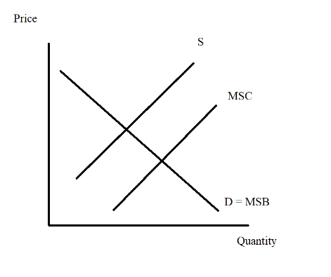
a. This good generates a positive production externality and the market, left to its own decisions, will produce too much of the good.
b. This good generates a positive production externality and the market, left to its own decision, will produce too little of the good.
c. This good generates a negative consumption externality and the market, left to its own decisions, will produce too much of the good.
d. This good generates a negative consumption externality and the market , left to its own decisions, will produce too little of the good.

WORKSHEET: DO NOT REMOVE FROM EXAM

Use the following information to answer the next two (2) questions.

Mary and Joe are the only residents in a community. They are debating the installation of streetlights in their community. For each individual contribution of $10 there will be total benefits of $15 that will be divided evenly among the residents of the community.

14. Which of the following payoff matrices represent this information accurately from the individuals’ perspectives?

a.
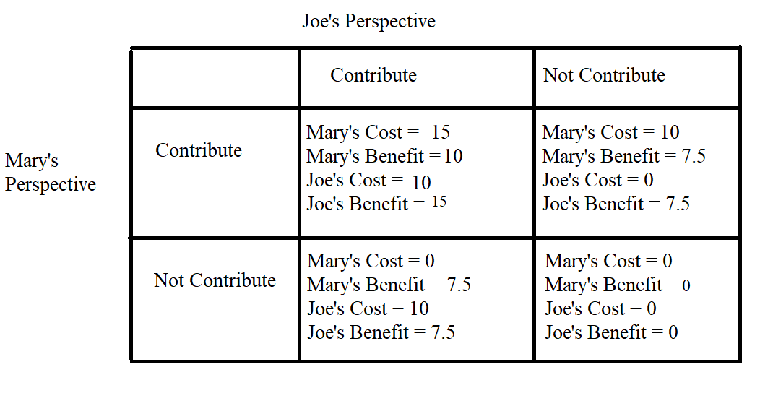
b.

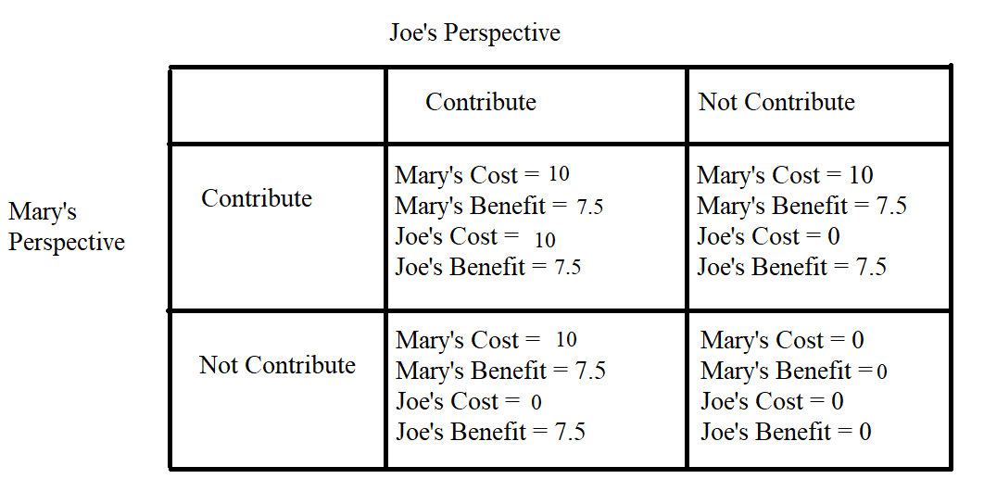
c.

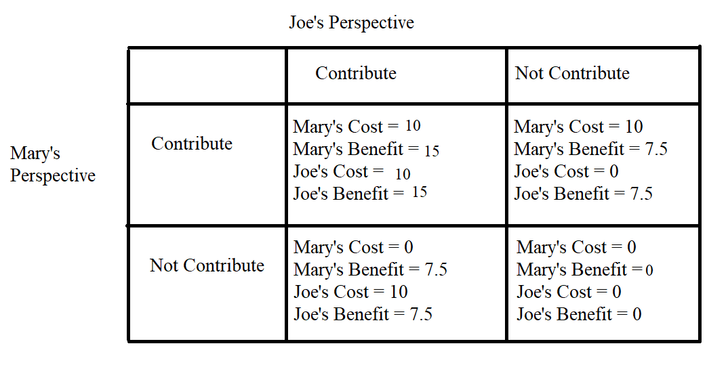
d.
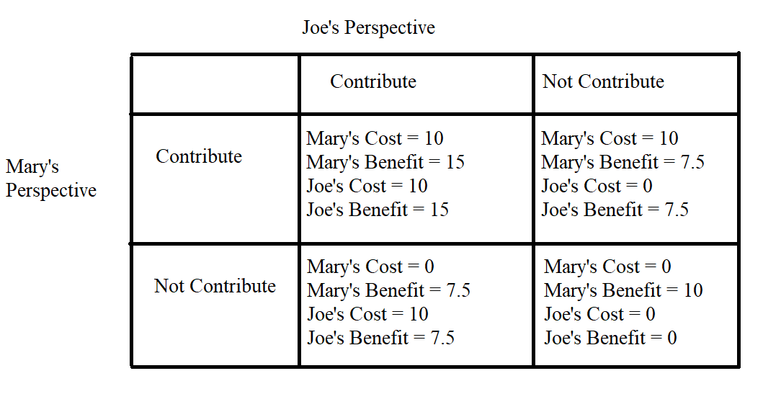

15. Given the above information and holding everything else constant, which of the following statements is true?

a. Both Joe and Mary’s dominant strategies are to “Not Contribute” and therefore streetlights will not be funded in their community.
b. Joe’s dominant strategy is to “Not Contribute” while Mary’s dominant strategy is to “Contribute”: some streetlights will be provided in their community.
c. Joe’s dominant strategy is to “Contribute” while Mary’s dominant strategy is to “Not Contribute”: some streetlights will be provided in their community.
d. Both Joe and Mary’s dominant strategies are to “Contribute” and therefore streetlights will be funded in their community.

16. When a good is non-rival, this implies that:

a. The good will not get produced at the socially optimal level because of the free rider problem.
b. Producers of this good have no incentive to provide the good since it is non-rival and multiple consumers can consume the same good without impacting the consumption benefits of the other consumers from this unit of the good.
c. The marginal social cost of providing an additional unit of the good will be greater than $0 per additional unit of the good.
d. It is socially optimal to provide the good at a price that is greater than $0 per unit of the good.

17. Consider a non-excludable good. How many of the following statements are true about this good?

- The price of the non-excludable good is equal to $0 per unit for the consumers of this good.
- Consumers will continue to consume this good until the marginal benefit they get from consuming the last unit of the good is equal to $0 per unit.
- Consumers, when deciding how much of the good to consume, fail to consider the cost of their consumption on the rest of society.
- When a good is non-excludable, too little of the good is consumed.

a. One statement is true.
b. Two statements are true.
c. Three statements are true.
d. Four statements are true.

18. Consider a good that is non-rival but excludable. Suppose that at some point the consumption of this good is complicated by the presence of congestion where there are many demanders of the good. In this situation this good can best be described as:

a. a common resource that has become a private good due to the presence of congestion.
b. a club good that has become a public good due to the presence of congestion.
c. a public good that has become a private good due to the presence of congestion.
d. a club good that has become a private good due to the presence of congestion.

19. Which of the following does not represent a common resource?

a. fish in the ocean
b. the air we breath
c. the native bird population in an area
d. the elk herd at the local petting zoo

20. The following figure shows the cost information for a representative firm selling baseball hats in a perfectly competitive market.
MC
ATC
8
4
•
Q
P
Given this information and holding everything else constant, which of the following statements is TRUE?

a. If market price of the baseball hat is $8, firms are making positive profit.
b. In the long run, each firm’s production level is greater than 4.
c. If the market price of the baseball hat is currently $10, new firms will enter the market.
d. Firms never produce at the production level lower than 4 because it generates negative profit.

Use the following information to answer the next two (2) questions:

In the computer industry, each firm’s cost functions are given by the following equations where Q is the quantity of computers:

Total Cost: TC = $\frac{1}{2}Q^{2}$+32
Marginal Cost: MC= $Q$

Assume that the industry is perfectly competitive, and that all firms are identical.
The market demand for computers is given by the following equation where P is the price per unit and Q is the number of computers:

Market Demand Curve: P = 80 - Q

21. Suppose the computer industry is in short run equilibrium, and there are currently seven firms competing in the market. What is the short run equilibrium market price?

a. $5 per computer
b. $10 per computer
c. $15 per computer
d. $20 per computer

22. Suppose the computer industry has entered long run equilibrium. Given this information and holding everything else constant, how many firms will stay in this industry in long run equilibrium? Assume the market demand curve does not change.

a. 7 firms
b. 8 firms
c. 9 firms
d. 10 firms

WORKSHEET: DO NOT REMOVE FROM EXAM

Answer the next three (3) questions using the following information.

Consider a monopoly that has the following characteristics where P is the price per unit and Q is the number of units of the good:

Market demand curve for the monopolist: P = 100 – Q
Marginal Cost for the monopolist: MC = 20 + 2Q
Total Cost for the monopolist: TC = 20Q + Q² + 10

23. Suppose this monopolist acts as a single price monopolist. How many of the following statements are true given this information and holding everything else constant?

- The marginal revenue curve for this single price monopolist is MR = 100 – (1/2)Q.
- The profit maximizing quantity for this single price monopolist is Q = 20 units.
- The profit maximizing price for this single price monopolist is P = $60 per unit.
- The profits for this single price monopolist will be greater than $1000.

a. One statement is true.
b. Two statements are true.
c. Three statements are true.
d. Four statements are true.

24. Suppose this monopolist acts as a perfect price discriminator. Given this information and holding everything else constant, which of the following statements is true?

a. Consumer surplus will be equal to zero, deadweight loss will be a positive number, and the monopolist will produce that quantity where MC equals the demand curve.
b. Consumer surplus will be a positive number, deadweight loss will be equal to zero, and the monopolist will produce the socially optimal amount of the good.
c. Producer surplus will be a positive number, consumer surplus will be equal to zero, and the monopolist will produce the socially optimal amount of the good.
d. Producer surplus will be equal to zero, deadweight loss will be equal to zero, and the monopolist will produce the socially optimal amount of the good.

25. Suppose this monopolist decides to act as a second degree price discriminator. The monopolist decides to produce the first twenty units and sell each of these units for $80 per unit. The monopolist will sell an additional three units for $77 per unit. Given this information and holding everything else constant, how many of the following statements are true?

- Total revenue for this second degree price discriminator will be $1831.
- This pricing plan results in an increase in consumer surplus relative to the consumer surplus that occurs when this monopolist acts as a single price monopolist.
- This pricing plan results in an increase in producer surplus relative to the producer surplus that occurs when this monopolist acts as a single price monopolist.
- This pricing plan results in the area of deadweight loss being smaller than the area of deadweight loss that occurs when this monopolist acts as a single price monopolist.

a. One statement is true.
b. Two statements are true.
c. Three statements are true.
d. Four statements are true.

Part III. Problems and Short Answers (10 points per question)

1. For this question you are expected to use complete sentences, standard English grammar, and your answers should be clear, concise and precise.

In the space below provide definitions of the property of rivalry and the property of excludability. Then provide an example of a good that fits each of following cases: 1) a good that is rival and excludable; 2) a good that is rival and non-excludable; 3) a good that is non-rival and excludable; and 4) a good that is non-rival and non-excludable. For each good explain briefly why they are a good example for their case.

(2 points) Definition of the property of rivalry:

(2 points) Definition of the property of excludability:

(1.5 points) Case 1: Good that is rival and excludable

(1.5 points) Case 2: Good that is rival and non-excludable

(1.5 points) Case 3: Good that is non-rival and excludable

(1.5 points) Case 4: Good that is non-rival and non-excludable

2. Consider a monopoly that serves two types of customers: business customers and non-business customers. The monopoly knows the following about these two types of customers where P is the price per unit of the good and Q is the number of units of the good:

Demand for good from non-business customers: P = 16 – Q
Demand for good from business customers: P = 20 – Q

Suppose you are also told that the monopoly has the following cost curves:

Marginal Cost for the monopolist: MC = 2 + Q
Total Cost for the monopolist: TC = 2Q + (1/2)Q² + 10

a. (2 points) In the space below draw a graph of the market demand curve for this monopolist. In your graph make sure you measure price, P, on the vertical axis and quantity, Q, on the horizontal axis. In your graph identify the coordinates of any “kink point” as well as the x-axis and y-axis intercepts. Label any lines you draw in your graph and also label the x axis and y axis.

Answer:
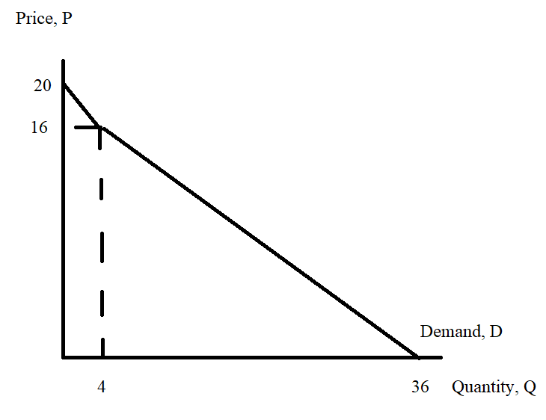
Scoring: There are seven things to label: so ¼ point for each of the seven plus ¼ point for general neatness.

b. (2 points) Given your work in (a), write an equation(s) for the market demand curve. If necessary provide the relevant range for the market demand curve. Write the market demand curve(s) in slope-intercept form.

Answer:
Top segment: P = 20 – Q for 16 ≤ P ≤ 20
Lower segment: P = 18 – (1/2)Q for 0 ≤ P ≤ 16

c. (3 points) Suppose this monopolist decides to treat these two types of customers as a single market: the monopolist will act as a single price monopolist. Calculate the following:
i. The price the monopolist will charge, Pm.
ii. The quantity of the good the monopolist will produce, Qm.
iii. The profits the monopolist will earn, Π.

For full credit show how you found your answers.

Answer:
To find the profit maximizing quantity the single price monopolist will equate its MC curve to its MR curve. The relevant MR curve is the MR curve for the lower segment of the market demand curve. Thus:
MR = 18 – Q
MC = 2 + Q
18 – Q = 2 + Q
16 = 2Q
Qm = 8 units of the good

Use the demand curve to find the price for the single price monopolist:
Pm = 18 – (1/2)Q
Pm = 18 – (1/2)(8) = $14 per unit

Calculate TR and TC to find the Π for the single price monopolist.
TR = ($14 per unit)(8 units) = $112
TC = 2(8) + (1/2)(8)(8) + 10 = $58
Π = 112 – 58 = $54

Scoring: 1 point for each right answer provided the necessary work is there to support the answer.

d. (3 points) Suppose this monopolist decides to treat these two types of customers as two separate markets: the monopolist will act as a third degree price discriminator. Calculate the following:
i. The price the monopolist will charge business customers, Pb, and the price the monopolist will charge non-business customers, Pn.
ii. The quantity of the good the monopolist will produce for business customers, Qb, and the quantity the monopolist will produce for non-business customers, Qn.
iii. The total level of profits the monopolist will earn as a third degree price discriminator, Π’.
For full credit show how you found your answers.

Answer:
To find the profit maximizing total quantity of the good the third degree price discriminator will produce we need to equate the market MR to the MC curve just as we did in part (c). So the third degree price discriminator will produce a total of 8 units. To see how many units are provided to business customers and how many units are provided to non-business customers we start by finding out the MC when 8 units are produced. Thus:
MC = 2 + Q = 2 + 8 = $10
Take this as the MC for the last unit produced in the business customer market as well as the MC for the last unit produced in the non-business customer market.

Then, equate each sub-market’s MR to this MC. So for business customers:
MRb = MC
20 – 2Qb = 10
2Qb = 10
Qb = 5 units of the good

Use this quantity and the business customer demand curve to find Pb:
Pb = 20 – Qb
Pb = 20 – 5 = $15 per unit for business customers

TRb = Pb*Qb = ($15 per unit)(5 units) = $75

Then, equate each sub-market’s MR to this MC. So for non-business customers:
MRn = MC
16 – 2Qn = 10
2Qn = 6
Qn = 3 units of the good (Note that Qb + Qn = 5 + 3 = 8 units!)

Use this quantity and the non-business customer demand curve to find Pn:
Pn = 16 – Qb
Pn = 16 – 3 = $13 per unit for business customers

TRn = Pn*Qn = ($13 per unit)(3 units) = $39

TR for the two markets = TRb + TRn = 75 + 39 = $114
TC for producing 8 units of the good = $58
Π’ = 114 – 58 = $56

Scoring: 1 point for each right answer (i, ii, and iii) provided the necessary work is there to support the answer.

