Economics 390 Name ______________________________
Fall 2019
October 8, 2019

FIRST MIDTERM
Version 1

There are multiple versions of this exam. You will be given a scantron to fill out. It is important that you:
- Fill out this scantron accurately and completely using a #2 pencil
- In “Special Codes” put your exam version number in column “A”

During the exam it is expected that you will always keep your answers for the exam covered. A failure to cover your answers may be grounds for an academic misconduct violation.

During the exam it is expected that you will always keeps your eyes solely on your own exam. Violation of this expectation may be grounds for academic misconduct violation.

This exam is 19 pages long!

Binary Choice Questions (20 points) __________________

Multiple Choice Questions (60 points) __________________

Problem One (10 points) __________________

Problem Two (10 points) __________________

TOTAL out of 100 points __________________

I. Binary Choice Questions (each question is worth 2 points)

1. A good that has low rivalry is a good:

a. That can be consumed by more than one person without affecting another person’s consumption of the same good.
b. Where the marginal cost of providing another unit of the good is high.

2. When the marginal external cost of the good is a positive value we know, holding everything else constant, that this good involves a:

a. Negative externality.
b. Positive externality.

3. A good that is both non-rival and non-excludable is a:

a. Public good.
b. Private good.

Answer the next two (2) questions based on the following information and matrix.

Consider the following matrix that represents Mary and Sam’s costs and benefits from contributing to the provision of a public good.

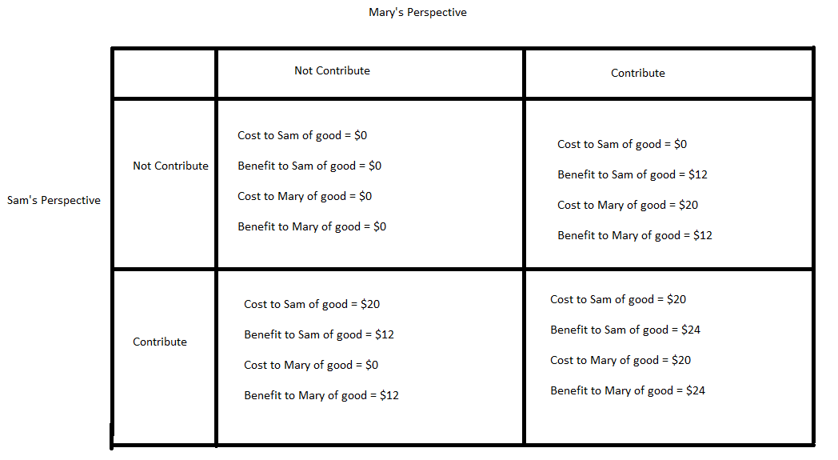

4. Given the above information, Mary’s dominant strategy is to:

a. Contribute.
b. Not contribute.

5. If this information was presented from a societal perspective where the members of the society (in this case, Mary and Sam) considered the marginal social cost and marginal social benefit from the good, then the optimal societal outcome would be:

a. for Sam to contribute while Mary did not contribute to the provision of the public good.
b. for both Sam and Mary to contribute to the provision of the public good.

6. A good that is excludable but non-rival can be described as:

a. A common resource.
b. A club good.

Use the following information to answer the next two (2) questions.

Assume that Susan and Jane are the only consumers of online movies and in this set of questions assume that each of them end up consuming movies. Susan and Jane are addicted to watching movies online. They have very different tastes so they can never watch a movie together! They both respect movie copyrights and therefore they pay for every movie they watch online. The demand functions of Susan and Jane for movies this year are given by the following equations where P is the price per movie and q is the quantity of movies demanded:

Susan: $P=40-2q$
Jane: $P=20$

7. Given this information, the market demand is:
  - $P=40-2q for P>20 and P=20 for P≤20$
  - $P=40-2q for P>20 and P=60-2q for P≤20$

Suppose that they are only two websites, Moviesforyou.com and Cinemathrills.com that offer online movie services to Susan and Jane. The supply curves for these two websites are given by the following equations where P is the price per movie and q is the quantity of movies supplied:

Moviesforyou.com: $P=4+2q$
Cinemathrills.com: $P=2q$

8. Given this information and holding everything else constant, when the online movie market is in equilibrium Susan will watch _________ movies this year, while Jane will watch __________ movies this year.
- 8; 10
- 10; 8

9. Which of the following goods exhibits low rivalry?

a. A hamburger from McDonald’s
b. A public beach in the off season.

10. Consider the following graph where MPC is the marginal private cost, MPB is the marginal private benefit, and MSB is the marginal social benefit.
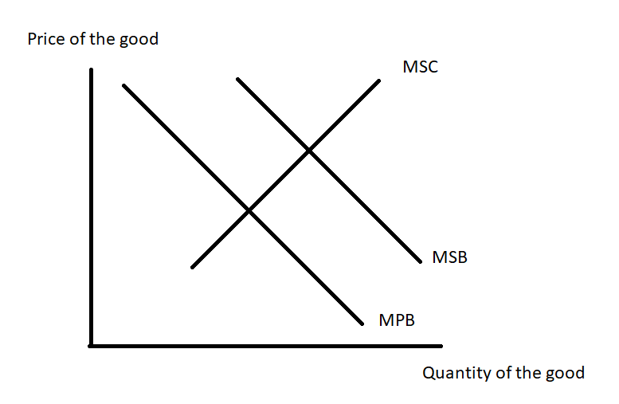
This graph depicts the situation where there is a:

a. Positive externality.
b. Negative externality.

II. Multiple Choice Questions (each question is worth 3 points)

11. Consider a public good. How many of the following statements are true?

- The non-rival nature of a public good results in the free rider problem.
- The non-excludable nature of a public good results in the marginal social cost of providing the public good being equal to or very close to $0.
- Since a public good is non-excludable the market demand curve for that public good will not reflect the true demand for the public good: the true demand will be a curve located to the right of the market demand curve.
- Since a public good is non-rival firms will be reluctant to supply the good.

a. One statement is true.
b. Two statements are true.
c. Three statements are true.
d. Four statements are true.

12. Consider the single price monopolist depicted in the graph below. Assume that the demand curve and the MC curve are both linear.

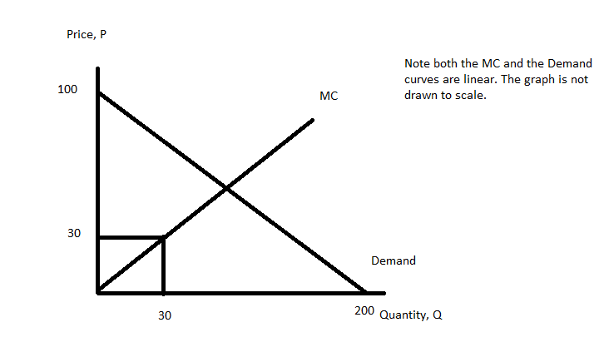

This single price monopolist will maximize profits by producing:

a. Q = 200/3 and charging a price of $200/3.
b. Q = 100 and charging a price of $50 per unit.
c. Q = 50 units and charging a price of $75 per unit.
d. Q = 60 units and charging a price of $70 per unit.

13. Consider a monopolist who engages in perfect price discrimination. How many of the following statements are true for this perfect price discriminator?

- This monopolist will produce the socially optimal amount of the good.
- This monopolist will expand the area of producer surplus by engaging in this behavior.
- This monopolist will create a deadweight loss due to the implementation of this behavior.
- Consumers of this product will pay more than they are willing to pay for this product when this behavior is implemented.

a. One statement is true.
b. Two statements are true.
c. Three statements are true.
d. Four statements are true.

14. Consider a monopolist that can be described by the following information:

Market Demand for monopolist’s product: P = 100 – (1/2)Q
MC for the monopolist: MC = Q

This monopolist decides to engage in second degree price discrimination and the pricing scheme they implement is to sell the first 50 units at a price of $75 per unit and then sell an additional 10 units at $70 per unit. Given this information and holding everything else constant, the value of consumer surplus in this market is:

a. $625
b. $650
c. $1275
d. $1250

Use the following information to answer the next three (3) questions.

Suppose you are given the following information about a producer who sells their product to two different classes of buyers, Class One and Class Two. The subscripts refer to the different classes: so P₁ is the price paid by Class One, P₂ is the price paid by Class Two, Q₁ is the quantity of the good in the Class One market, Q₂ is the quantity of the good in the Class Two market, and Q is the total market quantity.

Class One’s Demand for the Good: P₁ = 10 – (2/3) Q₁
Class Two’s Demand for the Good: P₂ = 10 – 2Q₂

The producer also has the following information:

Marginal Cost for the producer: MC = (1/4)Q
Variable Cost for the producer: VC = (1/8)Q²
Fixed Cost for the Producer: FC = 2

15. Suppose this firm decides to act as a single price monopolist and provide the good at a single price. Given this information and holding everything else constant:

a. Profit for this firm will equal $40.
b. Total cost for this firm will equal $10.
c. This firm will produce 13.3 units of the good.
d. This firm will earn economic profits of $12.

16. Given the above information and holding everything else constant, this producer, whether they price discriminate or not, will have maximum economic profits of:

a. $10
b. $36
c. $38
d. $48

17. Given the above information and holding everything else constant, how many of the following statements are true?

- If this firm practices third degree price discrimination, the result in terms of the price charged to each class and the total quantity produced is the same as the result if the firm is a single price monopoly.
- This firm will not find that third degree price discrimination increases their profitability relative to their profitability as a single price monopolist.
- If this firm practices third degree price discrimination, Class Two will pay a higher price than Class One for the good.
- If this firm practices third degree price discrimination, Class One will pay a higher price than Class Two for the good.

a. One statement is true.
b. Two statements are true.
c. Three statements are true.
d. Four statements are true.

18. Consider a perfectly competitive market that is in long run equilibrium. Given this information and holding everything else constant, how many of the following statements are true?

- Each firm will produce the profit maximizing quantity where MR = MC.
- Each firm will have positive accounting profits and zero economic profits.
- Each firm will produce at its minimum average total cost.
- The areas of consumer surplus and producer surplus will be maximized.

a. One statement is true.
b. Two statements are true.
c. Three statements are true.
d. Four statements are true.

19. Consider a perfectly competitive market that is short run equilibrium. Given this information and holding everything else constant, how many of the following statements are true?

- If short run economic profits are not equal to zero, then in the long run we can expect entry or exit of firms to bring economic profits to zero for each firm that is in the industry in the long run.
- In the short run, the firm is a price taker and its price will equal its average total cost.
- In the short run, the firm produces the profit maximizing quantity by equating its MR to its average cost curve.
- In the short run, the firm will select that output where the average total cost of producing the good is at its minimum.

a. One statement is true.
b. Two statements are true.
c. Three statements are true.
d. Four statements are true.

20. Which of the following situations is an example of 2nd degree price discrimination?

- Walmart offers Sam’s Club to those consumers who are willing to purchase larger quantities of the good provided the good is sold at a lower price.
- Movie Theaters offer different prices for seniors and students.
- Dell offers custom built computers.
- Factory outlets sell out-of-fashion clothing at a discount.

Use the following information to answer the next two (2) questions.

Suppose that Sam is the only HDTV seller in Madison. The average variable cost is constant at $200. There is no fixed cost. Suppose further that each consumer may buy up to one HDTV. Furthermore, imagine that there are 3 groups of consumers, high income, medium income and low income and there are 20 consumers in each group. Each of the high-income consumers is willing to pay up to $500 per HDTV set. Each of the medium income consumers is willing to pay up to $400 per HDTV set. Each of the low-income consumers is willing to pay up to $100 per HDTV set.

21. If Sam can perfectly price discriminate, what would be his maximum attainable profit?
- $10,000
- $14,000
- $20,000
- $22,000

22. Using the information from the previous question, suppose instead that Sam cannot charge different prices to different consumers but only one price. At which price should Sam sell HDTVs in order to maximize his profit?
- $300
- $200
- $400
- $500

Use the following information to answer the next four (4) questions.

A market is perfectly competitive with 10 identical firms. You are told the following information about this market where q is the quantity produced by a firm, Q is the market quantity, and P is the price per unit of the good:

Individual firm’s Total Cost Curve: TC = 10q² + 2q + 250
Individual firm’s Marginal Cost Curve: MC = 20q + 2

Market Demand Curve: P = 122 – 2Q

23. Given this information and holding everything else constant, in the short run:

a. The equilibrium quantity in the market will be 30 units, and each firm will earn Total Revenue equal to $186.
b. Firms will earn positive economic profits, and this will result in the entry of new firms into the market and the market supply curve will shift to the left.
c. The market supply curve will be given by the equation P = 2 + 2Q and the equilibrium quantity of production for the individual firm will be 2 units.
d. Firms will earn negative economic profits, and this will result in the exit of firms from the market and the market supply curve will shift to the right.

24. Given the above information and holding everything else equal, firms in this market will earn zero economic profit when they:

a. Produce 5 units of the good and they sell each unit for $100.
b. Produce at that price where MR = MC for the firm.
c. Produce at that quantity where ATC = MC for the firm.
d. Produce 10 units of the good and they sell each unit for $102.

25. Given this information and holding everything else constant except the natural adjustment that occurs in a perfectly competitive market in the long run, how many firms will be in this industry in the long run? Assume the market demand curve does not change.
a. 8 firms
b. 6 firms
c. 4 firms
d. 2 firms

26. Given this information and holding everything else constant except the natural adjustment that occurs in a perfectly competitive market in the long run, what is the value of Consumer Surplus (CS) and Producer Surplus (PS) in the long run? Assume that any shift in the market supply curve will be a shift that is parallel to the initial supply curve that you found.

a. CS = $100; PS = $900
b. CS = $100; PS = $200
c. CS = $900; PS = $200
d. CS = $900; PS = $900

Worksheet: Do Not Remove From Exam!!!

Please use the following information to answer the next two (2) questions.

Suppose that Bob is the only TV seller in Madison. The average variable cost is constant at $20. There is no fixed cost. Suppose further that each consumer may buy up to one TV.

27. Suppose that there are only rich people in Madison and there are 20 of them. Each is willing to pay up to $50 for each TV. What should be the price of TVs to maximize Bob’s profit?

- $20
- $40
- $50
- $30

28. Instead, suppose that there are 3 groups of consumers, high income, medium income and low income and there are 20 of them in each group. Each of the high income is willing to pay up to $50 for each TV. Each of the medium income is willing to pay up to $40 for each TV. Each of the low income is willing to pay up to $25 for each TV. If Bob can price discriminate in this market, what would be his maximum attainable profit?

- $1,100
- $1,000
- $600
- $400

29. Many elite private colleges charge different prices to students attending their institutions. The colleges use this differential pricing scale because:

a. Students who have the potential to be future wealthy donors to the school will only attend if they pay a price below the average rate of tuition.
b. This pricing plan increases the college’s total revenue relative to charging each student the same price.
c. The market for college-level education can be characterized as a perfectly competitive market since there are many producers of this level of education.
d. The colleges have insufficient market power to charge the same price to every student.

30. Consider a market that has two distinct classes of buyers: Class One and Class Two. The demand curves for these two groups of buyers can be described by the following equations where P is the price per unit and Q is the number of units:

Demand for Class One: P = 12 – 2Q
Demand for Class Two: P = 6 – (1/2)Q

You also know that there is only one firm serving this market and that firm has no fixed costs and its marginal cost can be described by the following equation:

MC = $4

Suppose this firm practices third degree price discrimination. Given this information and holding everything else constant:

a. The profit maximizing quantity for this firm will be 5 units of the good.
b. Class Two buyers will purchase 2 units of the good and pay $5 per unit.
c. Class One buyers will purchase the same quantity of the good as does Class Two, but Class One will pay a lower price for each unit purchased.
d. The marginal cost of the last unit produced by the firm will be less than $4 per unit.

Worksheet: Do Not Remove From Exam!!!

EXAM CONTINUES
III. Problems (two questions worth 10 points each)

1. Mandy is a supplier of dry cleaning services in her small town. She operates the only dry cleaning service and therefore has significant market power. She knows that she has two types of clients: business clients who come in regularly to have their clothing cleaned and non-business clients who have occasional garments to clean. She knows the following information where Q is the quantity of dry cleaning units and P is the price per unit of dry cleaning:

Demand for dry cleaning services from business clients: Q = 50 – (1/2)P
Demand for dry cleaning services from non-business clients: Q = 120 – (3/2)P
MC of providing dry cleaning services: MC = 25 + (1/3)Q
Fixed Costs of providing dry cleaning services: FC = 10
Total Costs for firm of providing dry cleaning services: TC = 25Q + (1/6)Q² + 10

Suppose that Mandy decides to treat her dry cleaning business as two separate monopolies: one providing dry cleaning services to business clients and one providing dry cleaning services to non-business clients. She can readily identify the status of each of her clients since she has been in business in this small town for a long, long time and she knows her customers well. (When Mandy decides to do this, she is making a decision to practice third degree price discrimination.)

a) (four points) Given that Mandy is going to treat these two types of customers as separate entities, what will be the profit maximizing price and quantity of the good in the market for her business clients? Show how you found your answers.

b) (four points) What will be the profit maximizing price and quantity of the good in the market for her non-business clients? Show how you found your answers.

c) (two points) What will be Mandy’s total profits if she treats this market as two separate monopolies? That is, what will be her total profits if she practices third degree price discrimination? Show your work.

EXAM CONTINUES
2. Consider a perfectly competitive industry composed of six identical firms that produce widgets. Suppose you are told that the representative firm has the following cost curves where TC is total cost measured in dollars and q is units of widgets produced by a representative firm:

Total Cost: TC = 4 + 4q + q²
Marginal Cost: MC = 4 + 2q

Suppose you also know that the market demand curve is given by the following equation where P is the market price in dollars and Q is the market quantity of widgets:

Market Demand: P = 19 – (1/2)Q

a) (two points) Given the above information write an equation for the market supply curve. Explain how you found this equation.

b) (six points) Given the market supply curve you found in (a), calculate the short run market equilibrium quantity and price in this market. Then, once you have done your work, complete the following table:

Short-run market equilibrium Quantity
Short-run market equilibrium Price
Short-run level of production by a representative firm
Short-run level of profits for a representative firm

EXAM CONTINUES ON NEXT PAGE!
e) (two points) Given no changes in the firm’s cost curves or the market demand curve, how many firms will be in this industry in the long run? Show how you found your answers.

END OF EXAM!

