Economics 390
Spring 2020
Answers to Homework #4
Due 4/2/20

Homework is due at the beginning of lecture. The professor reserves the right to not accept homework if it is late. The expectation is that the homework will be done in a professional manner: it should be stapled, it should be neat, well organized, and complete. You cannot receive full credit if you omit questions and do not follow the provided instructions. There is no need to submit the questions: you need to simply submit your answers. You will not be able to get full credit for the homework if you do not show your work in an organized, easy-to-follow manner. Make sure your name is clearly and legibly written on the homework. Illegible answers will not get full credit.

Health Insurance

1. Suppose you are the President of a small country and you have decided to provide health insurance to all the residents of your country. You plan to provide this health insurance by first assessing how much money you will need to set aside per year to cover the health costs of your citizens; second, figuring out what each person would need to contribute if everyone contributed the same amount to insure that all would get health insurance coverage; third, figuring out how big a subsidy per person would need to be paid by the government in order that all could afford the health insurance; and fourth, figuring out how much more needs to be collected from the affluent in order to cover the costs of these subsidies for the lower income individuals.

Luckily you do have some information:
- The population of your country is 20 people; this population is constant over time.
- 10% of your population in any given year will have significant healthcare costs of $120,000 per person; 40% of your population in any given year will have some healthcare costs of $20,000 per person; and 50% of your population in any given year will have low healthcare costs of $3000 per person. No one in the population knows with certainty whether they will have significant healthcare costs, some health care costs, or low healthcare costs each year.
- You also have the following information about everyone in your country:

Individual | Income Available to be spent on health insurance (this is related to total gross income of the individual)
Mike | $20,000
Shelley | $18,000
Pedro | $28,000
Maria | $32,000
Qian | $10,000
Zexing | $18,000
Sue | $36,000
Clyde | $12,000
Leigh | $50,000
Erika | $13,000
April | $18,000
Wenbo | $21,000
Martin | $12,000
Gary | $24,000
Taylor | $19,000
Gus | $18,000
Paul | $25,000
Abby | $20,000
Sam | $35,000
James | $30,000

a. Given the above information calculate the amount of money you will need to collect in order to cover this year’s health care costs in your country. Use the following table to help you calculate these costs.

% of population with health issue | Number of people with particular health issue | Cost per person of this particular health issue | Total cost for this health issue
10% of population have significant health costs
40% of population have some health costs
50% of population have low health costs
TOTAL COST OF COVERING ALL HEALTH ISSUES | ----- | -----

b. If everyone in the country is required to pay an equal amount for health insurance and the President wishes to collect enough funds to cover all health costs for the year, what payment will each individual be required to make?

c. Now that you have calculated the amount of money per person (the healthcare insurance premium) you will need to collect to cover the costs of the year’s health care, take the time to calculate how much additional money you will need to collect from the affluent in order to subsidize the lower income individuals when they go to purchase their health insurance. You will find it helpful to use the following table. Note: lest you think that this is an all-together dumb plan (against the Affordable Care Act) recall that in the U.S. our policy has been to provide healthcare even if you do not have insurance-and this healthcare cost does get past on to someone who has to pay in the form of a combination of higher taxes and higher medical costs.

Individual | Income Available to be spent on health insurance (this is related to total gross income of the individual) | Amount of subsidy required for the individual to be able to afford the healthcare insurance premium for the year
Mike | $20,000
Shelley | $18,000
Pedro | $28,000
Maria | $32,000
Qian | $10,000
Zexing | $18,000
Sue | $36,000
Clyde | $12,000
Leigh | $50,000
Erika | $13,000
April | $18,000
Wenbo | $21,000
Martin | $12,000
Gary | $24,000
Taylor | $19,000
Gus | $18,000
Paul | $25,000
Abby | $20,000
Sam | $35,000
James | $30,000
 | TOTAL ADDITIONAL AMOUNT OF MONEY THAT MUST BE COLLECTED TO COVER SUBSIDY TO LOWER INCOME INDIVIDUALS

d. Suppose the cost of the healthcare insurance subsidy is divided among those who have more income available for health insurance than the amount of required premium. Start by divvying up the healthcare insurance premium so that no one supports the subsidy beyond the level of income they have available for health insurance; and then divide any remaining subsidy needed evenly among those individuals who still have funds available (you will need to think carefully here). Show how you found your answer. Also fill in the following table to consolidate your work in this problem. Remember that each individual cannot spend more than the amount of their income they have available for health insurance: this implies that you may have to do some thinking about the amount of subsidy that is being paid by lower income individuals. [Hint: I found it extremely helpful to use Excel so that I could quickly check my math calculations! You might want to give it a try.]

Individual | Income Available to be spent on health insurance (this is related to total gross income of the individual) | Amount of subsidy required for the individual to be able to afford the healthcare insurance premium for the year | Healthcare Insurance Premium (what the individual paid for their healthcare insurance) | Additional charge per person to cover healthcare subsidy costs | Total Payment per person for Healthcare Insurance (includes premium plus subsidy)
Mike | $20,000
Shelley | $18,000
Pedro | $28,000
Maria | $32,000
Qian | $10,000
Zexing | $18,000
Sue | $36,000
Clyde | $12,000
Leigh | $50,000
Erika | $13,000
April | $18,000
Wenbo | $21,000
Martin | $12,000
Gary | $24,000
Taylor | $19,000
Gus | $18,000
Paul | $25,000
Abby | $20,000
Sam | $35,000
James | $30,000
COLUMN TOTALS | ---

e. To further complicate this issue let’s imagine that people in this group actually know more about their healthcare situation than does the President. The following table tells us what they privately know about their healthcare situation for the coming year (assume that this information is completely accurate).

Individual | Income Available to be spent on health insurance (this is related to total gross income of the individual) | Private Information the individual has about his healthcare for this year
Mike | $20,000 | Low Healthcare costs
Shelley | $18,000 | Significant Healthcare costs
Pedro | $28,000 | Some Healthcare costs
Maria | $32,000 | Low Healthcare costs
Qian | $10,000 | Some Healthcare costs
Zexing | $18,000 | Low Healthcare costs
Sue | $36,000 | Some Healthcare costs
Clyde | $12,000 | Some Healthcare costs
Leigh | $50,000 | Low Healthcare costs
Erika | $13,000 | Low Healthcare costs
April | $18,000 | Low Healthcare costs
Wenbo | $21,000 | Low Healthcare costs
Martin | $12,000 | Some Healthcare costs
Gary | $24,000 | Low Healthcare costs
Taylor | $19,000 | Some Healthcare costs
Gus | $18,000 | Low Healthcare costs
Paul | $25,000 | Low Healthcare costs
Abby | $20,000 | Some Healthcare costs
Sam | $35,000 | Low Healthcare costs
James | $30,000 | Some Healthcare costs

Given your answers in (b) and (d), make a prediction about whether each of these individuals will be willing to voluntarily pay into the healthcare pool. Assume that all individuals in this country consider only the financial costs to themselves of buying the healthcare insurance and their private healthcare information (that is, no one is altruistic in this community!). Use the following table to consolidate your predictions. Explain your answers.

Individual | Income Available to be spent on health insurance (this is related to total gross income of the individual) | Private Information the individual has about his healthcare for this year | Projected Total Payment per person for Healthcare Insurance (includes premium as well as any share of subsidy cost) from (d) | Projected Healthcare costs for the year | Prediction as to participation in healthcare insurance program if given option to participate or not
Mike | $20,000 | Low Healthcare costs
Shelley | $18,000 | Significant Healthcare costs
Pedro | $28,000 | Some Healthcare costs
Maria | $32,000 | Significant Healthcare costs
Qian | $10,000 | Some Healthcare costs
Zexing | $18,000 | Low Healthcare costs
Sue | $36,000 | Some Healthcare costs
Clyde | $12,000 | Some Healthcare costs
Leigh | $50,000 | Low Healthcare costs
Erika | $13,000 | Low Healthcare costs
April | $18,000 | Low Healthcare costs
Wenbo | $21,000 | Low Healthcare costs
Martin | $12,000 | Some Healthcare costs
Gary | $24,000 | Low Healthcare costs
Taylor | $19,000 | Some Healthcare costs
Gus | $18,000 | Some Healthcare costs
Paul | $25,000 | Low Healthcare costs
Abby | $20,000 | Some Healthcare costs
Sam | $35,000 | Low Healthcare costs
James | $30,000 | Low Healthcare costs

f. Given your work in this problem, provide a brief explanation of why the Affordable Care Act (“Obamacare”) includes both a subsidy for low income individuals as well as an Individual Mandate that requires everyone to purchase healthcare insurance.

Answers:

a.
% of population with health issue | Number of people with particular health issue | Cost per person of this particular health issue | Total cost for this health issue
10% of population have significant health costs | 2 | $120,000 per person | $240,000
40% of population have some health costs | 8 | $20,000 per person | $160,000
50% of population have low health costs | 10 | $3000 per person | $30,000
TOTAL COST OF COVERING ALL HEALTH ISSUES | ----- | ----- | $430,000

b. Since you need to collect $430,000 per year and there are 20 people in your country, you will need to collect $430,000/20 people are $21,500 per person.

c.

Individual | Income Available to be spent on health insurance (this is related to total gross income of the individual) | Amount of subsidy required for the individual to be able to afford the healthcare insurance premium for the year
Mike | $20,000 | $1500
Shelley | $18,000 | $3500
Pedro | $28,000 | $0
Maria | $32,000 | $0
Qian | $10,000 | $11500
Zexing | $18,000 | $3500
Sue | $36,000 | $0
Clyde | $12,000 | $9500
Leigh | $50,000 | $0
Erika | $13,000 | $8500
April | $18,000 | $3500
Wenbo | $21,000 | $500
Martin | $12,000 | $9500
Gary | $24,000 | $0
Taylor | $19,000 | $2500
Gus | $18,000 | $3500
Paul | $25,000 | $0
Abby | $20,000 | $1500
Sam | $35,000 | $0
James | $30,000 | $0
 | TOTAL ADDITIONAL AMOUNT OF MONEY THAT MUST BE COLLECTED TO COVER SUBSIDY TO LOWER INCOME INDIVIDUALS | $59,000

d. Our earlier work indicated that the healthcare insurance premium is $21,500 per person. Now, we also need to collect $59,000 to cover the cost of the subsidy for lower income individuals. There are 8 people (Pedro, Maria, Sue, Leigh, Gary, Paul, Sam, and James) who can fully fund their health insurance plus contribute a bit toward a subsidy support for those individuals who do not have enough income available to pay the full amount of their health insurance premium. So, we start the process of getting the needed $59,000 from these eight individuals: we start by sorting these individuals from least amount of extra funds available to most amount of available funds: Gary, Paul, Pedro, James, Maria, Sam, Sue, and Leigh. Gary can contribute an additional $2500; Paul can contribute an additional $3500; etc. At some point you need to pause and contemplate whether the remaining individuals have sufficient funds to divide the remaining amount of subsidy needed by the number of those remaining individuals. So, this calculation does take some thought! Initially with 8 people and a need for $59,000 the amount per person if everyone contributed the same amount would be 59,000/8 = $7,375. This is more than the individuals with lower amounts of income can afford. When you get down to Gary and Paul contributing, you now need $53,000 from the remaining 6 individuals: or a contribution of about $8834 per person. This is more than Pedro can contribute. So, Pedro pays as much as he can: $6500 and you continue moving down the list of contributors.

From this exercise I hope that you see that there is a redistribution of income that occurs with this program: poorer people cannot afford the health insurance and they are given a subsidy so that they be insured. (Do remember that prior to ACA, our default was to provide healthcare to those without insurance and then pass on this cost to insured people who paid higher prices.)

Here is the completed table: notice that if you sum the last column you do get $430,000, which is the total amount of dollars that must be collected in order to provide healthcare to everyone in this country for the year.

Individual | Income Available to be spent on health insurance (this is related to total gross income of the individual) | Amount of subsidy required for the individual to be able to afford the healthcare insurance premium for the year | Healthcare Insurance Premium (what the individual paid for their healthcare insurance) | Additional charge per person to cover healthcare subsidy costs | Total Payment per person for Healthcare Insurance (includes payment plus additional charge)
Mike | $20,000 | $1500 | $20,000 | $0 | $20,000
Shelley | $18,000 | $3500 | $18,000 | $0 | $18,000
Pedro | $28,000 | $0 | $21,500 | $6500 | $28,000
Maria | $32,000 | $0 | $21,500 | $9,500 | $31,000
Qian | $10,000 | $11500 | $10,000 | $0 | $10,000
Zexing | $18,000 | $3500 | $18,000 | $0 | $18,000
Sue | $36,000 | $0 | $21,500 | $9,500 | $31,000
Clyde | $12,000 | $9500 | $12,000 | $0 | $12,000
Leigh | $50,000 | $0 | $21,500 | $9,500 | $31,000
Erika | $13,000 | $8500 | $13,000 | $0 | $13,000
April | $18,000 | $3500 | $18,000 | $0 | $18,000
Wenbo | $21,000 | $500 | $21,000 | $0 | $21,000
Martin | $12,000 | $9500 | $12,000 | $0 | $12,000
Gary | $24,000 | $0 | $21,500 | $2,500 | $24,000
Taylor | $19,000 | $2500 | $19,000 | $0 | $19,000
Gus | $18,000 | $3500 | $18,000 | $0 | $18,000
Paul | $25,000 | $0 | $21,500 | $3,500 | $25,000
Abby | $20,000 | $1500 | $20,000 | $0 | $20,000
Sam | $35,000 | $0 | $21,500 | $9,500 | $31,000
James | $30,000 | $0 | $21,500 | $8500 | $30,000
COLUMN TOTALS | --- | $59,000 | $430,000 | $59,000 | $430,000
e. From (d) you know the projected total payment per person for healthcare insurance (includes the amount of the premium the individual pays as well as any share of subsidy cost shouldered by the individual). You also can now project healthcare costs based on private information. When you compare these two columns there are three possibilities: the payment for coverage will be either be greater than, equal to, or less than the projected healthcare costs. So, if the payment for coverage is greater than the projected healthcare costs you will opt out of coverage and instead self-insure; if the payment for coverage is less than the projected healthcare costs you will opt in for coverage; and if the payment for coverage is equal to the projected healthcare costs, the costs to you are the same whether you join the insurance pool or opt to self-insure.

Clearly if people have the right to opt in or opt out, the ability to cover the medical costs of the country collapses as the amount collected from the payments made by people who opt in will be insufficient to provide enough funds to cover the costs of healthcare. This explains why there was an Individual Mandate in the Affordable Care Act (“Obamacare”): the healthcare insurance market is a market that will clearly tend to fall apart due to the adverse selection problem. People electing to purchase insurance are adversely selected: they are a more expensive pool of individuals to insure than would be the case if the whole population was included in the insurance pool.

Individual | Income Available to be spent on health insurance (this is related to total gross income of the individual) | Private Information the individual has about his healthcare for this year | Projected Total Payment per person for Healthcare Insurance (includes premium as well as any share of subsidy cost) from (d) | Projected Healthcare costs for the year | Prediction as to participation in healthcare insurance program if given option to participate or not
Mike | $20,000 | Low Healthcare costs | $20,000 | $3000 | NOT Participate
Shelley | $18,000 | Significant Healthcare costs | $18,000 | $120,000 | Participate
Pedro | $28,000 | Some Healthcare costs | $28,000 | $20,000 | NOT Participate
Maria | $32,000 | Significant Healthcare costs | $31,000 | $120,000 | Participate
Qian | $10,000 | Some Healthcare costs | $10,000 | $20,000 | Participate
Zexing | $18,000 | Low Healthcare costs | $18,000 | $3000 | NOT Participate
Sue | $36,000 | Some Healthcare costs | $31,000 | $20,000 | NOT Participate
Clyde | $12,000 | Some Healthcare costs | $12,000 | $20,000 | Participate
Leigh | $50,000 | Low Healthcare costs | $31,000 | $3000 | NOT Participate
Erika | $13,000 | Low Healthcare costs | $13,000 | $3000 | NOT Participate
April | $18,000 | Low Healthcare costs | $18,000 | $3000 | NOT Participate
Wenbo | $21,000 | Low Healthcare costs | $21,000 | $3000 | NOT Participate
Martin | $12,000 | Some Healthcare costs | $12,000 | $20,000 | Participate
Gary | $24,000 | Low Healthcare costs | $24,000 | $3000 | NOT Participate
Taylor | $19,000 | Some Healthcare costs | $19,000 | $20,000 | Participate
Gus | $18,000 | Some Healthcare costs | $18,000 | $20,000 | NOT Participate
Paul | $25,000 | Low Healthcare costs | $25,000 | $3000 | Participate
Abby | $20,000 | Some Healthcare costs | $20,000 | $20,000 | Participate
Sam | $35,000 | Low Healthcare costs | $31,000 | $3000 | NOT Participate
James | $30,000 | Some Healthcare costs | $26,000 | $20,000 | NOT Participate

f. The adverse selection problem exists in the market of health insurance because of asymmetric information. People know more about their health and their potential health care issues than do insurers, so even when insurance companies do their homework about how much someone will cost them to insure, they can only know so much. When only sick people or people with a higher likelihood of becoming sick buy insurance, their costs of care will be relatively high compared to a more diverse (in terms of healthcare needs) pool of people and the insurance company will need to collect relative high insurance premiums for this group. Higher premiums make insurance even less attractive for healthy people, causing even more of them to drop out of the healthcare insurance market. As this problem continues to become a bigger problem it leads to coverage becoming too expensive for almost everyone and the healthcare insurance market fails. This is what we have now in our example - a market failure for individual health insurance.

There are two types of subsidies in Obamacare. First, the affluent members are subsidizing the poor members. This transfer payment makes health insurance affordable for everyone. Second, the healthy low-cost members are subsidizing the sick high-cost members. It is another transfer payment from those who might need health care but don’t yet, to those who do need it now. For Obamacare to Work, an individual mandate is necessary. Requiring all people to either purchase plans or face a penalty is a way to broaden the risk pool and avoid the adverse selection problem. A broader risk pool means that people become part of large, actuarially stable groups so that the average cost is affordable.

2. Consider a health insurance market that is made up of poor people and non-poor people. You are provided the following information where P is the price per medical visit and Q is the number of medical visits. For simplicity we will assume that all medical visits are the same and result in equivalent costs for the provider of medical services.

Demand for medical visits by the poor: P = 200 – 2Q
Demand for medical visits by the non-poor: P = 800 – 2Q
Supply of medical visits: P = 50 + (1/8)Q

a. Suppose that the government does not make any provision for providing reduced cost or free medical care to the poor. Given this assumption determine the following values, making sure you show your work.

i. Equation(s) for the market demand curve and the relevant domain: ____________________
ii. Price of a medical visit = ____
iii. Quantity of medical visits the poor receive = _____
iv. Quantity of medical visits the non-poor receive = ______

b. Suppose that instead of the approach of the government described in (a), that the government instead decides to implement a program that provides all medical visits for the poor for free. Given this assumption determine the following values, making sure you show your work. [Hint: keep all prices and quantities as improper fractions as you work through your answers.]

i. Equation(s) for the market demand curve and the relevant domain: ____________________
ii. Price of a medical visit = ____
iii. Quantity of medical visits the poor receive = _____
iv. Quantity of medical visits the non-poor receive = ______

c. Compare the two programs described in (a) and (b). Which program will the non-poor prefer and why? Which program will the poor prefer and why? Use your data to strengthen your answer.

Answers:

i. To find the market demand curve we need to horizontally sum the two demand curves: for quantities that are less than or equal to 300, the market demand curve is P = 800 – 2Q. For quantities greater than or equal to 300, the market demand curve is P = 500 – Q. Here is a graph to illustrate this outcome:
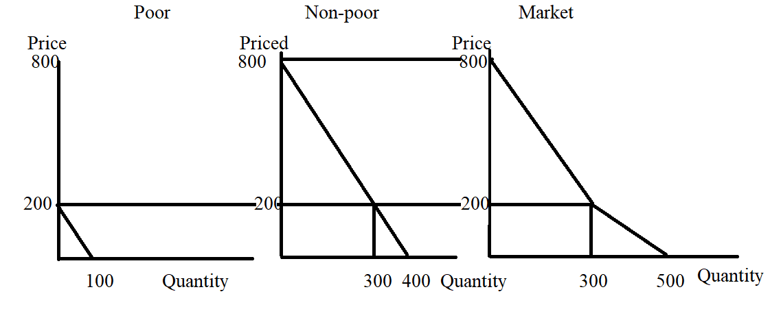
ii. To find the price of a medical visit we need to equate demand to supply: we need to also figure out whether we need to use the upper or lower segment of the demand curve. From our demand graph in (a) we know that when P = 200, the quantity demanded is 300 units. So, if we plug 200 into the supply equation as the price, what quantity supplied do we get?
P = 50 + (1/8)Q
200 = 50 + (1/8)Q
150*8 = Q
Q = 1200
Plotting the point (Q, P) = 1200, 200) quickly reveals to us that the supply curve will intersect the demand curve along the lower segment of the demand curve. So:
500 – Q = 50 + (1/8)Q
450 = (9/8)Q
450(8/9) = Q
Q = 400 medical visits
P = 500 – Q = 500 – 400 = $100 per medical visit
Or, P = 50 + (1/8)Q = 50 + (!/8)(400) = $100 per medical visit

iii. If the price of a medical visit is $100, then the poor will demand:
P = 200 – 2Q
100 = 200 – 2Q
2Q = 100
Q = 50 medical visits

iv. If the price of a medical visit is $100, then the non-poor will demand 350 medical visits since the poor are demanding 50 of the 400 medical visits supplied. Or, using the non-poor demand curve and the equilibrium price of $100 per medical visit:
P = 800 – 2Q
100 = 800 – 2Q
2Q = 700
Q = 350 medical visits

i. Equation(s) for the market demand curve and the relevant domain: ___for quantities less than or equal to 300, P = 800 – 2Q; and for quantities greater than or equal to 300, P = 500 - Q_____
ii. Price of a medical visit = __$100 per medical visit__
iii. Quantity of medical visits the poor receive = __50 medical visits___
iv. Quantity of medical visits the non-poor receive = __350 medical visits____

b. i. The new market demand curve will be the demand curve of the non-poor plus an additional 100 medical visits demanded by the poor at every price. The market demand curve will shift to the right and will include the points (0, 1000) and (500, 0). The equation for this new market demand is:
P = 1000 – 2Q
Note: that this demand curve has the same slope as the original non-poor demand curve but is simply shifted to the right by the number of medical visits the poor demand when the price of a medical visit for them is $0.

ii. To find the price of a medical visit, equate the new market demand curve to the market supply curve. Thus:
1000 – 2Q = 50 + (1/8)Q
950 = (17/8)Q
Q = 7600/17 medical visits (this is approximately 447 medical visits)
P = 1000 – 2Q
P = 1000(17)/17 – 2(7600)/17
P = 17000/17 – 15200/17
P = $1800/17 per medical visit (this is approximately $106 per medical visit)

iii. From inspection of the demand curve for the poor, we see that if the price of a medical visit is $0, then the poor demand 200 medical visits.

iv. We should expect that the non-poor will demand 7600/17 – 200 medical visits (or approximately 347 medical visits). Let’s see if that is what we get if we use the price of $1800/17 per medical visit and the non-poor demand curve. Thus:
P = 800 – 2Q
1800/17 = 800 – 2Q
1800 = 800(17) – 34Q
34Q = 13600 – 1800
34Q = 11800
Q = 11800/34 = 5900/17 (which is approximately 347 medical visits)

i. Equation(s) for the market demand curve and the relevant domain: _____P= 1000 – 2Q______
ii. Price of a medical visit = __$1800/17 per medical visit (approximately $106 per medical visit)__
iii. Quantity of medical visits the poor receive = __200 medical visits___
iv. Quantity of medical visits the non-poor receive = __5900/17 medical visits (approximately 347 medical visits)____

c. The non-poor will favor the program described in (a) and the poor will favor the program described in (b). The poor will get more medical visits at a cost of $0 per medical visit with (b) while the non-poor will get more medical visits at a lower cost per medical visit with (a).

3. Consider a market for health care that is described as follows where P is the price per medical visit and Q is the quantity of medical visits. For simplicity we will assume that all medical visits are the same and result in equivalent costs for the provider of medical services.

Demand for medical visits: P = 200 – (1/5)Q
Supply of medical visits: P = (1/3)Q – (200/3)

a. Given the above information, what is the equilibrium price and equilibrium quantity of medical visits in this market? Show your work.

b. Now, suppose that the consumers in this market get health insurance that covers 80% of the cost of a medical visit. Given this assumption and the provided information, provide your answers to the following.

i. What is the new market demand curve given this insurance?
ii. What is the new equilibrium price per medical visit?
iii. What is the new equilibrium quantity of medical visits?

Answers:

a. To find the equilibrium price and quantity set the market demand curve equal to the market supply curve. Thus:
200 – (1/5)Q = (1/3)Q – (200/3)
3000 – 3Q = 5Q – 1000
4000 = 8Q
Q = 500 medical visits
P = 200 – (1/5)Q = 200 – (1/5)(500) = 200 – 100 = $100 per medical visit
Or, P = (1/3)Q – (200/3) = (1/3)(500) – (200/3) = 300/3 = $!00 per medical visit

b. i. The new market demand curve is:
P = 1000 – Q
To see this, a graph will prove helpful. Obviously the consumer would not pay $200 for 0 medical visits, but this endpoint of the demand curve is a helpful reference point for figuring out the new y-intercept with the provision of insurance. The $200 now represents 1/5 of the total amount that can be paid out for 0 visits: the insurance company will pay 4/5’s or 80% of the price and the consumer will pay 1/5th or 20% of the price.
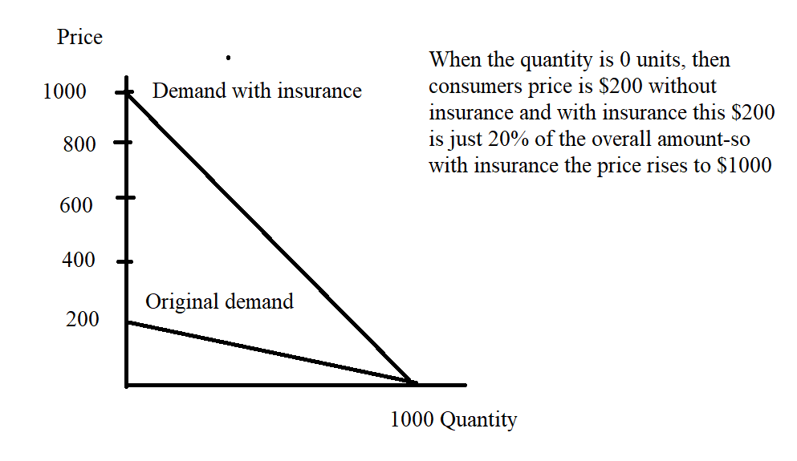
ii. and iii. The new equilibrium occurs at the intersection of the demand curve with insurance and the supply curve. Thus:
1000 – Q = (1/3)Q – (200/3)
3000 – 3Q = Q – 200
3200 = 4Q
Q = 800 medical visits
P = 1000 – Q = 1000 – 800 = $200 per medical visit
Or, P = (1/3)Q – (200/3) = (1/3)(800) – (200/3) = 600/3 = $200 per medical visit

Mortgages

4. In class we have studied mortgages and, in particular, a fixed rate thirty-year mortgage. Let us consider that kind of loan for this set of questions.

Suppose you have signed a thirty-year fixed rate mortgage in order to buy a house. Evaluate each of the following statements about this mortgage.

i. Each month this mortgage requires that the borrower make a payment of the same dollar amount to the lending institution. Suppose that this borrower misses several monthly payments in a row. If this happens the bank may decide to foreclose on the borrower and take back the ownership of the home.

ii. In the first years of this mortgage the borrower’s payment consists primarily of paying back the principal and in the last years of the mortgage the borrower’s payments consists primarily of paying interest on the loan to the lender.

iii. The principal balance on the loan initially decreases at a very slow rate and it is only after a number of years that the principal balance on the loan declines at an increasing rate.

iv. If a borrower borrows $300,000 at 5% interest per year for thirty years then the borrower, if they keep the loan for thirty years, will pay back (300,000)(1 + .05) = $315,000.

v. A requirement by the lender for the borrower to provide a down payment when securing a mortgage is a requirement that protects both the borrower and the lender.

Answer:

i. This is a TRUE statement. When a property is foreclosed this means that the lending institution repossesses the property. This means that the ownership of the property reverts to the lending institution and the borrower loses the property. If the lending institution sells the house for more than the amount that the borrower owes then the borrower keeps the excess; if the lending institution sells the house for less than the amount that the borrower owes then the borrower loses some portion of their downpayment. In either case the borrower’s credit rating is damaged.

ii. This statement is false: in the first years of the mortgage the payments are primarily interest payments and in the last years of the mortgage the payments are primarily principal payments.

iii. This is an accurate statement: see the example we did in class to review this concept.

iv. This is a FALSE statement. The fact that you are borrowing at 5% per year means that every year you must pay 5% interest on the amount you still owe. This is a very important concept for you to understand prior to signing any loan agreements.

v. This is a TRUE statement: if the borrower does not pay and the house is foreclosed the down payment limits the loss to the lender and it limits the loss to the borrower relative to the situation of no down payment.

