Economics 390
Spring 2020
Answers to Homework #2
Due 2/20/20

Homework is due at the beginning of lecture. The professor reserves the right to not accept homework if it is late. The expectation is that the homework will be done in a professional manner: it should be stapled, it should be neat, well organized, and complete. You cannot receive full credit if you omit questions and do not follow the provided instructions. There is no need to submit the questions: you need to simply submit your answers. You will not be able to get full credit for the homework if you do not show your work in an organized, easy-to-follow manner. Make sure your name is clearly and legibly written on the homework. Illegible answers will not get full credit.

Perfect Competition

1. Consider a perfectly competitive market that is comprised of eight identical firms. This market is currently in short run equilibrium. You are provided the following information about this market:

Market Demand: P = 98 – (1/2)Q
Total Cost for the Representative Firm: TC = 90 + 2q + 10q²
Marginal Cost for the Representative Firm: MC = 2 + 20q

where Q is the market quantity, q is the firm quantity, and P is the price per unit.

a. Given this information find the equation for the short run market supply curve. Show how you found this equation.

b. Given this information and the supply curve you found in (a), find the short run market price (P), the short run market quantity (Q), and the short run quantity produced by the representative firm (q), and the short run profits earned by the representative firm. Show how you found your answers in order to get full credit.

c. Given this information and the work you have done, what is your prediction for what will happen in the long run in this market? Assume that there are no changes to market demand. Be specific here: give a prediction on any shifts of curves that will occur, any entry or exit of firms, the market price, the market quantity, the level of profits for the representative firm and the representative firm’s level of production.

d. Assume there are no changes to the market demand curve. Find the long run equilibrium. Identify what the new supply curve will be, what the market price (P’) will be, the market quantity (Q’), the representative firm’s level of production (q’), the representative firm’s level of profit will be, and the number of firms in the industry will be. Show your work and your reasoning to get full credit.

Answers:

a. Here are two approached to finding the short run market supply curve. The first approach is a graphical approach:

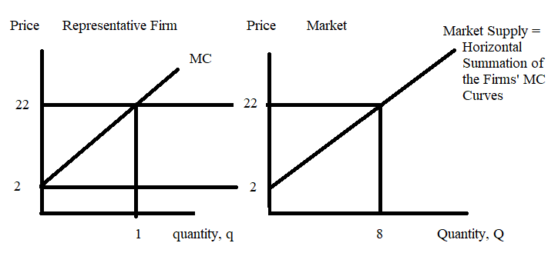
This approach starts with graphing a representative firm’s MC curve and then selecting a quantity, q, for that curve that yields a “nice” price. I chose q = 1. When q = 1, the MC is 22. If there are eight firms in the industry, then each firm produces 1 unit and the total quantity produced in the market when the MC is $22 will be 8 units. Thus, Q = 8 when MC = $22. I then have two known points on my market supply curve: (Q, P) = (0, 2) and (8, 22). Use these two points to write an equation for the market supply curve. Thus,
Y = mX + b
P = mQ + b
The slope, m, is equal to rise/run = 20/8 = 5/2
P = (5/2)Q + b
From the graph I can see that the y-intercept, b, is 2. Thus, the market supply curve is:
P = 2 + (5/2)Q

Here’s an algebraic approach. The market supply curve is the horizontal summation of the individual firm supply curves. So, I will start by writing the firm supply curve (the MC curve) in x-intercept form:
MC = 2 + 20q
20q = MC - 2
I will substitute P for MC since that is the variable we will be using when writing the supply curve.
20q = P - 2
q = (1/20)P - (1/10)
Qtotal = q1 + q2 + ….+ q8 = 8[(1/20)P – (1/10)]
Qtotal = (2/5)P – (4/5)
Rearranging this into y-intercept form:
(2/5)P = 4/5 + Q
P = 2 + (5/2)Q

b. To find the answers to this question first start by equating market demand to market supply. Thus:
998 – (1/2)Q = 2 + (5/2)Q
3Q = 96
Q = 32 units

P = 98 – (1/2)Q
P = 98 – (1/2)(32) = $82 per unit or
P = 2 + (5/2)(32) = $82 per unit

q = Q/8 = 32/8 = 4 units per firm

Profit for the representative firm = TR – TC
TR = ($82 per unit)(4 units) = $328
TC = 90 + 2(4) + 10(4)(4) = $258
Profit for the representative firm = 328 – 258 = $70

c. Since firms are earning positive economic profit in the short run, we can predict that more firms will enter this industry in the long run. So the total number of firms in the industry will be greater than 8 firms when we are at long run equilibrium. Furthermore, we know that the entry of firms will continue until profits are driven to equal $0 for the representative firm. The entry of firms will cause the market supply curve to shift to the right. For the given market demand curve, this implies that the market price will decrease relative to the price we found in (b), the market quantity will increase relative to the quantity we found in (b), and the representative firm will decrease their level of production relative to the quantity they were producing in (b).

d. In the long run the representative firm will earn $0 economic profit. The firm will produce where its MC curve intersects its ATC curve. We can find that quantity as follows:
MC = ATC
2 + 20q’ = 90/q’ + 2 + 10q’
90/q’ = 10q’
90/10 = q’*q’
9 = q’*q’
3 = q’

When q = 3, then MC = 2 + 20(3) = $62 per unit = P’

The long run price therefore needs to be $62 per unit for the representative firm to produce where its profits are equal to $0. Using the market demand curve we can find the market quantity at this price:
P’ = 98 – (1/2)Q’
62 = 98 – (1/2)Q’
(1/2)Q’ = 36
Q’ = 72

To find the number of firms in the long run:
Number of firms = Q/q = 72/3 = 24 firms

The new market supply curve will contain the two points (Q, P) = (0, 2) and (72, 62). Use these two points to find the market supply curve:

P = 2 + (5/6)Q

Monopoly and Price Discrimination

2. Consider a monopoly described by the following equations:

Market Demand: P = 100 – (1/2)Q
Monopoly’s Total Cost: TC = 20 + 10Q + (1/2)Q²
Monopoly’s Marginal Cost: MC = 10 + Q

a. Suppose this is a single price monopolist. Using the above information find the following:

i. Market Quantity, Q = __________________________
ii. Market Price, P = _________________________________
iii. Profit for the Single Price Monopolist = _______________________
iv. Consumer Surplus for the Single Price Monopolist, CS = ________________
v. Producer Surplus for the Single Price Monopolist, PS = _____________
vi. Deadweight Loss due to the Single Price Monopolist, DWL = _________________

Show your work to get full credit.

b. Draw a graph and label it clearly and carefully to illustrate your answers in (a).

c. Suppose this same monopoly decides to practice first degree price discrimination instead of being a single price monopolist. Using the above information and the fact that the firm possesses the needed information that it must have to be a perfect price discriminator, determine the following values:

i. Market Quantity, Q = __________________________
ii. Profit for the First Degree Price Discriminator = _______________________
iii. Consumer Surplus for the First Degree Price Discriminator, CS’ = ________________
iv. Producer Surplus for the First Degree Price Discriminator, PS’ = _____________
v. Deadweight Loss due to the First Degree Price Discriminator, DWL’ = _________________

Show your work to get full credit.

d. Why is PS’ not equal to profits in (c)? Explain your answer.

e. Provide a graph that illustrates the first degree price discriminator. In your graph indicate any relevant values and areas. Label your graph clearly and completely to get full credit.

f. Suppose this firm decides to act as a second degree price discriminator. The firm plans to sell the first 20 units of the good for $90 per unit, the next additional 10 units at $85 per unit, and a final 15 units of the good for $77.50. (The monopolist arrives at these quantities and their associated prices by using the demand curve: for example, if Q = 20 then the price customers will pay is $90 per unit.) Given the above information and the decision to practice second degree price discrimination, find the following:

i. Total revenue for the second degree price discriminator = _______________
ii. Total cost for the second degree price discriminator = ______________
iii. Profit for the second degree price discriminator = ______________
iv. Producer Surplus, PS”, for the second degree price discriminator = _________________
v. Consumer Surplus, CS”, for the second degree price discriminator = _______________
vi. Deadweight Loss, DWL”, for the second degree price discriminator = ___________

Show your work to get full credit.

g. Provide a graph illustrating fully your work in (f). Label it clearly and completely.

Answers:

a. To find these answers start by finding the monopolist’s marginal revenue curve, MR. The MR for a monopolist with a straight line demand curve will have the same y-intercept as the demand curve and twice the slope of the demand curve. Thus:
MR = 100 – Q
Set MR equal to MC:
100 – Q = 10 + Q
90 = 2Q
Q = 45 units

To find the price the single price monopolist will charge, take this quantity and plug it into the demand equation. Thus:
P = 100 – (1/2)Q = 100 – (1/2)(45) = $77.50 per unit

Profit = total revenue – total cost
Profit = (77.50)(45) – [20 + 10(45) + (1/2)(45)(45)]
Profit = 3487.50 – [470 + 1012.50]
Profit = $2005.00

CS = (1/2)($100 per unit - $77.50 per unit)(45 units) = $506.25
PS = ($77.50 per unit - $55 per unit)(45 units) + (1/2)($55 per unit - $10 per unit)(45 units)
PS = 1012.50 + 1012.50 = $2025
DWL = (1/2)($77.50 per unit - $55 per unit)((60 units – 45 units)
DWL = $168.75

i. Market Quantity, Q = ___45_______________________
ii. Market Price, P = _____$77.50____________________________
iii. Profit for the Single Price Monopolist = _________$2005.00______________
iv. Consumer Surplus for the Single Price Monopolist, CS = ______$506.25__________
v. Producer Surplus for the Single Price Monopolist, PS = ______$2025_______
vi. Deadweight Loss due to the Single Price Monopolist, DWL = _____$168.75____________

b. Here’s the graph:

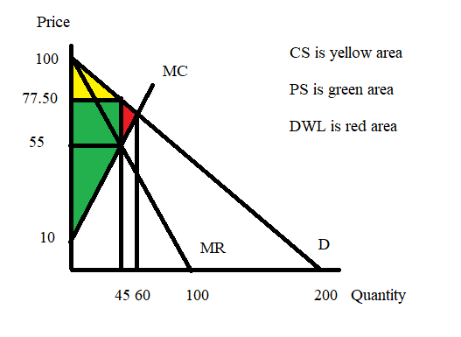
c. The first degree price discriminator will charge a different price to each of its customers: it will charge each customer the maximum the customer is willing to pay. Thus, the demand curve becomes the firm’s marginal revenue curve. The firm will produce that quantity where MR = MC. Thus:
100 – (1/2)Q = 10 + Q
90 = (3/2)Q
Q = 60 units
Note that the first degree price discriminator is producing the socially optimal amount of the good since MR = MC for the last unit produced.

To find the firm’s profit:
Profit = total revenue – total cost
Profit = [(1/2)($100 per unit - $70 per unit)(60 units) + ($70 per unit)(60 units)] – [20 + 10(60) + (1/2)(60)(60)]
Profit = [900 + 4200] – 2420
Profit = $2680

There is no consumer surplus since the first degree price discriminator captures all of the consumer surplus.

There is no deadweight loss since the firm is producing the socially optimal amount of the good.

PS’ = (1/2)($100 per unit - $10 per unit)(60 units) = $2700

i. Market Quantity, Q = _______60 units___________________
ii. Profit for the First Degree Price Discriminator = ________$2680_______________
iii. Consumer Surplus for the First Degree Price Discriminator, CS’ = _____$0___________
iv. Producer Surplus for the First Degree Price Discriminator, PS’ = _____$2700________
v. Deadweight Loss due to the First Degree Price Discriminator, DWL’ = ______$0______

d. PS’ is not equal to profits since the firm has fixed costs equal to $20. Producer surplus does not include these fixed costs while the calculation of profits includes the fixed costs as part of the costs of providing the good.

e. Here’s the graph:

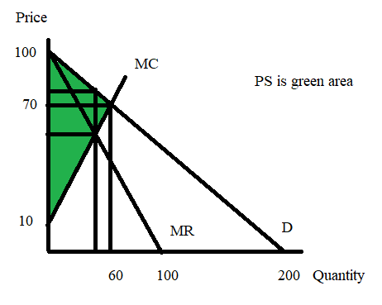
f. To calculate total revenue:
TR = ($90 per unit)(20 units) + ($85 per unit)(10 units) + ($77.50)(15 units)
TR = 1800 + 850 + 1162.50
TR = $3812.50

TC = 20 + 10(45) + (1/2)(45)(45)
TC = $1482.50

Profit = 3812.50 – 1482.50 = $2330.00

PS” = ($90 per unit - $55 per unit)(20 units) + ($85 per unit - $55 per unit)(10 units) + ($77.50 per unit - $55 per unit)(15 units) + (1/2)($55 per unit - $10 per unit)(45 units)
PS” = 700 + 300 + 337.50 + 1012.50
PS” = $2350.00

CS” = (1/2)($100 per unit - $90 per unit)(20 units) + (1/2)($90 per unit - $85 per unit)(10 units) + (1/2)($85 per unit - $77.50 per unit)(15 units)
CS” = 100 + 25 +56.25
CS” = $181.25

DWL” = (1/2)($77.50 per unit - $55 per unit)(60 units – 45 units)
DWL” = $168.75

i. Total revenue for the second degree price discriminator = _____$3812.50__________
ii. Total cost for the second degree price discriminator = ______$1482.50________
iii. Profit for the second degree price discriminator = ______$2330.00________
iv. Producer Surplus, PS”, for the second degree price discriminator = ____$2350.00_________
v. Consumer Surplus, CS”, for the second degree price discriminator = ______= $181.25______
vi. Deadweight Loss, DWL”, for the second degree price discriminator = ___$168.75________

g. Here’s the graph:
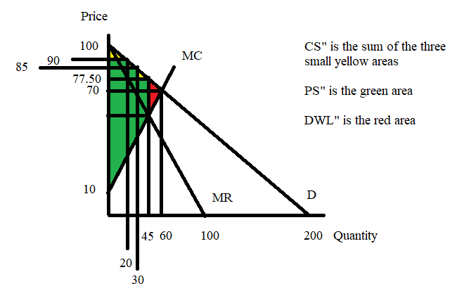

3. Consider a monopolist that sells their product to two different types of buyers: buyers in class one and buyers in class two. This is the information you are given about this monopolist:

Demand of Class One Buyers: P = 20 – Q
Demand of Class Two Buyers: P = 15 – (3/2)Q
Marginal Cost for the monopolist: MC = 6
Fixed Costs: FC = 0

a. Suppose that this monopolist decides to sell to the two classes of buyers without distinguishing whether the buyer is in Class One or Class Two. That is, the monopolist decides to be a single price monopolist. Given this decision, find the following values:

i. Quantity of the good the monopolist sells = _______
ii. Price of the good = _________
iii. Total revenue from selling the good as a single price monopolist = __________
iv. Total cost of producing the good as a single price monopolist = __________
v. Profits for the single price monopolist = __________
vi. CS for the single price monopolist = __________
vii. PS for the single price monopolist = _________
viii. DWL due to the single price monopolist = ____________

Show your work to get full credit for this problem. And, provide a graph to illustrate your answers! Make sure it is well labeled and complete!

b. Suppose that this monopolist decides to practice third degree price discrimination by separating these two classes of buyers and treating each of them as separate monopolies. Given this information and the information you were originally provided determine the following:

i. Total quantity of the good the third degree price discriminating monopolist sells = _______
ii. Quantity of the good sold to Class One = ______
iii. Quantity of the good sold to Class Two = ______
iv. Price of the good to Class One Buyers = _____
v. Price of the good to Class Two Buyers = ______
vi. TR from Class One Buyers = ______
vii. TR from Class Two Buyers = ______
viii. TC of producing the good for both classes = _______
ix. Total Profit for the third degree price discriminating monopolist = ________
x. CS for the third degree price discriminating monopolist = _______
xi. PS for the third degree price discriminating monopolist = _______
xii. DWL for the third degree price discriminating monopolist = _____

Show your work to get full credit for this problem. And, provide a graph to illustrate your answers! Make sure it is well labeled and complete!

Answers:

a. To answer this set of questions we need to first create the market demand curve for the single price monopolist. This will require the horizontal summation of the individual demand curves to create the market demand curve. A graph will prove helpful to us:
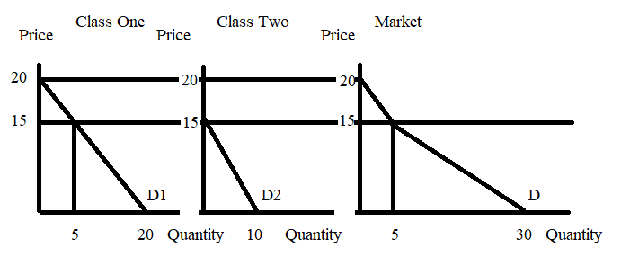
Examining this set of diagrams we see that the market demand curve is comprised of two segments. The top segment is the same as the demand for Class One for prices greater than or equal to $15. Thus, the top segment of the market demand curve can be written as P = 20 – Q for 15 ≤ P ≤ 20. The lower segment of the market demand curve contains the points (Q, P) = (5, 15) and (30, 0). Use these two points and the general slope intercept form to write the equation for this segment. Thus:
Slope = rise/run = -15/25 = -3/5
Y = mX + b
P = (-3/5)Q + b
0 = (-3/5)(30) + b
18 = b
P = 18 – (3/5)Q for 0 ≤ P ≤ 15

To find the profit maximizing quantity we need to set MR = MC. But, for this single price monopolist there are two MR curves: we need to consider both of these MR schedules. Thus:

MR for the top segment: MR = 20 – 2Q
MR = MC
20 – 2Q = 6
14 = 2Q
Q = 7
But Q = 7 is a level of output that lies outside the domain of this segment of the demand curve. Thus, we can discard this quantity as the profit maximizing quantity for this single price monopolist.

MR for the bottom segment: MR = 18 – (6/5)Q
MR = MC
18 – (6/5)Q = 6
12(5/6) = Q
10 = Q

Plug this quantity into the demand curve to find the profit maximizing price for the single price monopolist. Thus:
P = 18 – (3/5)Q
P = 18 – (3/5)(10)
P = 18 – 6 = $12 per unit

TR = PQ = ($12 per unit)(10 units) = $120
TC = ATC*Q and since MC is a horizontal line and there are no fixed costs, we can use MC = ATC in this equation!
TC = ($6 per unit)(10 units) = $60

Profit for the single price monopolist = TR – TC = 120 – 60 = $60

To find CS, PS and DWL a graph will prove helpful. Here’s that graph:
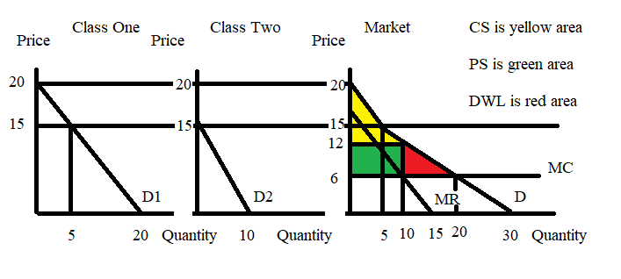

CS = (1/2)(20 – 15)(5) + (15 – 12)(5) + (1/2)(15 – 12)(10 – 5)
CS = 12.5 + 15 + 7.5
CS = $35
PS = (12 – 6)(10)
PS = $60
DWL = (1/2)(12 – 6)(20 – 10)
DWL = $30

i. Quantity of the good the monopolist sells = __10 units_____
ii. Price of the good = ____$12 per unit_____
iii. Total revenue from selling the good as a single price monopolist = ____$120______
iv. Total cost of producing the good as a single price monopolist = _____$60_____
v. Profits for the single price monopolist = ___$60_______
vi. CS for the single price monopolist = _____$35_____
vii. PS for the single price monopolist = ____$60_____
viii. DWL due to the single price monopolist = ____$30________

b. From (a) we already know the profit maximizing quantity for the entire market: this will still be the profit maximizing quantity for the third degree price discriminating monopolist. We also know the TC of producing this level of output from (a). So, on to the work!

This problem is actually quite easy due to the horizontal MC curve. We simply need to set MC = MR for each of the separate monopolies to find the quantity of the good sold to each class and then find the price by using this quantity and the class’ demand curve. Thus:

For Class One:
MR = 20 – 2Q
MC = MR
6 = 20 – 2Q
2Q = 14
Q = 7
P = 20 – Q
P = 20 – 7 = $13 per unit
TR from Class One = P*Q = (13)(7) = $91

For Class Two:
MR = 15 – 3Q
MR = MC
15 – 3Q = 6
9 = 3Q
Q = 3 (Note that 7 + 3 = 10!)
P = 15 – (3/2)Q
P = 15 – (3/2)(3)
P = $10.50 per unit
TR from Class Two = P*Q = (10.5)(3) = $31.50

Profit = TR from Class One + TR from Class Two – TC
Profit = 91 + 31.50 – 60 = $62.50

For CS, PS and DWL for the third degree price discriminating monopolist it will be helpful to have a graph. Here it is!
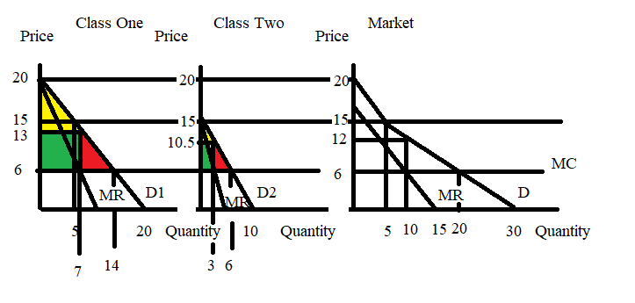
CS = sum of the yellow areas
CS = (1/2)(20 -13)(7) + (1/2)(15 – 10.5)(3)
CS = 24.50 + 6.75 = $31.25

PS = sum of the green areas
PS = (13 – 6)(7) + (10.5 – 6)(3)
PS = 49 + 13.5
PS = $62.50

DWL = sum of the red areas
DWL = (1/2)(13 – 6)(14 – 7) + (1/2)(10.5 – 6)(6 – 3)
DWL = 24.5 + 6.75
DWL = $31.25
The fact that the DWL is different from (a) versus (b) is quite interesting! You ought to take some time to think about what it is not the same!

i. Total quantity of the good the third degree price discriminating monopolist sells = ___10 units (this does not change from (a))____
ii. Quantity of the good sold to Class One = ___7 units ___
iii. Quantity of the good sold to Class Two = __3 units____
iv. Price of the good to Class One Buyers = ___$13 per unit__
v. Price of the good to Class Two Buyers = __$10.50 per unit____
vi. TR from Class One Buyers = __$91____
vii. TR from Class Two Buyers = ___$31.50___
viii. TC of producing the good for both classes = ___$60 (this does not change from (a))____
ix. Total Profit for the third degree price discriminating monopolist = ____$62.50____
x. CS for the third degree price discriminating monopolist = ___$31.25____
xi. PS for the third degree price discriminating monopolist = ____$62.50___
xii. DWL for the third degree price discriminating monopolist = ___$31.25

4. Consider a monopolist that sells their product to two different types of buyers: buyers in class one and buyers in class two. This is the information you are given about this monopolist:

Demand of Class One Buyers: P = 10 – Q
Demand of Class Two Buyers: P = 8 - 2Q
Marginal Cost for the monopolist: MC = (1/3)Q
Total Cost for the monopolist: TC = (1/6)Q²
Fixed Costs: FC = 0

a. Suppose that this monopolist decides to sell to the two classes of buyers without distinguishing whether the buyer is in Class One or Class Two. That is, the monopolist decides to be a single price monopolist. Given this decision, find the following values (round your answers to two places past the decimal):

i. Quantity of the good the monopolist sells = _______
ii. Price of the good = _________
iii. Total revenue from selling the good as a single price monopolist = __________
iv. Total cost of producing the good as a single price monopolist = __________
v. Profits for the single price monopolist = __________

Show your work to get full credit for this problem.

b. Suppose that this monopolist decides to practice third degree price discrimination by separating these two classes of buyers and treating each of them as separate monopolies. Given this information and the information you were originally provided determine the following (round your answers to two places past the decimal):

i. Total quantity of the good the third degree price discriminating monopolist sells = _______
ii. Quantity of the good sold to Class One = ______
iii. Quantity of the good sold to Class Two = ______
iv. Price of the good to Class One Buyers = _____
v. Price of the good to Class Two Buyers = ______
vi. TR from Class One Buyers = ______
vii. TR from Class Two Buyers = ______
viii. TC of producing the good for both classes = _______
ix. Total Profit for the third degree price discriminating monopolist = ________

Show your work to get full credit for this problem.

Answers:

a. To answer this set of questions we need to first create the market demand curve for the single price monopolist. This will require the horizontal summation of the individual demand curves to create the market demand curve.

The market demand curve is comprised of two segments. The top segment is the same as the demand for Class One for prices greater than or equal to $8. Thus, the top segment of the market demand curve can be written as P = 10 – Q for 8 ≤ P ≤ 10. The lower segment of the market demand curve contains the points (Q, P) = (2, 8) and (14, 0). Use these two points and the general slope intercept form to write the equation for this segment. Thus:
Slope = rise/run = -8/12 = -2/3
Y = mX + b
P = (-2/3)Q + b
0 = (-2/3)(14) + b
28/3 = b
P = 28/3 – (2/3)Q for 0 ≤ P ≤ 8

To find the profit maximizing quantity we need to set MR = MC. But, for this single price monopolist there are two MR curves: we need to consider both of these MR schedules. Thus:

MR for the top segment: MR = 10 – 2Q
MR = MC
10 – 2Q = (1/3)Q
10 = (7/3)Q
Q = 30/7
But Q = 30/7 is a level of output that lies outside the domain of this segment of the demand curve. Thus, we can discard this quantity as the profit maximizing quantity for this single price monopolist.

MR for the bottom segment: MR = 28/3 – (4/3)Q
MR = MC
28/3 – (4/3)Q = (1/3)Q
28/3 = (5/3)Q
28/5 units = Q

Plug this quantity into the demand curve to find the profit maximizing price for the single price monopolist. Thus:
P = 28/3 – (2/3)Q
P = 28/3 – (2/3)(28/5)
P = $28/5 per unit

TR = PQ = ($28/5 per unit)(28/5 units) = $31.36
TC = (1/6)(28/5)(28/5)
TC = $5.23

Profit for the single price monopolist = TR – TC = 31.36 – 5.23 = $26.13

i. Quantity of the good the monopolist sells = __28/5 units_____
ii. Price of the good = ____$28/5 per unit_____
iii. Total revenue from selling the good as a single price monopolist = ____$31.36______
iv. Total cost of producing the good as a single price monopolist = _____$5.23_____
v. Profits for the single price monopolist = ___$26.13_______

b. From (a) we already know the profit maximizing quantity for the entire market: this will still be the profit maximizing quantity for the third degree price discriminating monopolist. We also know the TC of producing this level of output from (a). So, on to the work!

Before we can go to the separate classes we need to know the MC value when Q = 28/5. Thus:
MC = (1/3)Q
MC = (1/3)(28/5)
MC = 28/15
We will use this value in the two separate markets to determine the quantity of the good for each class.

For Class One:
MR = 10 – 2Q
MC = MR
28/15 = 10 – 2Q
28 = 150 – 30Q
30Q = 122
Q = 61/15
P = 10 – (61/15)
P = 89/15
TR from Class One = P*Q = (89/15)(61/15) = $24.13

For Class Two:
MR = 8 - 4Q
MR = MC
8 – 4Q = 28/15
28 = 120 – 60Q
60Q = 92
Q = 23/15
Note that Q1 + Q2 = (61/15) + (23/15) = (84/15) = (28/5) which is the Qtotal that the firm is going to produce!
P = 8 - 2Q
P = 8 – 2(23/15)
P = $(74/15) per unit
TR from Class Two = P*Q = (74/15)(23/15) = $7.56

Profit = TR from Class One + TR from Class Two – TC
Profit = 24.13 + 7.56 – 5.23 = $26.46

i. Total quantity of the good the third degree price discriminating monopolist sells = ___28/5 units (this does not change from (a))____
ii. Quantity of the good sold to Class One = ___61/15 units ___
iii. Quantity of the good sold to Class Two = __23/15____
iv. Price of the good to Class One Buyers = ___$(89/15) per unit__
v. Price of the good to Class Two Buyers = __$(74/15) per unit____
vi. TR from Class One Buyers = __$24.13____
vii. TR from Class Two Buyers = ___$7.56___
viii. TC of producing the good for both classes = ___$5.23 (this does not change from (a))____
ix. Total Profit for the third degree price discriminating monopolist = ____$26.46____

Natural Monopoly

5. Consider a monopoly described by the following equations:

Total Cost for the Monopolist: TC = 80,000 + 10Q + (1/2)Q²
Marginal Cost for the Monopolist: MC = 10 + Q
Market Demand for the Monopolist: P = 100,000 – 250Q

a. Examine the data you have been provided. What is variable cost, VC, for this monopoly? What is fixed cost, FC, for this monopoly?

b. Suppose the monopoly produces 100 units of the good, what is the average fixed cost for this level of production? Suppose the monopoly produces 1000 units of the good, what is the average fixed cost for this level of production? Show your work for this question.

c. At what level of output is the average total cost minimized? Show how you found your answer.

d. At what level of output does the MC equal the average total cost of production? Show your work.

e. Suppose this monopolist acts as a single price monopolist. Find the following given this assumption.

i. Market price of the good = _____
ii. Market quantity of the good = _____ (calculate this to two places past the decimal)
iii. Profit for the single price monopolist = _____
iv. DWL when this firm acts as a single price monopolist = _____ (round all calculations to two places past the decimal) Hint: this will be a very big number!

f. Suppose that this monopoly is regulated so that it produces the socially optimal amount of the good. This quantity will be where the MC intersects the demand curve. Given this regulation determine the values of the following:

i. The price of the good with MC regulation = ____
ii. The quantity of the good produced with MC regulation = ______
iii. The profit for the firm if it is regulated with MC regulation = ____
iv. The amount of the total subsidy payment the firm must receive in order to produce the socially optimal amount of the good = _____
v. DWL when this firm is regulated with MC regulation = _____

Answers:

a. VC = 10Q + (1/2)Q² . VC varies as the level of production, Q, varies.
FC = $80,000. FC does not vary as the level of production, Q, varies.

b. When Q = 100, the AFC = FC/Q = 80,000/100 = $800 per unit. When Q = 1000, the AFC = FC/Q’ = 80,000/1000 = $80 per unit. FC is constant as Q varies while AFC gets smaller and smaller as Q increases.

c. To see where ATC is minimized we need to find the level of production, Q, where ATC = MC. Thus:
ATC = 80,000/Q + 10 + (1/2)Q
MC = 10 + Q
10 + Q = 80,000/Q + 10 + (1/2)Q
(1/2)Q = 80,000/Q
Q*Q = 160,000
Q = 400

d. This question is a repeat of the question in (c), so simply review the work that was done there!

e. If this firm acts as a single price monopolist it will equate its MC curve to its MR curve to determine the profit maximizing quantity. Thus:
MR = 100,000 – 500Q
MC = 10 + Q
100,000 – 500Q = 10 + Q
99,990 = 501Q
Q = 199.58 units

To find the price, put this quantity into the firm’s demand curve:
P = 100,000 – 250Q
P = 100,000 – 250(199.58)
P = 100,000 – 49,895
P = $50,105 per unit

Profit for the single price monopolist = TR – TC
Profit for the single price monopolist = (50105)(199.58) – [80,000 + 10(199.58) + (1/2)(199.58) (199.58)]
Profit for the single price monopolist = 9,999,956 - 101912
Profit for the single price monopolist = $9,898,044

To find the DWL we need to first find the quantity where MC = D. Thus:
10 + Q = 100,000 – 250Q
251Q = 99,990
Q = 99,990/251
Q = 398.37 units
We will also need to calculate the value of MC when Q = 199.58. Thus:
MC = 10 + 199.58 = $209.58

DWL = (1/2)(50105 – 209.58)(398.37 – 199.58)
DWL = (1/2)(49895.42)(198.79)
DWL = $4,959,355

i. Market price of the good = __$50,105per unit___
ii. Market quantity of the good = __199.58 units ___
iii. Profit for the single price monopolist = __$9,898,044___
iv. DWL when this firm acts as a single price monopolist = __$4,959,355___

f. From (e) when we calculated the DWL for the single price monopolist we know the socially optimal amount of the good is 398.37 units. We also know the price associated with this quantity and the demand curve: $209.58 per unit.

To calculate profit we need to find the firm’s TR as well as its TC when it produces 398.37 units and sells these units for $209.58 per unit.
TR = (209.58)(398.37)
TR = $83490.40
TC = 80,000 + 10Q + (1/2)Q*Q
TC = 80,000 + 10(398.37) + (1/2)(398.37)(398.37)
TC = 80,000 + 3983.7 + (1/2)(79349.3)
TC = $123658.4
Profit with MC regulation = $83490.40 - $123658.4
Profit with MC Regulation = $-40,168

Since the firm is producing the socially optimal amount of the good there is no DWL.

i. The price of the good with MC regulation = __$209.58 per unit__
ii. The quantity of the good produced with MC regulation = __398.37 units ____
iii. The profit for the firm if it is regulated with MC regulation = __$-40,168__
iv. The amount of the total subsidy payment the firm must receive in order to produce the socially optimal amount of the good = __$40,168___
v. DWL when this firm is regulated with MC regulation = ___$0__

