Economics 390
Spring 2020
Answers to Homework #1
Due 2/6/20

Homework is due at the beginning of lecture. The professor reserves the right to not accept homework if it is late. The expectation is that the homework will be done in a professional manner: it should be stapled, it should be neat, well organized, and complete. You cannot receive full credit if you omit questions and do not follow the provided instructions. There is no need to submit the questions: you need to simply submit your answers. You will not be able to get full credit for the homework if you do not show your work in an organized, easy-to-follow manner. Make sure your name is clearly and legibly written on the homework. Illegible answers will not get full credit.

The Property of Rivalry and Excludability

1. In class we discussed the property of excludability and the concept of free riding. In your own words define the property of excludability and the concept of free riding. Then write a brief statement about why non-excludability creates an environment that results in the free rider problem. In your statement make sure you include at least one example of non-excludability and the free riding that occurs due to the non-excludability.

Answer:

Answers here will vary but the key point is that the free rider can consume the good even though they have not paid for it. Non-excludability refers to the idea that the good can be consumed even if the consumer has not paid for the good. The fact that you can consume the good without paying for it naturally leads to the act of free riding: since the good is available to you at no charge, why not enjoy the good even though you have not contributed to its provision. So, you can enjoy your clean apartment even if you do not help your roommate clean the apartment: if you do not help them, then you are a free rider. You can enjoy the Fourth of July fireworks show even if you do not contribute to help fund the event: if you do not make the contribution, then you are a free rider.

2. For each of the following goods determine whether the good is rival or non-rival, and excludable or non-excludable. Fill in the provided table with your answer.

Good | Rival or Non-Rival? | Excludable or Non-excludable?
Public Firework Shows on the Fourth of July
City Parks
Water Service for an individual in a community
Doughnuts
Fishing for fish in a public fishing area
National Defense
A loaf of bread from your local bakery
A sandwich from a fast food restaurant
McDonald’s Hamburger
Public Health Measures like clean water

Answers:

Good | Rival or Non-Rival? | Excludable or Non-excludable?
Public Firework Shows on the Fourth of July | Non-rival | Non-excludable
City Parks | Non-rival unless congested | Non-excludable
Water Service for an individual in a community | Non-rival | Excludable
Doughnuts | Rival | Excludable
Fishing for fish in a public fishing area | Non-rival | Non-excludable although if you need to have a license for the season then the good is excludable
National Defense | Non-rival | Non-excludable
A loaf of bread from your local bakery | Rival | Excludable
A sandwich from a fast food restaurant | Rival | Excludable
McDonald’s Hamburger | Rival | Excludable
Public Health Measures like clean water | Non-rival | Non-excludable

Externalities

3. We live in a world confronted with a large array of challenges. Identify one challenge in the world today that arises because of the existence of an externality that is not being corrected for by the market. Discuss what the challenge is, how it reflects the existence of an externality, the consequences of not addressing the externality and at least two possible solutions to the problem posed by the challenge you have selected. In your answer make sure you identify why your example illustrates this concept. Use complete sentences and standard English when writing your answer. Grammatically incorrect answers will result in a lower homework score.

Answer:

Answers here will vary but the key concept here is that an externality occurs when there is a benefit or a cost from consuming or producing the good that is not incorporated in the transaction. For instance, there is a societal benefit from individuals getting an education. Yet, most individuals decide how much education they will get based upon the private benefits they will receive from the education. The social benefit from the education is not included in the transaction: there is a positive externality that is not internalized by the market. When a producer produces their product and creates a pollution by-product that they fail to clean up, then that producer is creating a negative externality that reflects a cost that they are inflicting on society. Failure to include this cost of their production generates the negative externality. When there is a positive externality, the market will under produce the good; when there is a negative externality, the market will produce too much of the good.

Here are some simple solutions for negative externalities: regulation, taxes, moral codes and social sanctions, contracts that limit or prohibit behaviors.

Here are some simple solutions for positive externalities: regulation (for instance, mandatory education through age 16), subsidies, moral codes and social sanctions, contracts that mandate behaviors.

4. Revisit your day today and identify three occasions when you saw or experienced an externality. Try to include both negative as well as positive externalities in your account. Be specific about the event and why it illustrates the ideas behind externalities.

Answer:

Your answers will vary since our days are comprised of a great deal of variety. I am writing this on December 24, 2019 and will try to provide a list of externalities I have experienced today.

1) Holiday decorations and lights: the homeowners who put these up derive benefits from them, but so do their neighbors. The goods are non-excludable and non-rival (so a public good), but they certainly provide more benefits than just the benefits that the owners derive.

2) Cars stopping for stoplights: a system of law and order that works for the most part. I like to walk and I am impacted by drivers and their respect or lack of respect for the law. When drivers routinely run yellow and red lights, their actions endanger walkers who are trying to cross during the time the offense is taking place.

3) Vulgar language in public spaces: (thankfully this one did not happen today!). As stated in the second point I enjoy walking and I am always a bit surprised and overwhelmed by the language that is spoken in public spaces. We share this public space and the externality arises when individuals acts without thinking about how their action might impact others.

Equating Marginal Social Cost and Marginal Social Benefit

5. Suppose you are charged with determining the optimal amount of pollution for a community. You are told that the marginal social cost (MSC) of pollution for the community can be expressed as a linear relationship over the relevant quantities of pollution. You are also told that the marginal social benefit (MSB) of pollution (this is a measure of the marginal cost abatement cost: that is, getting rid of pollution is not free) for the community can be expressed as a linear relationship over the relevant quantities of pollution. Here is some other data you have available:

  - When there are 10 tons of pollution per day, the marginal social cost of this level of pollution is $1000 per day.
  - When there are 40 tons of pollution per day, the marginal social cost of this level of pollution is $12,400 per day.
  - When all pollution per day is eliminated, the marginal social benefit of this level of pollution is $8,800 per day.
  - When there are 50 tons of pollution per day, the marginal social benefit of this level of pollution is $0 per day.

a. Given this information write an equation for the MSC for this community. For your equation use MSC as your y variable and the quantity of pollution (Q) as your x variable. Express your equation in slope-intercept form.

b. Given this information write an equation for the MSB for this community. For your equation use MSB as your y variable and the quantity of pollution (Q) as your x variable. Express your equation in slope-intercept form.

c. Given the equations you found in (a) and (b), determine the optimal amount of pollution for this community. Explain why the optimal amount of pollution is not likely to be zero tons of pollution.

Answer:

a. We know two points on the MSC curve from the provided information: (Q, MSC) = (10, $1000) and (40, $12,400). Use these two points to write the equation:
y = mx + b
MSC = mQ + b
m = slope of the MSC curve
m = (change in MSC)/(change in Q) = (1000 – 12,400)/ (10 – 40) = (-11,400)/(-30) = 380
MSC = 380Q + b
Use one of our known points to find the value for “b”:
1000 = (380)(10) + b
b = -2800
MSC = 380Q - 2800

b. We know two points on the MSB curve from the provided information: (Q, MSB) = (0, $8,000) and (50, $0). Use these two points to write the equation:
y = mx + b
MSB = mQ + b
m = slope of the MSB curve
m = (change in MSB)/(change in Q) = (8,000 – 0)/ (0 – 50) = (8,000)/(-50) =
(-160)
MSB = (-160)Q + b
Use one of our known points to find the value for “b”:
8,000 = (-160)(0) + b
b = 8,000
MSB = (-160)Q + 8,000

c. To find the optimal amount of pollution in this community set MSC = MSB:
380Q – 2800 = (-160)Q + 8,000
540Q = 10,800
Q = 20 tons of pollution
The optimal amount of pollution for this community is not zero units of pollution: at very low levels of pollution, the marginal social cost to the community of that pollution is very low while the marginal social benefit from the pollution is quite high. It is extraordinarily expensive to eliminate 100% of the pollution in a community.

6. Consider a perfectly competitive market that currently has five identical firms serving the market. You are provided the following information:

Marginal Cost (MC) for each firm: MC = 5 + 4q
Total Cost (TC) for each firm: TC = 2q² + 5q + 32

Market Demand: P = 96 – (1/2)Q

where q is the quantity produced by a firm, Q is the market quantity, and P is the price per unit for the good.

a. Given the above information and holding everything else constant, find the market supply curve. Explain how you found this curve. Write the market supply curve in y-intercept form. Assume that the market supply curve is linear.

b. Given the market curve you found in (a) and the provided information, determine the short-run equilibrium quantity and price in this market. Show how you found your answer in a well-ordered, logical explanation.

c. Given your answer in (b), now determine the quantity that a representative firm will produce in this market in the short-run. Make sure you show how you found your answer.

d. Given your answers in (b) and (c), now determine the short-run profit that a representative firm will earn in this market in the short-run. Make sure you show how you found your answer. What do you predict will happen in the long run in this market?

e. Assume that there are no changes to the market demand. From the provided information determine the long-run equilibrium quantity and price in this market. Remember that in the long-run all firms in the perfectly competitive market will earn zero economic profit. Make sure you show how you found your answer.

f. How many firms will be in this market in the long-run? Explain how you found your answer.

g. Given your answer in (f), find the long-run market supply curve. Assume that all firms are identical in this market and that the long-run market supply curve is linear. Write this equation in y-intercept form. Explain how you found your answer.

h. Calculate the long-run values for consumer surplus (CS), producer surplus (PS), and deadweight loss (DWL) in this perfectly competitive market. Show your work. You might find it helpful and time-saving to provide a graph that illustrates this market in long-run equilibrium with these areas marked.

Answer:

a. One can find the market supply curve by using a graph and reasoning or you can do it algebraically. I will provide both methods here.
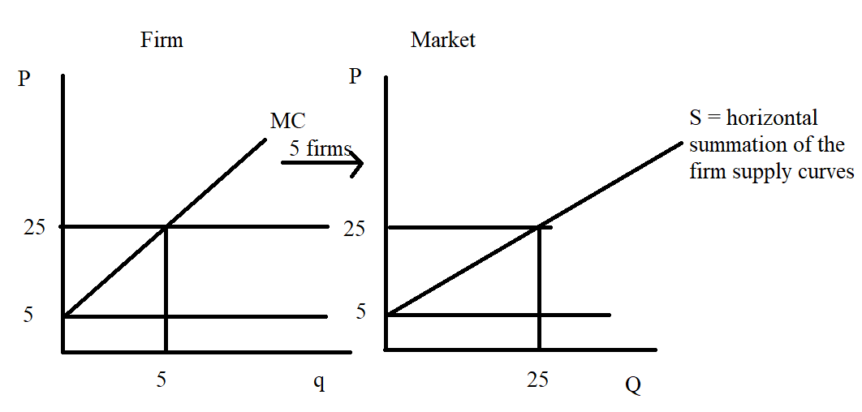
Once you have this graph, then it is really quite easy to write the equation for the market supply curve. (Note: that MC = 5 + 4q and that I chose to use q = 5 in order to get P = 25. You could use any q value you wished to then generate the price associated with that quantity.) We know that the market supply curve includes the two points (Q, P) = (0, 5) and (5, 25). Calculate the slope and then use the y-intercept to get: P = 5 + (4/5)Q as the equation for the market supply curve.

Alternatively, you can write the individual supply curve as:
4q = P – 5
q = (1/4)P – (5/4)
Since there are 5 firms that generate the market quantity, Q, and since we add the individual firm supply curves together horizontally to get the demand curve we can note that 10q = Q. Thus,
Q = 5q = 5[(1/4)P – (5/4)]
Q = (5/4)P -25/4
Or, P = (4/5)Q + 5

b. The equilibrium price and quantity in a perfectly competitive market is determined by the intersection of the demand and supply curves. We know that the market demand and market supply curves are:

Market Demand: P = 96 – (1/2)Q
Market Supply: P = (4/5)Q + 5

Set these two equations equal to one another:
96 – (1/2)Q = (4/5)Q + 5
91 = (13/10)Q
Q = 910/13
Q = 70 units of the good
P = 96 – (1/2)Q = 96 – (1/2)(70) = $61 per unit of the good
Or, P = (4/5)Q + 5 = (4/5)(70) + 5 = $61 per unit of the good

c. To find the quantity, q, that the representative firm will produce we need to remember that the firm is a price taking firm in perfect competition. Therefore, the firm will charge the price of $61 per unit for the good and the firm’s marginal revenue curve can be written as MR = 61. The firm will produce where MR = MC. Thus,
61 = 5 + 4q
56 = 4q
q = 14 units of the good
With each of the five firms producing 14 units of the good a total of (5)(14) = 70 units of the good will be produced.

d. To find the firm’s profit we need to calculate its total revenue (TR) and its total cost (TC).
Profit = TR – TC
TR = Pq = ($61 per unit)(14 units) = $854
TC = 2q² + 5q + 16 = 2(14)(14) + (5)(14) + 32 = $494
Profit for the firm = 854 - 494 = $360
Since short-run profit for the firm is greater than zero the model of perfect competition would predict that more firms would enter this market in the long run.

e. In the long-run each firm in a perfectly competitive market will earn zero economic profit. This implies that for each firm they produce that quantity where MC = ATC. So, we need to start by finding that quantity and then determining the price associated with that quantity.
MC = ATC
5 + 4q = 2q + 5 + (32/q)
2q = (32/q)
q² = 16
q = 4 units per firm in the market
In the long-run q = 4 for the firm. The price associated with quantity can be found by using the MC equation:
MC = 5 + 4q = 5 + (4)(4) = $21 per unit of the good
So, the long-run price in the market must by $21 per unit of the good in order for the firm to be producing that level of output where it will breakeven (earn zero economic profit). How much is demanded in the market if the market price is $26 per unit fo the good? Use the demand curve to find this quantity:
P = 96 – (1/2)Q
21 = 96 – (1/2)Q
(1/2)Q = 75
Q = 150 units of the good
Long-run equilibrium market quantity is Q = 150 units of the good.
Long-run equilibrium market price is P = $21 per unit of the good.

f. Number of firms in the market in the long-run = Q/q where Q is the long-run equilibrium market quantity and q is the long-run breakeven quantity for the representative firm. Thus:
Q/q = 150/4 = 37.5 firms in the market

g. Here are two ways to find the long-run market supply curve.

Method I: we know that the long-run market supply curve is going to have a y-intercept of 5 (see the explanation in (a) if this is not clear to you). So, P = 5 + mQ where m is the slope of the long-run market supply curve. We know that (Q, P) = (150, 21) is where the market demand curve intersects the market supply curve: this implies that this point lies on the market supply curve. Thus:
21 = 5 + m(150)
150m = 16
m = 16/150 = 8/75
So, the long-run market demand curve is: P = 5 + (8/75)Q

Method II: the individual firm supply curve is given by the MC equation. We can write this as:
P = 5 + 4q
Rearranging this equation into x-intercept form we have:
4q = P – 5
q = (1/4)P – (5/4)
The market Q being supplied in the long-run is the horizontal summation of the 37.5 firms’ MC curves or Q = 37.5q. Thus:
Q = 37.5(q) = 37.5[(1/4)P – (5/4)]
Q = (37.5/4)P – [(37.5)(5)/4]
Rearranging this (notice that I am not doing that math involved in the bracketed term) I get:
4Q = 37.5P – (37.5)(5)
37.5P = 4Q + (37.5)(5)
P = (4/37.5)Q + 5
Or,
P = (8/75)Q + 5
(Note: how nicely that messy term took care of itself!)

h. Here is the graph of just the market for this question.
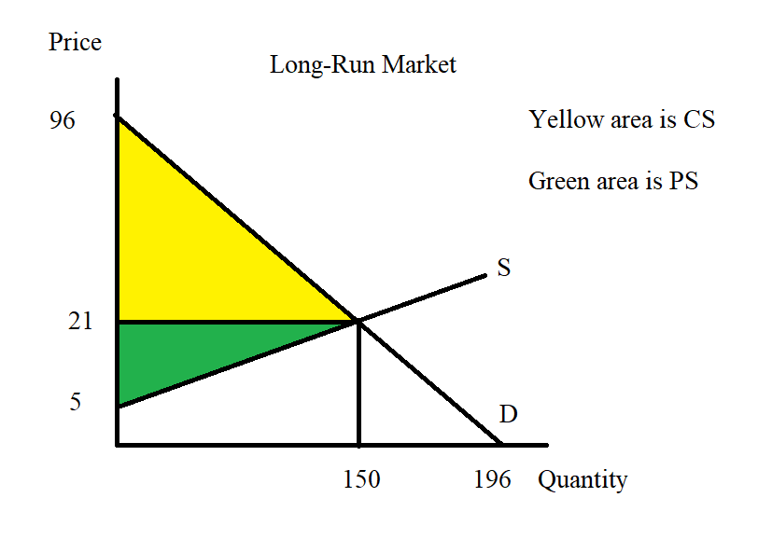

CS = (1/2)(96 – 21)(150) = $5625
PS = (1/2)(21 – 5)(150) = $1200
DWL = $0 (In a perfectly competitive market there is no deadweight loss.)

