Economics 390
Fall 2019
Homework #1 With Answers
Due on Thursday, October 3, 2019

Homework is due at the beginning of lecture. The professor reserves the right to not accept homework if it is late. The expectation is that the homework will be done in a professional manner: it should be stapled, it should be neat, well organized, and complete. You cannot receive full credit if you omit questions and do not follow the provided instructions. There is no need to submit the questions: you need to simply submit your answers. You will not be able to get full credit for the homework if you do not show your work in an organized, easy-to-follow manner. Make sure your name is clearly and legibly written on the homework. Illegible answers will not get full credit.

- In class we briefly discussed the idea of a free rider (we will return to this idea later in the semester). In a well-organized paragraph discuss an example of free riding from your own life experience. In your answer make sure you identify why your example illustrates this concept. Use complete sentences and standard English when writing your answer. Grammatically incorrect answers will result in a lower homework score.

Answer:
Answers here will vary but the key point is that the free rider can consume the good even though they have not paid for it. So, you can enjoy your clean apartment even if you do not help your roommate clean the apartment: if you do not help them, then you are a free rider. You can enjoy the Fourth of July fireworks show even if you do not make a contribution to help fund the event: if you do not make the contribution, then you are a free rider.

- We live in a world confronted with a large array of challenges. Identify one challenge in the world today that arises because of the existence of an externality that is not being corrected for by the market. Discuss what the challenge is, how it reflects the existence of an externality, the consequences of not addressing the externality and at least two possible solutions to the problem posed by the challenge you have selected. In your answer make sure you identify why your example illustrates this concept. Use complete sentences and standard English when writing your answer. Grammatically incorrect answers will result in a lower homework score.

Answer:
Answers here will vary but the key concept here is that an externality occurs when there is a benefit or a cost from consuming or producing the good that is not incorporated in the transaction. For instance, there is a societal benefit from individuals getting an education. Yet, most individuals decide how much education they will get based upon the private benefits they will receive from the education. The social benefit from the education is not included in the transaction: there is a positive externality that is not internalized by the market. When a producer produces their product and creates a pollution by-product that they fail to clean up, then that producer is creating a negative externality that reflects a cost that they are inflicting on society. Failure to include this cost of their production generates the negative externality. When there is a positive externality, the market will under produce the good; when there is a negative externality, the market will produce too much of the good.

Here are some simple solutions for negative externalities: regulation, taxes, moral codes and social sanctions, contracts that limit or prohibit behaviors.

Here are some simple solutions for positive externalities: regulation (for instance, mandatory education through age 16), subsidies, moral codes and social sanctions, contracts that mandate behaviors.

- For each of the following goods determine whether the good is rival or non-rival, and excludable or non-excludable. Fill in the provided table with your answer.

Good | Rival or Non-Rival? | Excludable or Non-excludable?
Street Lights
Sewer Service for an individual in a community
Grazing your sheep on public land in your community that is made available to anyone who would like to graze their sheep
Lighthouses
A loaf of bread from your local bakery
Commercial fishing in a nation’s fishing grounds
McDonald’s Hamburger
National Defense

Good | Rival or Non-Rival? | Excludable or Non-excludable?
Street Lights | Non-rival | Non-excludable
Sewer Service for an individual in a community | Non-Rival | Excludable
Grazing your sheep on public land in your community that is made available to anyone who would like to graze their sheep | Rival | Non-excludable
Lighthouses | Non-rival | Non-excludable
A loaf of bread from your local bakery | Rival | Excludable
Commercial fishing in a nation’s fishing grounds | Rival | Non-excludable
McDonald’s Hamburger | Rival | Excludable
National Defense | Non-rival | Non-excludable

- Suppose you are charged with determining the optimal amount of pollution for a community. You are told that the marginal social cost (MSC) of pollution for the community can be expressed as a linear relationship over the relevant quantities of pollution. You are also told that the marginal social benefit (MSB) of pollution (this is a measure of the marginal cost abatement cost: that is, getting rid of pollution is not free) for the community can be expressed as a linear relationship over the relevant quantities of pollution. Here is some other data you have available:
  - When there are 10 tons of pollution per day, the marginal social cost of this level of pollution is $2000 per day.
  - When there are 20 tons of pollution per day, the marginal social cost of this level of pollution is $3000 per day.
  - When all pollution per day is eliminated, the marginal social benefit of this level of pollution is $10,000 per day.
  - When there are 100 tons of pollution per day, the marginal social benefit of this level of pollution is $0 per day.

  - Given this information write an equation for the MSC for this community. For your equation use MSC as your y variable and the quantity of pollution (Q) as your x variable. Express your equation in slope-intercept form.

  - Given this information write an equation for the MSB for this community. For your equation use MSB as your y variable and the quantity of pollution (Q) as your x variable. Express your equation in slope-intercept form.

  - Given the equations you found in (a) and (b), determine the optimal amount of pollution for this community. Explain why the optimal amount of pollution is not likely to be zero tons of pollution.

Answer:
- We know two points on the MSC curve from the provided information: (Q, MSC) = (10, $2000) and (20, $3000). Use these two points to write the equation:
y = mx + b
MSC = mQ + b
m = slope of the MSC curve
m = (change in MSC)/(change in Q) = (2000 – 3000)/ (10 – 20) = (1000)/(10) = 100
MSC = 100Q + b
Use one of our known points to find the value for “b”:
2000 = (100)(10) + b
b = 1000
MSC = 100Q + 1000
- We know two points on the MSB curve from the provided information: (Q, MSB) = (0, $10,000) and (100, $0). Use these two points to write the equation:
y = mx + b
MSB = mQ + b
m = slope of the MSB curve
m = (change in MSB)/(change in Q) = (10,000 – 0)/ (0 – 100) = (10,000)/(-100) =
(-100)
MSB = (-100)Q + b
Use one of our known points to find the value for “b”:
10,000 = (-100)(0) + b
b = 10,000
MSB = (-100)Q + 10,000

- To find the optimal amount of pollution in this community set MSC = MSB:
100Q + 1000 = (-100)Q + 10,000
200Q = 9000
Q = 45 tons of pollution
The optimal amount of pollution for this community is not zero units of pollution: at very low levels of pollution, the marginal social cost to the community of that pollution is very low while the marginal social benefit from the pollution is quite high. It is extraordinarily expensive to eliminate 100% of the pollution in a community.

- Consider a perfectly competitive market that currently has ten identical firms serving the market. You are provided the following information:

Marginal Cost (MC) for each firm: MC = 10 + 4q
Total Cost (TC) for each firm: TC = 2q² + 10q + 32

Market Demand: P = 100 – (1/2)Q

where q is the quantity produced by a firm, Q is the market quantity, and P is the price per unit for the good.

- Given the above information and holding everything else constant, find the market supply curve. Explain how you found this curve. Write the market supply curve in y-intercept form. Assume that the market supply curve is linear.

- Given the market curve you found in (a) and the provided information, determine the short-run equilibrium quantity and price in this market. Show how you found your answer in a well-ordered, logical explanation.

- Given your answer in (b), now determine the quantity that a representative firm will produce in this market in the short-run. Make sure you show how you found your answer.

- Given your answers in (b) and (c), now determine the short-run profit that a representative firm will earn in this market in the short-run. Make sure you show how you found your answer. What do you predict will happen in the long run in this market?

- Assume that there are no changes to the market demand. From the provided information determine the long-run equilibrium quantity and price in this market. Remember that in the long-run all firms in the perfectly competitive market will earn zero economic profit. Make sure you show how you found your answer.

- How many firms will be in this market in the long-run? Explain how you found your answer.

- Given your answer in (f), find the long-run market supply curve. Assume that all firms are identical in this market and that the long-run market supply curve is linear. Write this equation in y-intercept form. Explain how you found your answer.

- Calculate the long-run values for consumer surplus (CS), producer surplus (PS), and deadweight loss (DWL) in this perfectly competitive market. Show your work. You might find it helpful and time-saving to provide a graph that illustrates this market in long-run equilibrium with these areas marked.

Answer:
- One can find the market supply curve by using a graph and reasoning or you can do it algebraically. I will provide both methods here.
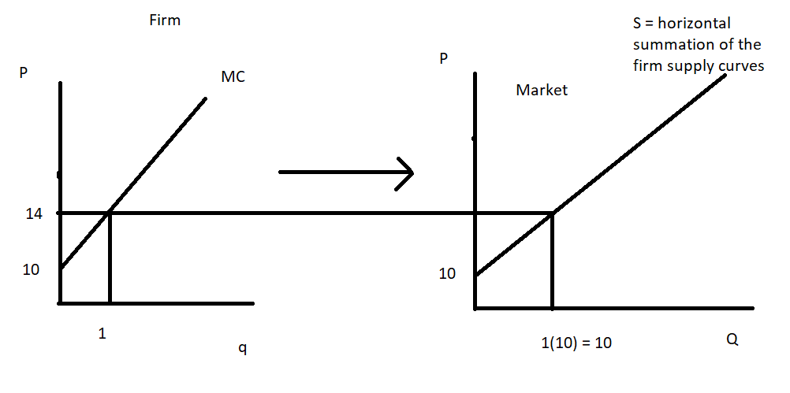
Once you have this graph, then it is really quite easy to write the equation for the market supply curve. (Note: that MC = 10 + 4q and that I chose to use q = 1 in order to get P = 14. You could use any q value you wished to then generate the price associated with that quantity.) We know that the market supply curve includes the two points (Q, P) = (0, 10) and (10, 14). Calculate the slope and then use the y-intercept to get: P = 10 + (2/5)Q as the equation for the market supply curve.

Alternatively, you can write the individual supply curve as:
4q = P – 10
q = (1/4)P – (5/2)
Since there are 10 firms that generate the market quantity, Q, and since we add the individual firm supply curves together horizontally to get the demand curve we can note that 10q = Q. Thus,
Q = 10q = 10[(1/4)P – (5/2)]
Q = (5/2)P -25
Or, P = (2/5)Q + 10

- The equilibrium price and quantity in a perfectly competitive market is determined by the intersection of the demand and supply curves. We know that the market demand and market supply curves are:

Market Demand: P = 100 – (1/2)Q
Market Supply: P = (2/5)Q + 10

Set these two equations equal to one another:
100 – (1/2)Q = (2/5)Q + 10
1000 – 5Q = 4Q + 100
900 = 9Q
Q = 100 units of the good
P = 100 – (1/2)Q = 100 – (1/2)(100) = $50 per unit of the good
Or, P = (2/5)Q + 10 = (2/5)(100) + 10 = $50 per unit of the good

- To find the quantity, q, that the representative firm will produce we need to remember that the firm is a price taking firm in perfect competition. Therefore, the firm will charge the price of $50 per unit for the good and the firm’s marginal revenue curve can be written as MR = 50. The firm will produce where MR = MC. Thus,
50 = 10 + 4q
40 = 4q
q = 10 units of the good
With each of the ten firms producing 10 units of the good a total of (10)(10) = 100 units of the good will be produced.

- To find the firm’s profit we need to calculate its total revenue (TR) and its total cost (TC).
Profit = TR – TC
TR = Pq = ($50 per unit)(10 units) = $500
TC = 2q² + 10q + 32 = 2(10)(10) + (10)(10) + 32 = $332
Profit for the firm = 500 – 332 = $168
Since short-run profit for the firm is greater than zero the model of perfect competition would predict that more firms would enter this market in the long run.

- In the long-run each firm in a perfectly competitive market will earn zero economic profit. This implies that for each firm they produce that quantity where MC = ATC. So, we need to start by finding that quantity and then determining the price associated with that quantity.
MC = ATC
10 + 4q = 2q + 10 + (32/q)
2q = (32/q)
q² = 16
q = 4 units per firm in the market
In the long-run q = 4 for the firm. The price associated with quantity can be found by using the MC equation:
MC = 10 + 4q = 10 + (4)(4) = $26 per unit of the good
So, the long-run price in the market must by $26 per unit of the good in order for the firm to be producing that level of output where it will breakeven (earn zero economic profit). How much is demanded in the market if the market price is $26 per unit fo the good? Use the demand curve to find this quantity:
P = 100 – (1/2)Q
26 = 100 – (1/2)Q
(1/2)Q = 74
Q = 148 units of the good
Long-run equilibrium market quantity is Q = 148 units of the good.
Long-run equilibrium market price is P = $26 per unit of the good.

- Number of firms in the market in the long-run = Q/q where Q is the long-run equilibrium market quantity and q is the long-run breakeven quantity for the representative firm. Thus:
Q/q = 148/4 = 37 firms in the market

- Here are two ways to find the long-run market supply curve.

Method I: we know that the long-run market supply curve is going to have a y-intercept of 10 (see the explanation in (a) if this is not clear to you). So, P = 10 + mQ where m is the slope of the long-run market supply curve. We know that (Q, P) = (148, 26) is where the market demand curve intersects the market supply curve: this implies that this point lies on the market supply curve. Thus:
26 = 10 + m(148)
148m = 16
m = 16/148 = 8/74 = 4/37
So, the long-run market demand curve is: P = 10 + (4/37)Q

Method II: the individual firm supply curve is given by the MC equation. We can write this as:
P = 10 + 4q
Rearranging this equation into x-intercept form we have:
4q = P – 10
q = (1/4)P – (5/2)
The market Q being supplied in the long-run is the horizontal summation of the 37 firms’ MC curves or Q = 37q. Thus:
Q = 37(q) = 37[(1/4)P – (5/2)]
Q = (37/4)P – [(37)(5)/2]
Rearranging this (notice that I am not doing that math involved in the bracketed term) I get:
(37/4)P = Q + [(37)(5)/2]
Or,
P = (4/37){Q + [(37)(5)/2]}
P = (4/37)Q + 10
(Note: how nicely that messy term took care of itself!)

- Here is the graph of just the market for this question.
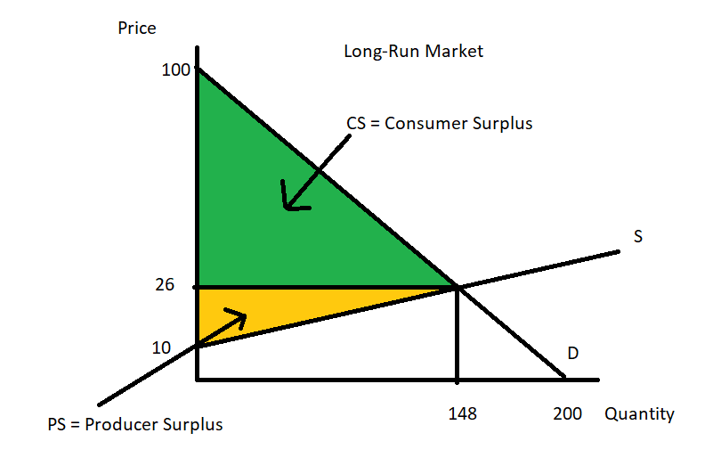

CS = (1/2)(100 – 26)(148) = $5476
PS = (1/2)(26 – 10)(148) = $1184
DWL = $0 (In a perfectly competitive market there is no deadweight loss.)

- Consider a monopoly that knows that the market demand for its product is given by the following equation where P is the price per unit and Q is the number of units of the good:

Market Demand: P = 200 – 2Q

Furthermore, the monopolist knows that its marginal cost curve (MC) is given by the equation:

MC = 50 + Q

  - Given this information determine the profit maximizing quantity, Q, for this firm if it acts as a single price monopolist. Then determine the monopolist’s price, P, for the good. Finally calculate the value of consumer surplus (CSmonopoly) for the monopoly, the value of producer surplus (PSmonopoly), and the value of the deadweight loss (DWLmonopoly) for the monopoly. Make sure you indicate how you found your answers to each of these values. You may find it very helpful to draw a graph of this monopolist in order to guide your work.

  - Suppose that instead of acting as a single price monopolist, this monopoly produced the perfectly competitive quantity of the good and charge the price that would be charged if this market were a perfectly competitive market. That is, suppose this firm produces where demand equals supply. What is the equilibrium quantity under this assumption (Qperfectcompetition) and the equilibrium price under this assumption (Pperfectcompetition). Calculate the values for CSperfectcompetition, PSperfectcompetition, and DWLperfectcompetition. Make sure you indicate how you found your answers to each of these values. You might find it helpful to draw a graph of this monopolist acting as if this were a perfectly competitive market.

  - Suppose this monopolist has the information and market power that allows the monopolist to practice first degree price discrimination (that is, perfect price discrimination, ppd). How many units of the good, Qppd, will the monopolist sell if the monopolist is a perfect price discriminator? What range of prices will the monopolist charge? Calculate the values of CSppd, PSppd, and DWLppd. Show how you found your answers.

  - Suppose this monopolist decides to practice second degree price discrimination (2pd). The monopolist decides it will charge three different prices: $180, $140, and $120 per unit of the good. How many units of the good can the monopolist sell at each of these prices when the monopolist practices second degree price discrimination. Show how you calculated these quantities. Then calculate CS2pd, PSppd, and DWLppd. You might find it helpful to draw a graph to guide your work.

Answer:
a. The single price monopolist profit maximizes by producing that quantity where MR = MC and then charging the price on its demand curve associated with this quantity. To get the monopolist’s marginal revenue curve we need to double the slope of the demand curve and keep the same y-intercept:
Demand Curve: P = 200 – 2Q
MR = 200 – 4Q
Setting MR = MC:
200 – 4Q = 50 + Q
150 = 5Q
Qmonopoly = 30 units of the good
Pmonopoly = 200 – 2Q = 200 – 2(30) = $140 per unit of the good

CSmonopoly = (1/2)(200 – 140)(30) = $900
PSmonopoly = (140 – 80)(30) + (1/2)(80 – 50)(30) = $2250
DWLmonopoly = (1/2)(140 – 80)(50 – 30) = $600

Here’s a graph of this single price monopolist:
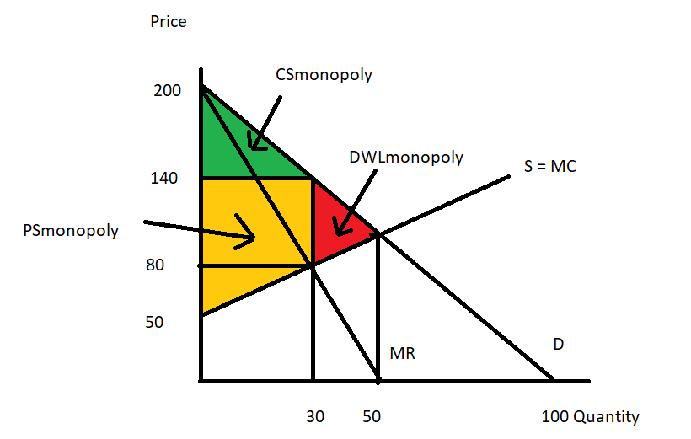
b. Setting demand equal to supply we get:
200 – 2Q = 50 + Q
150 = 3Q
Qperfectcompetition = 50 units of the good
Pperfectcompetition = 200 – 2Q = 200 – 2(50) = $100 per unit of the good
CSperfectcompetition = (1/2)(200 – 100)(50) = $2500
PSperfectcompetition = (1/2)(100 – 50)(50) = $1250
DWLperfectcompetiton = $0

Here’s a graph to illustrate this situation:
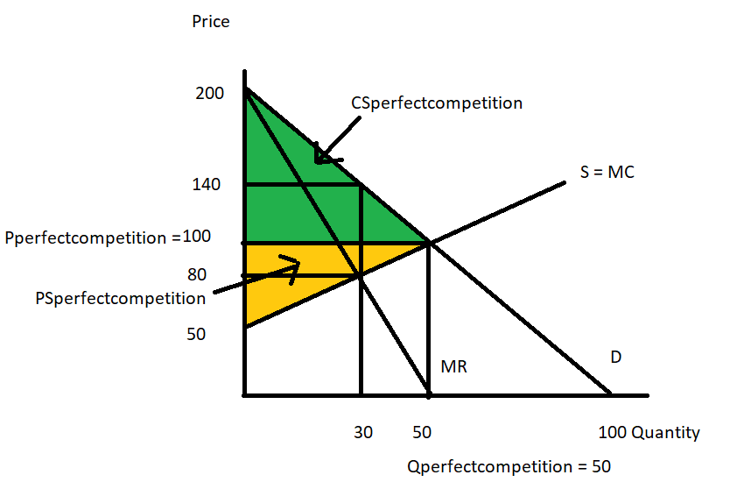
c. If the monopolist acts as a perfect price discriminator (ppd) then the monopoly will charge each consumer the maximum price that consumer is willing to pay for the good. The monopolist’s demand curve thus becomes the firm’s marginal revenue curve since with each additional unit sold the monopolist’s revenue increases by the amount of the new price. The firm will profit maximize by producing where this new MR = MC. Thus:
200 – 2Q = 50 + Q
Q = 50 units of the good
The monopolist will charge prices in the range of $100 per unit up to $200 per unit.
CSppd = $0 since the perfect price discriminating monopolist captures all of the consumers’ surplus
PSppd = $3750
DWLppd = $0 since the socially optimal amount of the good is produced

d. Given the demand curve we know that at a price of $180 per unit, the monopolist can sell a total of 10 units of the good. At a price of $140 per unit, the monopolist can sell a total of 30 units of the good: 10 units at the price of $180 per unit and an additional 20 units at a price of $140 per unit. At a price of $120 per unit, the monopolist can sell a total of 40 units of the good: 10 units at the price of $180 per unit, 20 additional units at a price of $140 per unit, and 10 more additional units at a price of $120 per unit.

CS2pd = (1/2)(200 – 180)(10) + (1/2)(180 – 140)(30 -10) + (1/2)(140 – 120)(40 – 30) = $600
PS2pd = (180 - 100)(10) + (140 - 100)(20) + (120 - 100)(10) + (100 - 90)(40) + (1/2)(90 - 50)(40) = $3000
DWL2pd = (1/2)(120 – 90)(50 – 40) = $150

Here’s a graph to illustrate this situation:
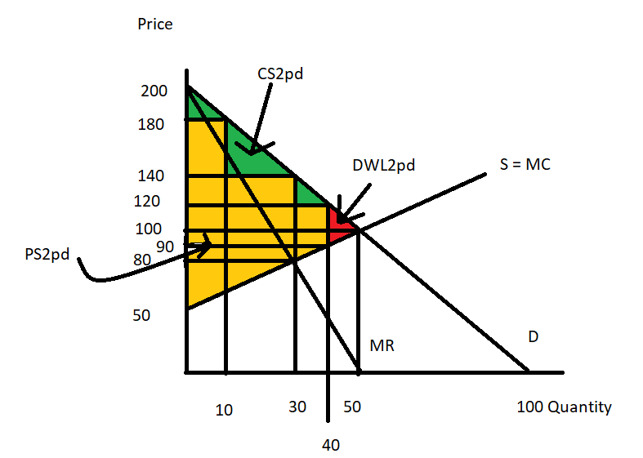

- Consider a monopoly that knows that it sells its product to two different classes of buyers. The monopolist knows the following:

Demand for Class One: P = 20 – Q₁
Demand for Class Two: P = 10 – (1/2)Q₂
Marginal Cost of producing the good: MC = (3/11)Q
Fixed Cost of producing the good: FC = $10

Initially the firm has no way of determining whether a buyer is in Class One or Class Two. This is a long problem and the numbers are not going to be “nice”: on this problem feel free to use a calculator and to round to two places past the decimal for any answer you are calculating.

a. Suppose that this monopolist acts as a single price monopolist. Calculate the following based upon this assumption. Make sure you show how you found your answers!

Quantity the firm will choose to produce = _________________
Price the firm will choose to charge = ___________________
Total Revenue for the firm = ________________________
Total Cost for the firm = _________________________
Profit for the firm = ____________________________

Note: to fully answer this question you will need to investigate two different (Q, P) possibilities to determine which possibility yields the higher profit for the firm. A complete answer would provide both sets of numbers and then make the argument as to which (Q, P) the firm will select if they want to profit maximize as a single price monopolist.

b. Now, suppose that the monopolist can readily distinguish between buyers in Class One and buyers in Class Two. The monopolist decides that they will practice third degree price discrimination (3pd). Given the above information determine the following. Make sure you show how you found your answers!

Quantity the firm will sell to Class One = ________________________
Price that Class One will pay = ___________________________
Quantity the firm will sell to Class Two = _______________________
Price that Class Two will pay = _____________________________
Total Revenue with third degree price discrimination = ___________________
Total Cost with third degree price discrimination = _________________
Profit for the firm with third degree price discrimination = _________________

Answer:
a. The single price monopolist will need to start by finding their market demand curve. This will be a demand curve with two segments that share a “kink point” in common. At prices that are equal to or greater than $10 per unit only Class One is willing to buy the good: the demand curve for this price range is P = 20 – Q. For prices that are less than or equal to $10 per unit, both groups of consumers are willing to buy the good, so we will need to add the two demand curves for the two classes together horizontally. When we do this we get the equation for the lower segment of the market demand curve (for prices less than or equal to $10 per unit) to be: P = 40/3 – (1/3)Q. Here’s an image to illustrate what is happening here.
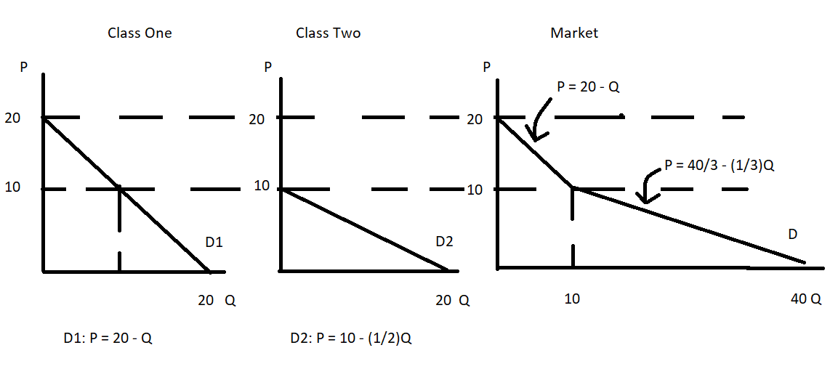

The single price monopolist determines its profit maximizing quantity by setting MR equal to MC. For this monopolist with its piecewise demand curve there are two demand equations and therefore two MR equations. We will need to check out the profitability of both MR curves to determine which option is the better option for this single price monopolist. We will also need to verify that the price and quantity are in the appropriate range for each demand curve segment.

For the top segment:
D: P = 20 – Q
MR: MR = 20 – 2Q
MC: MC = (3/11)Q
MR = MC
20 – 2Q = (3/11)Q
220 – 22 Q = 3Q
220 = 25Q
Q = 8.8 units of the good
Note: this level of output is within the domain for the acceptable quantities of the good for the top segment of the market demand curve.
P = 20 – Q = 20 – 8.8 = $11.20 per unit of the good
Note: this price is within the range for the acceptable prices for the good for the top segment of the market demand curve.
TR = P*Q = (11.20)(8.8) = $98.56
TC = (3/22)(8.8)(8.8) + 10 = $20.56
Profit for the firm if it produces (Q, P) = (8.8, $11.20) = TR – TC = $78

For the lower segment:
D: P = 40/3 – (1/3)Q
MR: MR = 40/3 – (2/3)Q
MC: MC = (3/11)Q
MR = MC
40/3 – (2/3)Q = (3/11)Q
440 – 22Q = 9Q
440 = 31Q
Q = 440/31 = 14.19 units of the good (note: having the improper fraction is a good idea since I will be using this fraction to do a lot of calculations as I continue with the problem)
Note: this level of output is within the domain for the acceptable quantities of the good for the lower segment of the market demand curve.
P = 40/3 – (1/3)Q = 40/3 – (1/3)(440/31) = 800/93 = $8.60 approximately per unit of the good
Note: this price is within the range for the acceptable prices for the good for the lower segment of the market demand curve.
TR = P*Q = (8.6)(14.19) = $122.03 approximately
TC = (3/22)(14.19)(14.19) + 10 = $37.46 approximately
Profit for the firm if it produces (Q, P) = (14.19, $8,60) = TR – TC = $84.57

Here’s a graph to illustrate what we have done:
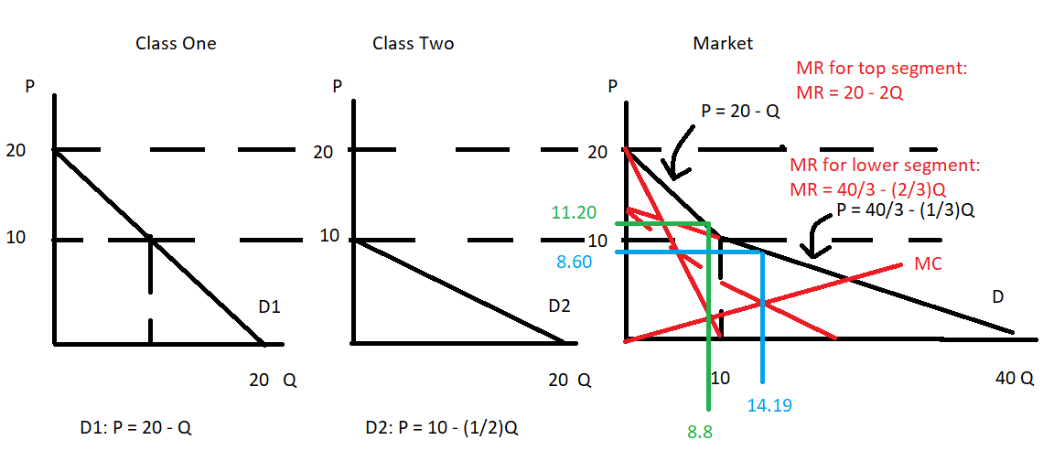
The green shows the profit maximizing quantity and price for the top segment of the demand curve; the blue shows the profit maximizing quantity and price for the lower segment of the demand curve.

To recap:
 | Single Price Monopolist Choosing to Produce on Top Segment of Demand Curve (not optimal!) | Single Price Monopolist Choosing to Produce on Lower Segment of Demand Curve (optimal!)
Quantity the firm will choose to produce | 8.8 units of the good | 14.19 units of the good
Price the firm will choose to charge | $11.20 per unit of the good | $8.60 per unit of the good
Total Revenue for the firm | $98.56 | $122.10
Total Cost for the firm | $20.56 | $13.87
Profit for the firm | $78 | $108.22

b. Thankfully we have already done significant work on this part of the problem. The monopolist knows that the profit maximizing quantity is always going to be that quantity where the MR from the last unit is equal to the MC from the last unit. And, we have calculated that quantity in (a)! The profit maximizing quantity for the monopolist is going to be Q = approximately 14.19 units of the good.

We need to know the MC of producing this last bit of the good (the 14.19th unit of the good). We can easily get that:
MC = (3/11)(440/31) = 3.87

We want the MC for the last unit sold to Class One to equal $3.87 and we want the MC for the last unit sold to Class Two to also equal $3.87.

Let’s do this calculation in two columns: one column for Class One and one for Class Two:

Class One:  MC = 3.87  MR = 20 – 2Q  20 – 2Q = 3.87  2Q = 16.13  Q for Class One is 8.07 approximately  P for Class One = 20 – Q  P for Class One = 20 – 8.07 = $11.94 per unit  TR for Class One = (11.94)(8.07) = $96.36 | Class Two:  MC = 3.87  MR = 10 – Q  10 – Q = 3.87  Q for Class Two is 6.13 approximately  Note: adding the quantitities for the two classes together gives us 8.07 + 6.13 = 14.20 which is basically the 14.19 we found in (a). The difference is just due to rounding error.  P for Class Two = 10 – (1/2)Q  P for Class Two = 10 – (1/2)(6.13) = $6.94 per unit  TR for Class Two = (6.94)(6.13) = $42.54

Now we need to do a bit more work to figure out the Total Cost as well as the Profit with third degree price discrimination.

Total Cost = Variable Cost for Class One + Variable Cost for Class Two + Fixed Cost
Note: you don’t want to include the fixed cost twice in this example!
TC = (3/22)Q*Q + FC = (3/22)(14.19)(14.19) + 10 = $37.46
TR = Total Revenue for Class One + Total Revenue for Class Two = 96.36 + 42.54 = $138.90
Profit with Third Degree Price Discrimination = TR – TC = 138.90 – 37.46 = $101.44

This firm will earn more if it practices third degree price discrimination than if it acts as a single price monopolist.

Here’s the recap of the answers:

Quantity the firm will sell to Class One | 8.07 units of the good
Price that Class One will pay | $11.94 per unit of the good
Quantity the firm will sell to Class Two | 6.13 units of the good
Price that Class Two will pay | $6.94 per unit of the good
Total Revenue with third degree price discrimination | $138.90
Total Cost with third degree price discrimination | $37.46
Profit for the firm with third degree price discrimination | $101.44

Here’s a final graph to illustrate this:
