Economics 302 Name ______________________________
Fall 2009* TA Name ___________________________
Answers to Quiz #1 Section Number or Time________________

Answer the following questions based upon the following production function for the aggregate economy:

Y = F(K, L) = A K^{0.6}L^{0.4}

Where Y is aggregate output, A is a measure of available technology, K is capital, and L is labor.

1. In the space below draw a sketch of the above production function with output, Y, on the vertical axis, and L on the horizontal axis.

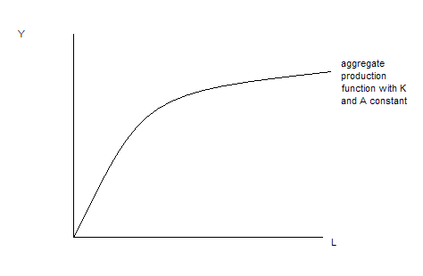

2. Suppose you quadruple labor and capital at the same time. Holding technology constant, what happens to output, Y, given this aggregate production function?

Since this aggregate production function exhibits constant returns to scale, output will quadruple when all the inputs are quadrupled.

3. Given the above aggregate production function, write an equation for the marginal product of labor, MPL, as a function of A, K and L.

MPL = 0.4A(K/L)^{0.6}

4. Holding everything else constant, what happens to the MPL for the above aggregate production function when L decreases?

When L decreases this means that the denominator gets smaller and therefore, holding everything else constant, the MPL gets larger. This implies that the slope of the aggregate production function is steeper at this lower level of labor usage.

5. Given the above aggregate production function and holding everything else constant, what happens to output per unit of labor, Y/L, when L increases?

As labor increases, the output to labor ratio will decrease since we can define Y/L as equal to A(K/L)^{0.6} and thus, if L increases the denominator of the K/L ratio is getting bigger and hence the whole term is getting smaller. This idea can be represented in the graph of the aggregate production function by considering two different levels of labor usage and the associated point on the aggregate production function for each of these levels of labor. The slope of the ray drawn from the origin to the relevant point on the aggregate production function represents the output to labor ratio and this slope decreases as the level of labor usage increases holding everything else constant.

6. Given the above aggregate production function, suppose capital decreases while labor and technology are held constant. At this initial level of labor, what happens to the MPL when capital decreases?

The MPL decreases.

7. Suppose you are told that aggregate output, Y, is equal to 100 for the economy depicted by the above aggregate production function. What is labor’s share of this output?

Labor will receive .4Y as its share or, in this case, 40.

Answer the last three questions based on the following information about an economy’s CPI. Also, please recall that the relationship between a real value, a nominal value and a price index can be given as

Real Value = [Nominal Value/(Inflation Index)]*(Scale Factor)

Year | CPI with Base Year equal to 2000 | Nominal Income | Real Income
2000 |  | 100
2004 | 150 | 200
2008 | 200 |  | 400

8. True or False? The inflation rate between 2000 and 2004 is equal to the inflation rate between 2004 and 2008. Circle your answer:

- True
- False

9. From the above table and calculations decide which of the following statements is true. Circle your answer.

- Between 2004 and 2008, the growth rate of nominal income was less than the rate of inflation during this same period of time.
- Between 2004 and 2008, the growth rate of nominal income was greater than the rate of inflation during this same period of time.

10. Between 2000 and 2008, the growth rate of real income was equal to ___________. Show your work in the space below to get credit for your answer.

The growth rate of real income from 2000 to 2008 = [(400- 100)/(100)]*100 = 300%

