Economics 302 Name ______________________________
Fall 2009 TA Name ___________________________
Answers to Quiz #1 Section Number or Time________________

Answer the following questions based upon the following production function for the aggregate economy:

Y = F(K, L) = A K^{0.4}L^{0.6}

Where Y is aggregate output, A is a measure of available technology, K is capital, and L is labor.

1. In the space below draw a sketch of the above production function with output, Y, on the vertical axis, and L on the horizontal axis.

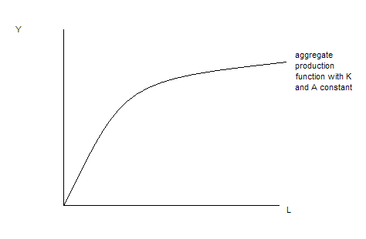

2. Suppose you triple labor and capital at the same time. Holding technology constant, what happens to output, Y, given this aggregate production function?

Since this aggregate production function exhibits constant returns to scale, output will triple when all the inputs are tripled.

3. Given the above aggregate production function, write an equation for the marginal product of labor, MPL, as a function of A, K and L.

MPL = 0.6A(K/L)^{0.4}

4. Holding everything else constant, what happens to the MPL for the above aggregate production function when L increases?

When L increases this means that the denominator gets larger and therefore, holding everything else constant, the MPL gets smaller. This implies that the slope of the aggregate production function is flatter at this higher level of labor usage.

5. Given the above aggregate production function and holding everything else constant, what happens to output per unit of labor, Y/L, when L decreases?

As labor decreases, the output to labor ratio will increase since we can define Y/L as equal to A(K/L)^{0.4} and thus, if L decreases the denominator of the K/L ratio is getting smaller and hence the whole term is getting larger. This idea can be represented in the graph of the aggregate production function by considering two different levels of labor usage and the associated point on the aggregate production function for each of these levels of labor. The slope of the ray drawn from the origin to the relevant point on the aggregate production function represents the output to labor ration and this slope increases as the level of labor usage decreases holding everything else constant.

6. Given the above aggregate production function, suppose capital increases while labor and technology are held constant. At this initial level of labor, what happens to the MPL when capital increases?

The MPL increases.

7. Suppose you are told that aggregate output, Y, is equal to 100 for the economy depicted by the above aggregate production function. What is labor’s share of this output?

Labor will receive .6Y as its share or, in this case, 60.

Answer the last three questions based on the following information about an economy’s CPI. Also, please recall that the relationship between a real value, a nominal value and a price index can be given as

Real Value = [Nominal Value/(Inflation Index)]*(Scale Factor)

Year | CPI with Base Year equal to 2000 | Nominal Income | Real Income
2000 |  | 100
2004 | 150 | 200
2008 | 200 |  | 400

8. True or False? The inflation rate between 2000 and 2004 is equal to the inflation rate between 2004 and 2008. Circle your answer:

- True
- False

9. From the above table and calculations decide which of the following statements is true. Circle your answer.

- Between 2004 and 2008, the growth rate of nominal income was greater than the rate of inflation during this same period of time.
- Between 2004 and 2008, the growth rate of nominal income was less than the rate of inflation during this same period of time.

10. Between 2000 and 2008, the growth rate of real income was equal to ___________. Show your work in the space below to get credit for your answer.

The growth rate of real income from 2000 to 2008 = [(400 – 100)/(100)]*100 = 300%

