Economics 111 Name _________________________________
Fall 2021
Second Midterm

Code of Conduct:
On this exam I understand that I may not get help from another human being and I may not provide help to another human being. Doing either of these things will be considered academic misconduct and may be punishable up to and including receiving a zero on this midterm. In the case of extreme academic misconduct, expulsion from the University is possible.
I may NOT use my notes, my textbook, and a calculator on this exam.
I agree and understand these exam expectations.

Signature _________________________

I. Binary Choice Questions: 10 questions worth 2 points each

1. If the average total cost for some firm is increasing as the level of its output increases, then its marginal cost is increasing as output increases.

a. True
b. False

2. A perfectly competitive firm in the long run will:

a. Produce that quantity where average total cost is less than price and where the firm will find its marginal revenue from selling the last unit is equal to its marginal cost of producing the last unit.
b. Produce that quantity where price equals marginal cost and where average total cost is minimized.

3. Consider an industry where all the potential firms in the industry are identical and where a firm's total cost curve is given by the following equation where Q is the number of units of the good:
Total Cost for the firm: TC = 10(Q*Q) + 20Q + 100
Suppose that in this industry a total of 100 units of the good are needed. If one firm produces this entire quantity, the average total cost of production for this firm is equal to _____; and if five firms produce this entire quantity (so each firm produces 1/5 of the total amount), then the average total cost of production for one of these firms is equal to ______.
a. $1021; $204.20
b. $1021; $225

4. Which of the following situations is an example of 2nd-degree price discrimination?

a. Movie theaters offer different prices for seniors and students.
b. The Walmart Company creates Sam’s Club to serve those consumers who are willing to purchase larger quantities of the good provided the good is sold at a lower price.

5. A monopolistically competitive market differs from a competitive market because in a monopolistically competitive market:

a. The goods sold by each firm are not identical.
b. There is no free entry and exit of firms.

6. The city of Orangeburg is installing streetlights. The government of Orangeburg has asked residents to voluntarily contribute to a "Streetlight Fund" so that they can install more streetlights. This collection effort is likely to fail since:

a. The responsibility to install streetlights is a government responsibility and not a citizen responsibility.
b. Streetlights are a public good.

7. For a natural monopoly, over the relevant range of output, as the level of output increases:

a. The price the natural monopoly can charge for its product is less than its average total cost of producing its product.
b. The average total cost of producing that output decreases.

WORKSHEET: DO NOT REMOVE FROM EXAM!

8. Consider the demand for ice cream cones and the demand for fireworks in a community. Suppose there are only two residents in the community, Bob and Stan. To find the market demand for ice cream cones in this community:

a. One should horizontally sum Bob and Stan's individual demand curves for ice cream cones and to find the market demand curve for fireworks one should vertically sum Bob and Stan's individual demand curves for fireworks.
b. One should vertically sum Bob and Stan's individual demand curves for ice cream cones and to find the market demand curve for fireworks one should horizontally sum Bob and Stan's individual demand curves for fireworks.

9. The socially optimal amount of the good will be produced:

a. In a perfectly competitive market, by the perfect price discriminator, and by the natural monopoly that is regulated with marginal cost regulation.
b. In the perfectly competitive market, and by the natural monopoly that faces average cost regulation.

10. In a perfectly competitive market:
a. Individual firms make zero economic profit in the long run.
b. The demand curve that any individual firm faces is perfectly elastic and the market demand is also perfectly elastic.

II. Multiple Choice Questions: 20 Questions worth 4 points each

11. Which of the following statements is true?
a. At a given level of output if you know that the average total cost is greater than the marginal cost, then it must be the case that the average total cost is increasing as output increases.
b. If a firm is operating under increasing returns to scale, this implies that the average total cost is increasing as output increases.
c. Suppose there are 99 factors of production used in the production of good X. Firms that produce good X are considered to be operating in the long run if they can freely adjust 98 of these factors of production.
d. In a perfectly competitive market, each firm produces the profit maximizing level of output where marginal cost is equal to market price.

12. A firm decides to triple its hiring of all its inputs. This firm is a small firm and its hiring decisions do not impact the price of the inputs that it hires. The firm initially produced 125 chairs and after it alters its hiring of inputs the firm finds that it can now produce 500 chairs. Given this information and holding everything else constant, which of the following statements is true? Assume this is a constant cost industry.
I. This firm has decreasing costs over the relevant range of production as output increases.
II. This firm's total costs increase but by an amount that is less than three times its original total cost level.
III. This firm finds that it is not beneficial to increase the size of its factory.
IV. Since this firm experiences decreasing costs of production as output increases, this firm experiences decreasing returns to scale.
a. Statements I and II are true.
b. Statements I and IV are true.
c. Only Statement I is true.
d. Statements III and IV are true.

WORKSHEET: DO NOT REMOVE FROM THE EXAM!

Use the following information to answer the next three (3) questions.
Sweettown is a city with many coffeeshops. Each of the coffeeshops has identical cost functions and they are given by the following equations where P is the price per cup of coffee and q is the number of cups of coffee:
Total cost curve for each firm: TC = (0.2)(q²) + 20
Marginal cost curve for each firm: MC = 0.4q
Let Q be the market quantity of coffee measured in cups of coffee. The market demand curve is given by the following equation:
Market Demand Curve: P = 124 - 2Q
There are initially 10 identical coffeeshops in Sweettown. Assume that the coffeeshops are operating as perfectly competitive firms in this industry.
13. Given this information and holding everything else constant, at what price will average total cost equal marginal cost?
a. $4 per cup of coffee
b. $3 per cup of coffee
c. $2 per cup of coffee
d. $1 per cup of coffee

14. Note: You may encounter an “ugly number” as you work through this problem. Given this information and holding everything else constant, which of the following statements is true about this market in the short run?
a. Firms will earn zero economic profits in the short run.
b. Firms may earn negative, positive or zero economic profits in the short run.
c. Firms will earn positive economic profit in the short run.
d. Firms will earn negative economic profits in the short run.

15. Given this information and holding everything else constant, how many firms will enter or exit from this industry in the long run? Assume there are no changes to the market demand curve.
a. 4 firms will enter the coffee shop market
b. 6 firms will exit the coffee shop market
c. 6 firms will enter the coffee shop market
d. 4 firms will exit the coffee shop market
WORKSHEET: DO NOT REMOVE FROM EXAM!

KEEP GOING! EXAM HAS 30 QUESTIONS!
16. Which of the following statements is true when the market structure is a monopoly?
a. There are many buyers and sellers in this market.
b. Each firm in the market always earns positive economic profit.
c. The products sold in this market by different firms are indistinguishable.
d. There are barriers to entry in this market.
17. A profit-maximizing monopolist produces a positive quantity Q* > 0. At Q* the monopolist also finds that the following conditions occur:
ATC > P for this monopolist
P > AVC for this monopolist
AVC > MR for this monopolist
MR = MC for this monopolist
Given this information, this monopolist should in the short run. Assuming that there are no changes to the above information, this monopolist will in the long run.
a. shut down and suffer losses that are equal to their total fixed cost of production; exit the industry
b. produce at Q* and earn positive economic profit; continue to produce at Q*
c. produce at Q* and suffer losses that are less than their total fixed cost of production; exit the industry
d. shut down and earn zero economic profit; exit the industry

WORKSHEET: DO NOT REMOVE FROM EXAM!

KEEP GOING! EXAM HAS 30 QUESTIONS!
18. A monopolist faces two groups of consumers. The demand for each group is given below:
Group 1: P = 20 - Q
Group 2: P = 16 - Q
The monopolist's marginal cost is: MC = Q
Suppose this monopolist cannot distinguish whether a buyer is a group 1 buyer or a group 2 buyer, but he does know the maximum each buyer is willing to pay for the good. Suppose this monopolist practices first degree or perfect price discrimination. How many units will the monopolist sell if he practices perfect price discrimination?
a. 36 units
b. 10 units
c. 12 units
d. 18 units

19. A monopolist faces two groups of consumers. The demand for each group is given below:
Group 1: P = 20 - Q
Group 2: P = 16 - Q
The monopolist's marginal cost is: MC = Q
Assume the monopolist can separate each consumer of this product into the relevant group and then charge a different price for the good to the people in each group. How many units of the good will the monopolist sell to each consumer group?
a. 4 units for Group 1 and 8 units for Group 2
b. 10 units for Group 1 and 2 units for Group 2
c. 5.5 units for Group 1 and 3.5 units for Group 2
d. 5 units for Group 1 and 4 units for Group2

20. Consider a monopoly that can be described by the following equations:
Market Demand for the monopoly: P = 200 - 2Q
Marginal Cost for the monopoly: MC = 20 + Q
Total Cost for the monopoly: TC = 10 + 10Q + (1/2)(Q)(Q)
This firm is debating whether it will be a single price monopolist or whether it will practice second degree price discrimination. If the monopoly practices second degree price discrimination it will sell the first 18 units of its output for $164 per unit and it will sell an additional 18 units of its output for $128. If the firm acts as a single price monopolist, its' profits will equal ____ and if the firm acts as the described second degree price discriminator its' profits will equal _____.
a. $1790; $1985
b. $2390; $2866
c. $2390; $4238
d. $3590; $4238

21. Suppose Scalar, Inc. and Positives, Ltd. are the only two firms in the market for a new type of widget. Consider the following payoff matrix for Scalar, Inc. and Positive, Ltd. The first number in each sell represent Scalar, Inc.'s utility, while the second number in each cell represents Positives, Ltd.'s utility.
 | Positives, Ltd. pursues strategy of  INVEST | Positives, Ltd. pursues strategy of  DON'T INVEST
Scalar, Inc. pursues strategy of  INVEST | X, 60 | 120, Y
Scalar, Inc. pursues strategy of  DON'T INVEST | 20, 80 | 100, 140
What can we say about the values of X and Y if we know that Scalar, Inc.'s dominant strategy is to invest and Positives, Ltd.'s dominant strategy is to not invest?
a. X < 20; Y < 120
b. X > 20; Y > 60
c. X > 120; Y < 60
d. X > 120; Y > 140

22. The following figure illustrates the cost structure (ATC, AVC, and MC) of a monopolist facing the market demand curve, D, and the marginal revenue curve, MR.
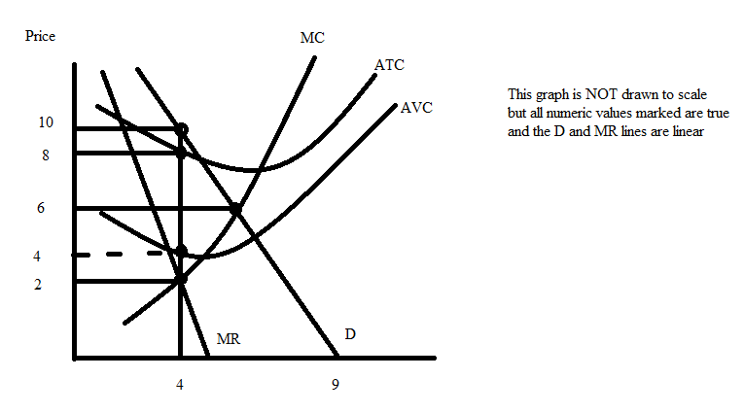
Given the information and the above figure, what is the value of the monopolist's profits when this monopolist maximizes their profit? Assume that the monopolist sells their product at only one price (i.e., no price discrimination).
a. $16
b. $24
c. $0
d. $8

23. How many of the following statements are true for a monopolistically competitive firm?
I. In the long run the monopolistically competitive firm will produce the socially optimal amount of the good just like in a perfectly competitive industry.
II. Monopolistically competitive firms provide us with variety, but the cost of this variety is that the monopolistically competitive firm does not produce at the minimum point of its average total cost curve in the long run.
III, Monopolistically competitive firms earn positive economic profit since they, like monopolies, are protected from competition due to barriers of entry.
IV. In the long run a monopolistically competitive firm finds that the price it charges for its product is greater than the average total cost of producing that product.
a. One statement is true.
b. Two statements are true.
c. Four statements are true.
d. Three statements are true.
24. Consider a market that can be described by the following equations where Q is the quantity of the good and P is the price per unit.
Market Supply Curve: P = 2 + Q
Market Demand Curve: P = 100 - Q
Suppose the production process causes $1 worth of social cost per unit of the good produced, and the firms in this market do not internalize this social cost. The consumption of the good also causes another $2 worth of social cost per unit of the good consumed and the consumers in this market do not internalize this social cost. Suppose the government decides that it wants the socially optimal amount of the good to be produced and that it will use an excise tax on producers in order to achieve this goal. How much excise tax should the government place on the producers to achieve the socially optimal quantity of the good?
a. An excise tax of $2 per unit of the good.
b. An excise tax of $3 per unit of the good.
c. An excise tax of $4 per unit of the good.
d. An excise tax of $1 per unit of the good.

25. Suppose the cost of providing public health information in a small town is $40,000 a year per unit of information (so, for example, a unit of public health information might be directives for how best to stay safe from COVID-19). The public health information is freely available to all residents in the community. The demand for public health information by each individual is given by the following equation where P is the amount per public health information the individual is willing to pay and Q is the number of units of public health information.
Individual demand for public health information: P = 100 - 20Q
There are 2000 residents in the town.
How many units of public health information will be provided in this small town if the socially optimal number of units of public health information are provided?
a. 4 units of public health information
b. 1 unit of public health information
c. 2 units of public health information
d. 3 units of public health information

WORKSHEET: DO NOT REMOVE FROM EXAM!

KEEP GOING! EXAM HAS 30 QUESTIONS!
26. Suppose the cost of providing public health information in a small town is $40,000 a year per unit of information (so, for example, a unit of public health information might be directives for how best to stay safe from COVID-19). The public health information is freely available to all residents in the community. The demand for public health information by each individual is given by the following equation where P is the amount per public health information the individual is willing to pay and Q is the number of units of public health information.
Individual demand for public health information: P = 100 - 20Q
There are 2000 residents in the town.
How much should each citizen be taxed in all if the socially optimal number of units of public health information is provided in this market?
a. Total tax bill equals $20
b. Total tax bill equals $60
c. Total tax bill equals $80
d. Total tax bill equals $40

27. Use the following diagram to answer this question.

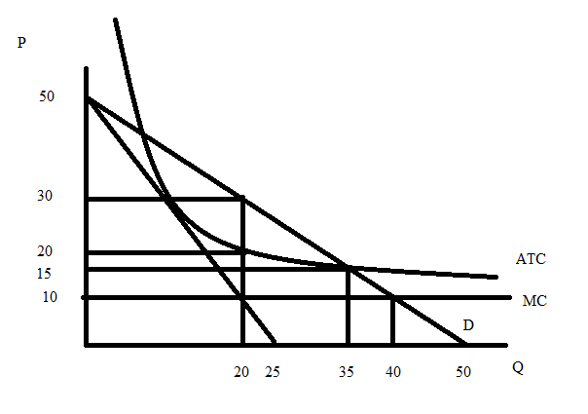
Suppose the government wants to minimize the deadweight loss in this industry through price regulation, but it wants to ensure that the monopolist still earns enough profit to remain in the industry. What price should the government force the monopolist to sell this product at given the above graph?
a. $15 per unit
b. $10 per unit
c. $30 per unit
d. $20 per unit
28. Suppose you read in the newspaper that real GDP in the United States in the second quarter of 2020 fell by approximately 32% due to the impact of the COVID-19 virus. From this you would predict:
a. The unemployment rate is rising and, at the same time, business investment is increasing since the interest rate for borrowing funds to finance investment spending is very low.
b. That business investment is not impacted by the virus and therefore is staying constant while the unemployment rate is rising.
c. That the level of unemployment in the economy is falling and business investment in the economy is growing.
d. That the level of unemployment in the economy is increasing and that business investment in the economy is falling.

29. You are given the following information about production and prices in an economy that produces only two goods: books and pizzas.

 | Quantities in 2019 | Price per item in 2019 | Quantities in 2020 | Price per item in 2020
Books | 100 books | $10 per book | 150 books | $12 per book
Pizzas | 200 pizzas | $20 per pizza | 150 pizza | $25 per pizza

Using 2019 as the base year and this data, which of the following statements is true?
a. Real GDP in 2020 using 2019 as the base year has the same value as nominal GDP in 2020.
b. Real GDP in 2020 measured in constant 2019 dollars is greater than nominal GDP in 2020 measured in 2020 dollars.
c. Since books and pizza became more expensive in 2020 relative to 2019, we know with certainty that real GDP in 2020 increased relative to real GDP in 2019.
d. Real GDP in 2020 decreased relative to real GDP in 2019.

30. The Sugar Company, located in Springfield, Iowa produces 100,000 pounds of sugar this year and it prices each pound of sugar at $10. Out of the total production of sugar 10,000 pounds are sold abroad and 60,000 are sold in the US. The remaining sugar produced this year remains unsold and stored in bags. Which of the following statements is true?
a. The above transactions result in investment in the U.S. this year decreasing by $300,000.
b. The Sugar Company's activities increase U.S. GDP by $600,000.
c. The above transactions result in investment in the U.S. this year increasing by $300,000.
d. The sugar Company's activities increase U.S. GDP by $700,000.

WORKSHEET: DO NOT REMOVE FROM EXAM!

END OF EXAM!

