Econ 111 Name _________________________
Fall 2021
First Midterm

Code of Conduct:
On this exam I understand that I may not get help from another human being and I may not provide help to another human being. Doing either of these things will be considered academic misconduct and may be punishable up to and including receiving a zero on this midterm. In the case of extreme academic misconduct, expulsion from the University is possible.
I may NOT use my notes, my textbook, and a calculator on this exam.
I agree and understand these exam expectations.

Signature _________________________

Binary Choice: 10 questions worth 2 points each
1. Suppose you are told that the market demand curve for apples is given by the following equation where P is the price per apples and Q is the quantity of apples:
P = 200 - (1/2)A
You are then told that tastes and preferences change so that at every price people now demand twice as many apples as they did initially. Given this information and holding everything else constant, the new demand curve can be written as:
- P = 200 - (1/4)A
- P = 800 - (1/2)A

2. Consider a market that is initially in equilibrium. Suppose an effective quantity control is implemented in this market. Given this information and holding everything else constant, this effective quantity control will result in:

- Fewer units of the good being sold and a reduction in consumer surplus.
- More units of the good being sold and an increase in producer surplus.

Use the following information to answer the next two (2) questions.

George produces watches (W) and pens (P). It takes George 10 hours to produce a watch and 4 hours to produce a pen. In a week George has forty hours that he spends making watches and pens. His production possibility frontier (PPF) is linear for these two goods. Assume that watches are measured on the vertical axis.

3. Write an equation in y-intercept form for George's PPF given this information and holding everything else constant.

- W = 10 - 2.5P
- W = 4 - (2/5)P

4. Suppose George is initially producing 1 watch. What is the opportunity cost of George increasing his watch production to 3 watches?

a. 2.5 pens
b. 5 pens

Workspace: DO NOT REMOVE FROM EXAM!

5. Consider a market that is initially in equilibrium. If the number of firms in the market increases, then holding everything else constant:

a. This will cause a movement along the supply curve.
b. This will cause a movement along the demand curve.

6. Megan and Roberto both produce chairs (C) and tables (T). The following equations describe Megan and Roberto's production possibility frontiers (PPF) for these two goods:
Megan's PPF: T = 40 - 3C
Roberto's PPF: T = 50 – 2C
Given this information and holding everything else constant:
a. Then Roberto has the comparative advantage in the production of tables.
b. Then Megan has the comparative advantage in the production of tables.

7. The cross-price elasticity of Good W with respect to the price of Good Z has a negative value. Therefore the two goods are:

a. Substitutes
b. Complements

8. Consider a good that is currently selling for $4.20 per unit. The producers of this good know that the market demand curve for this good is linear and can be described by the following equation where P is the price per unit and Q is the number of units of the good:
Market Demand for Good: Q = 500 - 25P
Given this information and holding everything else constant, the total revenue from selling this good in this market will increase if:
- Producers lower the price to some level less than $4.20 per unit.
- Producers raise the price to some level greater than $4.20 per unit and less than $10 per unit.

9. Which of the following accurately describes the budget line for an individual if we abbreviate their income as I, the price of good X measured on the horizontal axis as Px, the price of good Y measured on the vertical axis as Py, the quantity of good X as X, and the quantity of good Y as Y?

a. Y = (I/Px) - (Px/Py)X
b. X = (I/Px) - (Py/Px)Y

10. A consumer maximizes their utility by selecting that bundle of goods that lies on the indifference curve that is just tangent to their budget line. The budget line tells us about the constraints imposed on the individual by the prices of the goods he purchases while also describing the individual's tastes and preferences.
The above statement is:
a. Not an accurate description of what is happening when the individual maximizes their utility.
b. Is an accurate description of what is happening when an individual maximizes their utility.

Multiple Choice: 20 questions worth 4 points each

11. Consider the market for lamps which is initially in equilibrium and can be described by the following demand and supply curves where P is the price per lamp and Q is the quantity of lamps:
Market Demand Curve: P = 20 - (1/2)Q
Market Supply Curve: P = 2 + (1/2)Q
The government decides to implement an excise tax in this market and after the implementation of this tax the quantity of lamps sold in this market is 14 lamps. Given this information and holding everything else constant, the excise tax per lamp is equal to:
- $3 per lamp
- $5 per lamp
- $4 per lamp
- $2 per lamp

Use the following information to answer the next two (2) questions.

Suppose that initially the market depicted in the following graph is in equilibrium and the government decides to impose a minimum price of P = $30.
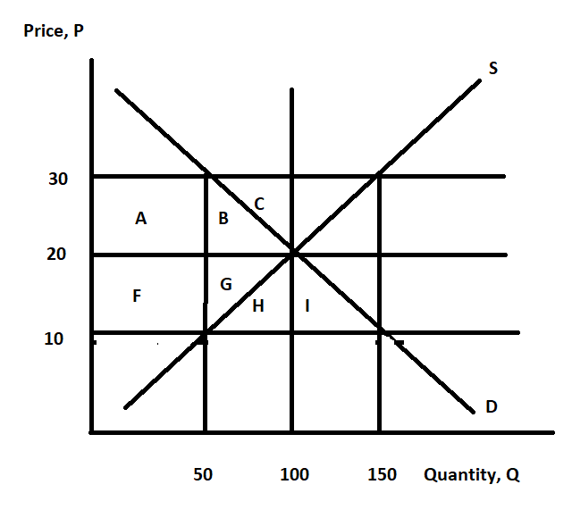
12. Given this information and holding everything else constant, the change in consumer surplus induced by this policy can be measured as a(n):
- Decrease of (area A + area B + area F + area G)
- Increase of (area F - area B)
- Decrease of (area B + area C)
- Decrease of (area A + area B)

13. Given this information and holding everything else constant, what is the deadweight loss from this minimum price rule?
- Area G + Area B
- Area A + Area B + Area G
- Area A + Area B
- Area H + Area I

Workspace: DO NOT REMOVE FROM EXAM!

Use the following information to answer the next three (3) questions.

Consider a hypothetical example using Taiwan and France. Suppose these two countries produce two goods from their available resources: tables and chairs. Furthermore, assume that both countries have linear production possibility frontiers. The table below shows the maximum production levels for these two goods when each country uses all of their resources to produce just one good.

TAIWAN | FRANCE
Tables Chairs | Tables Chairs
100 0 | 300 0
0 200 | 0 100

14. Given the above information and holding everything else constant, which of the following statements is FALSE?
- Taiwan has an absolute advantage in making chairs.
- France has an absolute advantage in making tables.
- Taiwan has a comparative advantage in making tables.
- France’s opportunity cost of producing a table is 1/3 chair.

15. Given this information and holding everything else constant, what is the opportunity cost of producing four tables for Taiwan?
- 4 chairs
- 4/3 chairs
- 8 chairs
- 2 chairs

16. Given this information and holding everything else constant, for which of the following trading terms will Taiwan and France refuse to exchange tables?
- 1.5 Chairs for 1 Table
- 2 Chairs for 1 Table
- 0.75 Chairs for 1 Table
- 3 Chairs for 1 Table

17. Fountain pens and bottled ink are complements. What will happen to the equilibrium price in the market for bottled ink if fountain pens become less expensive? Given this information and holding everything else constant, the equilibrium price for bottled ink will:

- Decrease and the equilibrium quantity will decrease.
- Increase and the equilibrium quantity will increase.
- Decrease and the equilibrium quantity will increase.
- Increase and the equilibrium quantity will decrease.

18. Demand for widgets is given by the following equation where Q is the quantity demanded and P is the price per widget:
Q = 20 - P
Income falls for individuals in this market and the demand for widgets is now given by the equation:
Q = 10 - 2P
Given this information and holding everything else constant, from this information we know that widgets are:
- A normal good.
- A substitute.
- A complement.
- An inferior good.

Workspace: DO NOT REMOVE FROM EXAM!

KEEP GOING! THE EXAM HAS THIRTY QUESTIONS!
19. The supply and demand for Brewer Baseball Hats are given by the following equations where P is the price per hat and Q is the quantity of hats:
Demand for Brewer Baseball Hats: Q = 100 - 2P
Supply of Brewer Baseball Hats: Q = 10 + P
The State of Wisconsin wants more people to wear Brewers hats and decides to offer a subsidy to induce 80 hats to be sold in the market. Given this information and holding everything else constant, what is the cost of this program to the State?
- $4800
- $1200
- $5600
- $60

20. There are two goods X and Y in the economy. Jaeho's utility function is given by the following equation:
Jaeho's Utility function: U(X, Y) = 4XY
You are also told his marginal utility for Good X and his marginal utility for Good Y are described by the following equations:
Marginal Utility of Good X: MU_{x} = 4Y
Marginal Utility of Good Y: MU_{y} = 4X
Suppose that the price of Good X is $4 per unit and the price of Good Y is $1 per unit and that Jaeho has $40 in income. Given this information and holding everything else constant, Jaeho will maximize his utility when he consumes:
- 20 units of Good X and 5 units of Good Y.
- 5 units of Good X and 20 units of Good Y.
- 10 units of Good X and 40 units of Good Y.
- 7 units of Good X and 12 units of Good Y.

21. Consider the following diagram depicting an individual's budget lines (BLa, BLm, and BLr) and two of his indifference curves (ICa and ICb). Use this diagram to answer this question.

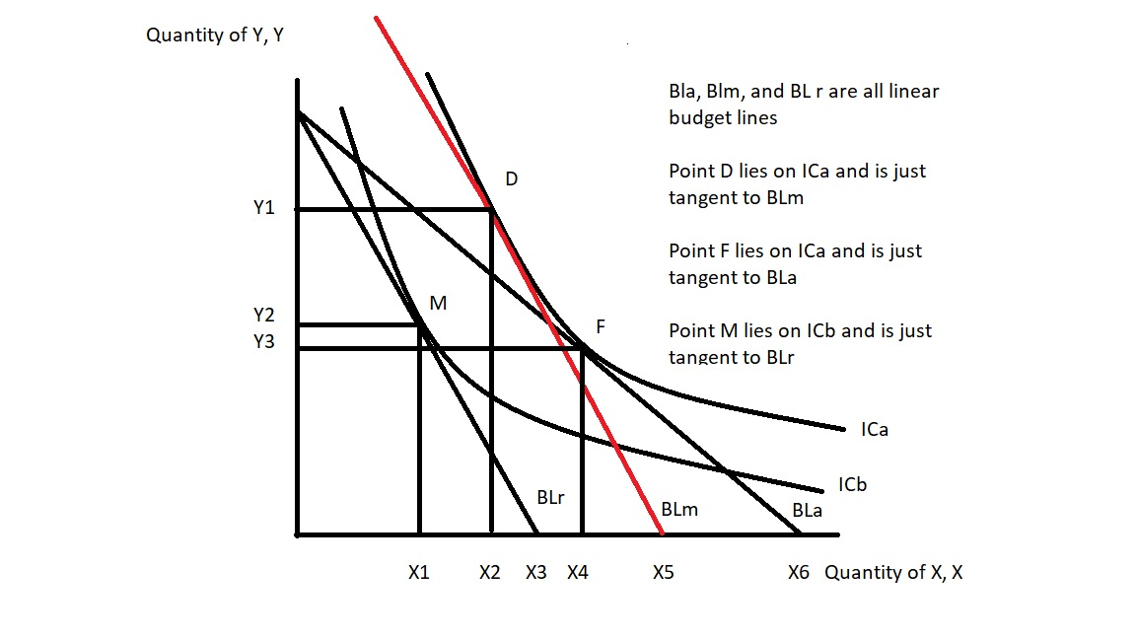

Given this graph and holding everything else constant, how many of the following statements are true?
I. If we compare BLr and BLa we can conclude that the price of good X decreases and the price of good Y is unchanged as this individual moves from BLr to BLa.
II. On this graph the substitution effect that results due to the increase in the price of good X is equal to (X₂ - X₁) units of good X.
III. Consider Point D on this graph: this point has the same utility as Point F.
IV. BLm has the same price of Good X as BLr but the income level associated with BLm is greater than the income level associated with BLr.
- One of these statements is true.
- Three of these statements are true.
- Four of these statements are true.
- Two of these statements are true.

22. The following equations describe the market for ice cream cones at the local ice cream shop where P is the price per ice cream cone and Q is the quantity of ice cream cones:
Demand: P = 90 - (3/4)Q
Supply: P = 35 + (5/8)Q
Calculate the price elasticity of demand (E_{D}) and the price elasticity of supply (E_{S}) when the market for ice cream cones is in equilibrium. (Hint: use the point slope elasticity formula for this calculation.)
- The price elasticity of demand is 9/8; the price elasticity of supply is 15/16.
- The price elasticity of demand is 2; the price elasticity of supply is 12/5.
- The price elasticity of demand is 1/2; the price elasticity of supply is 5/12.
- The price elasticity of demand is 8/9; the price elasticity of supply is 16/15.

23. Megan and Farrah love to go to the movies. The following equations provide their individual demand curves for going to the movies where P is the price of a movie ticket and Q is the quantity of movie tickets:
Megan's Demand for Movie Tickets: Qm = 20 - P
Farrah's Demand for Movie Tickets: Qf = 7 - (1/2)P
Suppose that Megan and Farrah are the only two movie goers in the market. What is the market demand curve for movies given this information and holding everything else constant?
- P = 20 - Q for quantities less than or equal to 6; P = 18 - (2/3)Q for quantities greater than or equal to 6 and less than or equal to 27.
- P = 27 - (3/2)Q for quantities greater than or equal to 0 and less than or equal to 14; P = 20 - Q for quantities greater than or equal to 14 and less than or equal to 20.
- P = 48 - (3/2)Q for quantities less than or equal to 24 and greater than or equal to 0; P = 40 - Q for quantities less than or equal to 40 or greater than or equal to 16.
- P = 40 - Q for quantities greater than or equal to 0 and less than or equal to 24; P = 32 - (2/3)Q for quantities greater than or equal to 24 and less than or equal to 48.

24. Consider the market for generic cereal that is initially in equilibrium. Generic cereal is an inferior good. How would a decrease in income and an increase in the number of sellers affect the equilibrium quantity of generic cereal and the equilibrium price of generic cereal relative to the initial equilibrium quantity and equilibrium price? Given this information and holding everything else constant, relative to the initial equilibrium price and equilibrium quantity:

a. The equilibrium price of generic cereal increases and the equilibrium quantity of generic cereal increases.
b. The equilibrium price of generic cereal is indeterminate and the equilibrium quantity of generic cereal decreases.
c. The equilibrium price of generic cereal is indeterminate and the equilibrium quantity of generic cereal increases.
d. The equilibrium price of generic cereal decreases and the equilibrium quantity of generic cereal increases.

25. Consider the tax below which depicts the market for widgets. D1 and S1 are the initial demand and supply curves, respectively. S2 is the new supply curve once an excise tax is implemented in this market. Assume that the y-intercept of S1 is a positive value.

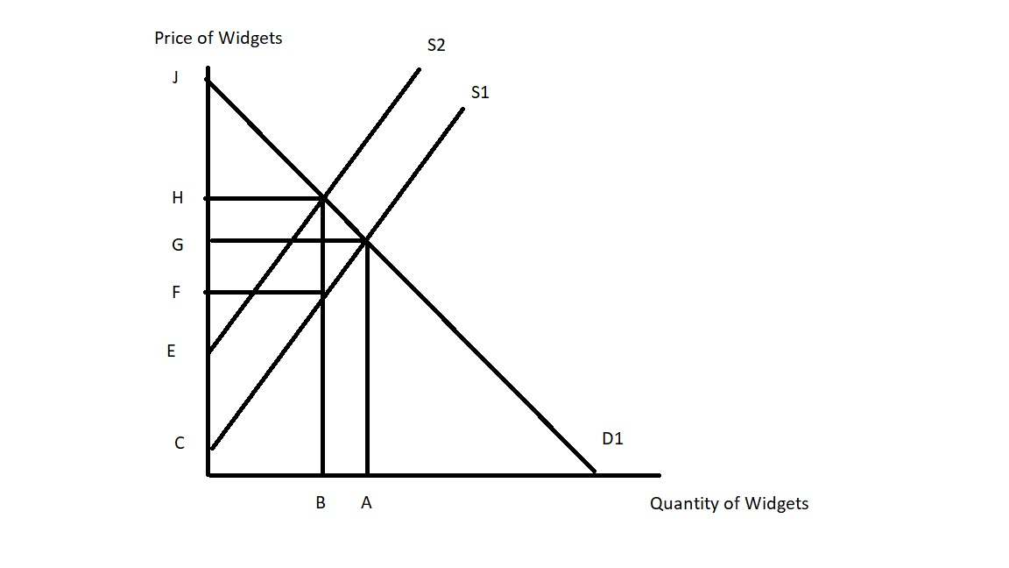
Given the above information and holding everything else constant, the economic incidence of this excise tax will fall more heavily on producers if:
- Distance (H - G) is greater than distance (G - F).
- Distance (G - F) is greater than distance (H - G).
- Distance (J - G) is greater than distance (G - C).
- Distance (J - H) is less than distance (G - E).

Workspace: DO NOT REMOVE FROM EXAM!

KEEP GOING! THE EXAM HAS THIRTY QUESTIONS!

Use the following information to answer the next three (3) questions.
Consider a fictional country, Premiere, which produces perfume. The domestic demand and supply curves for perfume are given by the following equations where P is the price per bottle of perfume and Q is the number of bottles of perfume:
Domestic Demand for Perfume: Q = 10 - 2P
Domestic Supply of Perfume: Q = 3P
Premiere's perfume market is not open to trade initially, but then Premiere decides to open this market to trade. The world price of a bottle of perfume is $1 per bottle.
26. Given the above information which of the following statements is WRONG about the interpretation of the labeled areas in the graph below?
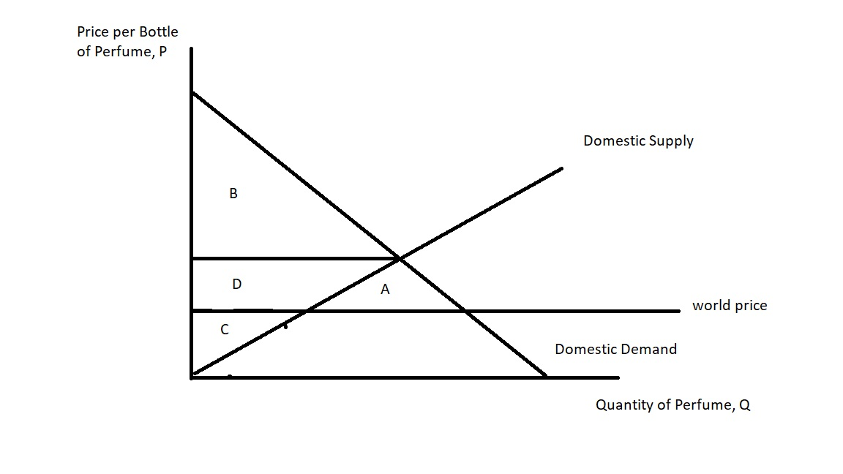

- Area B is the consumer surplus before free trade.
- Area A is the increase in total surplus due to free trade.
- Area D is the surplus that consumers "captured" from producers after free trade.
- Area (B + D) is the consumer surplus after free trade.

27. Due to complaints from domestic producers, the government of Premiere is considering imposing a tariff on imported perfume. Suppose the government implements a tariff that results in the price of a bottle of perfume increasing to $1.50 per bottle. What is the government's revenue from this tariff?
- $1.25
- $3.75
- $2.50
- $2.80

28. (Warning: this problem does have some significant math: get the easy points on the exam first!) Assume that any tariff or proposed tariff is no longer being implemented in this market. Due to complaints from domestic producers, the government of Premiere is considering imposing an import quota on imported perfume. Suppose the government implements an import quota of 2 bottles of perfume. Given this information and holding everything else constant, what is the deadweight loss (DWL) from the imposition of this import quota?
a. DWL = $0.36
b. DWL = $0.54
c. DWL = $0.90
d. DWL = $1.20

Use the following information to answer the next two (2) questions.

The demand and supply curves for honey are represented by the following equations where P is the price in dollars per unit of honey and Q is the number of units of honey:
Market Demand for Honey: Q = 20 - (1/2)P
Market Supply of Honey: Q = P - 4
29. Suppose the government decides to implement a price support program in this market where the government sets the price of a unit of honey at $24 and the government agrees to purchase any surplus honey that is produced given that price support price.
Given this information and holding everything else constant, consumer expenditure on honey with this program will equal _____ and the government will purchase ________.
- $192; 12 units of honey
- $200; 12 units of honey
- $128; 8 units of honey
- $200; 0 units of honey

30. Suppose the government decides to implement a price guarantee program in this market. (There is no price support now: we are back to the initial set-up.) The government guarantees that honey producers will get $20 per unit of honey, but the government tells honey producers to sell all the honey they produce given this guaranteed price to consumers and then the government will provide a subsidy to the producers so that the total price they receive with the subsidy will be equal to $20 per unit of honey. Given this information and holding everything else constant, the price consumers pay per unit of honey will equal _____ and the cost to the government of this subsidy program will equal _____.
a. $14 per unit of honey; $60
b. $8 per unit of honey; $192
c. $16 per unit of honey; $64
d. $16 per unit of honey; $16

