Economics 111
Fall 2019
Homework #4

General Instructions:

- Homework is due at the beginning of the lecture.
- Do not submit the homework questions. Just submit your answers: these answers should be neat, legible, and easy to follow. Be generous with your use of paper. Do not write in small, hard to read font. If asked to provide a graph, provide a generous graph.
- All homeworks should be stapled and on the front page your name should be legibly written.
- It is all right to do homework with a "study buddy": however, when asked to explain your answer your words should be significantly different from your "study buddy's" words. Homeworks that are too similar to one another will not receive any credit.
- To get full credit for the homework you need to answer every question that is asked. A failure to answer all the questions will result in a lower homework score.
- It is a good idea to make a copy of your homework so that you can compare your answers to the posted answers. Your copy (a digital photo) also provides a time-stamped proof that you did the homework.

Monopoly:

1. Consider a monopoly that produces widgets. Suppose you are told that the monopoly has the following cost curves where TC is total cost measured in dollars, Q is the quantity of widgets, and P is the price per widget in dollars:

Total Cost: TC = 4 + 4Q + Q2 Marginal Cost: MC = 4 + 2Q

Suppose you also know that the market demand curve is given by the following equation:
Market Demand: P = 19 – (1/2)Q

- Given the above information, what is this monopolist’s equation for MR?
- Determine the profit maximizing level of production for this monopolist as well as the price that will be charged for each unit of the good. Assume that this is a single price monopolist, i.e. the monopolist cannot engage in price discrimination. Explain how you found your answer.

- Given the above information and your answer in (b) calculate the level of profit in the short- run for this monopolist. Explain how you found your answer.

- Given your answer in (c), what do you predict will happen to this monopolist in the long-run?

- Calculate the deadweight loss that results from this market being served by a monopolist. Show how you found your answer. Provide a graph that is well labeled to illustrate your answer.

Natural Monopoly:

2. Use the following graph of a natural monopolist to answer this next question. The graph depicts the market for a monopolist where LRATC is the long-run average total cost curve, MC is the marginal cost curve, and Demand is the market demand for the product. You are also told that the reciprocal of the slope of the market demand curve is -5.
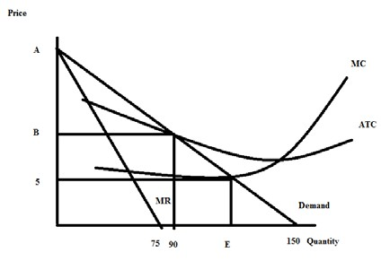

- Given the above information and the graph, write the equation for the market demand curve in slope intercept form. Explain how you found your answer. You will need to provide a numeric value for “A” in the above graph.

- Suppose that this monopolist is not regulated. Explain how this monopolist will determine its profit maximizing output and price. Assume that the monopolist is a single price monopolist. After explaining the process, identify the unregulated monopolist’s quantity and price on the graph labeling the quantity (F) and the price (G). Note: you will not be able to actually compute F and G – just label them on a well-drawn diagram.

- Will the monopolist described in (b) earn positive, negative, or zero economic profits? Explain your answer.

Price Discrimination:

3. Consider a market that is served by a single producer. This market has significant barriers to entry so the single producer has market power and is not likely to face any competition due to these barriers of entry. You are given the following information about this market:

Market Demand: Q = 450 – 3P MC = 30
Fixed Cost for the Producer: FC = 50

- Given the above information, if this producer acts as a single price monopolist, calculate the following:

Profit maximizing quantity =
Profit maximizing price =
Level of profits (remember you will need to adjust this to take into account FC) =__________________
Consumer Surplus = CS =
Producer Surplus) = PS = _____________
Deadweight Loss = ________________

Show your work and provide a graph to illustrate your answer.

b. Suppose that this monopolist decides to practice second degree price discrimination. The monopolist decides that it will sell its first 90 units of the good produced for a price of $120 per unit, its next thirty units for a price of $110 per unit, its next sixty units for a price of $90 per unit, and a final thirty units for a price of $80 per unit. Given this information and the initial information, calculate the following for the monopolist who practices this second degree price discrimination:

Total quantity produced by the second degree price discriminator = Prices charged by the second degree price discriminator = Level of profits for the second degree price discriminator (remember you will need to adjust this to take into account FC) =
Consumer Surplus in this case of second degree price discrimination = CS’ =

Producer Surplus in this case of second degree price discrimination = PS’ = Deadweight Loss in this case of second degree price discrimination =

Show your work and provide a graph to illustrate your answer.

c. Compare your answers in (a) and (b). Does second degree price discrimination benefit consumers in this case? Explain your answer here and provide evidence to support your answer. Does second degree price discrimination benefit the producer? Explain your answer here and provide evidence to support your answer.

d. Suppose this monopolist is able to practice first degree price discrimination in this market. Compute the following if this monopolist successfully implements first degree price discrimination.

Total amount of the good produced in the market =
PS” with perfect price discrimination =
CS” with perfect price discrimination = ____________________
Profit for firm with perfect price discrimination (remember to account for fixed costs here) = ________________
DWL with perfect price discrimination =

Show your work and provide a graph to illustrate your answer.

4. Karen is a supplier of dry cleaning services in her small town. She operates the only dry cleaning service and therefore has significant market power. She knows that she has two types of clients: business clients who come in regularly to have their clothing cleaned and non-business clients who have occasional garments to clean. She knows the following information where Q is the quantity of dry cleaning units and P is the price per unit of dry cleaning:

Demand for dry cleaning services from business clients: Q = 20 – (1/2)P
Demand for dry cleaning services from non-business clients: Q = 30 - P MC of providing dry cleaning services: MC = 4
Fixed Costs of providing dry cleaning services: FC = 10

Suppose that Karen decides to treat her dry cleaning business as two separate monopolies: one providing dry cleaning services to business clients and one providing dry cleaning services to non-business clients. She can readily identify the status of each of her clients since she has been in business in this small town for a long, long time and she knows her customers well.

a. Given that Karen is going to treat these two types of customers as separate entities, what will be the profit maximizing price and quantity of the good for each type of customer? And, what will total profits be equal to? Show how you found your answers to this set of questions clearly and logically! Provide a set of graphs to illustrate your answer.

b. Now, suppose Karen would like to verify that this two pricing scheme idea in (a) actually results in her earning greater profits than if she were to simply follow a single pricing monopoly model. So, find the market demand curve. Then determine the profit maximizing quantity and price if Karen treats this market as a single market with one price for dry cleaning. What happens to the level of profits Karen earns under this pricing decision? Provide numeric values for all your work and clearly and logically explain how you found your answers. Also, provide a graph to illustrate your answer.

Game Theory:

5. Consider the following payoff matrix which shows Roger's and Wilma's profits depending upon whether they sell stock or buy stock. The first numerical entry in a cell is Roger's profit and the second numerical entry in a cell is Wilma's profit. Use this information to answer this set of of questions.

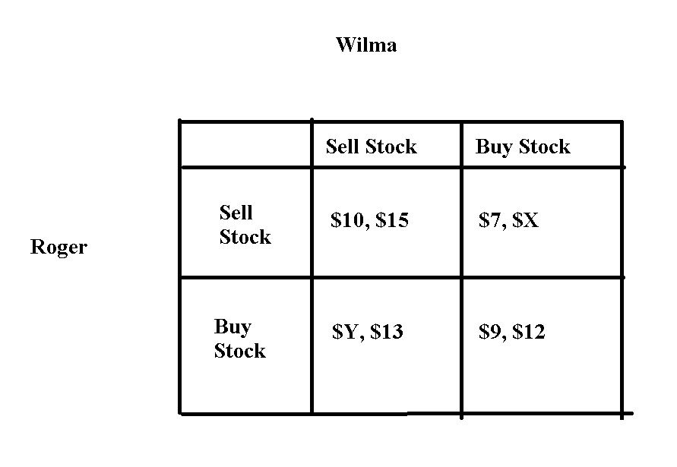
a. If Roger's dominant strategy is to "Buy Stock" what conclusion can you make? Be very specific in your statement here.

b. If Wilma's dominant strategy is to "Sell Stock" what conclusion can you make? Be very specific in your statement here.

c. Given the information in (a) and (b), what do you predict will be the outcome of this game? Be specific in your answer. Provide a numeric value for the profits Roger and Wilma will earn.

d. Suppose you know nothing about Roger and Wilma's preferred strategies. What would need to be true about the value of Y and the value of X to conclude that neither Roger nor Wilma have a dominant strategy? Be specific in your answer.

6. Joe and Maria both operate businesses that provide the same service. Joe is trying to decide whether he should engage in an advertising campaign or not: he reasons that the advertising campaign will certainly increase his cost, but it may also increase his level of profits. Maria is also analyzing whether she should engage in an advertising campaign: her reasoning is similar to Joe's reasoning. They both do some research! Joe discovers that if he advertises and Maria also advertises, he will earn $800 in profits and Maria will earn $800 in profits. If Joe does not advertise while Maria advertises then Maria will earn $1200 in profits while Joe will only earn $400 in profits. If Joe advertises and Maria does not advertise, then Joe will earn $700 in profits and Maria will earn $1000 in profits. And, finally if they both choose not to advertise then Joe will earn $300 in profits and Maria will earn $300 in profits.

a. Construct a payoff matrix given the above information. In your payoff matrix list Joe's profits first and Maria's profits second. Make sure your payoff matrix is completely and clearly labeled.

b. Analyze the payoff matric you constructed. Does Joe have a dominant strategy? Does Maria have a dominant strategy? What do you predict will be the outcome of this game? Explain your answer fully.

Externalities:

7. Consider the production of a good. At the market provided quantity of the good you are told that the marginal social benefit from consuming this good is less than the marginal social cost of producing this good.

a. Draw a graph that represents this provided information. In your graph be sure to include the marginal private benefit (MPB) curve, the marginal social benefit curve (MSB), and the marginal social cost (MSC) curve. Label the market quantity, Qmarket, as well as the socially optimal quantity, Qsocial optimum, in your graph. If there is an area of deadweight loss label this area as well.

b. Given the above information, does the market left to itself, produce too much or too little of the good? Explain your answer.

8. The marginal social cost of providing a good is given by the following equation where Q is the market quantity and P is the price per unit:

Marginal Social Cost: MSC = 10 + 2Q

The marginal private benefit of providing this good is given by the following equation:

Marginal Private Benefit: MPB = 100 – Q

You are also told that this good generates negative consumption benefits of $9 per unit of the good consumed.

a. Given this information what is the quantity produced by the market?

b. Given this information what is the socially optimum amount of the good. Show how you found your answer.

c. What is the deadweight loss when this market fails to internalize (to correct for) the externality? Show how you found your answer.

Public Goods:

9. Imagine a community that has only two residents: Paul and Sally. Paul and Sally both realize that their community would benefit from the installation of streetlights, and they are trying to figure out the optimal number of streetlights for their community. Paul and Sally are both willing to reveal their preferences for streetlights:
Paul’s preferences for streetlights are given by the equation: MPB = 20 – 2Q
Sally’s preferences for streetlights are given by the equation: MPB = 10 – (1/2)Q

where MPB is the marginal private benefit for the individual and Q is the number of streetlights. Both Paul and Sally know that the marginal social cost of installing a streetlight is given by the equation:

Cost of installing streetlights: MSC = 3.5Q

a. Given this information, start by constructing three graphs that are vertically drawn one under the other. In the top graph depict the MPB for Paul; in the second stacked graph depict the MPB for Sally; and in the final stacked graph depict the MSB (marginal social benefit) from streetlights assuming that Paul and Sally are the only two individuals in this community. Label all axis, and any “kink” points clearly and completely.

b. Given your graphs in (a), write an equation(s) for the MSB curve you found. Make sure you also indicate any relevant range for the MSB equation(s) you provide.

c. Calculate the optimal number of streetlights in this community and then determine the total price per streetlight and the amount of this price that will be paid by Paul and the amount that will be paid by Sally. Show your work and explain how you found your answers.

10. Consider a community that has two residents, Leslie and Ron. Leslie and Ron would both like to have some public parks in their community and they are trying to decide on the optimal number of parks to build, and what price they should each contribute for each park. Luckily they are both willing to reveal their preferences and so we do not have to worry about the free rider problem. You are provided the following equations describing these individuals demand curves for public parks where P is the price per park and Q is the quantity of parks:

Leslie’s demand for parks: Q = 6 – 2P
Ron’s demand for parks: P = 3/2 – (1/4)Q.

You are also told that the marginal social cost of providing a park is given by the equations:

Marginal Social Cost: MSC = $3

a. On your homework paper draw three graphs vertically one above the other. The first graph should be labeled “Leslie’s demand”; the second graph should be labeled “Ron’s demand”; and the third graph should be labeled “Market demand”. On each graph the horizontal axis should be labeled “Quantity of Parks” while the vertical axis should be labeled “Price of Parks”. Now in each graph draw in the demand curve corresponding to your label. Remember that the market demand curve will be a vertical summation of the individual demand curves since a public good is non-rival.

b. Write an equation for the market demand curve for the public good.

c. Given the above information, what is the optimal number of parks for the community? Show how you found this number.
d. Since Leslie and Ron each get benefits from the parks, they will each contribute towards the cost. Given her demand, how much will Leslie contribute per park? How much will Ron contribute per park? Why do Leslie and Ron contribute different amounts?

e. Now think about what would happen if Leslie and Ron were unable to share the same parks. Now each of them would have to build their own private park, and pay the full cost. How many parks are Leslie and Ron willing to pay for individually? How many total parks would be built? (Remember: we can’t build negative parks.)

