Economics 111 Name ______________________________
Fall 2019
October 8, 2019

FIRST MIDTERM
Version 1

There are multiple versions of this exam. You will be given a scantron to fill out. It is important that you:

- Fill out this scantron accurately and completely using a #2 pencil
- In “Special Codes” put your exam version number in column “A”

During the exam it is expected that you will always keep your answers for the exam covered. A failure to cover your answers may be grounds for an academic misconduct violation.

During the exam it is expected that you will always keeps your eyes solely on your own exam. Violation of this expectation may be grounds for academic misconduct violation.

This exam is 17 pages long!

Binary Choice Questions (20 points) __________________

Multiple Choice Questions (60 points) __________________

Problem One (10 points) __________________

Problem Two (10 points) __________________

TOTAL out of 100 points __________________

I. Binary Choice Questions (each question is worth 2 points)

1. Cary works part-time as a music teacher and she earns $20 per hour of instruction. On Friday she decides to attend a movie with a friend and then go out for a quick bite of food. The movie ticket costs $10 and the movie is a three-hour long saga. Dinner will cost her $8 which is $6 more than she would spend if she ate at home. Total time Cary will be out with her friend is five hours and she figures that this means that she will not be teaching music for three of those hours. What is Cary’s opportunity cost of spending the evening with her friend?

a. $76
b. $78

2. Which of the following subjects is more likely to be discussed in a microeconomics class?

a. The dollar value of all the production in the economy during the year 2019
b. The number of e-bikes produced in an economy in 2019 and the price of an e-bike in that economy in 2019

3. Consider a bowed out from the origin PPF. As you move down along this PPF the opportunity cost of producing an additional unit of the good measured on the horizontal axis will:

a. increase.
b. decrease.

4. The demand curve for widgets is given by the equation:

Q = 50 – (1/2)P

where P is the price per unit and Q is the quantity of the good. You are told that at every price the quantity increases by 100%. Given this information and holding everything else constant, the new demand curve is:

a. Q = 100 – (1/2)P
b. Q = 100 - P

5. Which of the following subjects is more likely to be discussed in a macroeconomics class?

a. The level of unemployment rose to 6% in the last recession.
b. The price of an apple this week is 30 cents.

6. Joe has a linear production possibility frontier (PPF). Joe is currently producing on his PPF and he is producing 30 erasers and 10 pens. You are also told that Joe could produce 24 erasers and 22 pens as a second possible production point on his PPF. Given this information, the opportunity cost for Joe of producing 3 additional erasers is:

a. 4 pens
b. 6 pens

7. Consider the joint PPF below which represents the production possibilities for Pizza (P) per day and Cookies (C) per day for Jenny and David given their resources, their technology and the given time period.

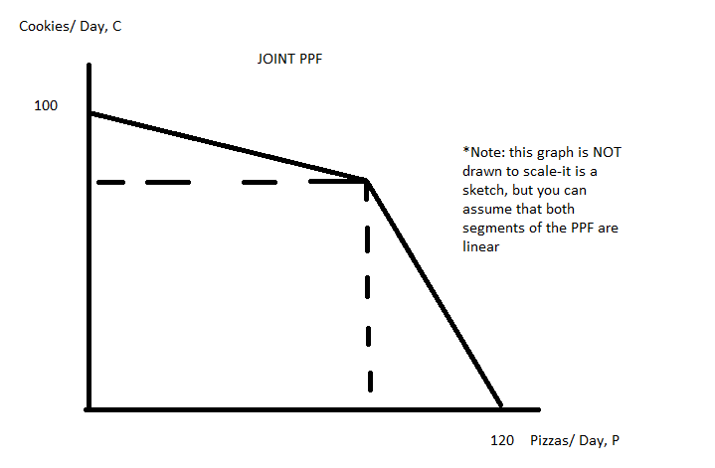
You are also provided the following information:

- Jenny’s opportunity cost for producing 1 unit of cookies is 5 pizzas per day.
- David has a comparative advantage in the production of cookies.
- It is feasible and efficient for David and Jenny to produce (P, C) = (115, 20).

Given this information and holding everything else constant, the coordinate (P, C) for the “kink point” of this PPF are:

a. (P, C) = (100, 80)
b. (P, C) = (70, 60)

8. Joe and Mary have linear demand curves for good X. You are told that when the price is $4 per unit, Joe demands 8 units of good X and Mary demands 6 units of good X. You also know that once the price reaches $20 per unit, Joe no longer demands the good; and when the price reaches $10 per unit, Mary no longer demands the good. Given this information and holding everything else constant, the equation for the market demand curve for prices less than or equal to $10 is:

a. P = (40/3) – (2/3)Q
b. P = (40/3) – (1/2)Q

9. Consider a market where the government has implemented an effective price control. In this market the “short side” of the market is the supply side. Given this information and holding everything else constant, you conclude that the government has implemented an effective:

a. price ceiling.
b. price floor.

10. Consider the agricultural market interventions discussed in class. The ________ results in consumers consuming less of the product and at a higher price per unit than they would consume if there was no intervention in the market by the government.

a. The price guarantee program.
b. The price support program.

II. Multiple Choice Questions (each question is worth 3 points)

11. Consider a market that is initially in equilibrium. Suppose that tastes and preferences change in favor of the good, and at the same time, the price of copper, an essential input into the production of the good, increases. Given this information and holding everything else constant you conclude that relative to the initial equilibrium:

a. The equilibrium price increases and the equilibrium quantity decreases.
b. The equilibrium price is indeterminate and the equilibrium quantity increases.
c. The equilibrium price increases and the equilibrium quantity is indeterminate.
d. The equilibrium price increases and the equilibrium quantity increases.

12. A market can be described by the following equations where P is the price per unit and Q is the quantity of units:

Market Demand: Q = 200 – 2P
Market Supply: Q = 2P

Suppose the government implements a price floor of $80 per unit. How many of the following statements are true given this information?

- This will be an effective price floor since it is set at a price that is greater than the equilibrium price in the market.
- This price floor will result in a shortage of 120 units of the good.
- Producers will “capture” $1200 of the area that had been consumer surplus prior to the imposition of the price floor.
- The deadweight loss due to the imposition of this price floor is equal to $3600.

a. One statement is true.
b. Two statements are true.
c. Three statements are true.
d. Four statements are true.

Use the following information to answer the next three (3) questions.

Paul, Chris and Jon have linear production possibility frontiers (PPFs) in the production of cupcakes (C) and brownies (B). Their three PPFs are given below.

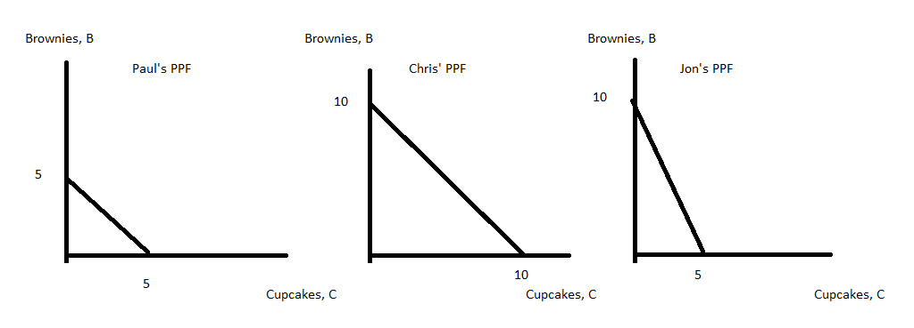
13. Given the above information and holding everything else constant, which of the following statements are true?

a. If Paul, Chris and Jon are currently making no brownies then it is best to send either Paul or Chris to make the first units of brownies.
b. If Paul, Chris and Jon are currently making no brownies then it is best to send Jon to make the first units of brownies.
c. Chris has the comparative advantage in producing brownies relative to Paul.
d. Jon has the comparative advantage in producing cupcakes relative to Chris and Paul.

14. Given the above information and holding everything else constant, which of the following statements are true?

a. Jon will buy cupcakes from Paul and Chris provided that the price of a cupcake is less than one brownie.
b. Jon will sell cupcakes to Paul and Chris provided that the price of a cupcake is less than 2 brownies.
c. Paul will buy cupcakes from Jon provided that the price of a cupcake is greater than or equal to 1 brownie and less than or equal to 2 brownies.
d. Paul will sell a cupcake to Jon provided he is paid at least one brownie and Jon will buy a cupcake provided the price is less than or equal to 2 brownies.

15. Which of the following diagrams provides the best representation of the joint PPF for Paul, Chris and Jon?

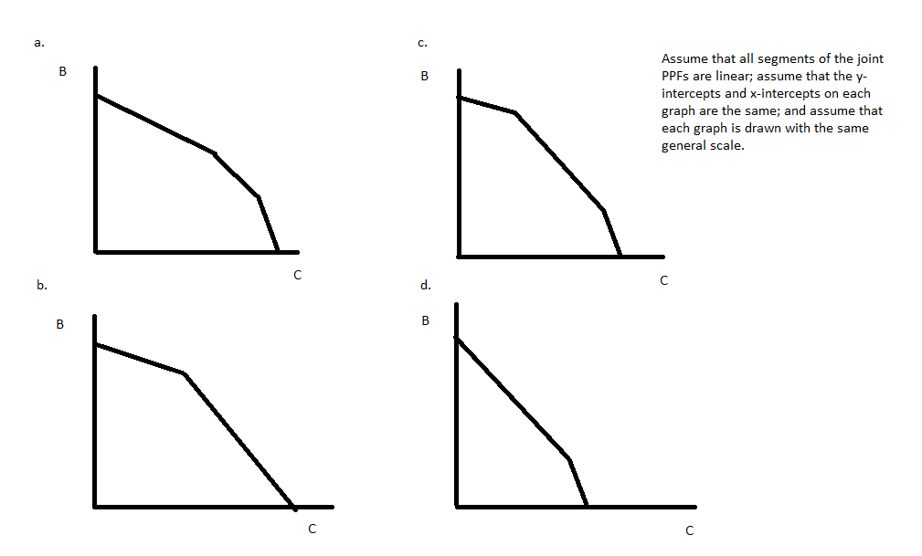

Use the following information to answer the next three (3) questions.

Suppose a market is composed of ten individuals. Five of these individuals have the same demand and the demand curve for one of these five individuals can be written as:

Individual Demand Curve if a member of the first group: P = 20 – Q

where P is the price per unit and Q is the number of units of the good.
The other five individuals have the same demand curve and the demand curve for one of these five individuals can be written as:

Individual Demand Curve if a member of the second group: P = 10 – (1/4)Q

16. Given the above information and holding everything else constant, how many of the following statements are true?

- Since this market demand curve is composed of ten individual demand curves, we can expect that there will be nine “kink points”.
- When the market demand curve is constructed, the market demand curve will bow out from the origin.
- The upper segment of the market demand curve will have a steeper slope than the bottom segment of the demand curve.
- If the price of the good is $5 per unit then the total quantity demanded in the market will be 175 units.

a. One statement is true.
b. Two statements are true.
c. Three statements are true.
d. Four statements are true.

17. Given the above information and holding everything else constant, the market demand curve for just the second group of consumers can be written as:

a. P = 12 – (1/25)Q
b. P = 10 – (1/25)Q
c. P = 10 – (1/20)Q
d. P = 20 – (1/5)Q

18. Given the above information and holding everything else constant, the market demand curve for the entire market is given by:

a. P = 100 – Q for quantities less than or equal to 100
P = 150 – (9/4)Q for quantities greater than or equal to 100

b. P = 100 – (1/5)Q for quantities less than or equal to 100
P = 12 – (1/25)Q for quantities greater than or equal to 100

c. P = 20 – (1/5)Q for quantities less than or equal to 50
P = 12 – (1/25)Q for quantities greater than or equal to 50

d. P = 20 – (1/5)Q for quantities less than or equal to 50
P = 12 – (1/3)Q for quantities greater than or equal to 50

19. Consider an agricultural market described by the following equations where P is the price per unit and Q is the number of units:

Market Demand: Q = 200 – P
Market Supply: Q = P

Suppose the government implements a price support of $120 per unit in this market. The government promises to buy up any surplus that is created with the implementation of this program. The government is aware that it costs $3 per unit to store this good. Given this information and holding everything else constant, the cost to the government, including storage cost, with this program is equal to:

a. $4900
b. $4940
c. $4920
d. $4880

20. Consider an agricultural market described by the following equations where P is the price per unit and Q is the number of units:

Market Demand: Q = 200 – P
Market Supply: Q = P

Suppose the government implements a price guarantee of $120 per unit in this market. Given this information and holding everything else constant, the subsidy per unit of the good with this program equals:

a. $20 per unit
b. $30 per unit
c. $40 per unit
d. $50 per unit

Use the following information to answer the next THREE (3) questions.

Consider the tomato market in the small economy of Econland. In Econland, the market for tomatoes is described by the following equations where P is the price of tomatoes in dollars and Q is the quantity of tomatoes:

Domestic Demand: Q = 1000
Domestic Supply: P = (1/100)Q

Furthermore, suppose you know that the world price of tomatoes is $5.

21. Given the above information and holding everything else constant, if Econland opens to trade in the tomato market, how many tomatoes will they import?
- 300 tomatoes
- 500 tomatoes
- 700 tomatoes
- 1000 tomatoes

22. If a $2 tariff is then imposed by Econland in the market for tomatoes, how many tomatoes will Econland import?
- 100 tomatoes
- 300 tomatoes
- 500 tomatoes
- 700 tomatoes

23. Suppose that the domestic demand for tomatoes in Econland increases to Q = 1200. Assume that the world price does not change and that Econland still has a $2 tariff implemented on tomatoes. Given this information and holding everything else constant, Econland’s government revenue from the $2 tariff:
- Increases by exactly $200.
- Increases by exactly $400.
- Increases by an amount between $200 and $400.
- Is indeterminate.

Use the following information for the next question.
Suppose that Treasure Land is a small economy and that its market for notebooks can be described by the following domestic demand and supply curves where P is the price of a notebook and Q is the quantity of notebooks:

Domestic Demand: P = 12 – Q
Domestic Supply: P = 2Q

You are also told that the World Price of a notebook is $2.

24. Suppose that the market for notebooks in Treasure Land is open but that the government has imposed an import quota of 3 notebooks on this market. Given this information, the license holder revenue will equal _____.

- $3
- $6
- $9
- $12

25. The government is considering imposing an excise tax of $2 per unit on a good. If the suppliers collect the tax for the government, which of the following statements about the economic incidence of this excise tax is true?
- Consumers do not bear any of the economic burden of the excise tax.
- Suppliers bear most of the economic burden of the excise tax.
- The economic burden of the excise tax is split equally between consumers and suppliers.
- We need more information to know who bears the economic burden of the excise tax.

26. A market is initially in equilibrium and in this market there has been no government intervention. Then the government imposes an excise tax. Under which of the following conditions will the price consumers pay under the excise tax exactly equal the previous market price plus the excise tax amount?
- This described outcome occurs when supply is upward sloping.
- This described outcome occurs when demand is perfectly inelastic.
- This described outcome is always the outcome with an excise tax.
- This described outcome can never happen.

The next two (2) questions are related to one another.

27. William Smith is operating a bus company. One day he raises the price of a bus ticket by a small amount and finds that his revenue increases. Then Smith:
- Was initially charging a price on the inelastic part of the demand curve.
- Was initially charging a price on the elastic part of the demand curve.
- Will definitely make more revenue if he increases the price even more.
- Will definitely make less revenue if he increases the price even more.

28. Suppose the demand curve for Smith's buses is linear. If Smith is charging a price that maximizes revenue, the point price elasticity of demand is
- Strictly greater than one.
- Equal to one.
- Strictly smaller than one.
- Indeterminate.

29. Suppose the demand for fried chicken is given by Q = 1900 - 45P. The point price elasticity at P = 20 is:
- 2
- -0.5
- 0.5
- 0.9

30. Suppose that a market is initially in equilibrium. You are told that the number of firms in this market increases at the same time that the population in the economy increases. Given this information and holding everything else constant:

a. The equilibrium price and the equilibrium quantity in this market relative to their initial levels increase.
b. The equilibrium price increases relative to the initial equilibrium price while the equilibrium quantity may increase, decrease or remain the same as the initial equilibrium quantity.
c. The equilibrium price may increase, decrease or remain the same as the initial equilibrium price while the equilibrium quantity increases relative to the initial equilibrium quantity.
d. The equilibrium price may increase, decrease or remain the same as the initial equilibrium price and the equilibrium quantity may increase, decrease or remain the same as the initial equilibrium quantity.

III. Problems (two questions worth 10 points each)

1. Alice and Jane both produce maps (M) and compasses (C). They both have linear production possibility frontiers and you are also told that Jane has the comparative advantage in the production of compasses. The figure below depicts Alice and Jane's joint PPF per year if they specialize according to comparative advantage.

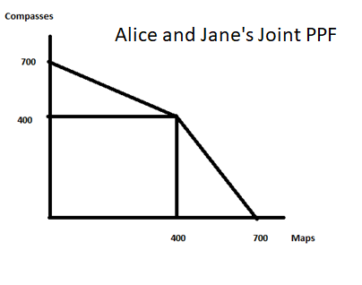
a. (2 points) In the space below draw Jane's PPF based upon the above information and figure. Make sure your graph is completely and carefully labeled.

b. (1 point) Write an equation in slope-intercept form (where compasses are the variable measured on the vertical axis) for Alice's PPF using M as the symbol for maps and C as the symbol for compasses.

c. (1 point) Write an equation in slope-intercept form for Jane's PPF using M as the symbol for maps and C as the symbol for compasses.

d. (2 points) In the space below write the equation(s) for the joint PPF. For any equation provided make sure you identify the relevant range for the equation.

e) (2 points) Suppose that Jane and Alice specialize and together they produce 600 compasses. Assume that they are producing on their joint PPF. Given this information answer the following questions:

i. How many compasses will Jane produce? _________________
ii. How many compasses will Alice produce? ___________________
iii. How many maps will Jane produce? _____________________
iv. How many maps will Alice produce? ________________________

f) (2 points) What is the trading range of prices for 180 maps? Use the number line approach to display your answer and in your answer indicate both Jane and Alice's perspectives with regard to this range of trading prices.

2. Use the following graph depicting the market for widgets for this set of questions. Assume that all demand and supply curves are linear.
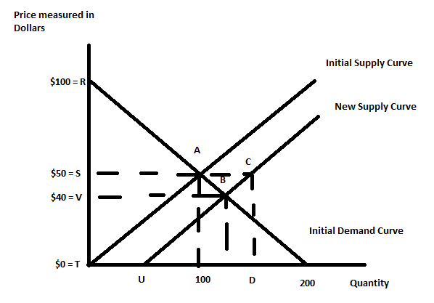

a) (1 point) Given the above graph, the initial equilibrium price is _____ and the initial equilibrium quantity is _____.

b) (1 point) Given the above graph, calculate the value of consumer surplus initially and the value of producer surplus initially. Show your work.

Consumer Surplus = CS =

Producer Surplus = PS =

Now suppose there is a technological improvement in the production of widgets that shifts the supply curve from the initial supply curve to the new supply curve. Assume the new supply curve is parallel to the initial one.

c) (2 points) Given the above graph, the new equilibrium price is _____ and the new equilibrium quantity is _____. (Provide numeric values and show your work.)

d) (4 points) Given the above graph, what is the numeric value of consumer surplus after the technological breakthrough? What is the numeric value of producer surplus after the technological breakthrough? Show your work.

Consumer Surplus' = CS' =

Producer Surplus' = PS' =

e) (2 points) What is the change in CS given this technological breakthrough (note whether it is a positive or negative change)? _________________What is the change in PS given this technological breakthrough (note whether it is a positive or negative change)?________________________

