**Economics 111**

**Fall 2019**

**Answers to Homework #4**

**General Instructions:**

* Homework is due at the beginning of the lecture.
* Do not submit the homework questions. Just submit your answers: these answers should be neat, legible, and easy to follow. Be generous with your use of paper. Do not write in small, hard to read font. If asked to provide a graph, provide a generous graph.
* All homeworks should be stapled and on the front page your name should be legibly written.
* It is all right to do homework with a "study buddy": however, when asked to explain your answer your words should be significantly different from your "study buddy's" words. Homeworks that are too similar to one another will not receive any credit.
* To get full credit for the homework you need to answer every question that is asked. A failure to answer all the questions will result in a lower homework score.
* It is a good idea to make a copy of your homework so that you can compare your answers to the posted answers. Your copy (a digital photo) also provides a time-stamped proof that you did the homework.

**Monopoly:**

1. Consider a monopoly that produces widgets. Suppose you are told that the monopoly has the following cost curves where TC is total cost measured in dollars, Q is the quantity of widgets, and P is the price per widget in dollars:

Total Cost: TC = 4 + 4Q + Q2 Marginal Cost: MC = 4 + 2Q

Suppose you also know that the market demand curve is given by the following equation:

Market Demand: P = 19 – (1/2)Q

1. Given the above information, what is this monopolist’s equation for MR?
2. Determine the profit maximizing level of production for this monopolist as well as the price that will be charged for each unit of the good. Assume that this is a single price monopolist, i.e. the monopolist cannot engage in price discrimination. Explain how you found your answer.
3. Given the above information and your answer in (b) calculate the level of profit in the short- run for this monopolist. Explain how you found your answer.
4. Given your answer in (c), what do you predict will happen to this monopolist in the long-run?
5. Calculate the deadweight loss that results from this market being served by a monopolist. Show how you found your answer. Provide a graph that is well labeled to illustrate your answer.

Answers:

a. The monopolist’s MR curve has the same y-intercept as the firm’s demand curve and for a linear demand curve, has a slope that is twice the slope of the demand curve. The monopolist is the only firm in the market so the market demand curve is the monopolist’s demand curve. Thus, the monopolist’s MR curve can be written as MR = 19 – Q.

b. The profit maximizing amount of output for the monopolist is that level of output where MR = MC. Thus,

19 – Q = 4 + 2Q

15 = 3Q

Q = 5 widgets

The price the monopolist will charge can be found by plugging in the profit maximizing quantity into the demand curve. Thus,

P = 19 – (1/2)(5) = $16.50 per widget

c. To find the monopolist’s profit we need to calculate the monopolist’s total revenue and its total cost:

TR = P*Q = ($16.50 per widget)(5 widgets) = $82.50

TC = 4 + 4Q + Q2 = 4 + 4(5) + (5)(5) = 4 + 20 + 25 = $49

Profit for the monopolist = TR – TC = $82.50 - $49.00 = $33.50

d. This monopolist will continue to earn positive economic profits in the long-run if there are effective barriers to entry that result in the monopoly continuing to operate as a monopoly and, therefore, be safe from competition.

e. To find the deadweight loss we need to first figure out the socially optimal amount of the good: this would be the amount of output where the MC equals the demand curve since for the last unit of output we have the addition to total cost from producing this last unit is equal to the value the consumer places on consuming the last unit (the price they would be willing to pay). So, setting MC equal to the demand curve we have:

4 + 2Q = 19 – (1/2)Q (5/2)Q = 15

Q = 6 widgets

Q socially optimal = 6 widgets.

We will also need to find the value of MC when Q = 6: so, MC = 4 + 2Q = 4 + 2(6) = $16.00

Deadweight Loss from the monopoly = (1/2)($16.50 per widget - $14 per widget)(6 widgets – 5 widgets)

Deadweight Loss from the monopoly = $1.25

The deadweight loss is shown in the graph below as (the very small) red triangle.

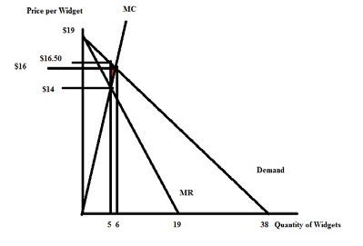

**Natural Monopoly:**

2. Use the following graph of a natural monopolist to answer this next question. The graph depicts the market for a monopolist where LRATC is the long-run average total cost curve, MC is the marginal cost curve, and Demand is the market demand for the product. You are also told that the reciprocal of the slope of the market demand curve is -5.

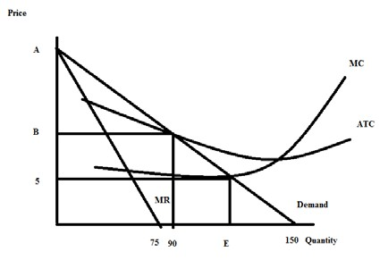

1. Given the above information and the graph, write the equation for the market demand curve in slope intercept form. Explain how you found your answer. You will need to provide a numeric value for “A” in the above graph.
2. Suppose that this monopolist is not regulated. Explain how this monopolist will determine its profit maximizing output and price. Assume that the monopolist is a single price monopolist. After explaining the process, identify the unregulated monopolist’s quantity and price on the graph labeling the quantity (F) and the price (G). Note: you will not be able to actually compute F and G – just label them on a well-drawn diagram.
3. Will the monopolist described in (b) earn positive, negative, or zero economic profits? Explain your answer.
4. Suppose that this monopolist is regulated with a MC pricing regulation. This insures that the monopolist produces the socially optimal amount of the good, but will require a subsidy for the producer since economic profits will be negative. From the graph and your prior work, identify (that is, provide a numeric value) the socially optimal amount of the good. Then amend the graph to show the amount of total subsidy this monopolist will need to receive if they are to produce the socially optimal amount of the good.
5. Suppose that this monopolist is regulated with AC pricing regulation. This insures that the monopolist produces the level of output where its economic profit is equal to zero. From the graph and your prior work, identify (that is, provide a numeric value) of the price the monopolist will charge if it is regulated to produce that level of output where the monopolist breaks even. Amend the graph to provide this numeric value.

Answer:

a. You are told that the reciprocal of the slope of the demand curve is -5: this implies that the slope of the demand curve is -1/5. You know from the provided figure that the x-intercept is 150 for the market demand curve so you need to figure out the y-intercept that will result in the slope of the line being - 1/5. Thus, (change in price)/(change in quantity) = - 1/5. Since change in quantity is equal to 150, this implies that change in price must be a negative 30: so the value of “A” is 30.

Once we have the value for “A” and the slope of the line it is easy to write the equation for the market demand curve in slope intercept form: P = 30 – (1/5)Q.

b. The unregulated single price monopolist will equate its MR curve to its MC curve and produce that quantity. It will go vertically up from this quantity to the demand curve to determine the price it will charge for the good. Here’s the altered graph:

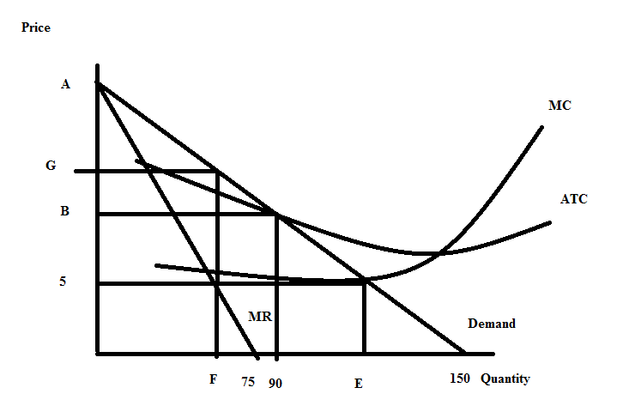

c. The single price unregulated monopolist will earn positive economic profits since when it produces “F” amount of the good, the price it sells the good for (“G”) is greater than the average cost per unit of producing this level of output. Since the price exceeds the ATC at this level of output then the firm must be earning positive economic profit.

d. The socially optimal amount of the good is that quantity where the demand curve intersects the MC curve. From the graph we can locate this point and see that we have the following: (Q, P)

= (E, 5). Let’s use the demand curve equation to solve for the value of “E”:

P = 30 – (1/5)Q but Q = E in this case, so P = 30 – (1/5)E

5 = 30 – (1/5)E

E = 125 units of output

Here’s the amended graph where the shaded area shows the total subsidy that the monopolist must receive if they are to produce the socially optimal amount of the good, “E”.

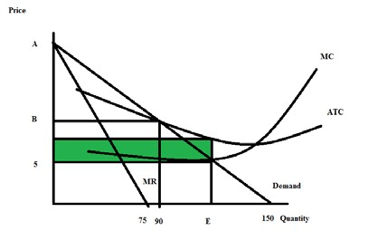

e. If the monopolist is regulated by AC pricing regulation the monopolist will produce where P = ATC and this will occur at that quantity where the LRATC curve intersects the demand curve. In the provided graph we can see that this is at a quantity of 90 units. We can find the regulated price by using this quantity in the market demand curve: thus,

P = 30 – (1/5)(Q) where Q is set to 90 units, the quantity where the firm will break even. P = 30 – (1/5)(90)

P = 12

Here’s the amended graph:

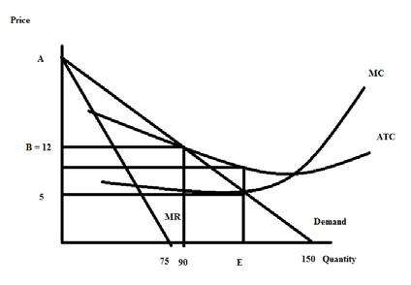

**Price Discrimination:**

3. Consider a market that is served by a single producer. This market has significant barriers to entry so the single producer has market power and is not likely to face any competition due to these barriers of entry. You are given the following information about this market:

Market Demand: Q = 450 – 3P MC = 30

Fixed Cost for the Producer: FC = 50

1. Given the above information, if this producer acts as a single price monopolist, calculate the following:

Profit maximizing quantity =

Profit maximizing price =

Level of profits (remember you will need to adjust this to take into account FC) =__________________

Consumer Surplus = CS =

Producer Surplus) = PS = _____________

Deadweight Loss = ________________

Show your work and provide a graph to illustrate your answer.

b. Suppose that this monopolist decides to practice second degree price discrimination. The monopolist decides that it will sell its first 90 units of the good produced for a price of $120 per unit, its next thirty units for a price of $110 per unit, its next sixty units for a price of $90 per unit, and a final thirty units for a price of $80 per unit. Given this information and the initial information, calculate the following for the monopolist who practices this second degree price discrimination:

Total quantity produced by the second degree price discriminator = Prices charged by the second degree price discriminator = Level of profits for the second degree price discriminator (remember you will need to adjust this to take into account FC) =

Consumer Surplus in this case of second degree price discrimination = CS’ =

Producer Surplus in this case of second degree price discrimination = PS’ = Deadweight Loss in this case of second degree price discrimination =

Show your work and provide a graph to illustrate your answer.

c. Compare your answers in (a) and (b). Does second degree price discrimination benefit consumers in this case? Explain your answer here and provide evidence to support your answer. Does second degree price discrimination benefit the producer? Explain your answer here and provide evidence to support your answer.

d. Suppose this monopolist is able to practice first degree price discrimination in this market. Compute the following if this monopolist successfully implements first degree price discrimination.

Total amount of the good produced in the market =

PS” with perfect price discrimination =

CS” with perfect price discrimination = ____________________

Profit for firm with perfect price discrimination (remember to account for fixed costs here) = ________________

DWL with perfect price discrimination =

Show your work and provide a graph to illustrate your answer.

Answer:

a. The firm if it acts as a single price monopolist will produce that quantity where MR = MC and then charge the price associated with this quantity from the demand curve. So, we need to find

MR first. Rewrite the demand curve in slope-intercept form: P = 150 – (1/3)Q. Recall that MR for the monopolist facing a linear demand curve shares the same y-intercept as the demand curve and has twice the slope of the demand curve. Thus, MR = 150 – (2/3)Q. Now, equate MR to MC: 150 – (2/3)Q = 30

120 = (2/3)Q

Q = 180 units

Go to the demand curve with this quantity to find the price the single price monopolist will charge:

P = 150 – (1/3)Q = 150 – (1/3)(180) = $90 per unit

Now, to calculate profit, we need TR and TC: Thus, TR = P*Q = 90(180) = $16,200

TC = FC + VC = 50 + 30(180) = $5450

Profit for the single price monopolist = $16,200 - $5450 = $10,750

CS = (1/2)($150 per unit - $90 per unit)(180 units) = $5400

PS = ($90 per unit - $30 per unit)(180 units) = $10,800

To calculate DWL we need to know the quantity which is socially optimal: to find this quantity locate where the MC intersects the demand curve and determine this quantity. Thus, 150 – (1/3)Q = 30 and Qsocially optimal = 360 units.

DWL = (1/2)($90 per unit - $30 per unit)(360 units – 180 units) = $5400

To summarize for the single price monopolist: Profit maximizing quantity = 180 units

Profit maximizing price = $90 per unit

Level of profits = $10,750

Consumer Surplus = CS = $5400 Producer Surplus = PS = $10,800 Deadweight Loss = $5400

Here’s the graph to illustrate this outcome:

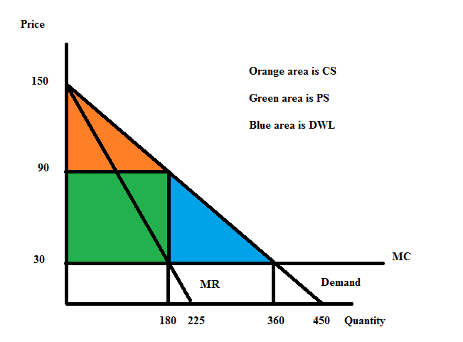

b. When this firm is a second degree price discriminator it chooses to produce 210 units in all. It will charge $120 per unit for the first 90 units sold, $110 per unit for the next 30 units, $90 per unit for the next 60 units, and $80 for the final thirty units. To calculate the level of profits the firm earns when it practices second degree price discrimination we need to calculate its TR and its TC:

TR = P*Q = ($120 per unit)(90 units) + ($110 per unit)(30 units) + ($90 per unit)(60 units) + ($80 per unit)(30 Units) = $10,800 + $3300 + $5400 + $2400 = $21,900

TC = FC + VC = $50 + ($30 per unit)(210 units) = $6350

Profits for this second degree price discriminator = $21,900 - $6350 = $15,550

CS’ = (1/2)($150 per unit - $120 per unit)(90 units) + (1/2)($120 per unit - $110 per unit)(120 units – 90 units) + (1/2)($110 per unit - $90 per unit)(180 units – 120 units) + (1/2)($90 per unit -

$80 per unit)(210 units – 180 units) = $2250

PS’ = ($120 per unit - $30 per unit)(90 units) + ($110 per unit - $30 per unit)(120 units – 90 units) + ($90 per unit - $30 per unit)(180 units – 120 units)+ ($80 per unit - $30 per unit)(210 units – 180 units) = $15,600

DWL’ = (1/2)($80 per unit - $30 per unit)(360 units – 210 units) = $3750

To summarize our findings:

Total quantity produced by the second degree price discriminator = 210 units

Prices charged by the second degree price discriminator = $120 per unit for the first 90 units, $110 per unit for the next 30 units, $90 per unit for the next sixty units, and $80 per unit for the final 30 units

Level of profits for the second degree price discriminator = $15,550

Consumer Surplus in this case of second degree price discrimination = CS’ = $2250

Producer Surplus = PS’ = $15,600

Deadweight Loss in this case of second degree price discrimination = $3750

Here’s the graph to illustrate the second degree price discrimination case:

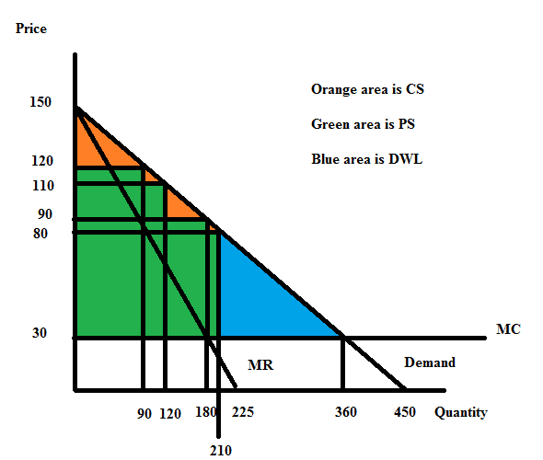

c. Second degree price discrimination benefits consumers by allowing them to consume more units of the good: in this case, 210 units instead of 180 units. And, some of these units are cheaper-30 units are now selling for $80 per unit. But, we can also see that second degree price discrimination in this case is shrinking CS from $5400 to $2250. We can also see that the area of DWL is shrinking from $5400 to $3750.

Second degree price discrimination benefits the producer: they sell more of the good and their total profit goes up from $10,750 to $15,550. We can also see that PS increases from $10,800 to

$15,600.

d. When the firm practices perfect price discrimination it charges a different price for every unit it sells. This results in the market demand curve also being the firm’s marginal revenue curve. To find the quantity the firm will produce we still set MR = MC but this time the MR is the firm’s demand curve. Thus,

MR = MC

150 – (1/3)Q = 30

Qsocially optimal = 360 = the amount that the perfect price discriminator will produce. This is the socially optimal amount of the good because the MC of producing the last unit is equal to the price the consumer pays for this last unit: that is, the cost to society of producing this last unit equals the value to the consumer of consuming this last unit.

CS” = 0 since the producer captures all of the consumer surplus when they practice perfect price discrimination

PS” = (1/2)($150 per unit - $30 per unit)(360 units) = $21,600

TR = (1/2)($150 per unit - $30 per unit)(360 units) + ($30 per unit)(360 units) = $32,400 TC = FC + VC = 50 + ($30 per units)(360 units) = $10,850

Profit for the perfect price discriminator = $32,400 - $10,850 = $21,550

DWL” = 0 since the firm is now producing the socially optimal amount of the good

To summarize our findings:

Total amount of the good produced in the market = 360 units

PS” with perfect price discrimination = $21,600

CS” with perfect price discrimination = $0

Profit for firm with perfect price discrimination = $21,550

DWL with perfect price discrimination = $0

Here’s the graph:

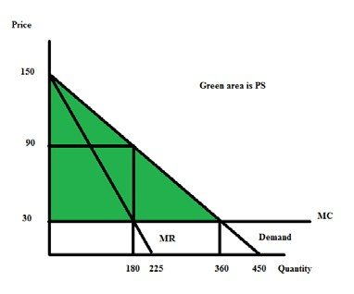

4. Karen is a supplier of dry cleaning services in her small town. She operates the only dry cleaning service and therefore has significant market power. She knows that she has two types of clients: business clients who come in regularly to have their clothing cleaned and non-business clients who have occasional garments to clean. She knows the following information where Q is the quantity of dry cleaning units and P is the price per unit of dry cleaning:

Demand for dry cleaning services from business clients: Q = 20 – (1/2)P

Demand for dry cleaning services from non-business clients: Q = 30 - P

MC of providing dry cleaning services: MC = 4

Fixed Costs of providing dry cleaning services: FC = 10

Suppose that Karen decides to treat her dry cleaning business as two separate monopolies: one providing dry cleaning services to business clients and one providing dry cleaning services to non-business clients. She can readily identify the status of each of her clients since she has been in business in this small town for a long, long time and she knows her customers well.

a. Given that Karen is going to treat these two types of customers as separate entities, what will be the profit maximizing price and quantity of the good for each type of customer? And, what will total profits be equal to? Show how you found your answers to this set of questions clearly and logically! Provide a set of graphs to illustrate your answer.

b. Now, suppose Karen would like to verify that this two pricing scheme idea in (a) actually results in her earning greater profits than if she were to simply follow a single pricing monopoly model. So, find the market demand curve. Then determine the profit maximizing quantity and price if Karen treats this market as a single market with one price for dry cleaning. What happens to the level of profits Karen earns under this pricing decision? Provide numeric values for all your work and clearly and logically explain how you found your answers. Also, provide a graph to illustrate your answer.

Answers:

a. Karen has decided to treat this pricing and production decision as two separate monopolies: so she needs to find the MR curves for each sub-market and then equate MR to MC to identify the profit maximizing quantity for each market. She will then take these quantities and use the respective demand curve to find the profit maximizing price for each market. Once she has the price and quantity for each sub-market she can calculate the total profit she will earn by treating this market as two separate monopolies. So, let’s go through this process:

Business Client Market Analysis:

Demand for this market: Q = 20 – (1/2)P or P = 40 – 2Q MR for this market: MR = 40 – 4Q

MC for this market: MC = 4 Set MR = MC: 40 – 4Q = 4

Q for business client market = 9 units of dry cleaning

Use this quantity in the demand curve to find the profit maximizing price for this sub-market: P = 40 – 2(9) = $22 = price for a unit of dry cleaning for the business clients

Non-business Client Market Analysis:

Demand for this market: P = 30 - Q

MR for this market: MR = 30 – 2Q MC for this market: MC = 4

Set MR = MC: 30 – 2Q = 4

Q for non-business client market = 13 units

Use this quantity in the demand curve to find the profit maximizing price for this sub-market: P = 30 – 13 = $17 = price for a unit of dry cleaning for the non-business clients

Here’s the set of graphs:

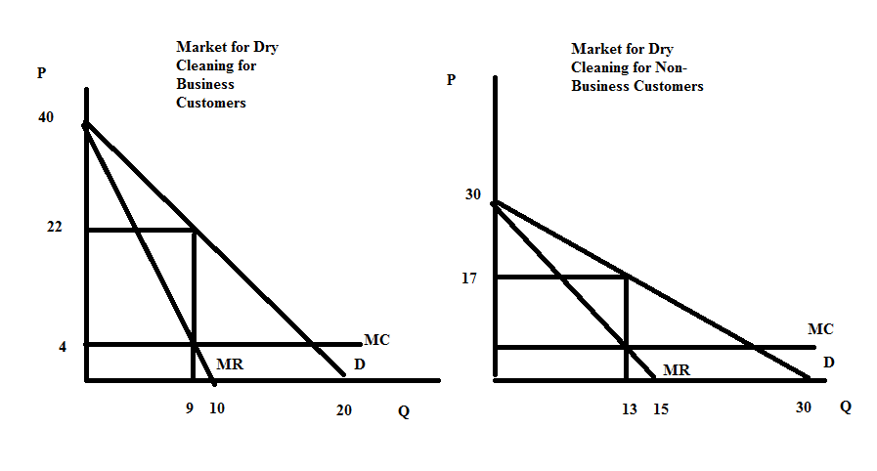

Profits with this pricing scheme can be calculated as follows:

TR from business customers = ($22 per unit of dry cleaning)(9 units of dry cleaning) = $198

TR from non-business customers = ($17 per unit of dry cleaning)(13 units of dry cleaning) = $221

Total TR from the two markets = $198 + $221 = $419

TC from production of 22 units of dry cleaning = VC + FC = ($4 per unit)(22 units) + 10 = $98

Profits from this pricing scheme = $419 - $98 = $321

b. Now, let's consider if this market is treated as a single price monopolist. We will need the market demand curve. Here's the picture of this market demand curve:

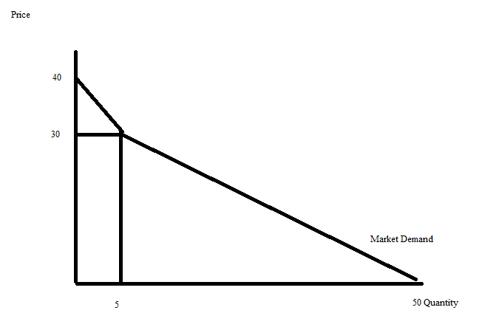

We can write the equations for the two segments of the market demand curve as: Top segment: P = 40 – 2Q for quantities less than or equal to 5

Lower segment: P = (100/3) – (2/3)Q for quantities greater than or equal to 5

The MR curves for these two segments are:

Top segment: MR = 40 – 4Q for quantities less than or equal to 5 Lower segment: MR = (100/3) – (4/3)Q for quantities greater than or equal to 5

But, which MR to use? Let's try both and decide which gives us greater profits! Using the top segment:

MR = MC 40 – 4Q = 4

4Q = 36

Q = 9 units of dry cleaning….but this quantity is beyond the domain of this segment of the market demand curve

Using the lower segment: MR = MC

(100/3) – (4/3)Q = 4

100 – 4Q = 12

4Q = 88

Q = 22 units of dry cleaning

P = (100/3) – (2/3)Q = (100/3) – (2/3)(22) = $18.67 per unit of dry cleaning

TR = ($18.67 per unit of dry cleaning)(22 units of dry cleaning) = $410.74

TC = ($4 per unit of dry cleaning)(22 units of dry cleaning) + 10 = $98

Profit with this output and price combination = 410.74 – 98.00 = $312.74

Comparison of the profits from the pricing scheme in (a) versus that in (b) reveals that charging different prices to business customers and non-business customers results in greater profits: $321 in profits versus $312.74. Price discrimination does pay off!

Here's a graph to illustrate this second possibility:

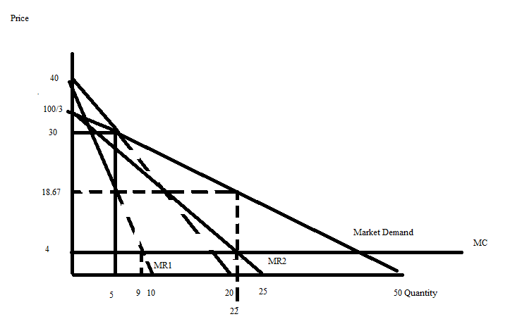

**Game Theory:**

5. Consider the following payoff matrix which shows Roger's and Wilma's profits depending upon whether they sell stock or buy stock. The first numerical entry in a cell is Roger's profit and the second numerical entry in a cell is Wilma's profit. Use this information to answer this set of questions.

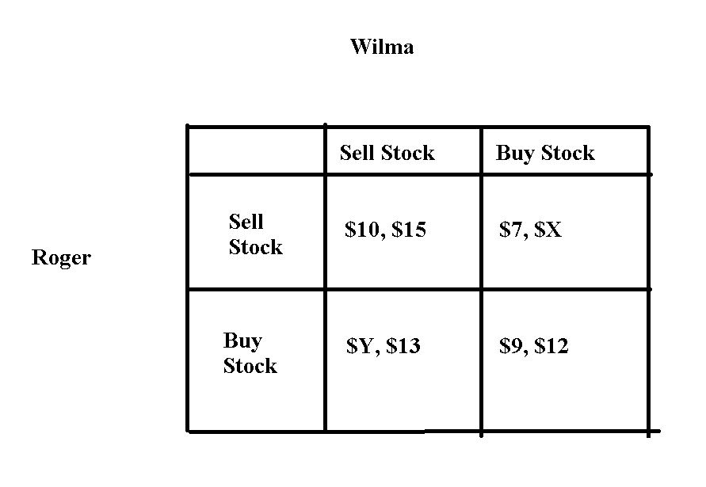

a. If Roger's dominant strategy is to "Buy Stock" what conclusion can you make? Be very specific in your statement here.

b. If Wilma's dominant strategy is to "Sell Stock" what conclusion can you make? Be very specific in your statement here.

c. Given the information in (a) and (b), what do you predict will be the outcome of this game? Be specific in your answer. Provide a numeric value for the profits Roger and Wilma will earn.

d. Suppose you know nothing about Roger and Wilma's preferred strategies. What would need to be true about the value of Y and the value of X to conclude that neither Roger nor Wilma have a dominant strategy? Be specific in your answer.

Answer:

a. If Roger's dominant strategy is to "Buy Stock" then the value of Y must be greater than $10.

b. If Wilma's dominant strategy is to "Sell Stock" then the value of X must be less than $15.

c. Roger will "Buy Stock" and Wilma will "Sell Stock". Roger will earn profits greater than $10 and Wilma will earn profits equal to $13.

d. If the value of Y is less than $10 and the value of X is greater than $15, than neither Roger nor Wilma will have a dominant strategy.

6. Joe and Maria both operate businesses that provide the same service. Joe is trying to decide whether he should engage in an advertising campaign or not: he reasons that the advertising campaign will certainly increase his cost, but it may also increase his level of profits. Maria is also analyzing whether she should engage in an advertising campaign: her reasoning is similar to Joe's reasoning. They both do some research! Joe discovers that if he advertises and Maria also advertises, he will earn $800 in profits and Maria will earn $800 in profits. If Joe does not advertise while Maria advertises then Maria will earn $1200 in profits while Joe will only earn $400 in profits. If Joe advertises and Maria does not advertise, then Joe will earn $700 in profits and Maria will earn $1000 in profits. And, finally if they both choose not to advertise then Joe will earn $300 in profits and Maria will earn $300 in profits.

a. Construct a payoff matrix given the above information. In your payoff matrix list Joe's profits first and Maria's profits second. Make sure your payoff matrix is completely and clearly labeled.

b. Analyze the payoff matric you constructed. Does Joe have a dominant strategy? Does Maria have a dominant strategy? What do you predict will be the outcome of this game? Explain your answer fully.

Answer:

a.

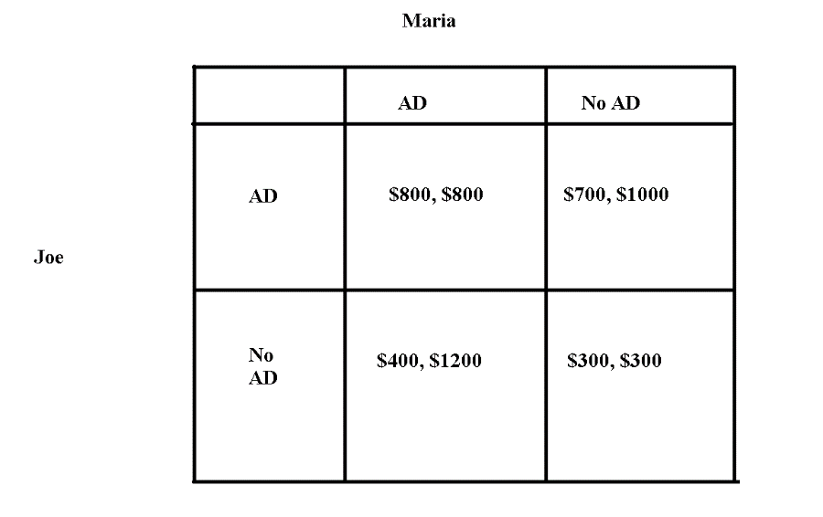

b. When Joe determines what he should do, he considers this payoff matrix as two columns. If Maria is assumed to "AD", then Joe sees that he is better off if he also selects "AD". If Maria is assumed to "no AD", then Joe sees that he is better off if he selects "AD". No matter what Maria decides to do, it is better for Joe to advertise his product. Joe's dominant strategy is "AD".

When Maria determines what she should do, she considers this payoff matrix as two rows. If Joe is assumed to "AD", then Maria sees that she is better off if she decides to select "No AD". If Joe is assumed to "no AD", then Maria sees that she is better off if she selects "AD". The better strategy for Maria depends upon what Joe selects as his strategy. Maria does not have a dominant strategy. However, since Joe does have a dominant strategy we can assume that he will "AD" and that Maria, recognizing this, will select "No AD" since this is the strategy that is better for her when Joe decides to "AD".

**Externalities:**

7. Consider the production of a good. At the market provided quantity of the good you are told that the marginal social benefit from consuming this good is less than the marginal social cost of producing this good.

a. Draw a graph that represents this provided information. In your graph be sure to include the marginal private benefit (MPB) curve, the marginal social benefit curve (MSB), and the marginal social cost (MSC) curve. Label the market quantity, Qmarket, as well as the socially optimal quantity, Qsocial optimum, in your graph. If there is an area of deadweight loss label this area as well.

b. Given the above information, does the market left to itself, produce too much or too little of the good? Explain your answer.

Answer:

a.

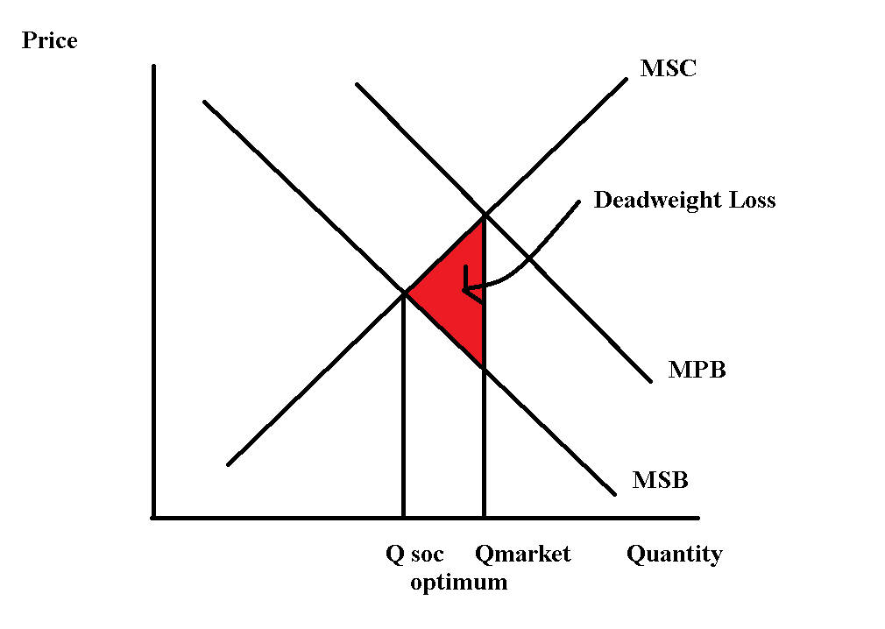

b. The market produces too much of the good since MSC > MSB at the market quantity. At the market quantity the value to the consumer of the last unit consumed is less than the cost to society of producing this last unit. The market, failing to internalize the externality, produces too much of the good.

8. The marginal social cost of providing a good is given by the following equation where Q is the market quantity and P is the price per unit:

Marginal Social Cost: MSC = 10 + 2Q

The marginal private benefit of providing this good is given by the following equation:

Marginal Private Benefit: MPB = 100 – Q

You are also told that this good generates negative consumption benefits of $9 per unit of the good consumed.

a. Given this information what is the quantity produced by the market?

b. Given this information what is the socially optimum amount of the good. Show how you found your answer.

c. What is the deadweight loss when this market fails to internalize (to correct for) the externality? Show how you found your answer.

Answer:

a. The market will produce where MPB = MSC:

100 – Q = 10 + 2Q

90 = 3Q

Qmarket = 30 units

b. The socially optimum amount of the good is where MSB = MSC. We need to find the MSB curve. We know that there is a negative externality of $9 per unit. This means that the MSB curve is shifted down from the MPB curve by $9 at every quantity. The MSB can be written as:

MSB = 91 – Q

Set the MSB = MSC:

91 - Q = 10 + 2Q

3Q = 81

Qsocial optimum = 27 units

c. DWL is calculated as follows:

DWL = (1/2)($9 per unit)(30 units – 27 units) = $13.50

**Public Goods:**

9. Imagine a community that has only two residents: Paul and Sally. Paul and Sally both realize that their community would benefit from the installation of streetlights, and they are trying to figure out the optimal number of streetlights for their community. Paul and Sally are both willing to reveal their preferences for streetlights:

Paul’s preferences for streetlights are given by the equation: MPB = 20 – 2Q

Sally’s preferences for streetlights are given by the equation: MPB = 10 – (1/2)Q

where MPB is the marginal private benefit for the individual and Q is the number of streetlights. Both Paul and Sally know that the marginal social cost of installing a streetlight is given by the equation:

Cost of installing streetlights: MSC = 3.5Q

a. Given this information, start by constructing three graphs that are vertically drawn one under the other. In the top graph depict the MPB for Paul; in the second stacked graph depict the MPB for Sally; and in the final stacked graph depict the MSB (marginal social benefit) from streetlights assuming that Paul and Sally are the only two individuals in this community. Label all axis, and any “kink” points clearly and completely.

b. Given your graphs in (a), write an equation(s) for the MSB curve you found. Make sure you also indicate any relevant range for the MSB equation(s) you provide.

c. Calculate the optimal number of streetlights in this community and then determine the total price per streetlight and the amount of this price that will be paid by Paul and the amount that will be paid by Sally. Show your work and explain how you found your answers.

Answers:

a.

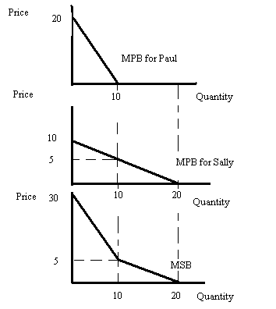

b. From the bottom graph in (a) we can see that there are two linear segments to the MSB curve. The top segment can be written as P = 30 – (5/2)Q for prices greater than or equal to $5 per unit. The bottom segment is P = 10 – (1/2)Q (this is just Sally’s MPB curve since at quantities greater than or equal to 10 units, Paul has no MPB from streetlights) for prices less than or equal to $5 per unit.

c. To find the optimal number of streetlights for the community, we first need to recognize that streetlights are a public good: non-rival and non-excludable. In this example, Paul and Sally have revealed their preferences and are not free riding. We can find the optimal amount of streetlights by equating MSC = MSB. But, this is a bit challenging for us since we have two MSB curves to consider. Let’s start with MSB = 30 – (5/2)Q. Setting this equal to MSC we have 30 – (5/2)Q = 3.5Q or 60 – 5Q = 7Q or Q = 5. Looking at the bottom graph in (a) we see that Q = 5 is in the range of quantities for this MSB curve. If 5 streetlights are produced then the MSC tells us that the price per streetlight will be equal to 3.5Q or 3.5(5) = $17.50 per streetlight. How much will Paul pay? Plug Q = 5 into his MPB curve to find out: MPB = 20 – 2Q = 20 – 2(5) = $10.00 per streetlight that Paul will play. (This implies that Sally will be paying $7.50 per streetlight-let’s check!).

How much will Sally pay? Plug Q = 5 into her MPB curve to find out: MPB = 10 – (1/2)Q = 10 – (1/2)(5) = $7.50.

10. Consider a community that has two residents, Leslie and Ron. Leslie and Ron would both like to have some public parks in their community and they are trying to decide on the optimal number of parks to build, and what price they should each contribute for each park. Luckily they are both willing to reveal their preferences and so we do not have to worry about the free rider problem. You are provided the following equations describing these individuals demand curves for public parks where P is the price per park and Q is the quantity of parks:

Leslie’s demand for parks: Q = 6 – 2P

Ron’s demand for parks: P = 3/2 – (1/4)Q.

You are also told that the marginal social cost of providing a park is given by the equations:

Marginal Social Cost: MSC = $3

a. On your homework paper draw three graphs vertically one above the other. The first graph should be labeled “Leslie’s demand”; the second graph should be labeled “Ron’s demand”; and the third graph should be labeled “Market demand”. On each graph the horizontal axis should be labeled “Quantity of Parks” while the vertical axis should be labeled “Price of Parks”. Now in each graph draw in the demand curve corresponding to your label. Remember that the market demand curve will be a vertical summation of the individual demand curves since a public good is non-rival.

b. Write an equation for the market demand curve for the public good.

c. Given the above information, what is the optimal number of parks for the community? Show how you found this number.

d. Since Leslie and Ron each get benefits from the parks, they will each contribute towards the cost. Given her demand, how much will Leslie contribute per park? How much will Ron contribute per park? Why do Leslie and Ron contribute different amounts?

e. Now think about what would happen if Leslie and Ron were unable to share the same parks. Now each of them would have to build their own private park, and pay the full cost. How many parks are Leslie and Ron willing to pay for individually? How many total parks would be built? *(Remember: we can’t build negative parks.)*

Answers:

a.

Macintosh HD:Users:Tom:Dropbox:Teaching:Econ 101 TA Fall 2014:Homeworks:Hw6graph1.pdf

Macintosh HD:Users:Tom:Dropbox:Teaching:Econ 101 TA Fall 2014:Homeworks:hw6graph2.pdf

Macintosh HD:Users:Tom:Dropbox:Teaching:Econ 101 TA Fall 2014:Homeworks:Hw6graph3.pdf

b.

Leslie: P = 3 – (1/2)Q

Ron: P = 3/2 – (1/4)Q

Market Demand Curve for the Public Good: P = 9/2 – (3/4)Q

c. To find the optimal number, find the market demand when the price equals marginal cost.

MC = 3

P = 9/2 – (3/4)Q

3 = 9/2 – (3/4)Q

Q = 2 parks

d. The marginal social cost of each park is $3, which must be paid by Leslie and Ron. From part (c), we know that the optimal number of parks is Q = 2. We can plug Q = 2 into the individual demand curves to find each person’s willingness to pay for 2 parks.

Leslie: P = 3 – (1/2)(2)

P = $2 per park

Ron: P = 3/2 – (1/4)(2)

P = $1 per park

So Leslie is willing to contribute $2 per park when 2 parks are built, and Ron is willing to contribute $1 per park. $2 + $1 = $3 = MSC, so together they cover the full cost of the parks. Because Leslie and Ron have different demand curves, or willingness to pay for parks, their contributions are different. This only works because both of them are honestly reporting their individual demand for parks.

e. If Leslie has to pay the full cost of $3 per park, she would be willing to pay for:

3 = 3 – (1/2)Q

Q = 0 parks

If Ron has to pay $3 per park, he would be willing to pay for:

3 = 3/2 – (1/4)Q

Which gives Q less than zero, so he wouldn’t pay for any parks either.

So if Leslie and Ron cannot share the benefits and costs of the parks, none will be built in the community.