Economics 111
Fall 2019
Answers to Homework #3

General Instructions:

- Homework is due at the beginning of the lecture.
- Do not submit the homework questions. Just submit your answers: these answers should be neat, legible, and easy to follow. Be generous with your use of paper. Do not write in small, hard to read font. If asked to provide a graph, provide a generous graph.
- All homeworks should be stapled and on the front page your name should be legibly written.
- It is all right to do homework with a "study buddy": however, when asked to explain your answer your words should be significantly different from your "study buddy's" words. Homeworks that are too similar to one another will not receive any credit.
- To get full credit for the homework you need to answer every question that is asked. A failure to answer all the questions will result in a lower homework score.
- It is a good idea to make a copy of your homework so that you can compare your answers to the posted answers. Your copy (a digital photo) also provides a time-stamped proof that you did the homework.

Elasticity:

1. Consider the following demand curve for widgets where P is the price per widget and Q is the quantity of widgets.

Demand: Q = 3000 – 3P

a. Fill in the following table using the above information.

P | Q | Total Revenue = TR
$0
120
180
200
250
450
600
800

b. In your own words describe what happens to total revenue if the price of this good goes from $450 to $600. In your answer make sure you include references to the price and quantity effects.

c. What is the maximum total revenue that could be earned given this demand curve and holding everything else constant? Assume that the supplier is free to set any price they want and their goal is to set their price to maximize their total revenue. Note: this price may not be in the table you just filled in!

Answer:

a.
P | Q | Total Revenue = TR
$0 | 3000 | $0
120 | 2640 | 316,800
180 | 2460 | 442,800
200 | 2400 | 480,000
250 | 2250 | 562,500
450 | 1650 | 742,500
600 | 1200 | 720,000
800 | 600 | 480,000

b. In this example, when the price is $450, the quantity demanded is 1650 widgets and the total revenue is $742,500; when the price rises to $600, the quantity demanded is 1200 widgets and the total revenue is $720,000. When price increases fewer units will be demanded and this quantity effect will cause total revenue to fall instead of selling 1650 widgets only 1200 widgets are demanded and therefore (450)($450) or $202,500 in total revenue is lost due to the quantity effect. But, the price effect causes total revenue to increase: the good is selling for $150 more and there are 1200 widgets demanded at this higher price-this implies that the price effect is an increase in total revenue of (1200)($150) or $180,000. Combining these two effects we see that total revenue decreases by $180,000 - $202,500 or -$22,500.

c. Total revenue will be maximized at the midpoint of this market demand curve. This will occur at a price of $500 and a quantity of 1500 widgets for an amount of total revenue equal to $750,000.

2. Consider the following market demand and market supply curves for scissors where P is the price per scissor and Q is the quantity of scissors.
Demand: P = 11 – (1/100)Q
Supply: P = 2 + (1/200)Q

a. Given the above information find the equilibrium price and quantity in this market. Show your work.

b. Calculate the point elasticity of demand at equilibrium. Provide the general formula and show your calculations. Is demand elastic or inelastic? Explain your answer. Given this answer, will producers enhance their total revenue by increasing or by decreasing the price they charge for scissors?

c. Calculate the point elasticity of supply at equilibrium. Provide the general formula and show your calculations. Is supply elastic or inelastic? Explain your answer.

d. Suppose the price increases by $1.00. Using the arc elasticity formula calculate the price elasticity of demand between the initial equilibrium and this new point on the demand curve. Provide the general formula and show your work. Is demand inelastic or elastic? Explain your answer.

Answer:

a. Set demand equal to supply: thus,
11 – (1/100)Q = 2 + (1/200)Q
9 = (3/200)Q
Q = 600 scissors
P = 11 – (1/100)Q = 11 – (1/100)(600) = $5.00 per pair of scissors
Or, P = 2 + (1/200)Q = 2 + (1/200)(600) = $5.00 per pair of scissors

b. Point elasticity of demand = (-1/slope)(P/Q) = (1/(1/100))(5/600) = 5/6
Since the value of point elasticity of demand is less than one, we can conclude that demand is inelastic at the equilibrium point. We can also see that total revenue will increase if producers raise the price of scissors since demand is inelastic.

c. Point elasticity of supply = (1/slope)(P/Q) = (1/(1/200))(5/600) = 5/3
Since the value of point elasticity of supply is greater than one, we can conclude that supply is elastic at the equilibrium point.

d. When the price of scissors is $6 per pair, the quantity demanded is equal to 500 pairs of scissors. We can use these two points on the demand curve (Q, P) = (600, 5) and (500, 6) and the formula for arc elasticity of demand to make this calculation. Here is the formula:
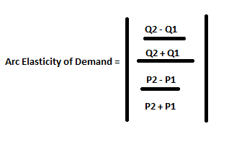
Arc elasticity of demand = │[(500 - 600)/(500 + 600)]/[(6 - 5)/(6 + 5)]│
Arc elasticity of demand = [(100)/(1100)]/[(1)/(11)] = 1
Since the measure of demand elasticity is one, we can conclude that demand is unit elastic.

3. a. You are told that the income elasticity of demand for bicycles is equal to 4. What does this mean if incomes in an economy increase by 20%?

b. You are told that the cross price elasticity of demand for bicycles and bike helmets is -2. What does this mean if the price of a bike helmet decreases by 10%?

c. You are told that the cross price elasticity of demand for bicycles and bus fares is equal to 1.5 What does this mean if the price of a bus fare increases by 5%?

Answer:

a. Income elasticity is equal to the percentage change in the quantity demanded divided by the percentage change in income. So, 4 = (percentage change in the quantity demanded)/(20%) implies that the percentage change in the quantity demanded was 80%. Thus, when incomes increased by 20%, the quantity of bicycles demanded increased by 80%. This would be good news if you were in the business of selling bicycles! Since income increased and the quantity of bicycles demanded increased, this tells us that bicycles are a normal good.

b. The cross price elasticity of demand is the percentage change in the quantity demanded of good X divided by the percentage change in the price of good Y. So, -2 = (percentage change in the quantity demanded of bicycles)/(-10%) implies that the percentage change in the quantity demanded was 20%. Thus, when the price of bike helmets fall by 10%, then the quantity of bicycles demanded increases by 20%. These two goods are complements.
c, The cross price elasticity of demand is the percentage change in the quantity demanded of good X divided by the percentage change in the price of good Y. So, 1.5 = (percentage change in the quantity demanded of bicycles)/(5%) implies that the percentage change in the quantity demanded was 7.5%. Thus, when the price of bus fares increases by 5%, then the quantity of bicycles demanded increases by7.5%. These two goods are substitutes.

4. Suppose your family runs a Greek yogurt factory which is famous in your town for its unique black Greek yogurt. After attending Econ 111 for a few weeks, you really feel like helping your father to make better pricing decisions. To begin with, you search for a market survey company to find out the demand curve for your black Greek yogurt, which turns out to be:

Q = 12 - 2P + 0.1I

where Q is the quantity demanded in US (in thousands of packages), P is the price for a package of Greek yogurt, and I is the median income in your town (in thousands of dollars).
Currently the price is set by your father at 2, and the median income is 40.

a. Using the point slope elasticity formula, what is the price elasticity of demand for Greek yogurt at the current price and income level?

b. Based on your result in part (a), do you think you should raise or lower the price in order to increase total revenue? (Think about the price elasticity of demand, and the price and quantity effects.)

c. Now verify your answer in part (b) by setting a new price which is $1 dollar higher/lower (based on your answer to part (b)) than the original price of $2 and then calculate the change in total revenue.

d. Using the two-point elasticity formula (the arc elasticity formula), what is the price elasticity of demand when you go from the original price to the new price?

Suppose the following two scenarios happen when your yogurt is priced at the new price level in part (c), and you hold your price unchanged during the following scenarios:

e. On the Greek yogurt market, your biggest rival is a kind of green Greek yogurt. Suppose the price of green Greek yogurt suddenly goes up from $3 to $3.5 due to an increase in the price of spinach, which is the main ingredient of the green Greek yogurt. Then, market investigation finds that this change causes the quantity demanded for your yogurt to increase by 2 units. So what is the cross-price elasticity of demand? Provide any formulas you use.

f. Your yogurt has an amazing effect of boosting productivity on the residents in your town, and this leads to an increase in the median income in your town: I goes from 40 to 50. Find the new quantity demanded for your yogurt and calculate the income elasticity of demand. Provide any formulas you use.

Answer:

a. Recall that the point slope elasticity formula is $\frac{\text{1}}{\text{|m|}}\frac{\text{P}}{\text{Q}}$, where m is the slope in the inverse demand curve. At I=40, we solve for the inverse demand curve (the demand curve written in slope-intercept form): P = 8 - 0.5Q. So m = -0.5. At P = 2, we have Q = 12 - 2*2 + 0.1*40 =12. So Plug m, P and Q in the formula we have, elasticity =$\frac{\text{1}}{\text{|0.5|}}\frac{\text{2}}{\text{12}}$=$\frac{\text{1}}{\text{3}}$

b. To increase total revenue, you should increase the price. Because at the current price, the price elasticity of demand is $\frac{\text{1}}{\text{3}}$< 1, meaning that we are on the inelastic part of the demand curve. When demand is inelastic, it means that a given percentage change in price will cause quantity to change by a smaller percentage. Another way of saying this is that the increase in revenue from raising the price (price effect) will be larger than the decrease in revenue from the lower quantity sold (quantity effect).

So as a general rule, if demand is inelastic, Total Revenue goes up when prices go up. When demand is elastic, Total Revenue goes up when prices go down. With a linear demand curve, Total Revenue will be maximized when price elasticity of demand = 1, which is called unit elastic. This will always occur at the midpoint of a linear demand curve.

c. When P = 2 + 1 = 3, Q = 12 - 2*3 + 0.1*40 = 10, so total revenue is P*Q = 30. While at P = 2, the total revenue is 2*12 = 24. So the new total revenue is higher than the original one when the price is increased, which verifies our rationale in part b).

d. Recall that the two-point price elasticity formula is given by$\left|\frac{percentage change in Q}{percentage in P}\right|=\left|\frac{\frac{Q_{2}-Q_{1}}{Q_{1}}*100\%}{\frac{P_{2}-P_{1}}{P_{1}}*100\%}\right|$. Here the original price P₁ = 2, original quantity Q₁ = 12, new price P₂ = 3, and new quantity Q₂ = 10. Plug them in, we have price elasticity of demand equals $\left|\frac{\frac{10-12}{12}}{\frac{3-2}{2}}\right|=\frac{1}{3}$.

e. Cross-price elasticity is given by$\left|\frac{percentage change in Q_{A}}{percentage in P_{B}}\right|$. Here A refers to your yogurt and B refers to the green Greek yogurt. Since change in $Q_{A}$ is 2, and before the change in $P_{B}$, demand for your yogurt is at 10 as in part c). So the percent change in $Q_{A}$ is $\frac{2}{10}*100\%$. Thus the cross-price elasticityof demand is $\left|\frac{\frac{2}{10}*100\%}{\frac{3-3.5}{3}*100\%}\right|=1.2$

f. First we need to find the new Q at the new income level. Put I=50 in the demand curve, we have Q=12 - 2*3 + 0.1*50 = 11. Then we are ready to apply the income elasticity of demand formula:
$$income elasticity=\left|\frac{percentage change in Q}{percentage in I}\right|=\left|\frac{\frac{11-10}{10}*100\%}{\frac{50-40}{40}*100\%}\right|=0.4$$

Consumer Theory:

5. Joe has $100 in income that he can spend on either good X or good Y. Good X costs $1 per unit while good Y costs $2 per unit.

a. Given the above information, draw a graph of Joe’s budget line (call it BL1) and write an equation in slope-intercept form for Joe’s budget line measuring good Y as the good on the vertical axis.

b. Given Joe’s income and the prices of these two goods and given Joe’s preferences he finds that he maximizes his satisfaction when he chooses to consume bundle A which consists of 60 units of good X and 20 units of good Y. Can Joe afford this bundle given his income and the prices of the two goods? Prove this mathematically. Does consumption of bundle A exhaust Joe’s available income?

c. Suppose that the price of good X increases to $2. Joe’s income and the price of good Y stay constant. Joe now finds that he maximizes his satisfaction when he consumes consumption bundle B which consists of 28 units of good X. Draw a graph that represents Joe’s BL1, his new budget line (BL2), bundle A and bundle B. Calculate how many units of good Y Joe consumes when he consumes consumption bundle B (make sure you show how you found this answer). Mark bundle B in your graph.

d. Suppose that Joe was constrained to stay on his first indifference curve-the one that bundle A sits on- while paying the new price for good X. We can construct this budget line 3 where Joe’s income has been compensated (in this case increased) so that he can reach the indifference curve that bundle A is on. On budget line 3 Joe finds that he maximizes his satisfaction by consuming bundle C which consists of 34 units of good x and 36 units of good Y. Draw a graph that illustrates BL1, BL2, BL3, bundle A, bundle B, and bundle C. Sketch in indifference curve 1 and indifference curve 2 in your graph.

e. How much would Joe’s income have to be increased by in order for him to have the same utility as he had initially while now facing the higher price for good X? You have all the necessary information at hand to calculate this increase in income. Show how you found your answer.

f. What is the amount of the substitution effect for good X given the above information? What is the amount of the income effect for good X given the above information? Explain your answer.

Answer:

a.
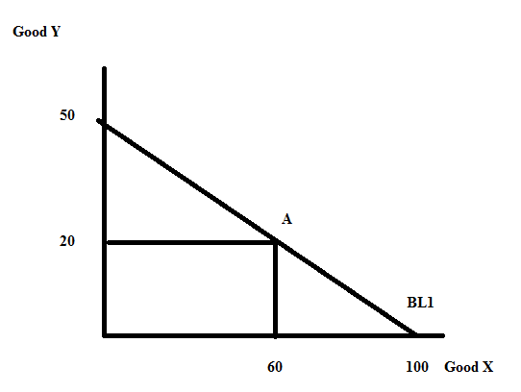
Y = 50 – (1/2)X

b. Bundle A consists of (X, Y) = (60, 40). We know that the price of good X is $1 per unit and the price of good Y is $2 per unit. 60 units of good X will cost $60 and 20 units of good Y will cost $40, for a total cost of $100. Since Joe's income is $100, he can afford this consumption bundle and his income will be exhausted (completely used up) when he purchases this bundle.

We know that the budget line for the two goods X and Y can be expressed as:
Income = (Price of good X)(Quantity of good X) + (Price of good Y)(Quantity of good Y)
$100 = ($1 per unit of good X)(60 units of good X) + ($2 per unit of good Y)(20 units of good Y)
100 = 60 + 40
This is a true statement: that tells us that the consumption bundle A sits on Joe's budget line 1.

c.
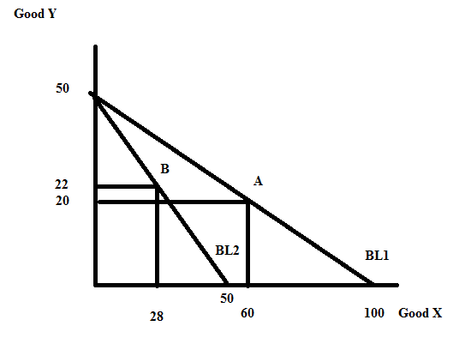
For BL2: Income = (New Price of good X)(Quantity of good X) + (Price of good Y)(Quantity of good Y)
100 = ($2 per unit of good X)(28 units of good X) + ($2 per unit of good Y)(Quantity of good Y)
100 = 56 – 2Y' where Y' is the Quantity of good Y
44 = 2Y'
Y' = 22

d.
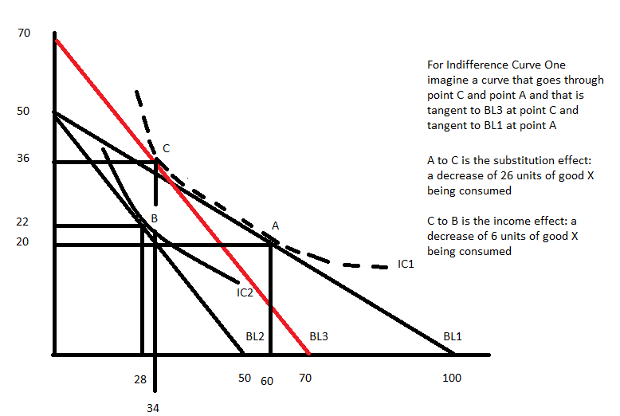
This is not a beautifully "drafted" image, but it gives the "flavor" of what is happening. Point A is just tangent to BL1 and lies on IC1. Point C is tangent to BL3 (new prices and compensated income) and lies on IC1 (same satisfaction as Joe gets at Point A). Point B is just tangent to BL2 (new prices and original income) and lies on IC2.

e. At Bundle C we know that Joe consumes 34 units of good X at a price of $2 per unit of good X and 36 units of good Y at a price of $2 per unit of good Y. We can therefore calculate the income Joe must have in order to consume this bundle:
Income' = ($2 per unit of good X)(34 units of good X) + ($2 per unit of good Y)(36 units of good Y)
Income' = 68 + 72 = $140
Joe needs a total of $140 in order to consume bundle C. If we were to compensate Joe so that when facing the new prices he had the same satisfaction or utility he got from Bundle A we would need to increase his income by $40 from $100 to $140.

f. The substitution effect can be measured as the change in good X as Joe moves from Bundle A to Bundle C: the substitution effect is therefore a decrease of 26 units (60 units of good X – 34 units of good X = 26 units of good X). Joe consumes 26 units less of good X due to the change in the relative price of good X.

The income effect can be measured as the change in good X as Joe moves from Bundle C to Bundle B: the income effect is therefore a decrease of 12 units (34 units of good X – 28 units of good X = 6 units of good X). Joe consumes 6 units less of good X due to the reduction in his purchasing power that occurs when the price of good X increases.

6. You are provided the following graph depicting Babette's budget line one, BL1, and Babette's budget line two, BL2. When Babette faces BL1 she maximizes her utility by consuming the consumption bundle designated as point A. When Babette faces BL2 she maximizes her utility by consuming the consumption bundle designated as point B. Suppose you also know that the price of good Y is $2 per unit.

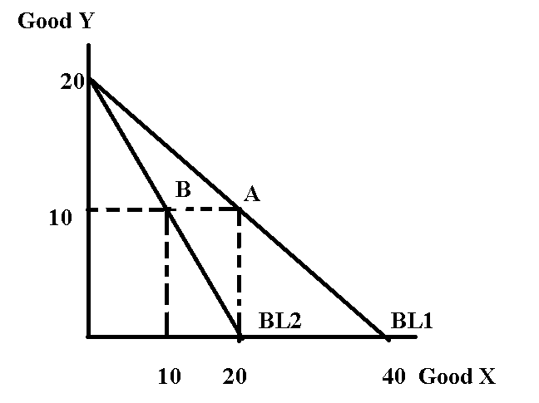

Given the above information and holding everything else constant, what is the equation for Babette's demand curve for good X? Assume that her demand curve for quantities between 10 and 20 units can be described by a linear demand curve.

Answer:

On examination of the provided graph and with the information given about the price of good Y we can first figure out the level of income for BL1:
Income = PyY + PxX
If good X = 0, then the individual can afford to buy 20 units of good Y. Therefore, Income = PyY = 2(20) = $40
And, once we know income we can then figure out the price of X. When good Y = 0, the individual can afford to consume 40 units of good X. Thus, Income = PxX or 40 = Px(40) and the price of X must be $1 per unit.
Now, that we have this essential and basic information we can recognize the point A represents the consumer utility maximization point when the price of good X is $1 per unit. And, when the price of good X is $1 per unit, the individual maximizes their satisfaction by consuming 20 units of good X. Thus, (Q, P) = (20, 1) is one point on the individual's demand curve.

For BL2, the price of good Y has not changed and the level of income has not changed. But, the price of good X has changed. We see now that the individual can only afford 20 units of good X if they buy only good X: this implies that the price of good X is now $2 per unit. The individual maximizes their satisfaction by consuming bundle B where the quantity of good X is 10 units. Thus, (Q, P) = (10, 2) is another point on the individual's demand curve.

We now have two points for the individual's demand curve. If we assume that the demand curve is linear we can write an equation for this demand curve. Thus,
y = mx + b
P = mQ + b
m = slope of demand curve = (change in the price of the good)/(change in the quantity of the good) = (1 – 2)/(20 – 10) = -1/10
P = (-1/10)Q + b
Using one of our known points we have:
1 = (-1/10)(20) + b
b = 3
And therefore the demand curve can be expressed as: P = 3 – (1/10Q

7. Martina's utility from consuming cookies (C) and milk (M) is described by the following information:

Utility = 2CM
Marginal utility of cookies = MUc = 2M
Marginal utility of milk = MUm = 2C

Martina's income is initially equal to $100 and the price of cookies is $5 per unit and the price of milk is $10 per unit.

a. Given the above information, write an equation for Martina's budget line. Let's refer to this budget line as BL1. In your work, measure cookies on the horizontal axis and milk on the vertical axis.

b. Given the above information find the consumption bundle (C, M) that maximizes Martina's utility. Show all your work in finding this bundle and explain the steps you are taking to get to your answer.

c. Suppose that the price of cookies increases to $10 per unit. Given this information and holding everything else constant, what is Martina's new utility if she maximizes her utility? Show all your work in finding this answer and explain the steps you are taking to get to your answer.

d. The price of cookies is still $10 per unit. Identify the size of the income effect and the substitution effect for this individual when they move from BL1 to BL2. Explain all your work and how you arrived at your final answer.

Answer:

a. BL1 can be expressed as Income = PyY + PxX = PmM + PcC where m is milk and c is cookies. We are measuring cookies on the horizontal or x-axis and milk on the vertical or y-axis.
Thus, 100 = 10M + 5C or 20 = 2M + C is the equation for BL1.

b. The bundle that maximizes Martina's utility is that bundle that lies on her budget line (BL1) and is just tangent to her highest indifference curve. So, this bundle must sit on the line described by BL1: 20 = 2M + C and it must also be that bundle where the slope of the indifference curve is equal to the slope of the budget line. The slope of the indifference curve is given by (MUc/MUm) and the slope of the budget line is given by the price ratio (Pc/Pm). Note since both curves are downward sloping the two negative signs will cancel one another. Thus,

2M/2C = 5/10 or 2M = C

Using these two equations, 20 = 2M + C and 2M = C we can solve for (C, M). Thus,
20 = 2M + C
20 = C + C
20 = 2C
C = 10 and therefore M = 5. The optimal consumption bundle is (C, M) = (10, 5).

c. To find the answer to this question we first need to note that the budget line has changed when the price of cookies changes. The new budget line, BL2, can be written as:
Income = PmM + Pc'C
100 = 10M + 10C or
10 = M + C

We also see that the change in the price of the cookies alters the consumer optimization condition where the consumer equates the slope of the indifference curve to the slope of the budget line. We now have:
2M/2C = 10/10 or
M = C

Using these two equations we can find the coordinates for bundle B where the consumer maximizes their utility given the new price of cookies. Thus,
10 = M + C
10 = C + C
10 = 2C
C = 5 and therefore M = 5
Point B has the coordinates (C, M) = (5, 5).

Utility at point B is given by U = 2CM and since we know that (C, M) = (5, 5) at point B we can find the utility. Thus, U = 2(5)(5) = 50.

d. To find the income and substitution effects we must find point C and its coordinates (C", M"). Recall that point C sits on BL3 which is parallel to BL2. Point C must also sit on IC1 or the indifference curve that contains point A. Points A and C have the same utility since they are on the same indifference curve.

So, Ua = Uc. The utility at point A can be found as Ua = 2CM = 2(10)(5) = 100. So,
Ua = Uc = 100
100 = 2C"M" at point C

Budget line 3, BL3, has three unknowns: the level of income, Income", needed to be on BL3, as well as the levels of C" and M". BL3 is not useful to us in finding the income and substitution effect since it introduces another unknown value.

But, we know that point C is a point where the slope of BL3 is equal to the slope of the indifference curve or: MUc/MUm = Pc'/Pm. That is, 2M"/2C" = 10/10 or M" = C".

We can take our two equations:
100 = 2C"M"
M" = C"
and solve for (C", M"). Thus,
100 = 2C"M"
50 = C"(C")
C" = 5(2^{1/2})
M" = 5(2^{1/2})

The substitution effect is the change in consumption of cookies from their level at point A (10 units) to their new level at point C (5(2^{1/2})). The substitution effect is therefore 5(2^{1/2}) – 10 or a decrease of approximately 3 units of cookies.

The income effect is the change in consumption of cookies from their level at point C (5(2^{1/2})) to their new level at point B (5). The income effect is therefore 5 - 5(2^{1/2}) or a decrease of approximately 2 units of cookies.

Note: here are a few more things we can do with this problem!
Ua = 100
Uc = 2C"M" = 2(7.01)(7.01) where 7.01 is an approximate value for 5(2^{1/2}).
Uc = 98.28 which is pretty close to Ua given that we are rounding!

What income would this individual need in order to afford bundle C?
Income' = PmM" + PcC"
Income" = 10(7.01) + 10(7.01) = $140.20 or an increase of $40.20. (This is a bit rounded due to our approximation, but it gives us the general idea. The increase in the price of cookies reduces Martina's purchasing power and that means for Martina to have the same level of satisfaction that she had at point A while paying the new higher price for cookies will require that she have a bigger income. How much bigger? She needs an additional $40.20 to maintain her same level of initial satisfaction or utility.

Production and Cost:

8. Consider an aggregate production function:

Q = 4K1/2L1/2

where Q is the number of widgets, K is the number of units of capital, and L is the number of units of labor. For this question assume K is initially fixed at 100 units. You also know that total cost, TC, is given as:

TC = PkK + PlL

where Pk is the price of capital and Pl is the price of labor. Assume that the price of labor and the price of capital are both constant.

a. Fill in the missing cells of the table below based on the above information. (Hint: you might find it fun to do this with Excel: practice your spreadsheet skills and generate the numbers fast!). Calculate your answers to two places past the decimal. Note: the numbers you get may not generate U-shaped curves.

L | K | Q | VC | FC | TC | AVC | AFC | ATC | MC
0 |  |  |  | $400 |  | --- | --- | --- | ---
1
4 |  |  | $80
9
16
25
36
49

b. What is the price of capital? Explain how you got this answer.

c. What is the price of labor? Explain how you got this answer.

d. Given the above information and your work in (a), fill in the following table. Round your answers to two places past the decimal. (Hint: if you used Excel earlier, you can continue to use Excel in this part of the exercise-just a great way to keep building your spreadsheet skills!)

L | Q | MPL
0 |  | ---
1
4
9
16
25
36
49

e. Given your work, does the production of this good show diminishing marginal returns to labor? Explain your answer.

f. Suppose that K doubles and L doubles. Without using numeric values, can you prove this production function has constant returns to scale? That is, can you show that if K and L both double that output, Q, will also double?

Answers:
a.

L | K | Q | VC | FC | TC | AVC | AFC | ATC | MC
0 | 100 | 0 | 0 | 400 | 400
1 | 100 | 40 | 20 | 400 | 420 | 0.50 | 10.00 | 10.50 | 0.50
4 | 100 | 80 | 80 | 400 | 480 | 1.00 | 5.00 | 6.00 | 1.50
9 | 100 | 120 | 180 | 400 | 580 | 1.50 | 3.33 | 4.83 | 2.50
16 | 100 | 160 | 320 | 400 | 720 | 2.00 | 2.50 | 4.50 | 3.50
25 | 100 | 200 | 500 | 400 | 900 | 2.50 | 2.00 | 4.50 | 4.50
36 | 100 | 240 | 720 | 400 | 1120 | 3.00 | 1.67 | 4.67 | 5.50
49 | 100 | 280 | 980 | 400 | 1380 | 3.50 | 1.43 | 4.93 | 6.50

b. The price of capital can be found by recognizing that FC = PkK and from the table we see that FC = $400, we are told that K = 100 and therefore 400 = Pk(100) or the Pk = $4 per unit of capital.

c. The price of labor can be found by using the provided information in the table: when L = 4 we see that VC = $80. We know that VC = PlL and so 80 = Pl (4) or Pl = $20 per unit of labor.

d.

L | Q | MPL
0 | 0
1 | 40 | 40.00
4 | 80 | 13.33
9 | 120 | 8.00
16 | 160 | 5.71
25 | 200 | 4.44
36 | 240 | 3.64
49 | 280 | 3.08

e. Yes. To see this calculate the MPL and see what happens to this measure as you increase your hiring of the variable input (in this case, labor) while holding constant your fixed input. From (d) we can see that the value of the MPL decreases as L increases: this indicates that the change in total product from hiring another unit of labor falls: this is diminishing marginal returns to labor.
f. Q = 4K1/2L1/2
Then K increases to 2K and L increases to 2L. So, Q’ = 4(2K)1/2 (2L)1/2
Q’ = 4(2)K1/2L1/2
Q’ =8K1/2L1/2 which is twice the original production function! This production function exhibits constant returns to scale.
Perfect Competition:

9. Consider a perfectly competitive industry composed of six identical firms that produce widgets. Suppose you are told that the representative firm has the following cost curves where TC is total cost measured in dollars and q is units of widgets produced by a particular firm:

Total Cost: TC = 4 + 4q + q2
Marginal Cost: MC = 4 + 2q

Suppose you also know that the market demand curve is given by the following equation where P is the market price in dollars and Q is the market quantity of widgets:
Market Demand: P = 19 – (1/2)Q
Q represents market quantity and q represents firm quantity.

a. Given the above information write an equation for the market supply curve. Explain how you found this equation.

b. Given the market supply curve you found in (a), calculate the short run market equilibrium quantity and price in this market. How many units of output will the representative firm produce in the short run? Calculate the short-run profits for the representative firm. Explain your work.

c. Given your calculations in (b), will the representative firm produce in the short-run? Explain your answer.

- Given your answer in (b), what do you predict will happen in the long-run in this industry?

e. Given no changes in the firm’s cost curves or the market demand curve, calculate the following and explain how you found your answers:

Long-run equilibrium market price =
Long-run equilibrium market quantity = Level of production by the representative firm = _ Approximate number of firms in industry in the long-run (this will not be a whole number) =

Answer:

a. We know that the firm’s MC curve is its supply curve: technically speaking the firm’s MC above its AVC curve is its supply curve, but for this exercise we can just take the MC curve as the firm’s supply curve (this is because AVC and MC only intersect when q=0, so the shutdown
point is also where P = MC gives zero quantity anyway). We also know that there are six firms in the industry. So, let’s put this together graphically to illustrate the connection between these two ideas:
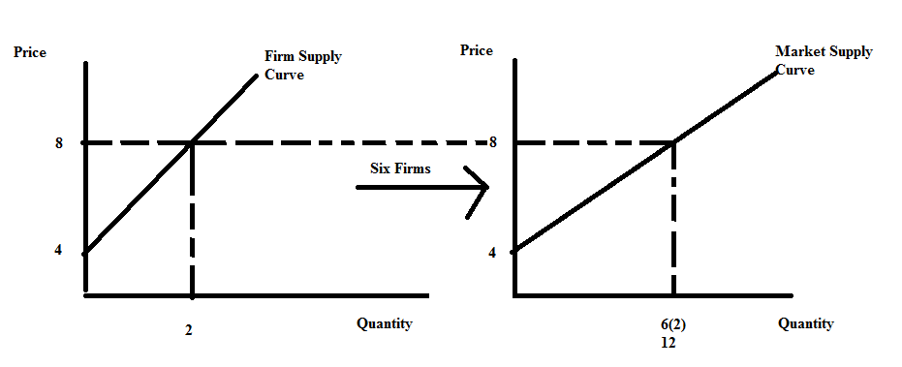
Graphing the representative firm’s MC curve we can see that the y-intercept is 4 and then choosing some cost per unit (in the graph I chose $8 per unit) we can see that the representative firm is willing to supply 2 units of output. Since there are six identical firms we can deduce that the total amount produced in the market when the cost for the additional unit is $8 per unit will be 12 units. The market supply curve can therefore be written as P = 4 + (1/3)Q.

b. We know that the market demand and market supply curves are as follows: Market Demand: P = 19 – (1/2)Q
Market Supply: P = 4 + (1/3)Q
Set these two equations equal to one another: 19 – (1/2)Q = 4 + (1/3)Q
114 - (3)Q = 24+ (2)Q
90 = 5Q
Q = 18 widgets
P = 19 – (1/2)Q = 19 - (1/2)(18) = 19 - 9 = $10 Or, P = 4 + (1/3)Q = 4 + (1/3)(18) = $10
The representative firm is a price-taking firm, so it will charge $10 per widget and it will view this market price as equivalent to its MR curve. Thus, MR = 10. The representative firm will equate MR to MC to decide its profit maximizing output. The firm does this because it wants to equate the addition to total cost from producing the last unit of the good (the MC) to the addition to total revenue from selling the last unit of the good (the MR): when the firm produces that quantity where MR = MC the firm knows that it is profit maximizing. Thus,
10 = 4 + 2q
6 = 2q
q = 3 widgets
In the short run the firm will produce 3 widgets and charge $10 per widget.

Short-run profit for the firm can be computed as TR – TC. For the representative firm: TR = P*q = ($10 per widget)(3 widgets) = $30
TC = 4 + 4q + q2 = 4 + 4(3) + (3)(3) = 4 + 12 + 9 = $25
Profit in the Short-run for the firm = $30 - $25 = $5

- The firm will produce in the short-run since its profits are greater than zero. This tells us that total revenue is greater than total cost and it assures us that this firm's revenue in the short run is sufficient to cover its variable costs of production in the short run. We know that the total revenue in the short run exceeds the sum of variable cost and fixed cost in the short run, so total revenue must exceed the short-run variable cost.

d. In the long-run ATC = MC for the representative firm since the representative firm earns zero economic profit in the long-run. Thus,
(4/q) + 4 + q = 4 + 2q
4/q = q
q = 2 widgets
We also know that in the long-run, the firm continues to profit maximize by producing where MR = MC and we can use this idea to find the long-run market price. Thus,
MR = MC MR = 4 + 2q
MR = 4 + 2(2) = $8 per widget = Long-run market price
We can use this market price (the price that will result in all firms left in the industry earning zero economic profit) and the market demand curve to calculate the long-run market equilibrium quantity. Thus,
P = 19 – (1/2)Q 8 = 19 – (1/2)Q
Q = 22 widgets
To find the number of firms in the industry in the long-run we can divide the market quantity, Q, by the representative firm’s production, q: thus,
Q/q = (22 widgets)/(2 widgets per firm) = 11 firms in the industry

To sum up:
Long-run equilibrium market price = $8
Long-run equilibrium market quantity = 22 widgets Level of production by representative firm = 2 widgets Number of firms in industry in the long-run = 11 firms

