Economics 111
Fall 2019
Answers to Homework #2

General Instructions:

- Homework is due at the beginning of the lecture.
- Do not submit the homework questions. Just submit your answers: these answers should be neat, legible, and easy to follow. Be generous with your use of paper. Do not write in small, hard to read font. If asked to provide a graph, provide a generous graph.
- All homeworks should be stapled and on the front page your name should be legibly written.
- It is all right to do homework with a "study buddy": however, when asked to explain your answer your words should be significantly different from your "study buddy's" words. Homeworks that are too similar to one another will not receive any credit.
- To get full credit for the homework you need to answer every question that is asked. A failure to answer all the questions will result in a lower homework score.
- It is a good idea to make a copy of your homework so that you can compare your answers to the posted answers. Your copy (a digital photo) also provides a time-stamped proof that you did the homework.

Basic Supply and Demand:

1. (Do not use a calculator on this problem: you are working to grow stronger computational skills and to do that I need you to stop turning to your calculator so quickly! Also, work this with the fractions (no decimals) but think about how you can "get rid of" the fractions. This is another aspect that I am working on with respect to growing your numerical literacy.) Suppose there are two firms in a market, Good Enterprises and Products Unlimited. You are told the following information about this market. Good Enterprises supplies 200 units of the product sold in this market when the price is $10 per unit. When the price in this market increases to $20, the quantity of the product supplied by Good Enterprises increases by 100 units. Good Enterprises supply curve is linear. Products Unlimited supplies 150 units of the product sold in this market when the price is $15 per unit. When the price increases to $30, the quantity of the product supplied by Products Unlimited increases to 300 units. Products Unlimited's supply curve is also linear.

a. From the above information write the equation for the supply curve for Good Enterprises.

b. From the above information write the equation for the supply curve for Products Unlimited.

c. Assuming that these two firms are the only producers of this product, draw a graph that illustrates the market supply curve for this product. Then, provide an algebraic expression for the market supply curve. If you need more than one equation please be sure to note what the relevant range of prices is for each equation.

Now, suppose that Products Unlimited discovers a new technology (that they patent and therefore do not share with any of their competitors) that allows them to double their output at every price level. [Hint: you might find it helpful to draw a graph of Products Unlimited's initial supply curve and then from this graph draw their new supply curve.]

d. Given this new information write the equation for Products Unlimited's new supply curve.

e. Given this new information, provide an algebraic expression for the market supply curve. If you need more than one equation please be sure to note what the relevant range of prices is for each equation.

Answers:
a. Good Enterprises' supply curve contains the two points (Q, P) = (200, $10) and (300, $20). From these two points we can calculate the slope of the supply curve as:
slope = (change in price)/(change in quantity) = (10 - 20)/(200 - 300) = 1/10. We can then plug this slope and one of our known points into the general slope intercept form equation to find the y-intercept:
y = mx + b
P = (1/10)Q + b
10 = (1/10)(200) + b
-10 = b
The equation for the supply curve for Good Enterprises is: P = (1/10)Q - 10.

b. Products Unlimited's supply curve contains the two points (Q, P) = (150, $15) and (300, $30). From these two points we can calculate the slope of the supply curve as: slope = (change in price)/(change in quantity) = (15 - 30)/(150 - 300) = 1/10. We can then plug this slope and one of our known points into the general slope intercept form equation to find the y-intercept:
y = mx + b
P = (1/10)Q + b
15 = (1/10)(150) + b
0 = b
The equation for the supply curve for Products Unlimited is: P = (1/10)Q.

c. Let's start with a sketch:
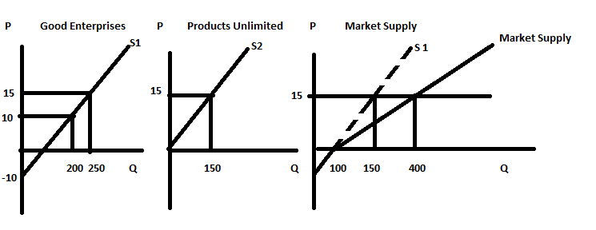
To find the market supply curve you need to horizontally sum the individual supply curves in the market. A simple sketch will guide you in this process. If you draw a graph of the supply curve for Good Enterprises (P = (1/10)Q - 10), and a sketch of the supply curve for Products Unlimited (P = (1/10)Q), then you can hold price constant and sum the quantity by these two firms at different prices. Thus, when the price is $0, the quantity supplied by the two firms is 100 units: Good Enterprises will supply 100 units and Products Unlimited will supply 0 units. When the price is $15, the quantity supplied by the two firms is 400 units (150 units supplied by Products Unlimited and 250 units supplied by Good Enterprises). With two linear supply curves summed together horizontally we can see that when the price is 0, the sum will be equal to 100 units. The market supply curve will have a kink in it that occurs at a price of $0. For prices greater than or equal to $0, the market supply curve is P = (1/20)Q - 5. There is no need to put in a range here since we are only going to consider positive values for price. Let me show you how I found this and let me provide you with two methods:

Method One: I know that (Q, P) = (100, $0) and (400, $15) are two points on the market supply curve. So,
m = slope = (0 - 15)/(100 - 400) = -15/-300 = 1/20
y = mx + b is the slope-intercept form. I will use this plus one of the points (100, 0) to find the value of "b". This procedure should be starting to seem familiar to you: we use this procedure frequently in this class.
P = (1/20)Q + b
0 = (1/20)(100) + b
b = -100/20 = -5
P = (1/20)Q - 5 for prices greater than or equal to $0.

Method Two: I could use my algebra skills to find this equation. I am summing horizontally so if I write the two equations in x-intercept form and then add them together I can get the market supply curve. So, here is the work:
Supply for Good Enterprises:
P = (1/10)Q - 10 in y-intercept form
Q = 10 P + 100 in x-intercept form
Supply for Products Unlimited:
P = (1/10)Q in y-intercept form
Q = 10P in x-intercept form
Market Supply:
Qa + Qs = Qtotal
Qtotal = (10 P + 100) + (10P)
Q = 20P + 100 in x-intercept form (note: that 100 is the x-intercept for the market supply curve)
Or, P = (1/20)Q - 5 for prices greater than or equal to $0

d. Now Products Unlimited's supply curve will contain the points (300, 15) and (600, 30). (I drew a sketch to direct my work and so should you!) Draw a sketch of the original supply curve and note that when price is equal to $15 Products Unlimited supplies 150 units and when price is equal to $30, the quantity they supply is equal to 300 units. Then, think about what quantities they will supply at each of these prices now that their production has doubled at every price. They will produce (300, $15) and (600, $30). The new supply curve for Products Unlimited can be written as P = (1/20)Q.

e. You are now adding together the supply curve for Good Enterprises and the new supply curve for Products Unlimited. When you do this you will see that for prices greater than or equal to $0 the market supply curve is the horizontal summation of the two firms' individual supply curves. Thus, for prices equal to or greater than $0, the market supply curve is P = (1/30)Q - (10/3). For prices less than or equal to $0, the supply curve is not relevant (no firm is going to sell their product for a negative price) but if you wanted to see what this "supply curve" looked like, you would simply be looking at the Good Enterprises supply curve.

Here are two approaches to finding the new market supply curve.

Method One: Draw a sketch that shows the individual supply curves and the market supply curve. Use this sketch to guide the math work you need to do to get the equation(s) for the market supply curve. Here is the graph:
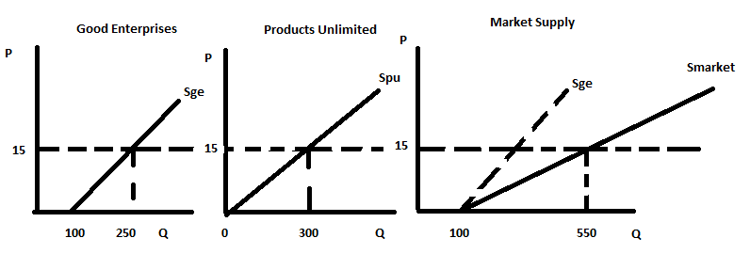

Method Two: I could use my algebra skills to find this equation. I am summing horizontally so if I write the two equations in x-intercept form and then add them together I can get the market supply curve. So, here is the work:
Good Enterprises' supply curve:
P = (1/10)Q - 10 in y-intercept form
Q = 10P + 100 in x-intercept form
Products Unlimited's new supply curve:
P = (1/20)Q in y-intercept form
Q = 20P in x-intercept form
The new Market Supply:
Qge + Qpu = Qtotal
Qtotal = (10P + 100) + (20P)
Q = 30P + 100 in x-intercept form (note: that 100 is the x-intercept for the upper segment of the market supply curve)
Or, P = (1/30)Q - (10/3) for prices greater than or equal to $0
Note: you can check that this equation works for some points that you know sit on the line: (Q, P) = (100, $0) and (550, $15). It does: I just checked it to make sure my math was right! And, I did not use a calculator throughout this entire problem.....best to not use one as you strengthen your numerical literacy!

2. You are given the following information:

Price | Quantity Demanded | Quantity Supplied
$1 | 20 | 10
$2 | 16 | 13
$3 | 12 | 16
$4 | 8 | 19

Given the above information and holding everything else constant, how many of the following statements are true? Provide a proof for each statement!

- The equation for the demand curve in x-intercept form is: Q = 6 – (1/4)P.
- The equilibrium price must be greater than $2.
- The equilibrium quantity must be less than 16 units.

Answer:

- The equation for the demand curve in x–intercept form is: Q = 6 – (1/4)P. FALSE

To see if this is true or not, you can try several (Q, P) pairs from the table. For example, if (Q, P) = (20, 1) then: when P = 1, the provided equation finds that Q is
Q = 6 – (1/4)(1) = 5.75 and this is not equal to Q = 20. So, this is a false statement!

- The equilibrium price must be greater than $2. TRUE

From the table we can see that when P = $2 that the quantity demanded is 16 units and the quantity supplied is 13 units. Since the quantity demanded is greater than the quantity supplied at this price we can conclude that the equilibrium price must be greater than $2.

- The equilibrium quantity must be less than 16 units. TRUE

From the table we can see that when P = $2 that the quantity demanded is 16 units and the quantity supplied is 13 units. When the price = $3 we can see that the quantity demanded is 12 units and the quantity supplied is 16 units. The equilibrium quantity must be less than 16 units given this information.

Use the information below to answer the next two (2) questions.

Suppose there is a market with three individuals. We know their individual demand curves and they are given by the following equations where P is the price of the good and Q is the quantity of the good:

Bob's demand curve for the good: Q = 10 – P
Ann's demand curve for the good: Q = 10 – 2P
Tom's demand curve for the good: Q = 4 – (1/2)P

3. Given this information and holding everything else constant determine which of the following statements are true and which are false. Provide a proof for each statement.

- If the price is between $5 and $8 then only Bob and Tom will have a demand for the good.

- If the price is between $5 and $10 then only Bob and Ann will have a demand for the good.

- If the price is between $5 and $8 then only Tom and Ann will have a demand for the good.

- If the price is less than $8 then all three of these individuals will have a demand for the good.

Answer:

First thing you need to do on this question is to rewrite each of the demand curves in y-intercept form:

Bob's demand: P = 10 – Q
Ann's demand: P = 5 – (1/2)Q
Tom's demand: P = 8 – 2Q

At a price greater than $10, no one is willing to buy this good.
At a price between $8 and $10, only Bob is willing to buy this good.
At a price between $5 and $8, Bob and Tom are willing to buy this good.
At a price less than $5, then all three of these individuals are willing to buy this good.

Statement (a) is a true statement.
Statement (b) is a false statement.
Statement (c) is a false statement.
Statement (d) is a false statement.

4. Given this information and holding everything else constant, how many of the following statements are true? Provide a proof for each statement.

- The market demand curve will have three kink points.
- One of the kink points for this market demand curve is (Q, P) = (6.5, 5).
- If the price of the good in the market was $4 per unit then the total quantity demanded at this price would be 14 units.
- If the price is lower than $4.50 than all three of these individuals will buy the good.

Answer:

- The market demand curve will have three kink points. FALSE

From the analysis from the last question we know that there are three different y-intercepts for the demand curves. This implies that there will be three different segments on the market demand curve and therefore two kink points.

- One of the kink points for this market demand curve is (Q, P) = (6.5, 5). TRUE

If the price is $5, then Bob and Tom are willing to buy the good. If P = 5, Bob demands 5 units of the good. If P = 5, Tom demands 1.5 units of the good. Together they demand 6.5 units of the good when the price is equal to $5.

- If the price of the good in the market was $4 per unit then the total quantity demanded at this price would be 14 units. FALSE

If the price of the good is $4, then all three individuals are willing to buy the good. At P = 4, Bob demands 6 units; at P = 4, Tom demands 2 units, and at P = 4, Ann demands 2 units. Total demand is therefore 10 units.

- If the price is lower than $4.50 than all three of these individuals will buy the good. TRUE

We have already determined the "kink points" in the previous question: so long as the price is less than or equal to $5 then all three of the individuals demand the good.

Price Ceilings and Price Floors:

5. Consider the market for luxury sport utility vehicles. Suppose that the demand and supply curves for these vehicles is given by the following two equations where P is the price per vehicle measured in thousands of dollars and Q is the quantity of vehicles measured in millions of vehicles:
Market Demand: P = 80 – 2Q
Market Supply: P = 20 + Q
a. Given this information, what is the equilibrium price and the equilibrium quantity in the market for luxury sport utility vehicles? Show how you found your answer and make sure you include the correct scale for both measures (thousands of dollars and millions of vehicles).

b. Given this information, what is the value of consumer surplus (CS) in this market? What is the value of producer surplus (PS) in this market? Show how you found your answer and make sure you include the correct scale for both measures.

c. Suppose that the government decides that the current price of luxury sport utility vehicles is too high. The government passes a price ceiling for this market where the price of a luxury sport utility vehicle is set at $30,000 per vehicle.

i. Given this price ceiling, how many luxury sport utility vehicles will be demanded?
ii. Given this price ceiling, how many luxury sport utility vehicles will be supplied?
iii. Given this price ceiling, which side of the market is the “short side”?
iv. What is the value of consumer surplus with this price ceiling (CS’)?
v. What is the value of producer surplus with this price ceiling (PS’)?
vi. Who do you think lobbied the government for the imposition of this price ceiling? Explain the reasoning behind your answer.
vii. Is there a deadweight loss with this price ceiling (DWL)? If there is a DWL, calculate its value.

Answer:
a. When the market is in equilibrium the quantity demanded is equal to the quantity supplied. We can find this point of equilibrium by setting the demand equation equal to the supply equation: 80 – 2Q = 20 + Q or Q = 20. But, remember that Q is measured in millions, so that means that in equilibrium there are 20 million luxury sport vehicles being demanded and supplied in this market. To find the equilibrium price, we need to substitute Q = 20 into either the demand or the supply curves: thus, P = 80 – 2(20) = 40 or P = 20 + 20 = 40. Recall thought that P is measured in thousands of dollars, so we know that the equilibrium price in this market is $40,000 per luxury sport utility vehicle.

b. CS = (1/2)($80,000 per vehicle - $40,000 per vehicle)(20,000,000 vehicles) = $400,000,000,000 or $400 Billion
PS = (1/2)($40,000 per vehicle - $20,000 per vehicle)(20,000,000 vehicles) = $200,000,000,000 or $200 Billion

c.
i. To find the quantity demanded with the price ceiling, use the demand equation and replace the P with the price ceiling price: thus, P = 80 – 2Q or 30 = 80 – 2Q and Q = 25. Recall that Q is measured in millions of vehicles, so this implies that the quantity demanded with the price ceiling is 25,000,000 luxury sport utility vehicles.

ii. To find the quantity supplied with the price ceiling, use the supply equation and replace the P with the price ceiling price: thus, P = 20 + Q or 30 = 20 + Q and Q = 10. Recall that Q is measured in millions of vehicles, so this implies that the quantity supplied with the price ceiling is 10,000,000 luxury sport utility vehicles.

iii. The “short side” of the market is the side of the market that acts as a constraint on the number of transactions being made. In this case there is an excess demand for these vehicles at the price ceiling price and thus, the short side of the market is the supply side since it the quantity supplied at this price that limits the number of transactions that can be made in this market.

iv. CS’ will involve our adding together two areas: a triangle plus a rectangle. You might find it helpful to sketch a graph depicting the price ceiling in this market prior to doing this calculation. CS’ = (1/2)($80,000 per vehicle - $60,000 per vehicle)(10,000,000 vehicles) + ($60,000 per vehicle - $30,000 per vehicle)(10,000,000 vehicles) = $400,000,000,000 = $400 Billion

v. PS’ = (1/2)($30,000 per vehicle - $20,000 per vehicle)(10,000,000 vehicles) = $50,000,000,000 = $50 Billion

vi. Consumers of luxury sport utility vehicles lobbied the government for this price ceiling. Even though CS does not change with the price ceiling in this example we can still see that the price ceiling decreases PS while also enabling those lucky enough to buy one of the “scarce” luxury sport utility vehicles now face a lower price.

vii. Yes, there is a DWL because the imposition of the effective price ceiling prevents some mutually beneficial trades from occurring. One way to quickly see this is to compare total surplus without the price ceiling (TS = CS + PS = $600 Billion) to total surplus with the price ceiling (TS’ = CS’ + PS’ = $450 Billion). The difference between these two measures is the DWL: hence, DWL = TS – TS’ = $150,000,000,000 or $150 Billion. Or, alternatively, DWL = (1/2)($60,000 per vehicle - $30,000 per vehicle)(20,000,000 vehicles – 10,000,000 vehicles) = $150,000,000 or $150 Billion.

Here are two figures to illustrate the two scenarios: the first figure shows the market, CS, and PS when there is no price ceiling; the second figure shows the market, CS’, and PS’ when there is a price ceiling.
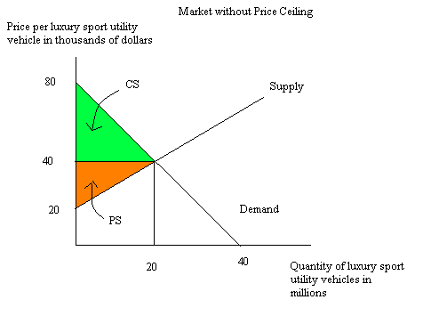
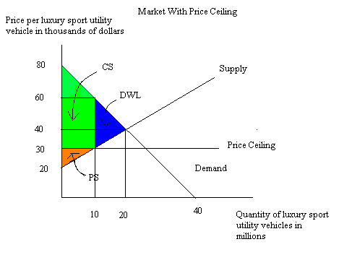

6. Let’s return to the set-up you were given for problem 5. But, instead of a price ceiling let’s analyze the impact of a quantity control on the market for luxury sport utility vehicles. Suppose that the government decides that driving these cars represents a huge negative externality to the residents of this country and that the government should actively intervene to limit the number of luxury sport utility vehicles that are sold. The negative externality is an idea we will study later in the semester, but basically in this example this negative externality refers to the costs society incurs when people drive gas guzzling cars: pollution costs, environmental damage, contribution to climate change, etc. Suppose that the market demand and supply curves you were given in problem 4 still describe this market, but now the government has imposed a quantity control or quota of 10,000,000 vehicles in this market. That is, the government has decreed that only 10,000,000 luxury sport utility vehicles can be sold during the current time period.

a. How does the quantity control affect the price that producers of these vehicles will charge demanders of these vehicles?

b. How does the quantity control affect the value of consumer surplus (CS”) in this market?
c. How does the quantity control affect the value of producer surplus (PS”) in this market?

d. Is there a DWL from the imposition of this quantity control? If so, provide a numeric measure of the DWL.

e. If the government sells licenses to car producers for the right to provide these vehicles, what is the maximum per luxury sport utility vehicle a supplier will pay for this right?

f. Draw a diagram that illustrates the effect of this quantity control on this market. In your diagram label CS”, PS”, the area that represents the total amount car producers would be willing to pay for the right to provide these vehicles, and any area of DWL.

Answer:
a. With the quantity control or quota, the price demanders are willing to pay for a luxury sport utility vehicle can be found by using the demand equation and substituting in a quantity of 10,000,000 vehicles into this equation. Thus, P = 80 – 2(10) = 60. Recall that the price per vehicle is measured in thousands of dollars, so the price demanders of these vehicles will pay will be $60,000 per vehicle since this represents the price at which a supply of 10,000,000 vehicles will be purchased in this market.

b. CS” in this market will now be calculated as (1/2)($80,000 per vehicle - $60,000 per vehicle)(10,000,000 vehicles) = $100,000,000,000 or $100 Billion.

c. PS” in this market will now be calculated as the area of a triangle plus the area of a rectangle. Thus, PS” = (1/2)($30,000 per vehicle - $20,000 per vehicle)(10,000,000 vehicles) + ($60,000 per vehicle - $30,000 per vehicle)(10,000,000 vehicles) = $350,000,000,000 or $350 Billion.

d. Yes, there is a DWL since the quantity control or quota prevents some mutually beneficial transactions form occurring. The DWL = (1/2)($60,000 per vehicle - $30,000 per vehicle)(20,000,000 vehicles – 10,000,000 vehicles) = $150,000,000,000 or $150 Billion.

e. The amount per vehicle that a car producer would be willing to pay for the right to sell these luxury sport utility vehicles would be the difference between the price demanders must pay in order to demand only 10,000,000 vehicles ($60,000 per vehicle) minus the price suppliers must receive in order to supply only 10,000,000 vehicles ($30,000 per vehicle). Thus, the price per vehicle a car producer would pay for the right to sell a luxury sport utility vehicle with the quantity control program would be $30,000 per vehicle or a total of $300,000,000,000 or $300 Billion.

f. Here’s the diagram:
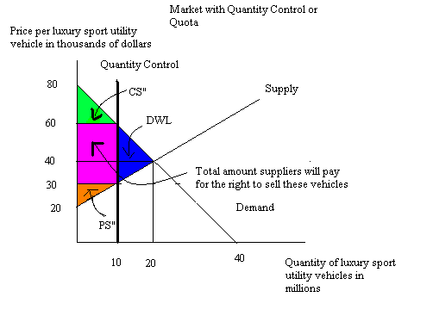

Government Intervention in Agricultural Markets: Price Support Programs and Price Guarantee Programs

7. Consider the market for soybeans. The market demand and supply curves are as follows where P is price per bushel of soybeans and Q is the quantity of soybeans measured in bushels:
Market Demand: Q = 10,000 – 1000P
Market Supply: Q = 250P
a. Given the above information, what is the equilibrium price and quantity of soybeans? Show your work.

b. Given the above information, what is the value of consumer surplus (CS), producer surplus (PS), and total surplus (TS)? Show your work for each of these calculations.

c. Suppose soybean farmers successfully lobby the government to institute a price floor in this market. To be effective, what must be true about this price floor? Use complete sentences to answer this question and provide specific numeric guidance with regard to this effective price floor.

d. Suppose the price floor is implemented and it results in the government cost (excluding any storage costs) of $11,250. Given this information, calculate the price the government set as the price floor. Show your work and your reasoning in a neat, easy to follow answer!

e. Given the price floor described in (c) and calculated in (d), what is the value of consumer surplus with the price floor (CS’) and the value of producer surplus with this price floor (PS’)? Show your work and your reasoning.

Answer:

a. In equilibrium, the quantity demanded equals the quantity supplied. Thus, 10,000 – 1000P = 250 P or P = 8 and Q = 10,000 – (1000)(8) = 2000 bushels of soybeans or, alternatively, Q = 250(8) = 2000 bushels of soybeans.

b. CS = (1/2)($10 per bushel - $8 per bushel)(2000 bushels) = $2000
PS = (1/2)($8 per bushel - $0 per bushel)(2000 bushels) = $8000
TS = CS + PS = $10,000

c. A price floor is only effective if it is set above the equilibrium market price: in this example, the price floor must be greater than $8 per bushel.

d. We know the government expenditure on the price floor program is $11,250 and we also know that this amount is the product of the price floor times the surplus bushels of soybeans the government must purchase when implementing this price floor. Thus,
11250 = (Price with Price Floor)(Quantity of Soybeans purchased by the government)
11250 = (Price with Price Floor)(Quantity supplied with price floor – quantity demanded with price floor)
We can use the given supply and demand equations to substitute in for the quantity supplied and the quantity demanded. Thus,
11250 = (Price with Price Floor)[250P – (10,000 – 1000P)] where P is the Price with the Price Floor
11250 = P[250P – (10,000 – 1000P)]
11250 = P[1250P – 10,000]
0 = P²-8P – 9
Hmmm, do you remember how to find the value of P from your first algebra class? One way is to factor this equation (another is to use the quadratic formula-I am hoping we can factor!). So,
0 = (P – 9)(P + 1) [check to make sure you see that this is the correct factorization for the equation]
Thus, P = 9 [P = -1 does not make any economic sense, so we will just ignore that solution since prices must be positive]
Our answer tells us that the government set the price floor at a price of $9 per bushel of soybeans.

e. CS’ = (1/2)($10 per bushel - $9 per bushel)(1000 bushels) = $500
PS’ = (1/2)($9 per bushel)(2250 bushels) = $10,125

8. Use the information below about the market for corn to answer this question.

The market for corn is described by the graph below where P is the price of corn, Q is the quantity of corn, S is the supply of corn, and D is the demand for corn. Use this graph to answer this set of questions. Assume this graph is drawn to scale.
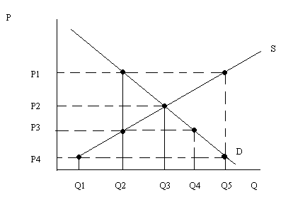
Suppose that the government promises farmers to pay them a total price of P1 per ton of soybeans but the government instructs the farmers in this market to sell as much of the soybeans as they can. Then, the government will pay a subsidy to the farmers equal to the difference between the price the government guaranteed and the price the soybeans actually sold for in the market. Given this program and holding everything else constant, answer the following questions:

a. The cost to the government of this program is given by area ___________.

b. The total revenue received by farmers with this program is given by area ________.

c. The expenditure by consumers on this product given this program is given by area ______.

Answer:

a. The cost to the government of this program is given by area __(P1 – P4)Q5_________.

b. The total revenue received by farmers with this program is given by area __P1Q5______.

c. The expenditure by consumers on this product given this program is given by area __P4Q5____.

Excise Taxes:

9. In Surburbia the demand and supply curves for gasoline are given by the following equations where P is the price per gallon and Q is the quantity of gasoline in gallons:

Market Demand: Q = 10,000 – 1000P
Market Supply: Q = 2000P + 4000

a. What is the slope of the demand curve? What is the slope of the supply curve?

b. What is the equilibrium price and equilibrium quantity of gasoline in Surburbia? Show your work in finding these answers.

c. What is the value of consumer surplus (CS) in this market? What is the value of producer surplus (PS) in this market? Show your work in finding these answers. In your answer be sure to include the units of measurement throughout your work.

d. Suppose that the government of Surburbia decides that less gasoline should be consumed in Surburbia due to concerns about climate change. The government decides to enact an excise tax so that the total consumption of gasoline falls by 3000 gallons from its equilibrium quantity. The government has asked you to advise them as to the size of the excise tax that will be necessary in order to achieve this goal. Assume that the only thing that changes in this market is the excise tax and also assume that this excise tax is levied on producers of gasoline.

e. Given the excise tax you calculated in (d): [Hint: you may find it helpful to do step (vii) before you tackle the rest of the steps!]

i. What is the total tax revenue that will be collected from this excise tax?
ii. What is the consumer tax incidence (CTI) equal to given this excise tax?
iii. What is the producer tax incidence (PTI) equal to given this excise tax?
iv. What is the deadweight loss (DWL) from this excise tax?
v. What is the change in consumer surplus due to this excise tax?
vi. What is the change in producer surplus due to this excise tax?
vii. Draw a diagram of the market for gasoline illustrating this excise tax. Make sure your graph is completely and carefully labelled!

f. Instead of the excise tax described in (d), suppose the government of Surburbia decides to approach the problem of too much gasoline being produced and consumed in Surburbia by targeting a particular price for gasoline. Suppose the government mandates that the price per gallon of gasoline must be $8 per gallon. How big must the excise tax be in order for the government of Surburbia to achieve their goal of the price of gasoline being $8 per gallon?

g. Given the excise tax you calculated in (f): [Hint: you may find it helpful to do step (vii) before you tackle the rest of the steps!]

i. What is the total tax revenue that will be collected from this excise tax?
ii. What is the consumer tax incidence (CTI) equal to given this excise tax?
iii. What is the producer tax incidence (PTI) equal to given this excise tax?
iv. What is the deadweight loss (DWL) from this excise tax?
v. What is the new consumer surplus given this excise tax?
vi. What is the new producer surplus given this excise tax?
vii. Draw a diagram of the market for gasoline illustrating this excise tax. Make sure your graph is completely and carefully labelled!

Answer:
a. Be careful on this question: this is not a hard question, but it does require that you recognize that both the demand and the supply equations are written in x-intercept form and not y-intercept form. That means that the coefficient for P represents the reciprocal of the slope, or 1/m. So, for the demand equation we see that the coefficient for P is -1000 and we plug this value into the equation: 1/m = -1000. Solving for m, the slope of the line, we get m = -1/1000 for the slope of the demand curve. We will follow a similar procedure for the slope of the supply curve: 1/m = 2000 or m = 1/2000: the slope of the supply curve is 1/2000.

b. To find the equilibrium we need to set the demand equation equal to the supply equation: 10,000 – 1000P = 2000P + 4000 or 3000P = 6,000 or P = 2. That is, the equilibrium price of gasoline is $2 per gallon. To find the equilibrium quantity you can substitute P = 2 into either the demand or the supply equation: Q = 10,000 – 1000(2) – 8,000 gallons of gasoline is demanded when the price of gasoline is $2 per gallon; or, Q = 2000(2) + 4000 = 8,000 gallons of gasoline is supplied when the price of gasoline is $2 per gallon.

c. CS = (1/2)($10 per gallon - $2 per gallon)(8,000 gallons) = $32,000
PS = the sum of the area of a triangle and the area of a rectangle = (1/2)($2 per gallon - $0 per gallon)(8000 gallons – 4000 gallons) + ($2 per gallon - $0 per gallon)(4000 gallons) = $12,000
The diagram below illustrates these areas:
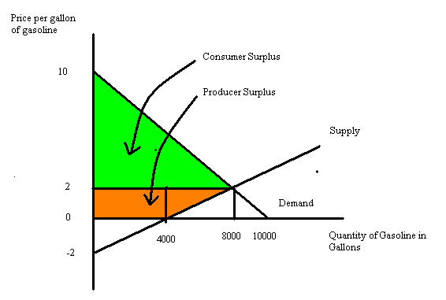
Note: that producer surplus is only the area above the supply curve and beneath the equilibrium price that is also in the first quadrant: the triangle that “sits” below the horizontal axis is not included in this calculation since it does not represent anything meaningful from an economic point of view.

d. The government wants to implement an excise tax that will result in total gasoline consumption falling by 3000 gallons. That means that the government wants Surburbia to end up consuming 5,000 gallons of gasoline instead of their current consumption level of 8,000 gallons of gasoline. If we set Q = 5000, then we find that demanders will demand this level of gasoline if the price per gallon is $5. (Q = 10,000 – 1000P and 5000 = 10,000 – 1000P and therefore P = $5 per gallon of gasoline.) If we set Q = 5000, then we find that suppliers will supply this level of gasoline if the price per gallon is $0.50 per gallon. (Q = 2000P + 4000 and 5000 = 2000P + 4000 and therefore P = $0.50 per gallon of gasoline.) The difference between the price consumers must pay to limit their consumption of gasoline to 5000 gallons and the price suppliers must receive in order to limit their production of gasoline to 5000 gallons is the amount of the excise tax: thus, $5 - $0.50 = $4.50 per gallon of gasoline is the level the excise tax should be set at. That is, the government of Surburbia should implements an excise tax of $4.50 in this market if it wishes to reduce gasoline consumption to 5000 gallons of gasoline.

e.
i. Total tax revenue = (Excise Tax per Unit)(# of Units Sold with the Excise Tax)
Total tax revenue = ($4.50 per gallon of gasoline)(5000 gallons of gasoline)
Total tax revenue = $22,500
ii. Consumer Tax Incidence = (Price consumer pays with the tax – Price consumer paid without the tax)(# of Units sold with the excise tax)
CTI = ($5 per gallon of gasoline - $2 per gallon of gasoline)(5000 gallons of gasoline) = $15,000
iii. Producer tax incidence needs to be equal to the total tax revenue minus the CTI or $7,500. So, let’s check to see if that is true: PTI = (Price suppliers received before the tax – Price suppliers now get to keep once the tax is implemented)(# of units sold with the excise tax) = ($2 per gallon of gasoline - $0.50 per gallon of gasoline)(5000 gallons of gasoline) = $7500. Make sure you understand that CTI + PTI = Total Tax Revenue.
iv. DWL = (1/2)($5 per gallon of gasoline - $0.50 per gallon of gasoline)(8000 gallons of gasoline – 5000 gallons of gasoline) = $6750
v. Change in CS = CS after the implementation of the tax – CS before the implementation of the tax. CS before the implementation of the tax = $32000. CS after the implementation of the tax = (1/2)($10 per gallon of gasoline - $5 per gallon of gasoline)(5000 gallons of gasoline) = $12,500. The change in CS = $12,500 - $32,000 = a decrease of $19,500.
vi. Change in PS = PS after the implementation of the tax - PS before the implementation of the tax . PS before the implementation of the tax = $12,000. PS after the implementation of the tax = (1/2)($0.50 per gallon of gasoline - $0.00 per gallon of gasoline)(5000 gallons of gasoline - 4000 gallons of gasoline) + ($0.50 per gallon of gasoline)(4000 gallons of gasoline) = $2250. The change in PS = $2,250 - $12,000 = a decrease of $9750.
vii.
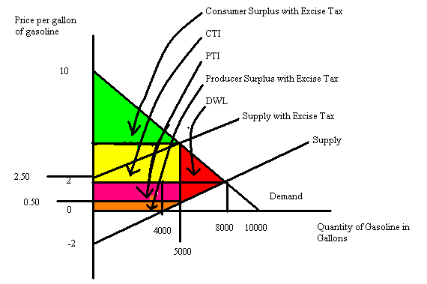

f. To answer this question, one method is to start by thinking about how many gallons of gasoline will be demanded if the price per gallon is $8. To find this quantity we use the demand curve and substitute P = 8: Q = 10,000 – 1000P or Q = 10,000 – 1000(8) = 2000 gallons of gasoline. Then, we can recognize that the excise tax is going to shift the supply curve to the left but parallel to the initial supply curve. That implies that the new supply curve with the excise tax could be written as P = b + (1/2000)Q where b is the new y-intercept of this supply curve that includes the tax. Recall that we can measure the vertical distance from the new y-intercept to the initial y-intercept in order to calculate the amount of the excise tax per unit. With this new supply curve that includes the excise tax we know the P = $8 (that’s the price that the government has decided is the “right” price for gasoline. We also know that Q = 2000 because if this market is going to be in equilibrium with this new excise tax it must be the case that at the new price the quantity demanded equals the quantity supplied. Thus, 8 = b = (1/2000)(2000) or b = 7. Recall the initial supply curve was given as Q = 2000P + 4000 and if we solve this equation for the slope-intercept form we have P = (1/2000)Q – 2. So, the initial y-intercept is -2 and the new y-intercept is 7. The difference, $9 per gallon of gasoline, is the amount of the excise tax per unit.

g.
i. Total tax revenue = ($8 per gallon of gasoline)(2000 gallons of gasoline) = $16,000. Note that although the tax is $9 per gallon of gasoline, that producers will not be netting -$1 per gallon of gasoline in this example. The lowest price producers can receive after they pay the tax to the government is $0 per gallon of gasoline they sell.
ii. CTI = (the new price consumers pay with the excise tax – the initial price consumers pay with there is no excise tax)(# of units of gasoline sold when there is an excise tax) = ($8 per gallon of gasoline - $2 per gallon of gasoline)(2000 gallons of gasoline) = $12,000.
iii. PTI = (the initial price producers received when there was no excise tax – the new net price producers receive with the excise tax)(# of gallons of gasoline sold when there is an excise tax) = ($2 per gallon of gasoline - $0 per gallon of gasoline)(2000 gallons of gasoline) = $4000.
iv. DWL = in this case the sum of the area of a triangle + the area of a rectangle + the area of a triangle. DWL = (1/2)($8 per gallon of gasoline - $6 per gallon of gasoline)(4000 gallons of gasoline – 2000 gallons of gasoline) + ($6 per gallon of gasoline - $0 per gallon of gasoline)(4000 gallons of gasoline – 2000 gallons of gasoline) + (1/2)($6 per gallon of gasoline - $0 per gallon of gasoline)(8000 gallons of gasoline – 4000 gallons of gasoline) = $2000 + $12,000 + $12,000 = $2600.
v. CS’ = (1/2)($10 per gallon of gasoline - $8 per gallon of gasoline)(2000 gallons of gasoline) = $2000.
vi. PS’ = 0. There is no PS with this excise tax since the government “captures” all of the area as its tax revenue.
vii. Here’s the figure!

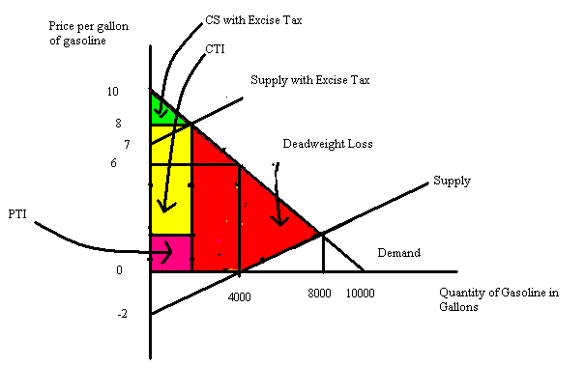

International Trade: Tariffs and Import Quotas:

10. Suppose that a small, closed economy manufactures pencils. There are five domestic manufacturers of these pencils and they have identical supply curves. Suppose the supply curve for a single manufacturer of these pencils is given by the equation P = Q + 20. Additionally you know that the domestic demand for pencils in this small, closed economy is given by the equation P = 50 – (1/10)Q.

a. What is the domestic supply curve for pencils in this economy?

b. Given the domestic supply curve and the domestic demand curve, what is the equilibrium price and quantity of pencils in this economy if the economy is closed?

c. Calculate the value of consumer surplus, producer surplus, and total surplus if the domestic economy is a closed economy with regard to the pencil market.

d. Suppose that this economy decides to open this market to trade. Analyze what happens in this market if the world price of pencils is $45 per pencil. In your answer identify the level of imports or exports, the new level of consumer surplus, the new level of producer surplus, the new level of total surplus, and identify the distributional consequences of opening this market to trade.

e. Suppose that this economy decides to open this market to trade. Analyze what happens in this market if the world price of pencils is $30 per pencil. In your answer identify the level of imports or exports, the new level of consumer surplus, the new level of producer surplus, the new level of total surplus, and identify the distributional consequences of opening this market to trade.

f. Suppose that this market for pencils is opened to world trade and the world price is $30 per pencil. Furthermore, suppose that the government of this economy decides to implement a tariff so that the price of pencils in the small open economy is equal to $35 per pencil. Analyze the effect of this tariff on imports or exports, consumer surplus, producer surplus, total surplus, government tariff revenue and deadweight loss relative to the results you got when the market was open to trade and there was no tariff.

Answers:

a. A quick sketch of the firm supply curve may help you when you are working to find the market supply curve. You know that a single firm will produce 0 units when the price is $20 and 5 units when the price is $25. If there are five identical firms that implies that the five firms will produce 0 units when the price is $20 and 25 units when the price is $25. Thus, (0, $20) and (25, $25) are two points on the market supply curve. We can write the market supply curve as P = (1/5)Q + 20.
An alternative method for finding this market supply curve:
Rewrite the individual supply curve in x-intercept form: Q = P – 20
Then, add five of these curves together to get Qtotal:
Qtotal = [P – 20] + [P – 20] + [P – 20] + [P – 20] + [P – 20] or
Qtotal = 5[P – 20] = 5P – 100
Rearrange this equation into y-intercept form:
5P = Q + 100
P = (1/5)Q + 20

b. Use the domestic supply curve and the domestic demand curve to solve for the equilibrium. Thus, (1/5)Q + 20 = 50 – (1/10)Q or Q = 100 units and P = $40.

c. Consumer surplus is equal to (1/2)($50/unit - $40/unit)(100 units) = $500. Producer surplus is equal to (1/2)($40/unit - $20/unit)(100 units) = $1000. Total surplus is equal to the sum of consumer surplus plus producer surplus or $1500.

d. When the world price is $45 per pencil and this economy opens to trade, domestic suppliers will supply 125 pencils while domestic consumers will demand 50 pencils. The excess supply of 75 pencils will be exported to the world market. Consumer surplus will equal (1/2)($50-$45)50 = $125 and will be smaller than it was when this market was closed to world trade. Producer surplus will equal (1/2)($45-$20)125 = $1562.50 and will be larger than it was when this market was closed to world trade. Trade is beneficial since total surplus will increase to $1687.50, an amount which is larger than the total surplus in this market when it is a closed market. Domestic consumers are hurt by the opening of this market , while domestic producers are benefitted.

e. When the world price is $30 per pencil and this economy opens to trade, domestic suppliers will supply 50 pencils while domestic consumers will demand 200 pencils. The excess demand of 150 pencils will be imported into this domestic economy. Consumer surplus will equal (1/2)($50-$30)200 = $2000 and will be larger than it was when this market was closed to world trade. Producer surplus will equal (1/2)($30-$20)50 = $250 and will be smaller than it was when this market was closed to world trade. Trade is beneficial since total surplus will increase to $2250 which is larger than the total surplus in this market when it is a closed market. Domestic producers are hurt by the opening of this market while domestic consumers are benefitted.
f. The imposition of this tariff will reduce the level of imports in this economy from 150 units to 75 units since at a price of $35 per pencil domestic producers are willing to produce 75 pencils while domestic consumers will demand 150 pencils. The difference, or 75 pencils, will be imported into this economy. Consumer surplus with the tariff will equal (1/2)($50-$35)150 = $1125 instead of $2000 when the economy is open to trade. Producer surplus with the tariff will equal (1/2)($35-$20)75 = $562.50 instead of $250 when the economy is open to trade. Government tariff revenue will equal ($5)65 = $375. Deadweight loss will equal $187.50. To find deadweight loss: DWL = (1/2)($35/unit - $30/unit)(75 units – 50 units) + (1/2)($35/unit - $30/unit)(200 units – 150 units) = $187.50.

11. Cubville is a small economy and its market for sweaters is currently a closed market that can be described by the following domestic demand and domestic supply curves where P is the price per sweater in dollars and Q is the quantity of sweaters:
Domestic Demand Curve for Sweaters: P = 200 – Q
Domestic Supply Curve for Sweaters: P = 50 + (1/2)Q
Currently the world price of sweaters is $60 per sweater.

a. The government of Cubville has decided to open its sweater market to trade, but at the same time it has decided it must either implement a tariff or a quota such that imports into its market are equal to 60 sweaters. The government of Cubville has asked you to determine what level of tariff will be necessary to obtain this goal. The government will also need a thorough explication of how you determined this tariff and the government has also requested that you provide a graph illustrating the sweater market and this tariff.

b. The government of Cubville has requested that you also provide them with an alternative to the tariff. The government needs to know if they choose to use a quota rather than a tariff, how big does the quota need to be? Remember that the government wants these two potential policies to result in the same outcome. The government of Cubville needs a thorough explication of how you determined this quota and they also need a graph illustrating the sweater market with this quota.

c. If the government of Cubville implements the quota you recommend in (b), what is the maximum that a foreign importer of sweaters will be willing to pay for the right to import a sweater? Explain how you found your answer.

Answer:
a. If the government of Cubville opens this market to trade while restricting its level of imported sweaters to 60, we first need to figure out if this restriction has any impact on this market. Let’s start by determining how many sweaters Cubville would import if this market were open to trade and there was no limit on imports. To do this, let’s plug in P = 60 = world price into both the demand and the supply equations: thus, in the demand equation we have P = 200- Q or 60 = 200 – Q or the quantity demanded domestically is 140 sweaters when sweaters are sold in Cubville at the world price; from the supply equation we have P = 50 + (1/2)Q or 60 = 50 + (1/2)Q or the quantity supplied domestically is 20 sweaters when sweaters are sold in Cubville at the world price. Thus, when this market opens to trade and there is no restriction on the level of imports, the level of imports will be equal to 140 – 20 or 120 imported sweaters. So, from this we can conclude that this restriction on imports will have an effect on this market.

Now we need to figure out what level of tariff will result in only 60 sweaters being imported. We can reflect that the quantity of sweaters supplied domestically + the number of imported sweaters equals the quantity of sweaters demanded domestically when this market is in equilibrium. We can rewrite this idea as follows: Qs + (# of imported sweaters) = Qd. Let’s use the supply and demand equations to find expressions for Qs and Qd: the supply equation is P = 50 + (1/2)Qs and rewriting this in terms of Qs we get Qs =2P – 100; the demand equation is P = 200 – Qd and rewriting this in terms of Qd we get Qd = 200 – P. Using these expressions we can rewrite Qs + (# of imported sweaters) = Qd as (2P – 100) + 60 = (200 – P) or $80 per sweater. So, if the tariff is set so that the price of sweaters increases from the world price of $60 per sweater to $80 per sweater this will result in only 60 sweaters being imported into this market. It will also result in domestic sweater producers producing 60 sweaters and domestic sweater consumers consuming 120 sweaters.

b. Well, this is an easy question. If the government has decided to limit the number of imported sweaters to 60, then the amount of the quota is 60 sweaters. When this limit is imposed on this market it results in the price of $80 per sweater. Read through the explanation in (a) again and make sure you understand how this all works.

c. If you are lucky enough to import one of the 60 imported sweaters that are allowed then you will find that you can sell this sweater for $80 rather than the world price of $60. The maximum you would be willing to pay to sell this imported sweater in Cubville is therefore the difference between these two prices, or $20 per sweater.

