Economics 111
Fall 2019
Answers to Homework #1

General Instructions:

- Homework is due at the beginning of the lecture.
- Do not submit the homework questions. Just submit your answers: these answers should be neat, legible, and easy to follow. Be generous with your use of paper. Do not write in small, hard to read font. If asked to provide a graph, provide a generous graph.
- All homeworks should be stapled and on the front page your name should be legibly written.
- It is all right to do homework with a "study buddy": however, when asked to explain your answer your words should be significantly different from your "study buddy's" words. Homeworks that are too similar to one another will not receive any credit.
- To get full credit for the homework you need to answer every question that is asked. A failure to answer all the questions will result in a lower homework score.
- It is a good idea to make a copy of your homework so that you can compare your answers to the posted answers. Your copy (a digital photo) also provides a time-stamped proof that you did the homework.

General Math Review:

1. a. Suppose you know that the two points (X, Y) = (12, 6) and (15, 3) sit on the same line. From this information write an equation for this line in slope-intercept form.

b. Suppose that you know that the slope of the line is 5 and that this line also contains the point (20, 25). What is the y-intercept for this line? Show your work.

c. You are given the following two equations:
Y = 10X + 100
Y = 76 – 2X
Find the solution (X, Y) for where these two equations intersect. Show your work.

d. Suppose that you know that the relationship between X and Y, where X is the variable measured on the horizontal axis, can be described by the following equation:
X = 40 – 2Y for all values of X ≥ 0
You are then told that for every Y value the X value has now increased by 10 units. Write the equation in slope-intercept form for this new line. Show your work. Hint: you might find it helpful to draw a "sketch" illustrating these two lines before you start doing your calculations.

e. Suppose that you know that the relationship between X and Y, where X is the variable measured on the horizontal axis, can be described by the following equation:
Y = 10 + 4X for all values of X ≥ 0
You are then told that for every X value the Y value has now decreased by 20 units. Write the equation in slope-intercept form for this new line. Show your work. Hint: you might find it helpful to draw a "sketch" illustrating these two lines before you start doing your calculations.
f. Suppose that you are told that when the price of a good is $10 per unit people are willing to purchase 20 units of the good and when the price of the good is $5 per unit people are willing to purchase 30 units of the good. If P is the symbol for the price of the good and Q is the symbol for the quantity of the good, write an equation for this relationship assuming that it is a linear relationship. Assume that price is the y-variable and quantity is the x-variable and then provide the equation in y-intercept and x-intercept form.

Answers:

a. To write the equation start by finding the slope of the line: slope = (change in Y)/(change in X) = (6 – 3)/(12 – 15) = -1. Then, use the general form of the slope-intercept equation and this slope value to find the y-intercept:
Y = mX + b where m = slope and b = y-intercept
Y = -X + b
Substitute one of the given points into this equation to find the value of the y-intercept, b:
6 = -12 + b
b = 18
Equation for the line containing these two points: Y = 18 - X

b. Since we know the slope of the line, we can write the equation for this line as:
Y = 5X + b
We are asked to find the value of the y-intercept, or b, in this equation. To do this, we can substitute into the equation the given point and solve for b:
25 = 5(20) + b
b = -75
The y-intercept for this line described by the provided information is -75 and the coordinates for this y-intercept are (0, -75).

c. To find the solution set the two equations equal to one another:
10X + 100 = 76 – 2X
12X = -24
X = -2
Then, use this X value in either equation to solve for Y:
Y = 10(-2) + 100 = 80
Or, Y = 76 – 2(-2) = 80
(X, Y) = (-2, 80)

d. I find it helpful to visualize what is happening to this line by drawing a sketch. Here is my sketch with the red line the original equation and the blue line indicating the new equation.
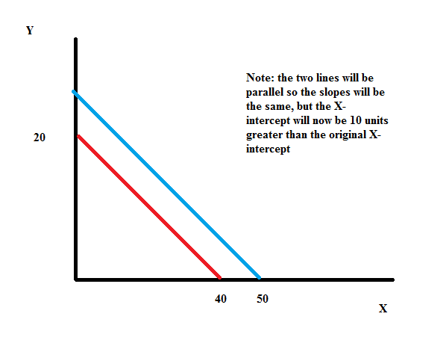
With my sketch it is easy to see that the X-intercept has increased by 10 units from 40 to 50: so, if the equation is in X-intercept form I simply need to change the X-intercept:
X = 50 – 2Y
But, I am asked to write the equation in Y-intercept form so I will rearrange the equation:
2Y = 50 – X
Y = 25 – (1/2)X

e. I find it helpful to visualize what is happening to this line by drawing a sketch. Here is my sketch with the red line the original equation and the blue line indicating the new equation.
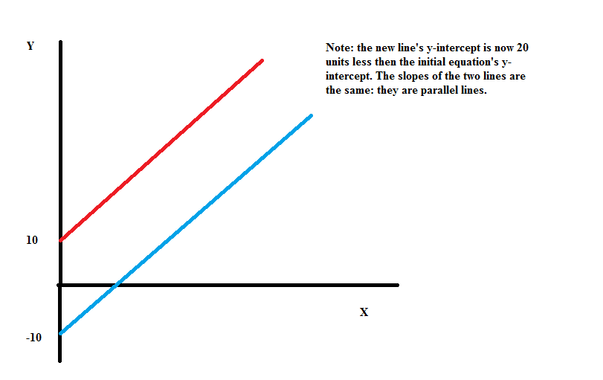

With my sketch it is easy to see that the Y-intercept has decreased by 20 units from 10 to =10: so, if the equation is in Y-intercept form I simply need to change the Y-intercept:
Y = -10 + 4X
Or, I might write it as
Y = 4X – 10 so that the negative sign before the 10 does not get visually lost!

f. From the given information we can calculate the slope as the (change in the price)/(change in the quantity) = -5/10 or -1/2. Then using the basic y-intercept form of y = mx + b we can write:
y = mx + b
P = (-1/2)Q + b
Then, use one of our "known points" (Q, P) = (20, 10) or (30, 5) to find the value of "b":
10 = (-1/2)(20) + b
b = 20
Equation in y-intercept form: P = 20 – (1/2)Q
Equation in x-intercept form: Q = 40 – 2P

- a. Suppose you are given the following two points that sit on a straight line: (x, y) = (10, 2) and (5, 4)
What is the equation for this line in slope-intercept form? Show all your work in finding this equation.

- Suppose you are asked to find the equation in slope-intercept form of a straight line that has slope = 4 and contains the point (100, 50). Find this equation, showing all the work you did.

- You are given the two equations: y = 4x + 20
y = 100 – x
Find the (x, y) coordinate values where these two lines intersect each other. Show your work.

- You are given the

equation: y = 10 – 2x for y ≤ 10

Draw a sketch of this line for all values of x and y that are ≥ 0. Label this line 1. Now, suppose that for every y value, the x value doubles. Draw this new line in your graph showing just the values of x and y that are ≥0. Label this line 2. Write an equation for line 2 showing your work.

- You are given the equation: y = 10 – 2x for y ≤ 10
and told that for every x value in this original equation, the y value has increased by 10 units. Draw a graph that illustrates the original line as well as this new line. Label these two lines Line 1 and Line 2, respectively. Then, write the equation for Line 2 and provide a verbal explanation for how you found this new equation.

Answer:
- We can start by finding the slope of the line: slope = ∆Y/∆X = (4 – 2 )/(5 – 10) = (-2/5)
Then, general slope-intercept form is y = mx + b. Thus, y = b – (2/5)x and using one of the given points we can find the y-intercept, or b, value. Thus,
2 = b – (2/5)(10)
2 = b – 4
b = 6
The equation for the line is y = 6 – (2/5)x.

- Slope-intercept form is y = mx + b and we know the slope, or m, is given as 4. Thus, y = 4x + b. Substitute the given point (x, y ) = (100, 50) into this equation to find the value of b, the y-intercept.
50 = 4(100) + b
b = -350
Thus, the equation is y = 4x – 350.

- To find where these two lines intersect set the two equations equal to one another. Thus, 4x + 20 = 100 – x
5x = 80
x = 16
To find the y value, substitute x = 16 into either equation. Thus, y = 4(16) + 20 = 64 + 20 = 84 or
y = 100 – 16 = 84
The coordinates (x, y) for where these two lines intersect are (x, y) = (16, 84). d.
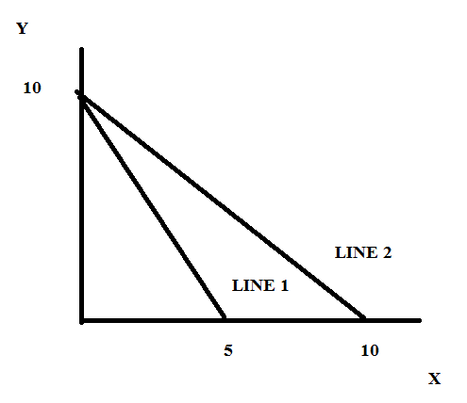
When y = 10, x = 0 initially. This means that when x doubles for every y value, the point (x, y) = (0, 10) sits on line 2 (as well as line 1). When y = 0, x = 5 initially. This means that when x doubles for every y value, the point (10, 0) sits on line 2. By looking at our drawn graph we can see that line 2 has slope of -1 and a y-intercept of 10: thus, the equation for line 2 can be written as y = 10 – x.

e.

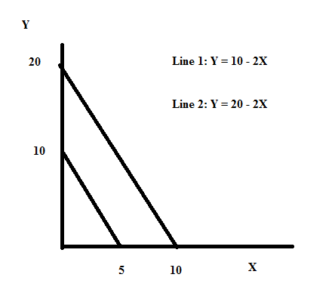

Line 2 is parallel to Line 1, which implies that the slope of both lines is the same and equal to (-2). Since the y-value increases by 10 at every x value this tells us that if the initial point (x, y) = (0, 10) then the new point for this x value will be (0, 20). That is, the y-intercept increases from 10 to 20.

3. More math review:
Consider three individuals who are enrolled in Professor Kelly's Econ 101 class: Howard, Sue, and Mike. In class Professor Kelly has emphasized the importance of turning in the homework and despite this advice these three individuals have taken decidedly different approaches. Professor Kelly anticipates that students will need to earn a total of 90 points on a 100 point scale from the various assignments for the semester in order to earn an A in the class. The assignments are as follows:
- Five homework assignments that are each worth 2 points: if a student turns in all five homeworks and shows good effort they will earn 10 points on that 100 point scale from this effort. If they turn in four homeworks that show good effort they will earn 8 points on that 100 point scale from this effort. And, so on. If the student turns in none of the homeworks, they will earn 0 points on that 100 point scale.
- Two midterms that contribute 25% each to their weighted score total. So, for instance if a student scores a 50 on each of these two midterms they will get 12.5 points on a 100 point scale from each of these exams (a total of 25 points on that 100 point scale from these two exams).
- A final that contributes 40% to their weighted score total. (Note that we have now accounted for 100% of that weighted score total.) If a student scores a 70 on the final, the student will get 28 points on a 100 point scale from this final.
Here is the data you have for Howard, Sue, and Mike. You are asked to calculate the score each of these individuals needs on the final exam (assume it is a 100 point final exam) in order to get an A in the class. Show your work for each calculation. For some individuals you may find that it is impossible to earn that "A" in the class.
 | Howard | Sue | Mike
Number of Homeworks turned in | 0 | 3 | 5
Score per Homework Submitted | 2 | 2 | 2
Score on First Midterm out of a Possible 100 Points | 84 | 84 | 84
Score on Second Midterm out of a Possible 100 Points | 88 | 88 | 88
Score Needed on Final out of a Possible 100 Points to Earn an "A" in the class

Answers:

In general we can write this calculation as:
Final Score Needed to Earn an "A" = (Number of Homeworks Submitted)(Score on Submitted Homeworks) + .25(Score on First Midterm) + .25(Score on Second Midterm) + .4(Score on Final)
We also know that the final score needed to earn an "A" in the class is 90. Thus,
90 = (Number of Homeworks Submitted)(Score on Submitted Homeworks) + .25(Score on First Midterm) + .25(Score on Second Midterm) + .4(Score on Final)

For Howard:
90 = (Number of Homeworks Submitted)(Score on Submitted Homeworks) + .25(Score on First Midterm) + .25(Score on Second Midterm) + .4(Score on Final)
90 = (0)(2) + .25(84) + .25(88) + .4(Score for Howard)
90 = 21 + 22 + .4(Score for Howard)
.4(Score for Howard) = 47
Score for Howard = 117
If the final exam has only 100 points, then it is impossible for Howard to earn an "A" in the class. Howard should have done his homework!

For Sue:
90 = (Number of Homeworks Submitted)(Score on Submitted Homeworks) + .25(Score on First Midterm) + .25(Score on Second Midterm) + .4(Score on Final)
90 = (3)(2) + .25(84) + .25(88) + .4(Score for Sue)
90 = 6 + 21 + 22 + .4(Score for Sue)
.4(Score for Sue) = 41
Score for Sue = 102.5
If the final exam has only 100 points, then it is impossible for Sue to earn an "A; in the class. Sue should have done her homework!

For Mike:
90 = (Number of Homeworks Submitted)(Score on Submitted Homeworks) + .25(Score on First Midterm) + .25(Score on Second Midterm) + .4(Score on Final)
90 = (5)(2) + .25(84) + .25(88) + .4(Score for Mike)
90 = 10 + 21 + 22 + .4(Score for Mike)
.4(Score for Mike) = 37
Score for Mike = 92.5
If Mike scores a 92.5 on the final exam, Mike will earn the "A" in the class: Mike was smart to do that homework!

Production Possibility Frontiers:

4. Suppose that there are three countries that produce popcorn (P) and juice (J): Merryland, Happyland, and Sedateland. The maximum amount of popcorn and juice each country can produce if they only produce that one good is given in the table below. Use this information to answer this set of questions. Assume that each of the three countries have constant opportunity costs with respect to the production of popcorn and juice: that is, each country has a linear production possibility frontier.
Country | Maximum Amount of Popcorn Production Possible | Maximum Amount of Juice Production Possible
Merryland | 10 units of popcorn | 20 units of juice
Happyland | 10 units of popcorn | 10 units of juice
Sedateland | 5 units of popcorn | 20 units of juice

a. Given the above information, what is Sedateland's opportunity cost of producing one more unit of popcorn?

b. Given the above information, what is Happyland's opportunity cost of producing one more unit of juice?

c. Given the above information, rank these three countries in order of their comparative advantage in the production of popcorn. List the order from the country with the greatest comparative advantage to the country with the least comparative advantage.

d. Given the above information, rank these three countries in order of their comparative advantage in the production of juice. List the order from the country with the greatest comparative advantage to the country with the least comparative advantage.

e. Construct the joint PPF for these three countries if they specialize according to comparative advantage. For this joint PPF measure popcorn on the vertical axis and juice on the horizontal axis. After constructing this joint PPF, provide the coordinates of any intercept or "kink point" in your diagram. Then write the equation for each segment of the joint PPF and provide a range or domain for each segment.

f. Consider each of the production combinations given in the table below and decide whether this production combination is possible if these three countries specialize according to comparative advantage and then trade with one another. Enter your answer as a "Yes, this combination lies on the joint PPF", "Yes, this combination lies inside the joint PPF" or "No, this combination lies outside the joint PPF" in the provided column.

Combination | Amount of Units of Popcorn in Combination | Amount of Units of Juice in Combination | Is this Combination a Possible Production Combination for these Three Countries?
A | 22 | 12
B | 22 | 8
C | 20 | 22
D | 15 | 30
E | 3 | 48

Answers:

a. Sedateland's opportunity cost of producing one more unit of popcorn is 4 units of juice.

b. Happyland's opportunity cost of producing one more unit of juice is one unit of popcorn.

c. Happyland, Merryland, and Sedateland
To see this ordering, first write the opportunity cost of producing one unit of popcorn for each of these countries: you may find it helpful to draw a sketch of each country's PPF and then use the slope measure to guide these opportunity cost measures. For example, if you measure popcorn on the vertical axis and juice on the horizontal axis, then the PPF for Merryland has a slope of -1/2: this tells us that the opportunity cost of one more unit of the good on the X axis (juice) is 1/2 unit of the good on the Y axis (popcorn). We can use the reciprocal of the slope (-2) to find the opportunity cost of one more unit of the good measured on the Y axis: in this case, this means that the opportunity cost of one more unit of popcorn is 2 units of juice.

Using this method: the opportunity cost of producing one more unit of popcorn for Merryland is 2 juices, for Happyland is 1 juice, and for Sedateland is 4 juices. Happyland has the lowest opportunity cost and therefore the comparative advantage in the production of popcorn.

d. Sedateland, Merryland, and Happyland
To see this ordering, first write the opportunity cost of producing one unit of juice for each of these countries: you may find it helpful to draw a sketch of each country's PPF and then use the slope measure to guide these opportunity cost measures. For example, if you measure popcorn on the vertical axis and juice on the horizontal axis, then the PPF for Merryland has a slope of -1/2: this tells us that the opportunity cost of one more unit of the good on the X axis (juice) is 1/2 unit of the good on the Y axis (popcorn). We can use the reciprocal of the slope (-2) to find the opportunity cost of one more unit of the good measured on the Y axis: in this case, this means that the opportunity cost of one more unit of popcorn is 2 units of juice.

Using this method: the opportunity cost of producing one more unit of juice for Merryland is 1/2 unit of popcorn, for Happyland is 1 popcorn, and for Sedateland is 1/4 unit of popcorn. Sedateland has the lowest opportunity cost and therefore the comparative advantage in the production of juice.

e. Here is the joint PPF.
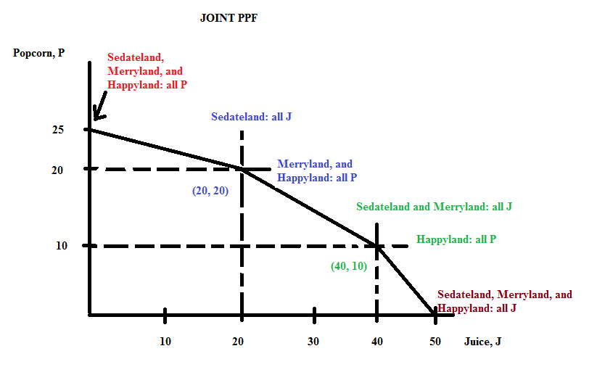

And, now for the equations:
For 0 ≤ J ≤ 20, P = 25 – (1/4)J

For 20 ≤ J ≤ 40, P = 30 – (1/2)J
To see this start with your basic y-intercept form for the equation: Y = mX + b
Then, replace Y and X with the relevant variables:
P = mJ + b
Then, calculate the slope of this segment: m = slope = -10/20 = -1/2 and plug this slope value into the equation:
P = b – (1/2)J
Then use one of the points that you know is on the joint PPF in this segment to solve for b: (J, P) = (20, 20) or (40, 10) are known points. Thus,
20 = b – (1/2)(20)
30 = b
The equation for this segment is thus, P = 30 – (1/2)J

For 40 ≤ J ≤ 50, P = 50 - J
To see this start with your basic y-intercept form for the equation: Y = mX + b
Then, replace Y and X with the relevant variables:
P = mJ + b
Then, calculate the slope of this segment: m = slope = -10/10 = -1 and plug this slope value into the equation:
P = b – J
Then use one of the points that you know is on the joint PPF in this segment to solve for b: (J, P) = (50, 0) or (40, 10) are known points. Thus,
50 = b – (0)
50 = b
The equation for this segment is thus, P = 50 – J

f. For this question you will find it helpful to use the equations you found in (e). For example, for (J, P) = (12, 22) you will need to use the first equation: P = 25 – (1/4)J since 12 units of juice lies in the domain of 0 ≤ J ≤ 20. In this equation, if J = 12 units, then the point on the joint PPF associated with 12 units of juice would provide 22 units of popcorn. Thus, the point (J, P) = (12, 22) is a possible production combination since it lies on the joint PPF.

Repeat this process for each combination using the appropriate equation for the segment of the PPF you are considering.

Here are the final answers:

Combination | Amount of Units of Popcorn in Combination | Amount of Units of Juice in Combination | Is this Combination a Possible Production Combination for these Three Countries?
A | 22 | 12 | Yes, this combination lies on the joint PPF
B | 22 | 8 | Yes, this combination lies inside the joint PPF
C | 20 | 22 | No, this combination lies outside the joint PPF
D | 15 | 30 | Yes, this combination lies on the joint PPF
E | 3 | 48 | No, this combination lies outside the joint PPF

5. Helen and Charlie produce windows (W) and doors (D). The table below provides information about how many hours of labor they need individually to produce a window or a door. Assume that they only need labor to produce these two goods and assume that both Helen and Charlie have linear PPFs.
 | Number of Hours of Labor Needed to Produce One Window | Number of Hours of Labor Needed to Produce One Door
Helen | 2 hours of labor | 1 hour of labor
Charlie | 4 hours of labor | 5 hours of labor

a. Suppose that Helen and Charlie each have 40 hours a week that they can devote to producing windows and doors. In two separate graphs draw Helen's and Charlie's production possibility frontiers: label each graph clearly and completely. In your graphs, measure doors on the vertical axis and windows on the horizontal axis.

b. Given the above information, who has the comparative advantage in the production of doors? Explain your answer.

c. Given the above information, who has the comparative advantage in the production of windows? Explain your answer.

d. Given the above information, fill in the following table:
 | Opportunity Cost of Producing One More Window | Opportunity Cost of Producing One More Door
Helen
Charlie

e. Based upon Helen and Charlie each having forty hours of labor available per week, construct the joint PPF for these two individuals if they decide to specialize and trade with one another. In your graph measure doors on the vertical axis and windows on the horizontal axis. Make sure that the coordinates of all kink points are identified.

f. Given the joint PPF you constructed in (c), write the equation(s) for each segment of this joint PPF. Make sure you identify either the relevant range or domain for any equation you provide.

g. Using the number line approach discussed in class show the range of acceptable trading prices for 5 windows if Helen and Charlie specialize according to comparative advantage and then trade with one another.

Answers:
a.
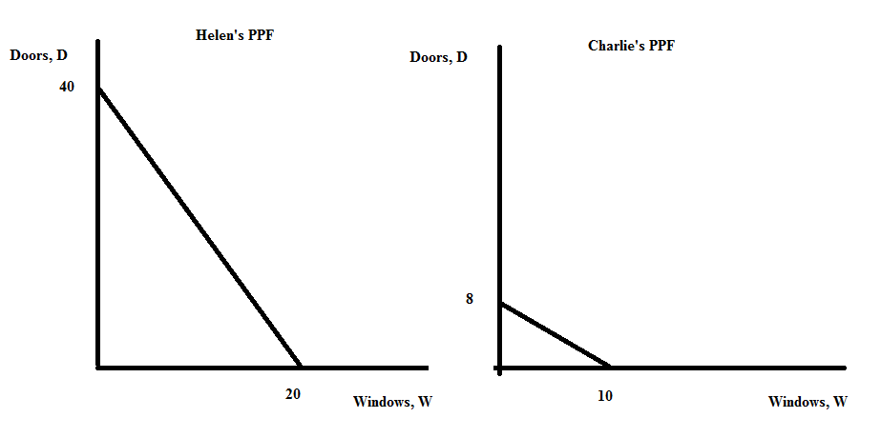
b. Helen has the comparative advantage in the production of doors: Helen's opportunity cost of producing an additional door is 1/2 window while Charlie's opportunity cost of producing an additional door is 5/4 window.

c. Charlie has the comparative advantage in the production of windows. Charlie's opportunity cost of producing an additional window is 4/5 door while Helen's opportunity cost of producing an additional window is 2 doors.

d.
 | Opportunity Cost of Producing One More Window | Opportunity Cost of Producing One More Door
Helen | 2 doors | 1/2 window
Charlie | 8/10 door or 4/5 door | 5/4 window or 1.25 windows

e.
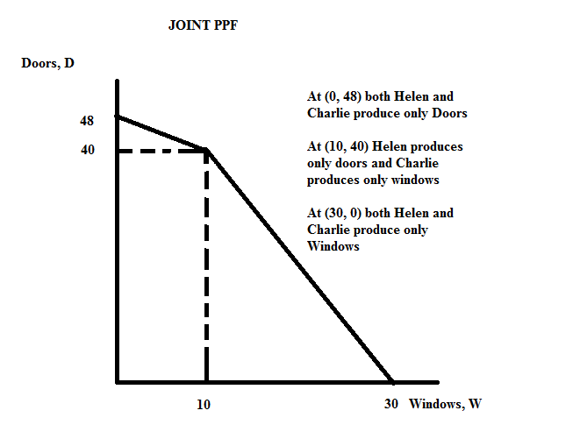
f. The top segment of the joint PPF can be written as:
D = 48 – (4/5)W for the 0 ≤ W ≤ 10
The bottom segment of the joint PPF takes a bit more work:
y = mx + b
D = (-2)W + b
We know that the points (W, D) = (10, 40) and (30, 0) sit on this part of the PPF. So, use one of these points to solve for the value of b, the y-intercept for the equation.
40 = (-2)(10) + b
b = 60
The equation for this lower segment of the joint PPF can be written as:
D = 60 – 2W for 10 ≤ W ≤ 30

g.
Let's start by drawing this sketch showing the acceptable range of trading prices in terms of doors for 1 window and then we can "gross this up" for five windows.
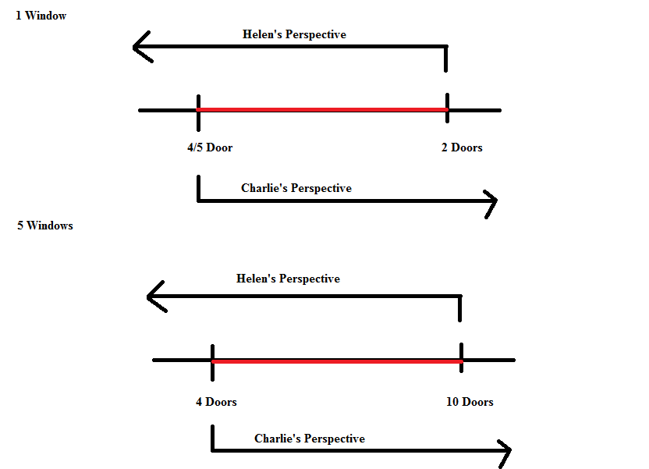

6. The graph below depicts the production possibility frontier for a small economy that produces only buckets (B) and ladders (L). This PPF is linear between any two adjacent points on the PPF: e.g., the PPF is linear between points A and B, between points B and C, and between points C and D….
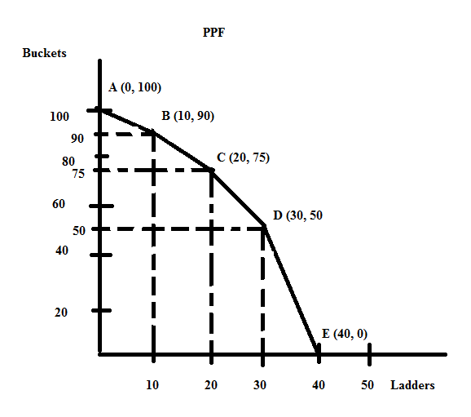

a. Suppose this economy is currently producing at point B. What is the opportunity cost of producing one additional bucket given this information? Explain your answer. Make sure your answer provides the units of measurement.

b. Suppose that this economy is currently producing at point B. What is the opportunity cost of producing one additional ladder given this information? Explain your answer. Make sure your answer provides the units of measurement.

c. Suppose this economy is currently producing at point C. What is the opportunity cost of producing one additional bucket given this information? Explain your answer. Make sure your answer provides the units of measurement.

d. Suppose this economy is currently producing at point C. What is the opportunity cost of producing one additional ladder given this information? Explain your answer. Make sure your answer provides the units of measurement.

e. Suppose this economy is currently producing at point D. What is the opportunity cost of producing one additional bucket given this information? Explain your answer. Make sure your answer provides the units of measurement.

f. Suppose this economy is currently producing at point D. What is the opportunity cost of producing one additional ladder given this information? Explain your answer. Make sure your answer provides the units of measurement.

g. Given the above PPF, write the equation(s) for each segment of the PPF. Identify the relevant range or domain for each equation. Show your work and how you found these equations.

Answers:

a. If this economy is initially at point B and wants to produce an additional bucket, then the economy is moving along the PPF from point B toward point A. To find the opportunity cost of an additional bucket we would need to find the reciprocal of the slope of the segment of the PPF between points A and B. The slope of this segment is -1, so the reciprocal of the slope of this segment is also -1. The opportunity cost of an additional bucket if this economy is at point B is therefore 1 ladder.

Alternatively, you could write the equation for the PPF between points A and B:
B = 100 – L and then plug in B' = 91. When you do this, you find that L' = 9. Instead of having 10 ladders you now only have nine ladders: the opportunity cost of producing that additional bucket (going from 90 buckets to 91 buckets) is measured by what you gave up...in this case, this economy gives up 1 ladder.

b. If this economy is initially at point B and wants to produce an additional ladder, then the economy is moving along the PPF from point B toward point C. To find the opportunity cost of an additional ladder we would need to find the slope of this segment of the PPF between points B and C. The slope of this segment is -3/2: the opportunity cost of an additional ladder if this economy is at point B is therefore 3/2 buckets.

Alternatively, you could write the equation for the PPF between points B and C: this takes a bit more work. So, here are the steps:
y = mx + b is the general form of an equation for a straight line
B = (-3/2)L + b
Then, use one of the known points that lies on this segment to find the value of the y-intercept, b: we know that (L, B) = (10, 90) and (20, 75) both are on this segment.
90 = (-3/2)(10) + b
b = 105
B = 105 – (3/2)L and then plug in L' = 11. When you do this, you find that B' = 88.5. Instead of having 90 buckets you now only have 88.5 buckets: the opportunity cost of producing that additional ladder (going from 10 ladders to 11 ladders) is measured by what you gave up...in this case, this economy gives up 1.5 buckets.

c. If this economy is initially at point C and wants to produce an additional bucket, then the economy is moving along the PPF from point C toward point B. To find the opportunity cost of an additional bucket we would need to find the reciprocal of the slope of the segment of the PPF between points B and C. The slope of this segment is -3/2, so the reciprocal of the slope of this segment is -2/3. The opportunity cost of an additional bucket if this economy is at point C is therefore 2/3 ladder.

Alternatively, you could write the equation for the PPF between points B and C: this takes a bit more work. So, here are the steps:
y = mx + b is the general form of an equation for a straight line
B = (-3/2)L + b
Then, use one of the known points that lies on this segment to find the value of the y-intercept, b: we know that (L, B) = (10, 90) and (20, 75) both are on this segment.
90 = (-3/2)(10) + b
b = 105
B = 105 – (3/2)L and then plug in B' = 76. When you do this, you find that L' = 19.3. Instead of having 20 ladders you now only have 19.3 ladders: the opportunity cost of producing that additional bucket (going from 75 buckets to 76 buckets) is measured by what you gave up...in this case, this economy gives up 2/3 ladder.

d. If this economy is initially at point C and wants to produce an additional ladder, then the economy is moving along the PPF from point C toward point D. To find the opportunity cost of an additional ladder we would need to find the slope of this segment of the PPF between points C and D. The slope of this segment is -5/2: the opportunity cost of an additional ladder if this economy is at point C is therefore 5/2 buckets.

Alternatively, you could write the equation for the PPF between points C and D: this takes a bit more work. So, here are the steps:
y = mx + b is the general form of an equation for a straight line
B = (-5/2)L + b
Then, use one of the known points that lies on this segment to find the value of the y-intercept, b: we know that (L, B) = (30, 50) and (20, 75) both are on this segment.
50 = (-5/2)(30) + b
b = 125
B = 125 – (5/2)L and then plug in L' = 21. Instead of having 75 buckets you now only have 72.5 buckets: the opportunity cost of producing that additional ladder (going from 20 ladders to 21 ladders) is measured by what you gave up...in this case, this economy gives up 2.5 buckets.

e. If this economy is initially at point D and wants to produce an additional bucket, then the economy is moving along the PPF from point D toward point C. To find the opportunity cost of an additional bucket we would need to find the reciprocal of the slope of the segment of the PPF between points C and D. The slope of this segment is -5/2, so the reciprocal of the slope of this segment is -2/5. The opportunity cost of an additional bucket if this economy is at point D is therefore 2/5 ladder.

Alternatively, you could write the equation for the PPF between points C and D: this takes a bit more work. So, here are the steps:
y = mx + b is the general form of an equation for a straight line
B = (-5/2)L + b
Then, use one of the known points that lies on this segment to find the value of the y-intercept, b: we know that (L, B) = (30, 50) and (20, 75) both are on this segment.
50 = (-5/2)(30) + b
b = 125
B = 125 – (5/2)L and then plug in B' = 51. When you do this, you find that L' = 29.6. Instead of having 30 ladders you now only have 29.6 ladders: the opportunity cost of producing that additional bucket (going from 75 buckets to 76 buckets) is measured by what you gave up...in this case, this economy gives up .4 or 2/5 ladder.

f. If this economy is initially at point D and wants to produce an additional ladder, then the economy is moving along the PPF from point D toward point E. To find the opportunity cost of an additional ladder we would need to find the slope of this segment of the PPF between points D and E. The slope of this segment is -5: the opportunity cost of an additional ladder if this economy is at point D is therefore 5 buckets.

Alternatively, you could write the equation for the PPF between points D and E: this takes a bit more work. So, here are the steps:
y = mx + b is the general form of an equation for a straight line
B = (-5)L + b
Then, use on of the known points that lies on this segment to find the value of the y-intercept, b: we know that (L, B) = (30, 50) and (40, 0) both are on this segment.
0 = (-5)(40) + b
b = 200
B = 200 – 5L and then plug is L' = 31. When you do this, you find that B' = 45. Instead of having 50 buckets you now only have 45 buckets: the opportunity cost of producing that additional ladder (going from 30 ladders to 31 ladders) is measured by what you gave up…in this case, this economy gives up 5 buckets.

g.
For the segment between points A and B: B = 100 – L
This equation holds from 90 ≤ B ≤ 100 or for 0 ≤ L ≤ 10.

For the segment between points B and C: B = 105 – (3/2)L
This equation holds from 75 ≤ B ≤ 90 or for 10 ≤ L ≤ 20.

For the segment between points C and D: B = 125 – (5/2)L
This equation holds from 50 ≤ B ≤ 75 or for 20 ≤ L ≤ 30.

For the segment between points D and E: B = 200 – 5L
This equation holds from 0 ≤ B ≤ 50 or for 30 ≤ L ≤ 40.

Basic Supply and Demand:

7. For each of the following scenarios describe whether the demand curve and/or the supply curve shifts as well as the direction of the shift(s). Assume that each market is initially in equilibrium and that each market adjusts to the scenario to find its new equilibrium.

Scenario | Which Curve(s) Shift? | What is the direction of the shift(s)? Describe the shift as a shift to the left or a shift to the right
In the market for new cars a hailstorm damages all the new cars in Iowa. The damage is so bad that none of these cars can be sold.
In the market for pizza researchers determine that pizza consumption is positively correlated with academic success.
In the market for cellphones a new phone is developed with a wider range of popular applications.
There is an economic boom and you are asked to evaluate the impact of this economic boom on the market for generic cereals.
The government decides to subsidize corn production. You are asked to evaluate the impact of this subsidy on the market for biofuels made from corn.

Answer:

Scenario | Which Curve(s) Shift? | What is the direction of the shift(s)?
In the market for new cars a hailstorm damages all the new cars in Iowa. The damage is so bad that none of these cars can be sold. | The supply curve for new cars shifts | The supply curve shifts to the left: at every price fewer new cars will be supplied
In the market for pizza, researchers determine that pizza consumption is positively correlated with academic success. | The demand curve for pizza shifts due to a change in tastes and preferences | The demand curve shifts to the right: at every price more pizzas will now be demanded
In the market for cellphones a new phone is developed with a wider range of popular applications. | The demand curve for cellphones shifts due to a change in tastes and preferences | The demand curve shifts to the right: at every price more cellphones will now be demanded
There is an economic boom that results in an increase in incomes and you are asked to evaluate the impact of this economic boom on the market for generic cereals. | The demand curve for generic cereals will shift | In an economic boom, incomes increase and this will cause the demand curve for generic cereals to shift: if generic cereals are an inferior good (likely) then the demand curve for these cereals will shift to the left and at every price the quantity demanded will be lower; if generic cereals are a normal good (less likely) then the demand curve for these cereals will shift to the right and at every price the quantity demanded will be higher
The government decides to subsidize corn production. You are asked to evaluate the impact of this subsidy on the market for biofuels made from corn. | The supply curve for biofuels will shift | The supply curve for biofuels will shift to the right since the corn subsidy will lead to higher corn production and lower prices for corn (the supply curve for corn effectively shifts to the right) and these lower corn prices will result in lower biofuels costs of production leading to the supply curve for biofuels shifting to the right

8. For each of the following scenarios describe the impact of the described change on the equilibrium price and equilibrium quantity in the chosen market. Describe any shift or movement that occurs as well. Assume that each market is initially in equilibrium.

Scenario | Impact on Equilibrium Price and Equilibrium Quantity | Shifts and/or Movements
In the market for soft drinks people decide that ingesting sugar is bad for their health.
In the market for soft drinks a study reports that consumption of soft drinks is a direct contributor to increased obesity; and, at the same time, the price of sweeteners used to produce soft drinks increase.
In the market for gasoline there is an increase in the number of fuel efficient cars sold; and, at the same time, widespread was breaks out in the Middle East disrupting oil production.
In the market for college education, the number of students attending colleges increases and, at the same time, the government decides to provide subsidies to those institutions providing college educations.

Answer:

Scenario | Impact on Equilibrium Price and Equilibrium Quantity | Shifts and/or Movements
In the market for soft drinks people decide that ingesting sugar is bad for their health. | Equilibrium price decreases and equilibrium quantity decreases | The demand curve for soft drinks shifts to the left and there is a movement along the supply curve for soft drinks
In the market for soft drinks a study reports that consumption of soft drinks is a direct contributor to increased obesity; and, at the same time, the price of sweeteners used to produce soft drinks increase. | The equilibrium price of soft drinks is indeterminate (the price may increase, decrease or remain the same relative to the initial equilibrium price) and the equilibrium quantity decreases | The demand curve for soft drinks shifts to the left and the supply curve for soft drinks shifts to the left
In the market for gasoline there is an increase in the number of fuel efficient cars sold; and, at the same time, widespread war breaks out in the Middle East disrupting oil production. | The equilibrium price of gasoline is indeterminate (the price may increase, decrease or remain the same relative to the initial equilibrium price) and the equilibrium quantity decreases | The demand curve for gasoline shifts to the left and the supply curve for gasoline shifts to the left
In the market for college education, the number of students attending colleges increases and, at the same time, the government decides to provide subsidies to those institutions providing college educations. | The equilibrium price of a college education is indeterminate (the price may increase, decrease, or remain the same relative to the initial equilibrium price) and the equilibrium quantity increases | The demand curve for college education shifts to the right and the supply curve for college education shits to the right

9. Suppose that the price of bubble gum increases. This results in Suzy buying more candy bars and fewer sweet tarts. From this information and holding everything else constant, what do you know about Suzy’s view of candy bars and sweet tarts relative to bubble gum? Explain your answer fully using complete sentences. Strive for conciseness and clarity!

Answer:

From our study in class we know that two goods are substitutes if an increase in the price of one of these goods results in an increase in the consumption of the other good at a given price and holding everything else constant. Bubble gum and candy bars are substitutes for one another for Suzy given the above information.

From our study in class we know that two goods are complements if an increase in the price of one of these goods results in a decrease in the consumption of the other good at a given price and holding everything else constant. Bubble gum and sweet tarts are complements for one another for Suzy given the above information.

10. Analyze each of the following scenarios and provide a graph to illustrate your answer. Use (Qo, Po) to designate the initial equilibrium price and quantity, and (Q', P') to designate the new equilibrium price and quantity. Illustrate in your graph any shifts that occur in the demand and/or supply curves.

a. Consider the market for coffee mugs that is initially in equilibrium. Suppose that the price of coffee decreases. Analyze the impact of this change on the equilibrium price and quantity of coffee mugs. Use a graph to illustrate your answer.

b. Return to the coffee mug market that is initially in equilibrium. Suppose that the price of coffee decreases while at the same time, clay, an input in coffee mugs, has a price increase. Analyze the impact of this change on the equilibrium price and quantity of coffee mugs. Use a graph to illustrate your answer.

c. Consider the market for televisions that is initially in equilibrium. New technology makes it possible to view visual content not only on televisions, but also on smart phones, laptops, and a variety of other types of smart devices. Given these developments what do you predict is going to happen to the equilibrium price and quantity of televisions? Use a graph to illustrate your answer.

d. Consider the market for traditional cars: that is, gasoline-powered cars. Younger Americans are choosing to live in more urban locations; take advantage of car services like Uber, Lyfe, and Zipcar; and even, in some cases, choosing to not get a driver's license (and maybe not even bother to learn to drive). At the same time, Google and Uber are pioneering new technology that will replace gasoline-powered and human-driven cars with driverless, electric cars. Given these changes, what do you predict will happen to the equilibrium price and equilibrium quantity of gasoline-powered cars over the next two decades (think about this in a longer time frame than just what is happening in this twenty-four hour period of time)? Use a graph to illustrate your answer.

e. Consider the market for ice cream that is initially in equilibrium. Suppose that people's income increase and that you know that the income elasticity of demand for ice cream is .5. This means that with every 1% increase in income, the quantity of ice cream demanded will increase by 0.5%. From this information, analyze what happens to the equilibrium price and equilibrium quantity of ice cream. Illustrate your answer with a graph.

Answer:
a. Coffee and coffee mugs are complements. When the price of coffee decreases, the demand for coffee mugs will shift to the right. The equilibrium price of coffee mugs will increase and the equilibrium quantity of coffee mugs will increase. Here is a graph to illustrate this change.
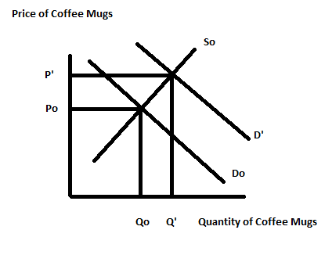
b. Coffee and coffee mugs are complements. When the price of coffee decreases, the demand for coffee mugs will shift to the right. But, we also have the price of clay, an input in the production of coffee mugs, increasing. This will cause the supply curve to shift to the left. We do not know the relative size of these two shifts: so we can predict that the equilibrium price of coffee mugs will increase, but the equilibrium quantity of coffee mugs may increase, decrease, or remain the same (quantity will be indeterminate). Here are two graphs to illustrate this idea.

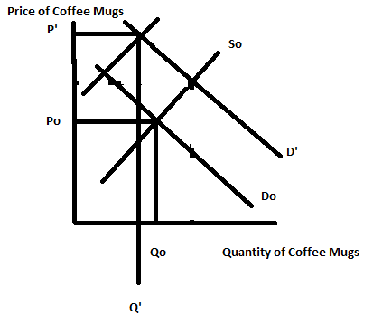

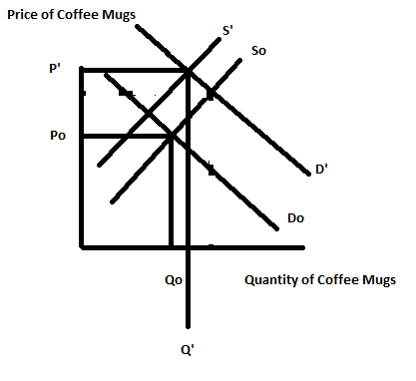
c. The ability to view television type content on a variety of devices will likely mean that tastes and preferences for televisions will decrease: this will shift the demand for television to the left. Equilibrium price and quantity in the television market should decrease given these changes. Here's the graph to illustrate this situation.

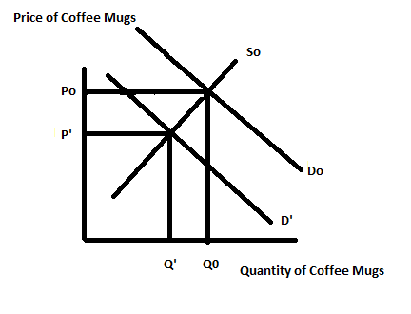
d. This is a more complicated scenario! It is easy to see that the demand for gasoline-powered cars will shift to the left due to changing tastes and preferences from this younger group of drivers. But, the supply curve will also likely shift to the left: driverless cars and gasoline-powered cars are substitutes in production. Driverless cars also represent a change in technology that will have a negative impact on gasoline-powered cars. So, I would model this as two shifts: a shift to the left of the demand curve and a shift to the left of the supply curve. This means that the equilibrium quantity will decrease and the equilibrium price may increase, decrease or remain the same (price will be indeterminate). Here are two graphs to illustrate these possibilities:
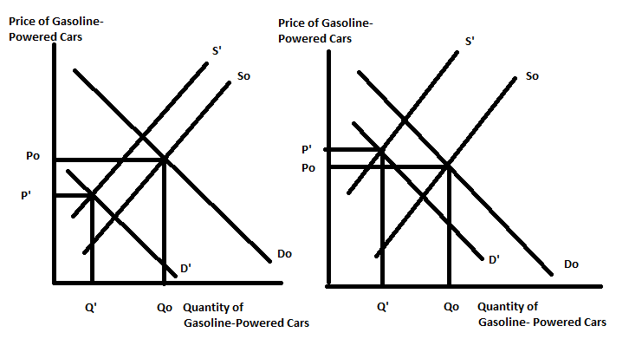

e. First, you need to recall that income elasticity of demand is the ratio of the percentage change in the quantity demanded of the good to the percentage change in income. You are told that this is a positive number and that income has increased: this implies that the percentage change in the quantity demanded must be a positive number. That is, as income rises the quantity of ice cream demanded is also increasing. This tells us that ice cream is a normal good: when income increases and the good is a normal good, then the demand curve for that good will shift to the right. From this we can conclude that the equilibrium price and equilibrium quantity of ice cream has risen relative to their initial levels. Here's the graph:
