Econ 102 Name _________________________________
Summer 2014
Answers to Quiz #4

Please write all answers neatly and legibly.

- (3 points) Suppose the loanable funds market is initially in equilibrium. Holding everything else constant, if the government increases the size of its surplus what do you predict will happen to the equilibrium interest rate and the equilibrium level of private investment spending? Explain your answer verbally and also provide a graph of the loanable funds market to support your analysis. Make sure your graph is completely and fully labeled.

Answer:
You can model this problem by either showing the increase in the government surplus as 1) a rightward shift in the supply of loanable funds curve or 2) a leftward shift in the demand for loanable funds curve.

- In the first approach the supply of loanable funds curve shifts to the right because when the government increases its surplus the amount of government savings increases. So, at every interest rate there are now more loanable funds being supplied to this market. This will result in the equilibrium interest rate in the market falling and as the interest rate falls the level of private investment spending will increase. Here is a diagram to illustrate this analysis.
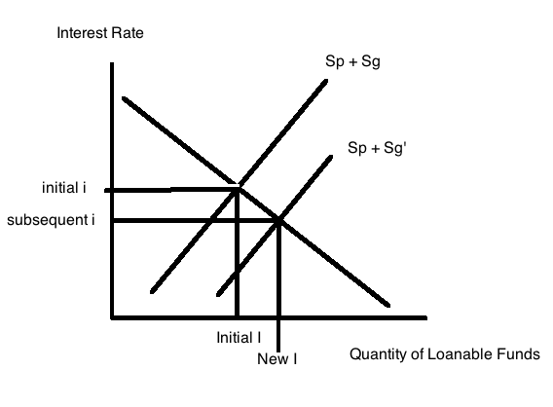

- In the second approach the demand for loanable funds curve shifts to the left because when the government increases its surplus the amount of government savings increases. If you model this on the demand for loanable funds side of the market this means that Sg is getting bigger and that I – Sg is getting smaller: thus, the demand for loanable funds curve is shifting to the left. This will result in the equilibrium interest rate in the market falling and as the interest rate falls the level of private investment spending will increase. Here is a diagram that illustrates a potential outcome in this market (you could have the leftward shift be bigger or smaller and the interest rate would still be falling and the level of private investment spending would be increasing).
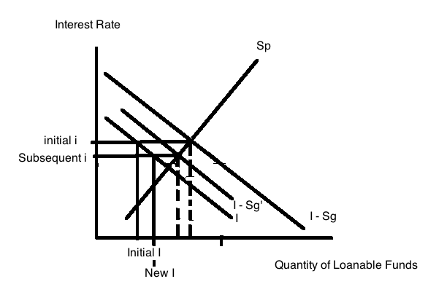

- (2 points) Suppose the loanable funds market is initially in equilibrium. Holding everything else constant, what will happen to the equilibrium interest rate and the equilibrium level of private savings if the country runs a trade surplus? Explain your answer verbally and also provide a graph of the loanable funds market to support your analysis. Make sure your graph is completely and fully labeled.

Answer:
If the country runs a trade surplus this will shift the supply of loanable funds curve to the left because when a country runs a trade surplus (X – M > 0) this implies that the country has capital inflows that are negative (M – X < 0). Negative KI inflows will cause the supply of loanable funds curve to shift to the left relative to its initial position. We can predict that the equilibrium interest rate will increase and that the equilibrium level of private investment will decrease when the country runs a trade surplus. We can also predict that the level of private savings will increase due to the increase in the interest rate. Here’s a diagram to illustrate this answer.
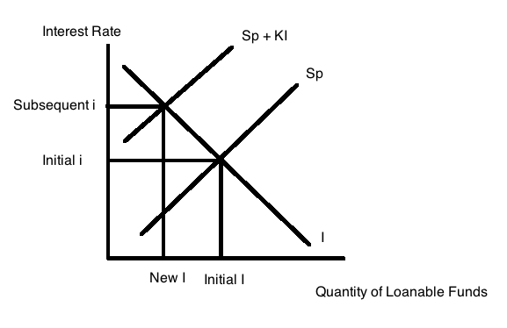

- Suppose that an economy can be described with the following information:
Sp = -20 + .2(Y – T)
T = 10
G = 20
I = 20
X – M = -20
where Sp is private savings, Y is real GDP, T is autonomous taxes, G is government spending, I is private investment spending, and (X – M) is net exports. Assume there are no government transfers.

- (1 point) From this information we know that the government is currently operating with a ________ and that the economy has a trade _________________.

Answer:
Government is operating with a government deficit.
Economy has a trade deficit.

- (1 point) What is this economy’s consumption function with respect to Y?

Answer:
From the savings function we can write the consumption function with respect to disposable income (Y – T): C = 20 + .8(Y – T). But the question asks for the consumption function with respect to Y, so this implies that we must get rid of the T in the equation. You are told that T = 10 so plug this value into the consumption function to get C = 12 + .8Y.

- (2 points) What is the equilibrium level of output in this economy given the above information? For full credit show your work.

Answer:
In equilibrium Y = AE. We know that AE = C + I + G + (X – M). So,
Ye = 12 + .8Ye + 20 + 20 + (-20)
.2Ye = 32
Ye = 160

- (1 point) What will be the change in GDP if the government of this economy increases its spending to 40 while holding everything else constant? For full credit show your work.

Answer:

Correct answer reads this as an increase in government spending to 40 and not “by 40”: I will provide answers to both of these readings though in case you read this way.

To answer this question you could use the multiplier concept or you could simply solve for the new equilibrium given the increased level of government spending. Let’s look at both of these methods:

Change in GDP = (multiplier)(change in government spending)
Change in GDP = (1/(1 – MPC))(20) since G is initially 20 and then increases to 40
Change in GDP = (1/.2)(20)
Change in GDP = 5*40 = 100

Or, Ye’ = 12 + .8Ye’ + 20 + 40 + (-20)
.2Ye’ = 52
Ye’ = 260
Remember that the question asks for the change in GDP: Ye’ – Ye = 260 – 160 = 100

If you read the question as saying government spending increased by 40 then you would have G changing from 20 to 60, or a change of 40. To answer this question you could use the multiplier concept or you could simply solve for the new equilibrium given the increased level of government spending. Let’s look at both of these methods:

Change in GDP = (multiplier)(change in government spending)
Change in GDP = (1/(1 – MPC))(40)
Change in GDP = (1/.2)(40)
Change in GDP = 5*40 = 200

Or, Ye’ = 12 + .8Ye’ + 20 + 60 + (-20)
.2Ye’ = 72
Ye’ = 360
Remember that the question asks for the change in GDP: Ye’ – Ye = 360 – 160 = 200

