Economics 102
Summer 2014
Answers to Homework #1
Due 6/26/14

Directions: The homework will be collected in a box before the lecture. Please place your name, TA name and section number on top of the homework (legibly). Make sure you write your name as it appears on your ID so that you can receive the correct grade. Please remember the section number for the section you are registered, because you will need that number when you submit exams and homework. Late homework will not be accepted so make plans ahead of time. Please show your work. Good luck!

Please remember to
- Staple your homework before submitting it.
- Do work that is at a professional level: you are creating your “brand” when you submit this homework!
- Not submit messy, illegible, sloppy work.

1. This set of questions will help you review some basic algebra, the slope-intercept form, finding a solution given two linear equations, and finding a new equation based upon an initial equation that has undergone a change. Each question below is independent of the other questions in the set.
a. You are given two pairs of coordinates that lie on a linear relationship. The two pairs of coordinates are (x, y) = (20, 5) and (15, -2). You are asked to find the equation for the line that these two points lie on.
b. You are given two pairs of coordinates that lie on a linear relationship. The two pairs of coordinates are (x, y) = (10, 15) and (2, 5). You are asked to find the equation for the line that these two points lie on.
c. You are given two equations:
Equation 1: y = 10 + 6x
Equation 2: y = 26 – 2x
Find the (x, y) solution that represents the intersection of these two lines.
d. You are given two equations:
Equation 1: y = 10 + 2x
Equation 2: y = 26 – 2x
But, you are also told that equation 1 has changed and now the y value is 10 units bigger at every x value than it was initially.
i. Write the equation that represents the new Equation1’.
ii. Given the new Equation 1’ and Equation 2, find the (x,y) solution that represents the intersection of these two lines.

Answer:
a. Start by finding the slope of the equation using the two points: slope = (change in y)/(change in x) = [5 – (- 2)]/(20 – 15) = 7/5. Then, use the slope-intercept form, y = mx + b, to find the equation for the line. Thus, y = (7/5)x + b. Then, plugging in one of the given points-in this case, let’s use (20, 5) we get 5 = (7/5)(20) + b or b = -23. The equation is therefore y = (7/5)x - 23.

b. Start by finding the slope of the equation using the two points: slope = (change in y)/(change in x) = (15 – 5)/(10 – 2) = 5/4. Then, use the slope-intercept form, y = mx + b, to find the equation for the line. Thus, y = (5/4)x + b. Then, plugging in one of the given points-in this case, let’s use (10, 15) we get 15 =
(5/4)(10) + b or b = 5/2. The equation is therefore y = (5/4)x + 5/2.

c. To find where these two lines intersect set the two equations equal to one another:
10 + 6x = 26 – 2x
8x = 16
x = 2
y = 10 + 6x = 10 + 6(2) = 22
Or, y = 26 – 2x = 26 – 2(2) = 22
The solution for these two equations is (x, y) = (2, 22).

d.
i. We know that (0,10) was on the original line represented by Equation 1; the new Equation 1’ would contain the point (0, 20) since the y value at every x value has increased by 10 units. The slope of Equation 1’ is the same as the slope of Equation 1. Thus, y = b’ + 2x where b’ is the y-intercept of the new Equation 1’. Use the point (0, 20) to find the value of b’. Thus, 20 = b’ + 2(0) or b’ = 20. The equation for Equation 1’ is y = 2x + 20.
ii. To find where Equation 1’ and Equation 2 intersect set the two equations equal to one another:
2x + 20 = 26 – 2x
4x = 6
x = 3/2
y = 2x + 20 = 2(3/2) + 20 = 23
Or, y = 26 – 2x = 26 – 2(3/2) = 23
The solution for these two equation is (x, y) = (3/2, 23).

2. The price of money is called the interest rate. Suppose that when the interest rate is 2%, the demand for money is $1000 and when the interest rate is 7% the demand for money is $500. Assume the relationship between the quantity of money demanded (Q) and the interest rate (r) is linear.
a. Draw a graph representing the above information. In your graph measure Q on the horizontal axis and r on the vertical axis.
b. Write an equation for this relationship in slope-intercept form.

Answer:
a.
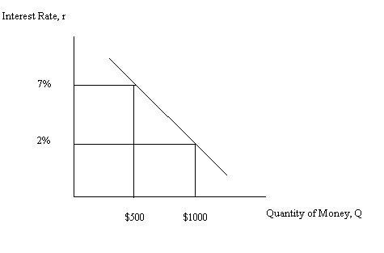
b. r = mQ + b
m = -5/500 = -1/100
r = b + (-1/100)Q
Substitute in the coordinates of a point that you know is on this line: (Q, r) = (500, 7)
7 = b + (-1/100)(500)
b = 12
r = 12 – (1/100)Q is the equation for this relationship.

3. Morey’s wealth on December 31, 2010 was equal to $200,000; his wealth on December 31, 2011 was equal to $250,000; and his wealth on December 31, 2012 was $300,000. Use this information to answer this next set of questions. For this set of questions assume there was no inflation during this three year period of time.
a. Using the given information calculate the percentage change in Morey’s wealth for each year. Place your answers in the following table. But, make sure you show how you got your answers for the table in the homework answers you provide.
Date | Wealth on that date | % change in wealth from previous year
12/31/2010 | $200,000 | ---
12/31/2011 | $250,000
12/31/2012 | $300,000

b. Given that Morey’s wealth increases by $50,000 in both 2011 and 2012, does that mean that the percentage change in his wealth is the same for each of these years? Explain your answer.

a. To find the percentage change in wealth from the previous year you will use the simple percentage change formula:
% change in variable = {[new value – old value]/[old value]} * (100%)
So, for example the percentage change in Morey’s wealth from 2011 to 2012 would be given by the following:
% change in wealth from 2011 to 2012 = [(250,000 – 200,000)/(200,000)] * 100% = 25%.
Here is the completed table.

Date | Wealth on that date | % change in wealth from previous year
12/31/2010 | $200,000 | ---
12/31/2011 | $250,000 | 25%
12/31/2012 | $300,000 | 20%

b. Even though Morey’s wealth increases by $50,000 in 2011 and 2012 that does not mean that the percentage change in his wealth from 2010 to 2011 is the same as the percentage change in his wealth from 2011 to 2012. In the percentage change formula you should see that the denominator value in 2011 is $200,000 while the denominator value in 2012 is $250,000: that is, the base upon which the percentage change is calculated is different in the two years and that leads to a different percentage change in the two years.

4. The following table provides data on the amount of labor Pablo and Lou need in order to produce watches (W) and blankets (B). Assume that both Pablo and Lou have linear production possibility frontiers and that the production of watches and blankets requires only labor as an input.

 | Labor Needed to Produce One Watch | Labor Needed to Produce One Blanket
Pablo | 3 Hours of Labor | 5 Hour of Labor
Lou | 2 Hours of Labor | 3 Hours of Labor

a. Assume that Pablo and Lou each have 60 hours of labor they can devote to watch and blanket production. Fill in the following statements given this information. Assume both Pablo and Lou produce at points on their PPFs.
i. When Pablo produces 10 blankets, his watch production must equal _________.
ii. When Pablo produces 6 blankets, his watch production must equal _________.
iii. When Lou produces 8 blankets, his watch production must equal _________.
iv. When Lou produces 16 blankets, his watch production must equal _________.
b. For Pablo, the opportunity cost of producing 2 blankets is equal to __________________.
c. For Lou, the opportunity cost of producing 4 blankets is equal to __________________.
d. Pablo has the comparative advantage in the production of ___________________ and Lou has the comparative advantage in the production of ________________. Explain your answer.
e. Construct Pablo and Lou’s joint PPF measuring watches (W) on the vertical axis and blankets (B) on the horizontal axis.
f. The acceptable range of trading prices for 10 watches is ________________________.

Answer:
a. First start by drawing two graphs: one representing Pablo’s PPF and the other representing Lou’s PPF with both PPFs based upon each of these individuals having 60 hours of labor.
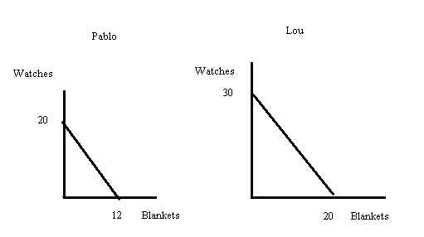

Given these two graphs it is relatively easy to write equations for the two PPFs:
Pablo’s PPF can be written as W = 20 – (5/3)B where W is watches and B is blankets.
Lou’s PPF can be written as W = 30 – (3/2)B where W is watches and B is blankets.
Use these two equations to answer (a):
i. 10/3 watches
ii. 10 watches
iii. 18 watches
iv. 6 watches

b. For Pablo the opportunity cost of 2 blankets is 10/3 watches: to see this answer start by assuming that Pablo is initially producing 0 blankets and 20 watches. If Pablo changes his blanket production to 2 blankets then his watch production will fall: W = 20 – (5/3)(2) = 50/3 watches. How many watches did Pablo give up? He gave up 60 – 50/3 or 10/3 watches.

c. For Lou the opportunity cost of 4 blankets is 6 watches: to see this answer start by assuming that Lou is initially producing 0 blankets and 30 watches. If Lou changes his blanket production to 4 blankets then his watch production will fall: W = 30 – (3/2)(4) = 24 watches. How many watches did Lou give up? He gave up 30 – 24 or 6 watches.

d. Pablo has the comparative advantage in the production of watches while Lou has the comparative advantage in the production of blankets.

To see this: Pablo’s opportunity cost of producing a blanket is 5/3 watch while Lou’s opportunity cost of producing a blanket is 3/2 watch- this implies that Lou has a lower opportunity cost than Pablo of producing blankets. In contrast, Pablo’s opportunity cost of producing 1 watch is 3/5 blanket which is less than Lou’s opportunity cost of producing a watch which is 2/3 blanket.

e.
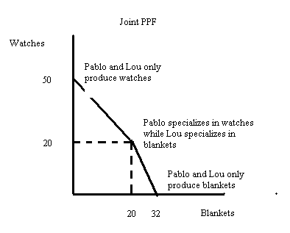

f. The acceptable range of trading prices for 10 watches will be between 6 blankets and 20/3 blankets. The following image illustrates this range of trading prices.

