Economics 102
Summer 2013
Answers to Homework #1
Due June 27, 2013

Directions: The homework will be collected in a box before the lecture. Please place your name, TA name and section number on top of the homework (legibly). Make sure you write your name as it appears on your ID so that you can receive the correct grade. Please remember the section number for the section you are registered, because you will need that number when you submit exams and homework. Late homework will not be accepted so make plans ahead of time. Please show your work. Good luck!

Please remember to
- Staple your homework before submitting it.
- Do work that is at a professional level: you are creating your “brand” when you submit this homework!
- Not submit messy, illegible, sloppy work.

1. This set of questions will help you review some basic algebra, the slope-intercept form, finding a solution given two linear equations, and finding a new equation based upon an initial equation that has undergone a change. Each question below is independent of the other questions in the set.
a. You are given two pairs of coordinates that lie on a linear relationship. The two pairs of coordinates are (x, y) = (10, 15) and (5, 12). You are asked to find the equation for the line that these two points lie on.
b. You are given two pairs of coordinates that lie on a linear relationship. The two pairs of coordinates are (x, y) = (10, 15) and (12, 5). You are asked to find the equation for the line that these two points lie on.
c. You are given two equations:
Equation 1: y = 10 + 2x
Equation 2: y = 26 – 2x
Find the (x, y) solution that represents the intersection of these two lines.
d. You are given two equations:
Equation 1: y = 10 + 2x
Equation 2: y = 26 – 2x
But, you are also told that equation 1 has changed and now the x value is 10 units bigger at every y value than it was initially.
i. Write the equation that represents the new Equation1’.
ii. Given the new Equation 1’ and Equation 2, find the (x,y) solution that represents the intersection of these two lines.

Answer:
a. Start by finding the slope of the equation using the two points: slope = (change in y)/(change in x) = (15 – 12)/(10 – 5) = 3/5. Then, use the slope-intercept form, y = mx + b, to find the equation for the line. Thus, y = (3/5)x + b. Then, plugging in one of the given point-in this case, let’s use (10, 15) we get 15 = (3/5)(10) + b or b = 9. The equation is therefore y = (3/5)x + 9.

b. Start by finding the slope of the equation using the two points: slope = (change in y)/(change in x) = (15 – 5)/(10 – 12) = -5. Then, use the slope-intercept form, y = mx + b, to find the equation for the line. Thus, y = (-5)x + b. Then, plugging in one of the given points-in this case, let’s use (10, 15) we get 15 =
(-5)(10) + b or b = 65. The equation is therefore y = (-5)x + 65.

c. To find where these two lines intersect set the two equations equal to one another:
10 + 2x = 26 – 2x
4x = 16
x = 4
y = 10 + 2x = 10 + 2(4) = 18
Or, y = 26 – 2x = 26 – 2(4) = 18

d.
i. We know that (0,10) was on the original line represented by Equation 1; the new Equation 1’ would contain the point (10, 10) since the x value at every y value has increased by 10 units. The slope of Equation 1’ is the same as the slope of Equation 1. Thus, y = b’ + 2x where b’ is the y-intercept of the new Equation 1’. Use the point (10, 10) to find the value of b’. Thus, 10 = b’ + 2(10) or b’ = -10. The equation for Equation 1’ is y = 2x – 10.
ii. To find where Equation 1’ and Equation 2 intersect set the two equations equal to one another:
2x -10 = 26 – 2x
4x = 36
x = 9
y = 2x – 10 = 2(9) – 10 = 8
Or, y = 26 – 2x = 26 – 2(9) = 8

2. The price of money is called the interest rate. Suppose that when the interest rate is 5%, the demand for money is $1000 and when the interest rate is 10% the demand for money is $500. Assume the relationship between the quantity of money demanded (Q) and the interest rate (r) is linear.
a. Draw a graph representing the above information. In your graph measure Q on the horizontal axis and r on the vertical axis.
b. Write an equation for this relationship in slope-intercept form.

Answer:
a.
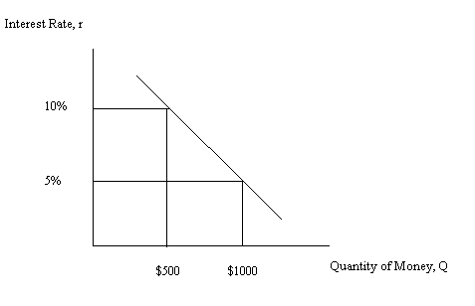
b. r = mQ + b
m = -5/500 = -1/100
r = b + (-1/100)Q
Substitute in the coordinates of a point that you know is on this line: (Q, r) = (500, 10)
10 = b + (-1/100)(500
b = 15
r = 15 – (1/100)Q is the equation for this relationship

3. Josie’s income in 2010 was $50,000 and her income in 2011 was $60,000. Her income in 2012 was $50,000. Use this information to answer this next set of questions. For this set of questions assume there was no inflation during this three year period of time.
a. What was the percentage change in Josie’s income in 2011 relative to 2010?
b. What was the percentage change in Josie’s income in 2012 relative to 2011?
c. Given that in both (a) and (b) you are measuring percentage changes and the numbers in both examples use $50,000 and $60,000, do you get the same answers? Explain your answer.

Answers:
a. Percentage change in Josie’s income from 2010 to 2011 = [(New income-Initial income)/(Initial income)[*(100%)] = [(60,000 – 50,000)/(50,000)]*100% = (.2)(100%) = 20%. Josie’s income increased by 20% between 2010 and 2011.
b. Percentage change in Josie’s income from 2011 to 2012 = [(New income-Initial income)/(Initial income)[*(100%)] = [(50,000 – 60,000)/(60,000)]*100% = (-.1667)(100%) = -16.67%. Josie’s income decreased by 16.67% between 2011 and 2012.

c. Even though both (a) and (b) are measuring percentage changes and they both use $50,000 and $60,000 you do not get the same answers. That is because the base value, or the initial value, is different in the two questions. The choice of base matters in measuring percentage changes.

4. The following table provides data on the amount of labor Chin and Luis need in order to produce widgets (W) and gadgets (G). Assume that both Chin and Luis have linear production possibility frontiers and that the production of widgets and gadgets requires only labor as an input.

 | Labor Needed to Produce One Gadget | Labor Needed to Produce One Widget
Chin | 2 Hours of Labor | 1 Hour of Labor
Luis | 3 Hours of Labor | 4 Hours of Labor

a. Assume that Chin and Luis each have 60 hours of labor they can devote to gadget and widget production. Fill in the following statements given this information. Assume both Chin and Luis produce at points on their PPFs.
i. When Chin produces 10 gadgets, his widget production must equal _________.
ii. When Chin produces 20 gadgets, his widget production must equal _________.
iii. When Luis produces 8 gadgets, his widget production must equal _________.
iv. When Luis produces 16 gadgets, his widget production must equal _________.
b. For Chin, the opportunity cost of producing 2 gadgets is equal to __________________.
c. For Luis, the opportunity cost of producing 4 gadgets is equal to __________________.
d. Chin has the comparative advantage in the production of ___________________ and Luis has the comparative advantage in the production of ________________. Explain your answer.
e. Construct Chin and Luis’ joint PPF measuring gadgets (G) on the vertical axis and widgets (W) on the horizontal axis.
f. The acceptable range of trading prices for 10 gadgets is ________________________.

Answer:
a. First start by drawing two graphs: one representing Chin’s PPF and the other representing Luis’ PPF with both PPFs based upon each of these individuals having 60 hours of labor.
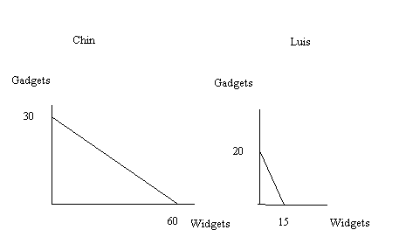

Given these two graphs it is relatively easy to write equations for the two PPFs:
Chin’s PPF can be written as G = 30 – (1/2)W
Luis’ PPF can be written as G = 20 – (4/3)W
Use these two equations to answer (a):
i. 40 widgets
ii. 20 widgets
iii. 9 widgets
iv. 3 widgets

b. 4 widgets: to see this answer start by assuming that G is initially 0. This implies W = 60. Then, if G’ = 2, this implies W’ = 56. Widget production decreases by 4 units when gadget production increases by 2 units.

c. 3 widgets: to see this answer start by assuming that G is initially 0. This implies W = 15. Then G’ = 4, and this implies W’ = 12. Widget production decreases by 3 units when gadget production increases by 4 units.

d. Widgets; Gadgets

To see this: Chin’s opportunity cost of producing 1 widget is (1/2)gadget while Luis’ opportunity cost of producing 1 widget is (4/3)gadget: Chin’s opportunity cost of producing widgets is lower than Luis’ opportunity cost of producing widgets. That implies that Chin has the comparative advantage in the production of widgets.

Luis’ opportunity cost of producing 1 gadget is (3/4)widget while Chin’s opportunity cost of producing 1 gadget is 2 widgets: Luis’ opportunity cost of producing gadgets is lower than Chin’s opportunity cost of producing gadgets. That implies that Luis has the comparative advantage in the production of gadgets.

e.
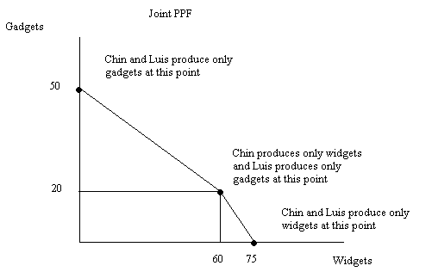
Notice that the above figure does not show a straight line from (0, 50) to (75, 0) but instead it illustrates two line segments that meet at a kink. Initially at (0, 50) both Chin and Luis produce only gadgets. As you move down the curve, initially Luis continues to produce gadgets since he has the comparative advantage in gadget production while Chin begins to produce widgets. Thus, when they start to produce widgets, they will first assign the person to widget production who has the comparative advantage in widget production.

f. The acceptable range of trading prices for 10 gadgets will be between 7.5 widgets and 20 widgets.

The price of 1 gadget would lie between the opportunity costs (3/4,2). The price of 1 gadget is in this range since when Chin wants to buy gadgets using widgets, he would not pay a price that is higher than his opportunity cost, which is 2 widgets. Similarly, Luis will not sell the gadget for a price that is lower than his opportunity cost.

