Economics 101 Name
Fall 2016 TA Name
November 22, 2016 Discussion Section Number
Second Midterm Student ID Number

Version 1
READ THESE INSTRUCTIONS CAREFULLY.
DO NOT BEGIN WORKING UNTIL THE PROCTOR TELLS YOU TO DO SO

You have 75 minutes to complete this exam. The exam consists of 9 binary response questions worth 2 points each and 20 multiple choice questions worth 4 points each for a total of 98 points. You will receive two points if you accurately and completely provide your name, ID number, discussion section number, version number, and TA name on the scantron sheet AND this exam booklet. Thus, the total number of points on the exam is 100. Answer all questions on the scantron sheet with a #2 pencil. There are 20 printed pages in this exam, including this cover sheet.

WARNING: NO COMMUNICATION OR CALCULATING DEVICES, OR FORMULA SHEETS ARE ALLOWED. NO CONSULTATION AND CONVERSATION WITH OTHERS ARE ALLOWED WHILE YOU ARE TAKING EXAM OR IN THE EXAM ROOM. PLAGIARISM IS A SERIOUS ACADEMIC MISCONDUCT AND PUNISHABLE TO THE FULLEST EXTENT.

PICK ONLY ONE BEST ANSWER FOR EACH QUESTION.

How to fill in the scantron sheet and other information:
- Print your last name, first name, and middle initial in the spaces marked "Last Name," "First Name," and "MI." Fill in the corresponding bubbles below.
- Print your student ID number in the space marked "Identification Number." Fill in the bubbles.
- Write the number of the discussion section you’ve been attending under "Special Codes" spaces ABC, and fill in the bubbles. You can find the discussion numbers below on this page.
- Write the version number of your exam booklet under "Special Codes" space D, and fill in the bubble. The version number is on the top of this page.

- If you believe there is an error on the exam or you do not understand something, make a note on your exam booklet and the issue will be addressed AFTER the examination is complete. No questions regarding the exam can be addressed while the exam is being administered.
- When you are finished, please get up quietly and bring your scantron sheet and this exam booklet to the place indicated by the proctors.

Discussion Sections (Sorted by TA):
Section Number | Time | Room | TA |  | Section Number | Time | Room | TA
335 | F 11:00 – 11:50 | Van Hise 379 | Hans Schwarz |  | 332 | Th 15:30 – 16:20 | Soc. Sci. 6322 | Sam Schreiber
339 | F 12:05 – 12:55 | Van Hise 205 | Hans Schwarz |  | 336 | F 11:00 – 11:50 | VanVleck B219 | Sam Schreiber
331 | F 9:55 – 10:45 | Van Hise 395 | Saber Ahmadi |  | 341 | F 12:05-12:55 | VanVleck B325 | Sam Schreiber
333 | F 13:20 – 14:10 | Van Hise 207 | Saber Ahmadi |  | 344 | F 9:55 – 10:45 | Ingraham 215 | Sam Schreiber
337 | F 14:25 – 15:15 | Soc. Sci. 5231 | Saber Ahmadi |  | 334 | F 13:20 – 14:10 | Van Hise 140 | Shuhei Otani
346 | F 12:05-12:55 | Sterling 2425 | Saber Ahmadi |  | 340 | F 14:25 – 15:15 | Soc. Sci. 6203 | Shuhei Otani
330 | F 8:50 – 9:40 | Sterling 2329 | Yixi Yang |  | 342 | F 9:55 – 10:45 | Sterling 2319 | Shuhei Otani
338 | F 9:55 – 10:45 | Sterling 2333 | Yixi Yang |  | 343 | F 11:00 – 11:50 | Sterling 2333 | Shuhei Otani
345 | F 11:00 – 11:50 | Sterling 2425 | Yixi Yang

(This page is intentionally left blank as an extra work sheet.)
DO NOT DETACH THIS SHEET FROM THIS EXAM BOOKLET!

I, , agree to neither give nor receive any help on this exam from others. I understand that the use of a calculator or communication device on this exam is academic misconduct. I also understand that providing answers to questions on this exam to other students is academic misconduct as is taking or receiving answers to questions on this exam from other students. Thus, I will cover my answers and not expose my answers to other students. It is important to me to be a person of integrity and that means ALL ANSWERS on this exam are my answers. Any violation of these guidelines will result in a penalty of at least receiving a zero on this exam.

Signed

BINARY CHOICE QUESTIONS (9 QUESTIONS WORTH 2 POINTS EACH)

- Assume that the market for milk is perfectly competitive in Wisconsin and that it is currently in its long-run equilibrium. A recent study proves that drinking milk reduces the risk of a cardiovascular disease, so the demand for milk increases permanently. Given this information and holding everything else constant, what happens to the price of milk in the short run and in the long run?
  - The price of milk increases in the short run, but the price will return to the original long run equilibrium level over time.
  - The price of milk increases in both the short run and the long run relative to the initial long run equilibrium price.

- Consider the market for electricity in Madison. The demand for electricity is relatively inelastic due to the lack of substitutes available. The price elasticity of supply is 3.1. Given this information, if the government decides to implement a $5 excise tax on Madison electricity companies, who will bear more of the economic burden of this excise tax?
  - Producers
  - Consumers

- Imagine that you have been hired as the new CEO of Budget Bicycle Center in Madison, WI and that you must set up a new sale price for the bicycles. The demand for bicycles is linear and given by the equation:
Demand: Q^{d} = 25 – P – 0.2 I
where Q^{d} is quantity demanded, P is price, and I is the mean income of households in Madison. You also know that the old price of the bicycles was maximizing total revenue one year ago, and that the income of households in Madison has decreased throughout 2016. What should you do to the sale price of bicycles if you want to maximize total revenue for Budget Bicycle Center?
  - Increase the price of the bicycles.
  - Decrease the price of the bicycles.

- Molly is an economics student and needs to calculate the real price of a pound of coffee in 2001 using 1995 as the base year. She collects information on the cost of the market basket in 1995 through 2001 and obtains the nominal price of a pound of coffee in 2001. She then calculates the real price of coffee, using 100 as her scale. After turning in her assignment, the professor tells her that she understated the market basket cost in 1995. Will her calculated real price increase or decrease with this adjustment?
  - Increase
  - Decrease
(This page is intentionally left blank as an extra work sheet.)
DO NOT DETACH THIS SHEET FROM THIS EXAM BOOKLET!

- Assess whether the following statement is true or false: “A firm will not choose to produce if the price of its product is lower than the average variable cost of producing the product."
  - True.
  - False.

- Yixi only eats energy bars or bowls of cereal in the morning. Either one bowl of cereal or three energy bars will make him equally happy. Assume that the price for one bowl of cereal is 5 dollars and the price for one energy bar is 2 dollars. Given this information and holding everything else constant, what will he buy for breakfast this month?
  - Yixi will buy only cereal this month for breakfast.
  - Yixi will buy only energy bars this month for breakfast.

- Consider the market for mushrooms in Japan. The world price is $x for each pound of mushrooms. If the market is open to trade, then Japan imports y pounds of mushrooms. However, if an import quota is set at z pounds, the domestic price will be $w per pound. Assume that the domestic demand and supply curves are linear, and that x, y, z, and w are all positive numbers. Given the above information, the domestic price of mushrooms if the market is closed to trade must be:
  - Between $x and $w.
  - Above $w.

- In the following graphs, you are presented with the percentage of total revenue in 2014 and 2015 that was generated by the two main products that a local cafeteria sells: coffee and cookies.

Total Revenue 2014: $ 1,000 | Total Revenue 2015: $ 1,050

Given all the information presented above, which product had the biggest percentage change between 2014 and 2015 in terms of revenue, in absolute value?
  - Coffee.
  - Both products had the same percentage change in revenue when measured in absolute value.

- The Gini coefficient is an index that is used to measure income inequality in a nation. The Gini coefficient can take the values in the range between 0 and 1. As the value of the Gini coefficient increases toward 1, this represents more income inequality in a given country. In the following scatter plot, the GDP per capita (on the X-axis) is measured in U.S. dollars and the Gini coefficient (measured on the Y-axis and using a 100 point scale rather than a 1 point scale) in the year 2010 are graphed as dots for 73 countries. The dotted line in the graph provides a linear relationship indicating the "best fit" for this data if you are describing it with a single linear line.

GDP per capita and Gini coefficient for a sample of countries, 2010

According to the graph, there appears to be:
  - A positive relationship between degree of income inequality and GDP per capita.
  - A negative relationship between degree of income inequality and GDP per capita.

MULTIPLE CHOICE QUESTIONS (20 QUESTIONS WORTH 4 POINTS EACH)

The following graph depicts Noel’s optimal consumption problem under three different budget constraints. Initially, his budget constraint was given by BL1. A change in the price of X caused his budget line to pivot to BL2; his income remained the same. In the diagram, BL stands for budget lines and IC stands for indifference curve.
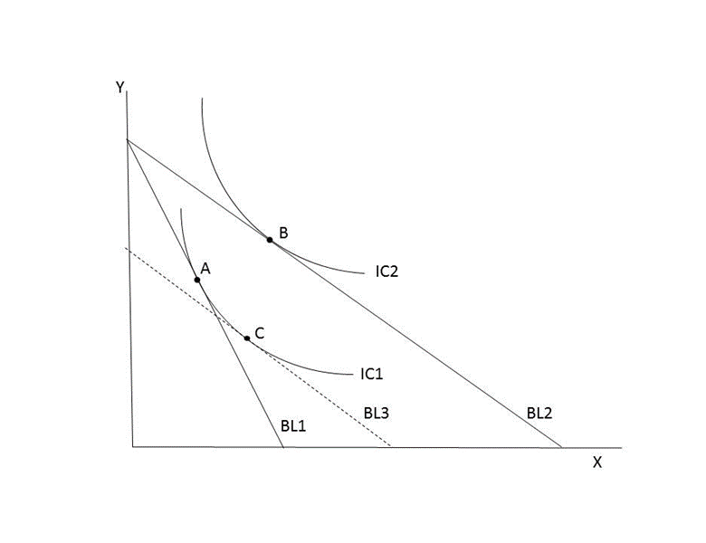
Use the provided graph and information to answer the next TWO (2) questions.
- Moving from BL1 to BL2, the price for good X ________. The income effect of the change in the price of X is captured by the movement from bundles ________.
  - decreases; C to B.
  - decreases; A to C.
  - increases; A to B.
  - increases; C to B.

- Which of the following statements is false?
  - After the change in the price of X, Noel achieves a higher level of utility.
  - Bundles B and C were not affordable at the original prices.
  - Considering only the substitution effect, Noel would consume more of Y and less of X.
  - Considering only the income effect, both X and Y are normal goods for Noel.
Use the following information for the next TWO (2) questions:

Anthony is writing a research paper on consumer spending habits and wants to analyze the price of a tennis racquet throughout the previous 20 years. Anthony gathered the following information:

Year | CPI | Nominal Price of Tennis Racquet
1996 | 100 | $300
2006 | 150 | $350
2016 | 200 | $400

- Which of the following statements is true?
  - The real price of a tennis racquet decreased from 2006 to 2016.
  - The real price of a tennis racquet increased from 1996 to 2006.
  - The real price of a tennis racquet increased from 1996 to 2016.
  - The real price of a tennis racquet might have increased or decreased depending on the determination of the base year.

- Suppose you want to use 2006 as the base year in your calculations. What is the real price of a tennis racquet in 2016 using 2006 as the base year?
  - The real price of a tennis racquet in 2016 using 2006 as the base year is $200.
  - The real price of a tennis racquet in 2016 using 2006 as the base year is $266.66.
  - The real price of a tennis racquet in 2016 using 2006 as the base year is $300.
  - The real price of a tennis racquet in 2016 using 2006 as the base year is $533.33.

(This page is intentionally left blank as an extra work sheet.)
DO NOT DETACH THIS SHEET FROM THIS EXAM BOOKLET!

Use the following information for the next TWO (2) questions:

- Jake can decide whether to consume pizzas (x) or hamburgers (y). The marginal utility that Jake receives from consuming pizza and hamburgers is given by the following equations:
MUx = 2/x
MUy = 1/y
Consider that Jake’s income is $72, the price of x is $2 and the price of y is $6. Which of the following consumption bundles is optimal for Jake?
- (x, y) = (0, 12)
- (x, y) = (12, 8)
- (x, y) = (24, 4)
- (x, y) = (36, 0)

- Jake's income decreases to $48 while the price of x and the price of y are unchanged from the previous question. Given this information, which of the following consumption bundles (x, y) can Jake NOT afford?
- (9, 5)
- (5, 6)
- (4, 7)
- (0, 8)

Use the following information for the next TWO (2) questions:

In an attempt to reduce the number of trees cut down in Dane, Wisconsin the local government has proposed the implementation of an excise tax on paper. The market demand and market supply for paper are given by the following equations, where P is the price of a ream of paper and Q is the quantity:
Demand: P = 60 - Q
Supply: P = 2Q

- If the proposed excise tax is $6, what is the new value of consumer surplus after the imposition of this excise tax?
  - $150
  - $162
  - $184
  - $324

- Instead of specifying the excise tax amount, suppose now that the policy calls for an excise tax that will reduce the consumption of paper to 15 reams. What is the size of the excise tax required to reach this consumption goal?
  - $6 per ream of paper
  - $8 per ream of paper
  - $11 per ream of paper
  - $15 per ream of paper
Use the following information for the next THREE (3) questions:

Consider the market of soy beans in the U.S. The world price of soy beans is $10. The domestic demand and supply curves are given as follows, where Q is the number of units of soy beans and P is the price per unit:
Domestic demand: P = 60 – Q
Domestic supply: P = 1/2 Q + 15

- Which of the following statements is true?
  - Total surplus with free trade in this economy is equal to $2,500.
  - The government tariff revenue will be equal to $375 if the government implements a tariff of $25 per unit of soy beans in this economy.
  - A tariff of $5 on soy bean imports will not cause any deadweight loss in the domestic soy bean market.
  - A subsidy of $5 per unit of soybeans to domestic producers in this market will not cause any deadweight loss in the domestic soy bean market.

- The government imposes a tariff to restrict the amount of imports to 15 units of soy beans. How much is the government tariff revenue when this policy is implemented?
  - $0
  - $150
  - $225
  - $375

- Unexpected bad weather in Africa and Japan cause the world price of soy beans to rise to $75. Given this statement and assuming the initial situation, which of the following statements is false?
  - U.S. will now export 120 units of soy beans to the rest of the world.
  - Total surplus in the domestic soy bean market will increase to $3,600.
  - The implementation of a tariff of $15 on soy bean imports will not cause any deadweight loss in the domestic soy bean market.
  - A subsidy of $15 per unit to local producers will not cause any deadweight loss in the domestic soy bean market.

(This page is intentionally left blank as an extra work sheet.)
DO NOT DETACH THIS SHEET FROM THIS EXAM BOOKLET!

- An economic analyst has concluded that the cross-price elasticity of good X with respect to Y is 0.5 and that the income elasticity of good X is 1.5. Then, the analyst can conclude that:
  - X is a normal good, and X and Y are substitutes.
  - X is an inferior good, and X and Y are substitutes.
  - X is a normal good, and X and Y are complements.
  - X is an inferior good, and X and Y are complements.

- Liam always consumes shoes in pairs (left shoes and right shoes are perfect complements in consumption for him) and in Liam's world all the pairs of shoes are the same style. Liam has recently inherited 2 left shoes from his one-legged uncle. Assume the unit price for left shoes is $6, while the unit price for right shoes is $2. If his budget for shoes is $12, which of the following bundles is an optimal purchase plan for Liam?
  - 2 left shoes.
  - 6 right shoes.
  - 3 right shoes and 1 left shoe.
  - 2 right shoes and 2 left shoes.

- A shoe factory has a total cost function given by the following equation:
TC = 5q² + 4q
where q represents the number of shoes produced in the factory. Assume that partial units of pairs of shoes can be produced.

The only input of production is labor, and the wage of each worker is $7. Using this information and the total cost function, how many workers does the factory need to produce 2 shoes?
  - 2 workers
  - 3 workers
  - 4 workers
  - There is not enough information provided to solve this question.

(This page is intentionally left blank as an extra work sheet.)
DO NOT DETACH THIS SHEET FROM THIS EXAM BOOKLET!

Use the following information for the next THREE (3) questions:

The following graph presents the MC, ATC, and AVC curves of a factory that produces shirts in a perfectly competitive market.
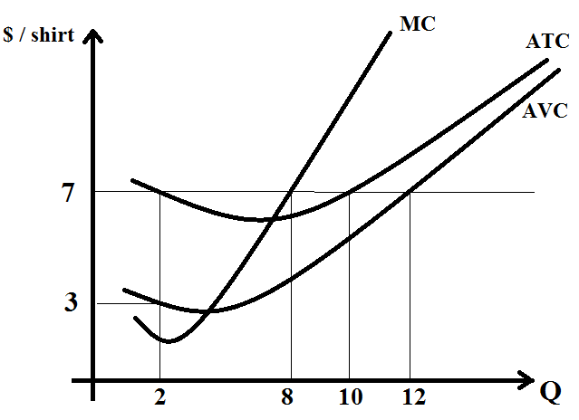

- The current price of shirts is $7. Which is the optimal production of shirts in the short run?
  - 2 shirts
  - 8 shirts
  - 10 shirts
  - 12 shirts

- The price of shirts is still $7. What will happen to the price, to the number of firms in the industry, and to the individual production of each firm in the long run compared to the short run?
  - The price of shirts, the number of firms in the industry and the individual production of each firm will increase.
  - The price of shirts will not change, the number of firms in the industry will increase and the individual production of each firm will decrease.
  - The price of shirts will not change, the number of firms in the industry will decrease and the individual production of each firm will increase.
  - The price of shirts and the individual production of each firm will decrease, while the number of firms in the industry will increase.

- Using the graph, what are the total costs of the firm at Q = 12?
  - $84
  - $92
  - $96
  - There is not enough information provided to answer this question.

(This page is intentionally left blank as an extra work sheet.)
DO NOT DETACH THIS SHEET FROM THIS EXAM BOOKLET!

- Fill in the blanks in the following statements with the appropriate words. Note that your answer to (i) must be the same for each of the blanks with this designation.

Consider the market for coffee in a closed, small country where the domestic price of coffee is lower than the world price of coffee. Suppose that the country opens to trade. Then, the country (i) _______ coffee. If the government of the country imposes a quota to reduce the amount of (i) ________ , the producer surplus will (ii) _________ compared to the case without the quota.

  - (i) imports; (ii) increase
  - (i) imports; (ii) decrease
  - (i) exports; (ii) increase
  - (i) exports; (ii) decrease

- The arc-elasticity between points X and Y on a demand curve is equal to 2. Suppose that you know that point X is (Q, P) = (20, 20). Which of the following points may be point Y?
  - (Q, P) = (4, 10)
  - (Q, P) = (40, 10)
  - (Q, P) = (4, 40)
  - (Q, P) = (10, 100)

- Find the point (Q, P) in the linear demand curve given by Q = 30 – 2P where the point elasticity of demand is equal to 2.
  - (Q, P) = (7.5, 11.25)
  - (Q, P) = (10, 10)
  - (Q, P) = (15, 7.5)
  - (Q, P) = (20, 5)

END OF THE EXAM
(This page is intentionally left blank as an extra work sheet.)
DO NOT DETACH THIS SHEET FROM THIS EXAM BOOKLET!

Answers
- a
- b
- a
- a
- a
- a
- b
- b
- b
- a
- c
- a
- c
- c
- c
- b
- d
- d
- c
- d
- a
- c
- c
- b
- d
- b
- d
- c
- Versions 1,4,5: Point elasticity of 2 – Answer: b
Versions 2,3,6: Point elasticity of ½ - Answer: d

