Economics 101
Spring 2020
Quiz #9 with answers

1. Consider a monopoly that decides to engage in first degree price discrimination (perfect price discrimination). How many of the following statements are true for this monopoly given this decision?

- The monopoly’s marginal revenue curve will now be the same as its downward sloping demand curve.
- The monopoly will produce the socially optimal amount of the good when it practices first degree price discrimination.
- The monopoly practicing first degree price discrimination will create a deadweight loss through this behavior that is a positive value but smaller than the deadweight loss it creates when it acts as a single price monopolist.
- The monopoly when it acts as a perfect price discriminator will maximize the area of consumer surplus since the monopoly is now providing a much greater quantity of the good than it did when it was a single price monopolist.

- Two statements are true.
- One statement is true.
- Three statements are true.
- Four statements are true.

2. Consider the following monopoly that can be described by the following equations where P is the price per unit and Q is the number of units of the good:

Market Demand Curve: P = 200 – 2Q
Marginal Cost for the Monopoly: MC = 2Q + 20
Total Cost for the Monopoly: TC = Q² + 20Q + 10

Suppose this monopolist engages in first degree (perfect price) discrimination. The firm will produce ____ of the good and its total revenue will equal ____.

a. 45 units; $6975
b. 30 units; $5100
c. 30 units; $4200
d. 30 units; $900

Use this diagram to answer the next two (2) questions.

3. Use the following diagram of a monopoly that practices second degree price discrimination to answer this question. This monopolist decides it will produce and sell its first twenty units for $80 per unit, its second twenty units of the good for $60 per unit, and a final twenty units for $40 per unit.

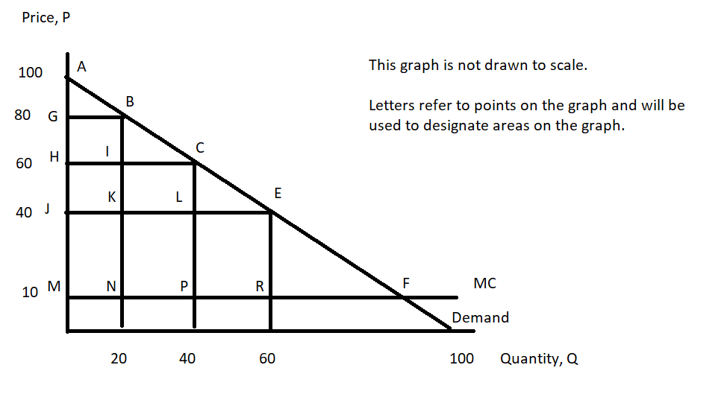

Given this monopolist’s plans, the area(s) of consumer surplus when the monopolist engages in the described second degree price discrimination can be described as:

a. Areas (ABG + BCI + CEL)
b. Area (AJE)
c. Areas (ABG + BCI + CEL + EFR)
d. Area (EFR)

4. Use the following diagram of a monopoly that practices second degree price discrimination to answer this question. This monopolist decides if will produce and sell its first twenty units for $80 per unit, its second twenty units of the good for $60 per unit, and a final twenty units for $40 per unit.

Given this monopolist’s plans, the area(s) of producer surplus when the monopolist engages in the described second degree price discrimination can be described as:

a. Areas (GBNM + ICPN + LERP)
b. Areas (GBKJ + ICLK)
c. Area (JERM)
d. Areas (GBNM + ICPN + LERP + (10)(60))

5. Consider a firm that is a monopolistically competitive firm. How many of the following statements are true about this firm?

- In the short run this firm will produce only if it makes positive economic profit.
- In the short run this firm will be willing to produce provided that its total revenue is greater than its variable costs.
- In the long run, entry and exit of firms ensures that this firm will earn zero economic profits and the price for its good will be equal to the minimum of its average total cost.
- In the long run, this firm will earn zero economic profits.

- Two statements are true.
- One statement is true.
- Three statements are true.
- Four statements are true.

