Economics 101
Spring 2020
Quiz #8 with answers

1. Consider a market that is served by a monopoly. How many of the following statements are true?

- If this monopoly charges a single price for its product, then the amount that the monopoly will provide to the market is smaller than the amount of the good that would be provided if this market were a perfectly competitive market.
- If this monopoly charges a single price for its product, then at its profit maximizing level of output the monopoly will find that the marginal cost of producing the last unit of the good it produces will be greater than the marginal revenue it earns from producing this last unit of the good.
- If this monopoly charges a single price for its product, then at its profit maximizing level of output the monopoly will find that the marginal cost of producing the last unit of the good it produces will be smaller than the marginal revenue it earns from producing this last unit of the good.
- If this monopoly charges a single price for its product, it will produce too small a quantity of the good and charge too high a price relative to what would happen if this same market were a perfectly competitive market. The monopolist will create a deadweight loss.

a. Two statements are true.
b. One statement is true.
c. Three statements are true.
d. Four statements are true.

2. Consider a monopoly that can be described by the following equations where P is the price per unit and Q is the number of units of the good that the monopolist produces.

Market Demand for the Good: Q = 200 – 2P
Total Cost of Producing the Good: TC = 2Q² + 20Q + 20
Marginal Cost of Producing the Good: MC = 4Q + 20

Given this information and holding everything else constant, what is the profit maximizing price for this monopolist if the monopolist charges a single price for the good that they produce?

a. $92 per unit of the good
b. $84 per unit of the good
c. $88.75 per unit of the good
d. $50 per unit of the good

3. Consider a monopoly that can be described by the following equations where P is the price per unit and Q is the number of units of the good that the monopolist produces.

Market Demand for the Good: Q = 200 – 2P
Total Cost of Producing the Good: TC = 2Q² + 20Q + 20
Marginal Cost of Producing the Good: MC = 4Q + 20

Given this information and holding everything else constant, what are the profits for this monopoly if they charge a single price for each unit of the good they produce?

a. Profits for this monopoly are equal to $620.
b. Profits for this monopoly are equal to $1472.
c. Profits for this monopoly are equal to $852.
d. Profits for this monopoly are equal to $1388.

4. Which of the following situations is a good example of a created barrier to entry?

a. Annie, a research chemist, has recently developed a new vaccine that has proven effective in clinical trials for the treatment of a new aggressive virus. She has secured a patent on this new vaccine.
b. Joe produces a product that requires a rare earth mineral and he has successfully purchased all known sources of this rare earth mineral.
c. Sarah is the owner of a manufacturing plant that produces a product that requires an enormous investment in capital equipment to produce even a small amount of the good. The market for this product is small relative to the productive capacity of a single manufacturing plant.
d. Michael produces a product where the more people who use the better the product performs because the product requires the development of a large spread network to be effective. His product has managed to achieve this large network of users.

5. Consider the following graph of a natural monopoly. Assume that the demand curve is linear.

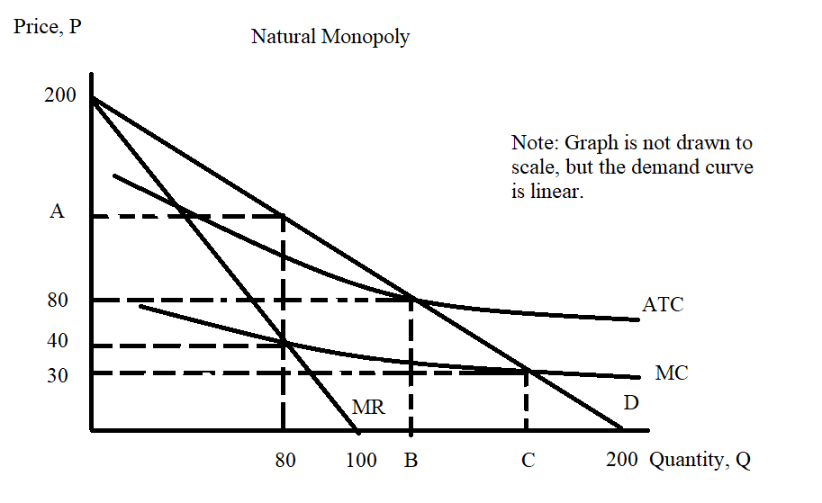

You are asked to determine the values of A, B, and C in the above graph. A is the price the monopolist will charge if it is unregulated and if the monopoly charges a single price for each unit of the good. B is the quantity of the good the monopolist will produce if the monopolist is regulated so that it earns zero economic profit. C is the quantity the monopoly will produce if the monopolist is regulated so that it produces the allocatively efficient amount of the good.

a. A = $120 per unit of the good; B = 120 units of the good; C = 170 units of the good
b. A = $130 per unit of the good; B = 120 units of the good; C = 160 units of the good
c. A = $110 per unit of the good; B = 110 units of the good; C = 180 units of the good
d. A = $150 per unit of the good; B = 110 units of the good; C = 175 units of the good

