Economics 101 Name __________________________________
Spring 2020
Quiz #6 with answers
3/5/2020 TA/Discussion Section Number ______________

All quizzes will be graded on a 10 point scale: you will get two points simply by being on time to class and putting your name on the quiz for that day. The remaining eight points are based upon your answers to the quiz questions.

1. Bob has $100 in income that he spends on burgers (B) and fries (F) each month. You are told that his budget line, BL1, is depicted in the following graph.
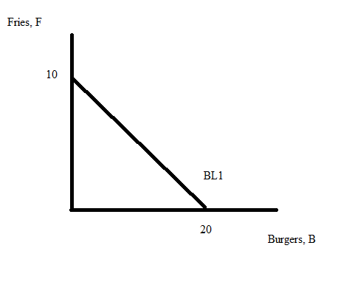
a. (2 points) Given this budget line and the above information, what is the price of a unit of fries?
Explain how you found your answer.

Answer:
Bob can afford 10 units of fries if he purchases only fries with his $100. This implies that the price of fries is $10 per unit of fries since (income spent on fries)/(number of units he can afford) = price of a unit of fries.

b. (2 points) Suppose that the price of burgers increases from its initial level. Given this information and holding everything else constant, what happens to Bob’s budget line? Use complete sentences to describe the impact of this price change on his budget line.

Answer:
Bob’s budget line will pivot inward along the horizontal axis: with the same income but a higher price for a burger, Bob will now be able to afford fewer burgers than he could originally. The new budget line will have the same y-intercept as BL1 but will have an x-intercept that is smaller than 10 units.

c. (4 points) You are told that the marginal utility from fries is equal to 1 burger and the marginal utility from burgers is equal to 4 fries. Given this information and Bob’s original budget line, BL1, what is the consumption bundle of (burgers, fries) that will maximize his satisfaction? Show your work to get full credit.

Answer:
At the optimal consumption bundle we know that:

(Marginal Utility from fries)/(Price of fries) = (Marginal Utility from burgers)/(Price of a Burger)
(1 Burger)/($10) = (4 Fries)/($5)
Therefore,
B = 8F

We also can write the equation for the budget line as:
Income = (price of a burger)(quantity of burgers) + (price of fries)(quantity of fries)
100 = 5B + 10F

Since B = 8F, we have:
100 = 5(8F) + 10F
100 = 50F
F = 2 units of fries
B = 8(2) burgers = 16 burgers
Optimal consumption bundle (burgers, fries) = (16, 2)

