Economics 101 Name __________________________________
Spring 2020
Quiz #6
3/5/2020 TA/Discussion Section Number ______________

All quizzes will be graded on a 10 point scale: you will get two points simply by being on time to class and putting your name on the quiz for that day. The remaining eight points are based upon your answers to the quiz questions.

1. Bob has $100 in income that he spends on burgers (B) and fries (F) each month. You are told that his budget line, BL1, is depicted in the following graph.
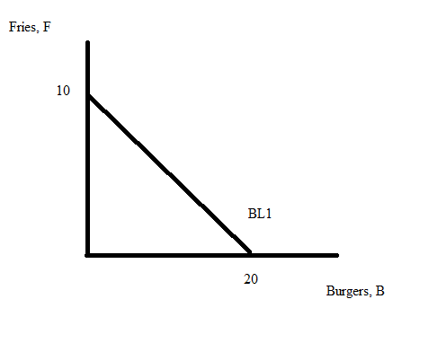
a. (2 points) Given this budget line and the above information, what is the price of a unit of fries?
Explain how you found your answer.

b. (2 points) Suppose that the price of burgers increases from its initial level. Given this information and holding everything else constant, what happens to Bob’s budget line? Use complete sentences to describe the impact of this price change on his budget line.

c. (4 points) You are told that the marginal utility from fries is equal to 1 burger and the marginal utility from burgers is equal to 4 fries. Given this information and Bob’s original budget line, BL1, what is the consumption bundle of (burgers, fries) that will maximize his satisfaction? Show your work to get full credit.

