Econ 101 Name _________________________________
Summer 2014
Quiz #3

Please write all answers neatly and legibly.

1. (2 points) Suppose you know that prices in Grayland have risen 10% in 2012, 20% in 2013, and 50% in 2014. If 2012 is used as the base year for calculating the CPI on a 100 point scale, what is the value of the CPI in 2014? Show your work.

2. Suppose that the market basket underlying the CPI in Grayland is composed of 2 loaves of bread and 5 cans of tune. You are given the following information about prices of these items over the three year period 2010-2012.

 | 2010 | 2011 | 2012
Price of a loaf of bread | $0.50 | $2.50 | $2
Price of a can of tuna | $4 | $5 | $2.20

a. (2 points) Given this information calculate the CPI on a 100 point scale for 2010, 2011, and 2012 using 2011 as the base year. Show all your work in a logical, organized manner. Put your index numbers in the following table after you do your calculations (you must show the steps you took to get the index numbers in order to get full credit on this question).

Year | CPI
2010
2011
2012

b. (2 point) Calculate the annual rate of inflation between 20010 and 2011, and the annual rate of inflation between 2011 and 2012. Show any formulas used and the work you did to get this inflation rate. After computing your answers put them in the following table (you must show the steps you took to get the rate of inflation in order to get full credit on this question). Round your answer to the nearest tenth of a percent.

Period | Rate of Inflation
2010 to 2011
2011 to 2012

3. (1 point) (Circle the correct response) Judy is considering raising the price she charges for her accounting services. She currently is selling 100 units of accounting services for $100 a unit. She estimates that she can sell 120 units of accounting services if she drops her price to $90 a unit. From this information you can conclude that
a. The price elasticity of demand for Judy’s accounting services is elastic over this price range.
b. The price elasticity of demand for Judy’s accounting services is inelastic over this price range.

4. (1 point) (Circle the correct response) Jacob estimates that the cross price elasticity of demand between pretzels and sandals is -0.25. This tells us that pretzels and sandals are
a. Complements since as the price of sandals decreases the quantity of pretzels demanded increases.
b. Substitutes since as the price of sandals increases the quantity of pretzels demanded decreases.

5. Use the following graph to answer this next set of questions.

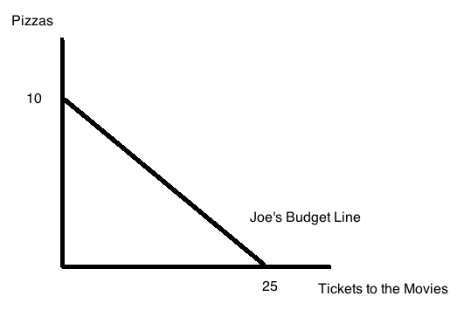

The above graph depicts Joe’s budget line. You are also told that the price of a movie ticket is $10.

a. (1 point) From this information determine Joe’s income as well as the price of a pizza. Show how you found your answer.

b. (1 point) Suppose you are told that Joe maximizes his utility when he purchases 15 movie tickets. How many pizzas will Joe consume when he maximizes his utility? Show how you found your answer.

