Economics 101 Name __________________________________
Spring 2020
Quiz #2 with answers
2/13/20 TA/Discussion Section Number ______________

All quizzes will be graded on a 10 point scale: you will get two points simply by being on time to class and putting your name on the quiz for that day. The remaining eight points are based upon your answers to the quiz questions.

1. Suppose that you are told that the demand for pencils is downward sloping and can be described by the following equation where P is the price per pencil and Q is the number of pencils:

Demand for pencils: P = 100- 2Q

a. (2 points) Suppose that the price of pencils is initially $2 per pencil and then the price rises to $8 per pencil. What is the change in the quantity demanded of pencils given this information and holding everything else constant?

Answer:
When the price of pencils is $2 per pencil, then 49 pencils are demanded. When the price of pencils is $8 per pencil, then 46 pencils are demanded. Thus, when the price rises from $2 per pencil to $8 per pencil, the quantity demanded decreases by 3 pencils.

b. (2 points) Suppose that there is an increase in the number of school children. Given this information and holding everything else constant, how will this impact the demand curve? Write a coherent explanation in standard grammatically correct English.

Answer:
If there is an increase in the number of school children, holding everything else constant, we would expect the demand for pencils to shift to the right at every price. Thus, the demand curve shifts out away from the origin or it shifts to the right.

2. (2 points) You are given the following information about a demand schedule and you are also told that the demand curve for this good is linear.

Price | Quantity Demanded
$1 | 20
$2 | 16
$3 | 12
$5

Given the above information and holding everything else constant, write an equation for the demand curve in y-intercept form where price or P is the y variable and quantity or Q is the x variable.

Answer:
Start by finding the slope of this relationship: slope = change in price/change in quantity = -1/4
Use the y-intercept form:
Y = mX + b
P = (-1/4)Q + b
Use one of the (Q, P) points in the table:
1 = (-1/4)(20) + b
6 = b
P = 6 – (1/4)Q

3. (2 points) Consider a market that is comprised of five individuals. Each of these individuals have demand curves for the good that can be described by the following equation where P is the price per unit and Q is the number of units of the good:

Individual Demand Curve for the Good: P = 10 – Q

Given this information and holding everything else constant, what is the equation for the market demand curve for this good if the market is only comprised of these five individuals?

Answer:
Here’s a graph showing you the work visually:
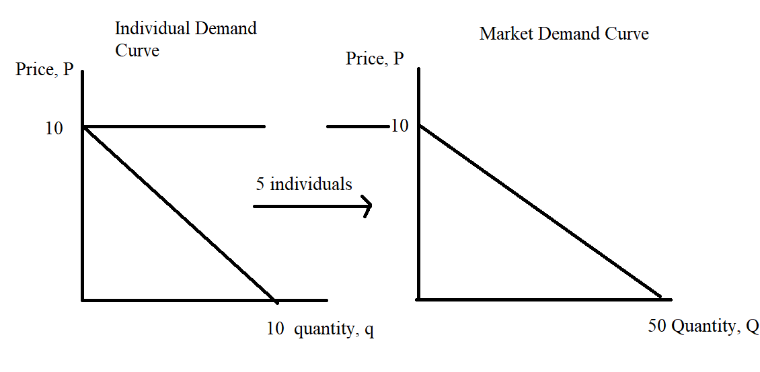
P = 10 – (1/5)Q

