Economics 101 Name __________________________________
Spring 2020
Quiz #1 with answers
2/6/20 TA/Discussion Section Number ______________

All quizzes will be graded on a 10 point scale: you will get two points simply by being on time to class and putting your name on the quiz for that day. The remaining eight points are based upon your answers to the quiz questions.

1. Peter and Mary both produce watches (W) and pencils (P) using their available resources, technology and the given time period. You are provided the following information about Peter and Mary’s production possibility frontiers for these two goods.

Peter’s Production Possibility Frontier for Watches and Pencils: P = 10 – (1/3)W
Mary’s Production Possibility Frontier for Watches and Pencils: P = 40 - W

a. (1 point) Given the above information, who has the absolute advantage in producing watches?

Answer:
Mary has the absolute advantage in producing watches since she can absolutely produce more watches (40) than Peter (10).

b. (1 point) Given the above information, who has the absolute advantage in producing pencils?

Answer:
Mary has the absolute advantage in producing pencils since she can absolutely produce more pencils (40) than Peter (30).

c. (4 points) In the graph below, draw Peter and Mary’s joint production possibility frontier. Measure Pencils (P) on the y-axis and Watches (W) on the x-axis. Your graph must include:

- The values for the y-intercept and the x-intercept
- The coordinates for any “kink points” that your joint production possibility frontier contains
Answer:
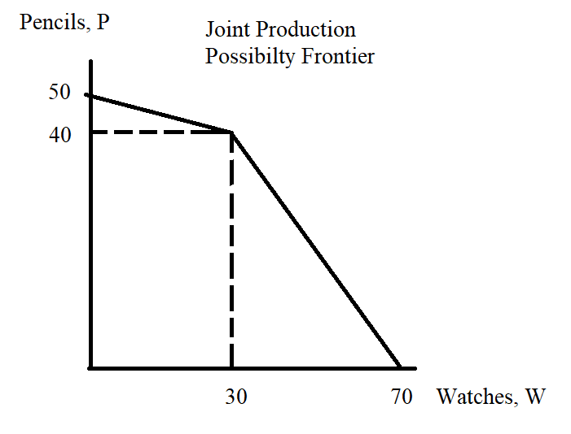

d. (1 point) Who has the comparative advantage in the production of pencils?

Answer:
Mary has the comparative advantage in the production of pencils since her opportunity cost of producing 1 pencil is 1 watch which is less than Peter’s opportunity cost of producing 1 pencil which is 3 watches.

e. (1 point) What is the acceptable trading range in terms of pencils for 3 watches?

Answer:
3 watches will trade for between 1 pencil and 3 pencils.

