Economics 101
Spring 2020
Quiz #10

1. You are given the following payoff matrix that shows the profits of Acme Manufacturing and Total Production (first number in each cell refers to Acme Manufacturing Profits and second number to Total Production Profits), two firms that produce ball bearings. Both firms are trying to decide if they should engage in an advertising campaign or not: the two firms have estimated their profits depending upon their decisions about advertising.

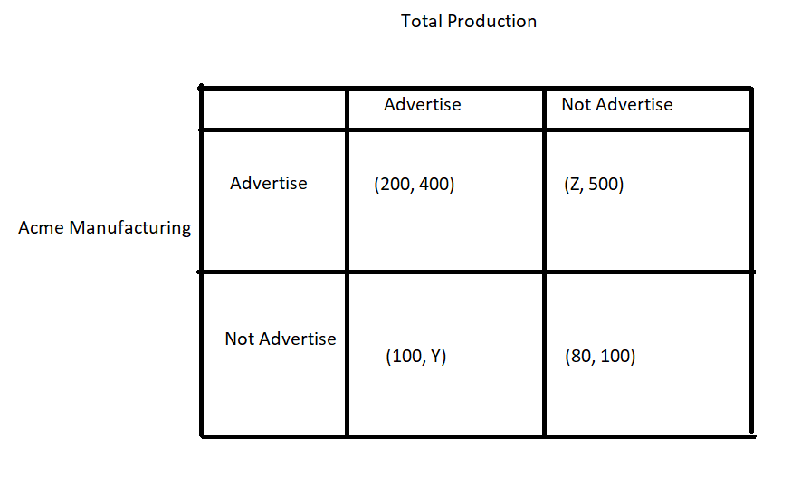
You are also told that Acme Manufacturing has a dominant strategy of “Advertising” and Total Production has a dominant strategy of “Not Advertising”. Given this information and holding everything else constant, then:

a. The value of Z must be greater than 80 and the value of Y must be less than 100.
b. The value of Z must be greater than 200 and the value of Y must be less than 400.
c. The value of Z must be greater than 500 and the value of Y must be less than 100.
d. The value of Z must be less than 80 and the value of Y must be greater than greater than 200.

2. Consider the following graph depicting the market for good X.

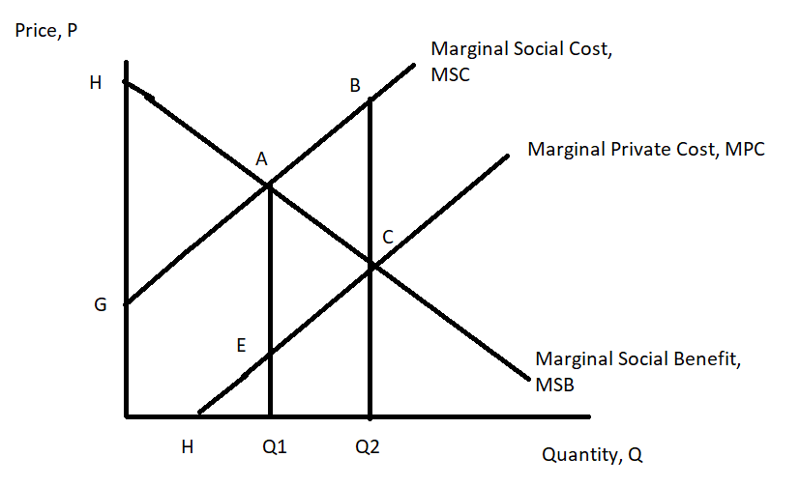

From this graph we can conclude that:

a. The production of good X generates a negative externality.
b. The production of good X generates a positive externality.
c. The consumption of good X generates a negative externality.
d. The consumption of good X generates a positive externality.

3. Consider the following graph depicting the market for good X.

From this graph we can conclude that the market will produce ____ if the externality is not corrected for (not internalized) and that the deadweight loss will be equal to _____.

a. Q2; area ABC
b. Q1; area ABC
c. Q2; area ABCE
d. Q1; area HAG
4. Consider a public good. These goods generally face the problem for free riding. Free riding refers to:

a. Someone choosing to consume the good even though they have not paid for the good; free riding occurs due to the good being non-excludable.
b. The idea that someone can consume the same good without impacting someone else’s consumption of that good; free riding occurs due to the good being non-excludable.
c. Someone enjoying the good even if they have not paid for the good; free riding occurs due to the good being non-rival.
d. The idea that I can enjoy the same good as you do without it impacting the enjoyment either one of us gets from the good; free riding occurs due to the good being non-rival.

5. Joe and Ann are the only residents in their community. They recognize that it would be great to have some streetlights and that these streetlights would be a public good. They both agree that they will reveal their true preferences and will not free ride on the provision of the streetlights. You are given the following information about their individual demand curves for streetlights where P is the price per streetlight and Q is the number of streetlights.

Joe’s demand for streetlights: P = 10 – (1/2)Q
Ann’s demand for streetlights: P = 20 – Q

You are also told the following information about the marginal social cost (MSC) of providing streetlights:

MSC = 9 + 2Q

Given this information you conclude that the socially optimal amount of this good is _____ and that Joe will pay ____ per streetlight.

- 6 streetlights; $7 per streetlight
- 2 streetlights; $9 per streetlight
- 5 streetlights; $7.50 per streetlight
- 10 streetlights; $5 per streetlight

