Economics 101 Name __________________________________
Spring 2020
Quiz #0 with answers Student ID Number _______________________
1/30/20 TA/Discussion Section Number ______________

This is a practice quiz: it is not for credit. It is intended to help you assess your math readiness and to give you a sense of how the class quizzes will work. All quizzes will be graded on a 10 point scale: you will get two points simply by being on time to class and putting your name on the quiz for that day. The remaining eight points are based upon your answers to the quiz questions.

1. Josie likes doughnuts. If the price of a doughnut is $1 she purchases 10 doughnuts and if the price of a doughnut is $2 she purchases 4 doughnuts. The relationship between the price of doughnuts and the quantity of doughnuts she buys is a linear (straight-line) relationship.

- (2 points) Provide an equation that describes the relationship between the price of the doughnut (P) and the quantity of the doughnuts (Q) for Josie. Write this equation in y-intercept form where you treat the price as the y-variable. Show your work to get full credit.

Answer:
We know information about two points on Josie’s line depicting the relationship between the quantity of doughnuts she purchases and the price of doughnuts. These two points are: (Q, P) = (10, $1) and (4, $2). We can use these two points to find the slope of the relationship. Thus:
Slope = rise/run = change in Y/change in X = change in Price/change in Quantity = (1 – 2)/ (10 – 4) = -1/6
Then, the standard y-intercept form is:
Y = mX + b where Y is the price, P, and X is the quantity, Q. Thus:
P = mQ + b
m is the slope of the line: in this case m = -1/6. Thus:
P = (-1/6)Q + b
b is the y-intercept of the line. To find the value for “b”, use one of our known points. Thus:
1 = (-1/6)10 + b
6/6 + 10/6 = b
16/6 = 8/3 = b
The equation for the line is: P = 8/3 – (1/6)Q

- (2 points) Suppose the price of doughnuts is $0: how many doughnuts would Josie consume based upon the above information? Provide an explanation for how you found your answer to get full credit.

Answer:
One could answer this in a variety of ways: you could draw a graph and recognize that for every $1 decrease in price, Josie increases the quantity of doughnuts she consumes by 6 doughnuts. Thus, if the price falls from $1 per doughnut to $0 per doughnut, Josie will change her consumption from 10 units to 16 units.

Or, you could use the equation you found in (a) and plug in a price of $0 to get a quantity of 16 units.

2. The graph below depicts Jerry’s production possibility frontier (PPF). Jerry produces cookies (C) and brownies (B). His production possibility frontier is linear. Jerry is able to produce any combination of cookies and brownies that lies on the straight line depicted in the graph below.

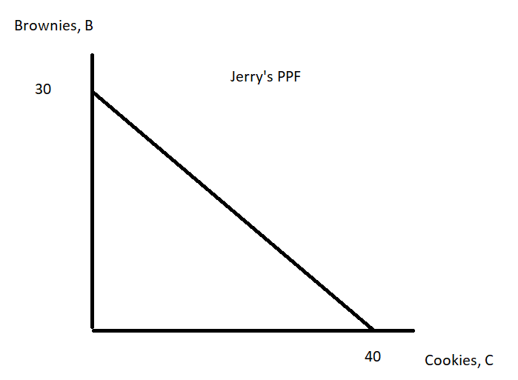
- (2 points) Jerry is currently producing 16 cookies. If he is producing efficiently, how many brownies is he producing? To get full credit here, show your work.

Answer:
The equation for Jerry’s PPF can be written as:
B = 30 – (3/4)C
If Jerry is producing C = 16, then:
B = 30 – (3/4)(16) = 30 – 12 = 18 Brownies

- (2 points) Is possible for Jerry to produce 38 cookies and 2 brownies given his PPF depicted in the above graph? Explain your answer.

Answer:
If C = 38, then the equation for Jerry’s PPF tells us that he can produce B = 1.5. To see this, substitute C = 38 into the equation that represents his PPF. Thus,
B = 30 – (3/4)C
B = 30 – (3/4)(38)
B = 120/4 – 114/4 = 6/4 = 1.5
So, it is not possible for Jerry to produce 38 cookies and 2 brownies given his PPF. He can only produce 1.5 brownies if he is producing 38 cookies.

