Economics 101 Name __________________________________
Spring 2020
Quiz #0 Student ID Number _______________________
1/30/20 TA/Discussion Section Number ______________

This is a practice quiz: it is not for credit. It is intended to help you assess your math readiness and to give you a sense of how the class quizzes will work. All quizzes will be graded on a 10 point scale: you will get two points simply by being on time to class and putting your name on the quiz for that day. The remaining eight points are based upon your answers to the quiz questions.

1. Josie likes doughnuts. If the price of a doughnut is $1 she purchases 10 doughnuts and if the price of a doughnut is $2 she purchases 4 doughnuts. The relationship between the price of doughnuts and the quantity of doughnuts she buys is a linear (straight-line) relationship.

- (2 points) Provide an equation that describes the relationship between the price of the doughnut (P) and the quantity of the doughnuts (Q) for Josie. Write this equation in y-intercept form where you treat the price as the y-variable. Show your work to get full credit.

- (2 points) Suppose the price of doughnuts is $0: how many doughnuts would Josie consume based upon the above information? Provide an explanation for how you found your answer to get full credit.

2. The graph below depicts Jerry’s production possibility frontier (PPF). Jerry produces cookies (C) and brownies (B). His production possibility frontier is linear. Jerry is able to produce any combination of cookies and brownies that lies on the straight line depicted in the graph below.

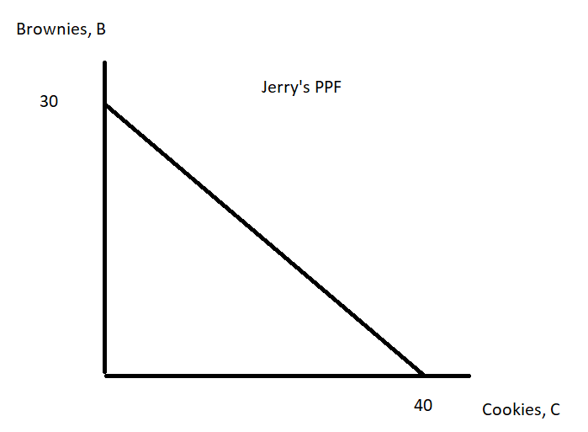
- (2 points) Jerry is currently producing 16 cookies. If he is producing efficiently, how many brownies is he producing? To get full credit here, show your work.

- (2 points) Is possible for Jerry to produce 38 cookies and 2 brownies given his PPF depicted in the above graph? Explain your answer.

