Practice Quiz as we transition to online instruction
3/13/2020

1. Consider a small closed economy’s market for apples. If this market opens to trade, then:

a. Total surplus will increase relative to total surplus in this market if the market is closed to trade.
b. If the world price is greater than the domestic closed economy price for apples, domestic consumers will favor opening this market to trade.
c. If the world price is less than the domestic closed economy price for apples, domestic producers will be indifferent about opening this market to trade.
d. The distributional consequences of trade will more than offset the changes in total surplus.

2. Consider a small closed economy’s market for apples that is described by the following graph.

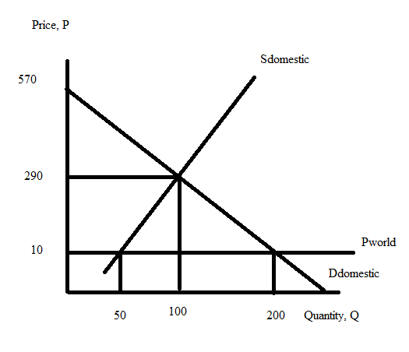

Suppose the world price of apples is $10 per unit of apples. If this market opens to trade and at the same time the small economy imposes an import quota of 75 units of apples, what will be the price per unit of apples in this small economy?

a. $130 per unit of apples
b. $140 per unit of apples
c. $150 per unit of apples
d. $160 per unit of apples

3. The coronavirus has impacted both supply and demand in many markets. Suppose that the supply of some goods and services have been disrupted due to supply chain issues (supply chains refer to how goods and services are assembled across the world with components of the goods and services produced in multiple locations) while at the same time, the increase in social distancing (this refers to people avoiding crowds and staying more isolated from social interactions than normal) has reduced the demand for many goods and services. Given this information and holding everything else constant, what do you predict about the impact of the equilibrium price and equilibrium quantity in a market experiencing these changes?

a. The new equilibrium quantity will be indeterminate and the new equilibrium price will increase.
b. The new equilibrium quantity will be indeterminate and the new equilibrium price will decrease.
c. The new equilibrium price will be indeterminate and the new equilibrium quantity will decrease.
d. The new equilibrium price will be indeterminate and the new equilibrium quantity will increase.

4. Mary sells a good in a market and she knows that her cross price elasticity of demand of the good she produces with respect to gadgets has a value of -2.5 and that the income elasticity of demand for her product is -0.5. Given this information and holding everything else constant, how many of the following statements are true?
- Mary’s good and gadgets are substitutes for one another.
- If the price of gadgets increases, the demand for Mary’s good will increase but by a smaller percentage than the percentage change in the price of gadgets.
- If the economy enters into a recession and incomes drop by 10%, Mary expects that she will sell 5% more of her good, holding everything else constant.
- When Mary reads that the economy is booming and incomes are rising, she anticipates that she will need to hire fewer people to make her good.

a. One statement is true.
b. Two statements are true.
c. Three statements are true.
d. Four statements are true.

5. Joe’s demand curve for apples is given by the equation P = 100 – 2Q where Q is the quantity of units of apples and P is the price per unit of apples. The initial price of apples is $40 per unit of apples. Suppose the price of apples falls to $30 per unit of apples. Using the arc elasticity (or midpoint method) concept to measure the price elasticity of demand we can compute the price elasticity of demand as being equal to:

a. (1/13)(1/7)
b. 13/7
c. -13/7
d. (1/13)/(1/7)

6. Suppose the CPI in 2019 using 2010 as the base year has a value of 105. You read in the newspaper that the CPI in 2020 using 2010 as the base year is projected to equal 98. From this information you conclude that:

a. overall prices in the economy are falling between 2019 and 2020 and that if you get a pay increase of 2% your real income will increase.
b. overall prices in the economy are rising between 2019 and 2020 and that if you get a pay increase of 2% your real income will increase since the percentage change in your pay is greater than the percentage change in overall prices.
c. overall prices in the economy are falling between 2019 and 2020 and that if you get a pay increase of 2% your real income will decrease.
d. overall prices in the economy are falling between 2019 and 2020 and that if you get a pay increase of 2% your real income will decrease since the percentage change in your pay is smaller than the percentage change in overall prices.

7. The CPI in 2018 using 2000 as the base year has a value of 200. The CPI in 2019 using 2000 as the base year has a value of 220. Jamie’s income in 2018 was $40,000. If Jamie is to have the same purchasing power in 2019 as she had in 2018, what must her nominal income be in 2019?

a. $40,000
b. $36,363
c. $88,000
d. $44,000

8. Consider the graph below which depicts Bob’s budget line for consuming muffins and coffee.
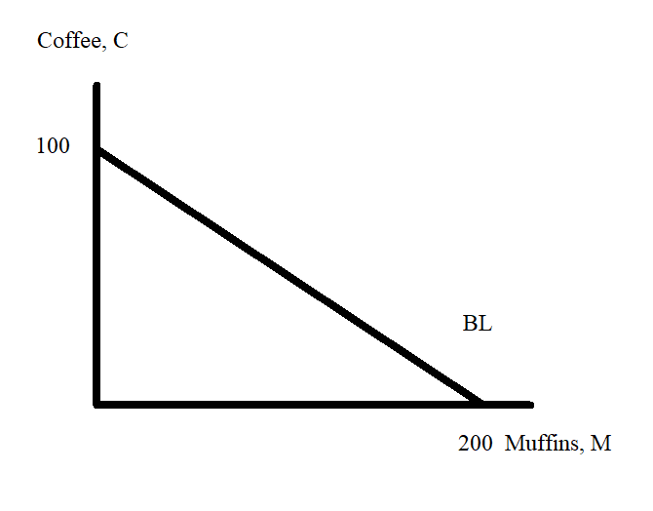
Given this graph and holding everything else constant, then:

a. Bob’s income that he can spend on muffins and coffee could be equal to $200 provided that the price of muffins is greater than the price of coffee.
b. Bob’s income that he can spend on muffins and coffee could be equal to $300 provided that the price of a cup of coffee is half the price of a muffin.
c. Bob’s income that he can spend on muffins and coffee could be equal to $400 provided that the price of a cup of coffee is $4.
d. From the above graph it is impossible to know whether the price of a cup of coffee is greater than, less than, or equal to the price of a muffin.

9. Suppose that you are provided the following information about Marcia’ utility function for good X and good Y, her income, and the prices for these two goods:

Marcia’s Utility function: U = XY
Marginal Utility of good X: Mux = Y
Marginal Utility of good Y: MUy = X
Marcia’s Income: I = 100
Price of Good X: Px = $4 per unit of good X
Price of Good Y: Py = $10 per unit of good Y

Marcia’s budget line can be written as:

a. 25 = X + 2.5Y
b. 10Y = 100 + 4X
c. 100 = 10X + 4Y
d. Y = 10 – (2.5)X

10. Suppose that you are provided the following information about Marcia’ utility function for good X and good Y, her income, and the prices for these two goods:

Marcia’s Utility function: U = XY
Marginal Utility of good X: Mux = Y
Marginal Utility of good Y: MUy = X
Marcia’s Income: I = 100
Price of Good X: Px = $4 per unit of good X
Price of Good Y: Py = $10 per unit of good Y

Given this information and holding everything else constant, Marcia’s utility optimizing bundle of good X and good Y, (X, Y) is equal to:

a. (X, Y) = (7.5, 7)
b. (X, Y) = (20, 2)
c. (X, Y) = (25, 5)
d. (X, Y) = (12.5, 5)

