Economics 101 Name
Spring 2016 TA Name
March 1, 2016 Discussion Section Number
First Midterm Student ID Number

Version 2
READ THESE INSTRUCTIONS CAREFULLY.
DO NOT BEGIN WORKING UNTIL THE PROCTOR TELLS YOU TO DO SO

You have 75 minutes to complete this exam. The exam consists of 9 binary response questions worth 2 points each and 20 multiple choice questions worth 4 points each for a total of 98 points. You will receive two points if you accurately and completely provide your name, ID number, discussion section number, version number, and TA name on the scantron sheet AND this exam booklet. Thus, the total number of points on the exam is 100. Answer all questions on the scantron sheet with a #2 pencil. There are 18 printed pages in this exam, including this cover sheet.

WARNING: NO COMMUNICATION OR CALCULATING DEVICES, OR FORMULA SHEETS ARE ALLOWED. NO CONSULTATION AND CONVERSATION WITH OTHERS ARE ALLOWED WHILE YOU ARE TAKING EXAM OR IN THE EXAM ROOM. PLAGIARISM IS A SERIOUS ACADEMIC MISCONDUCT AND PUNISHABLE TO THE FULLEST EXTENT.

PICK ONLY ONE BEST ANSWER FOR EACH QUESTION.

How to fill in the scantron sheet and other information:
- Print your last name, first name, and middle initial in the spaces marked "Last Name," "First Name," and "MI." Fill in the corresponding bubbles below.
- Print your student ID number in the space marked "Identification Number." Fill in the bubbles.
- Write the number of the discussion section you’ve been attending under "Special Codes" spaces ABC, and fill in the bubbles. You can find the discussion numbers below on this page.
- Write the version number of your exam booklet under "Special Codes" space D, and fill in the bubble. The version number is on the top of this page.

- If you believe there is an error on the exam or you do not understand something, make a note on your exam booklet and the issue will be addressed AFTER the examination is complete. No questions regarding the exam can be addressed while the exam is being administered.
- When you are finished, please get up quietly and bring your scantron sheet and this exam booklet to the place indicated by the proctors.
Discussion Sections (Sorted by TA):
Section Number | Time | Room | TA
DIS 301 | R 4:35-5:25PM | 5321 Sewell Social Sciences | Omar
DIS 307 | F 9:55-10:45AM | B219 Van Vleck Hall | Omar
DIS 305 | F 11:00-11:50AM | B219 Van Vleck Hall | Omar
DIS 302 | F 2:25-3:15PM | 4308 Sewell Social Sciences | Omar
DIS 311 | F 8:50-9:40AM | 120 Ingraham Hall | Wenqi
DIS 308 | F 9:55-10:45AM | B341 Van Vleck Hall | Wenqi
DIS 309 | F 11:00-11:50AM | B341 Van Vleck Hall | Wenqi
DIS 310 | F 12:05-12:55PM | 2323 Sterling Hall | Diwakar
DIS 304 | F 2:25-3:15PM | 6314 Sewell Social Sciences | Diwakar
DIS 306 | F 3:30-4:20PM | 4322 Sewell Social Sciences | Diwakar
DIS 313 | R 3:30-4:20PM | 6322 Sewell Social Sciences | Moheeb
DIS 303 | R 4:35-5:25PM | 6322 Sewell Social Sciences | Moheeb

(This page is intentionally left blank as an extra work sheet.)
DO NOT DETACH THIS SHEET FROM THIS EXAM BOOKLET!

I, , agree to neither give nor receive any help on this exam from others. I understand that the use of a calculator or communication device on this exam is academic misconduct. I also understand that providing answers to questions on this exam to other students is academic misconduct as is taking or receiving answers to questions on this exam from other students. Thus, I will cover my answers and not expose my answers to other students. It is important to me to be a person of integrity and that means ALL ANSWERS on this exam are my answers. Any violation of these guidelines will result in a penalty of at least receiving a zero on this exam.

Signed

BINARY CHOICE QUESTIONS (9 QUESTIONS WORTH 2 POINTS EACH)

- Ethan works 10 hours a day and produces two goods, tables (T) and chairs (C). His individual PPF curve per day is given by the function:
T=8-2C
Given this information and holding everything else constant, how many hours does it take for Ethan to make one chair?
  - 2.5 hours
  - 1.25 hours

- The following graph depicts the demand and supply for cheese in the U.S. market.
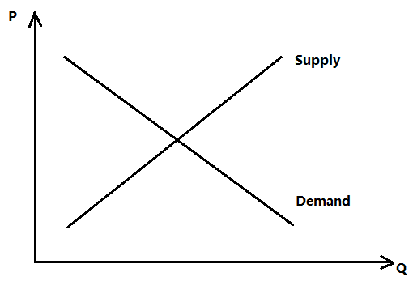

Imagine that the price of milk (an ingredient in making cheese) has fallen. How does that affect the consumer surplus and producer surplus in the cheese market?
- Consumer surplus must have increased.
- Producer surplus must have increased.
- Suppose that you know the points (X, Y) = (1, 16) and (4, 4) sit on a straight line. Which of the following coordinates sit above this straight line?
  - (X, Y) = (2, 13)
  - (X, Y) = (0,19)

- Economics is the study of:
  - the production, allocation and distribution of goods and services.
  - the production, and allocation of goods and services in a just world.

- The statement “Donald Trump shouldn’t win the 2016 presidential election” is a:
  - Positive statement.
  - Normative statement.

- Ashley has a summer internship offer from an accounting firm that pays $2,000, and an offer from a bank that pays $1,500. Otherwise, she could also spend the summer at the local community center that offers her a salary of $500. What is Ashley’s opportunity cost of accepting the offer from the bank?
  - $2000
  - $500

- In Harry's economics class, his final score is determined by three exams with equal weight. The first exam has a total of 25 possible points, the second exam has a total of 50 possible points, and the final exam has a total of 100 possible points. Suppose Harry receives a total of 16 points out of a maximum of 25 on his first exam. What is the highest average score percentage Harry can obtain in the class given this information and holding everything else constant?
  - 88%
  - 64%

- Which of the following would NOT be studied in microeconomics?
  - Analyzing how individuals make decisions
  - Explaining why recessions occur

- Consider the market for tobacco products. Suppose that health studies report that tobacco smoking is not good for you. At the same time that people's incomes fall. Assume that tobacco products are inferior goods. Given this information, relative to the initial equilibrium price and quantity, the equilibrium price will _____ and the equilibrium quantity will _____.

  - be indeterminate; decrease
  - be indeterminate; be indeterminate

MULTIPLE CHOICE QUESTIONS (20 QUESTIONS WORTH 4 POINTS EACH)

Use the following information to answer the next Two (2) questions.

The table below shows the time needed to produce a shirt or a sweater for each worker, as well as the total amount of time available for each worker.
 | Total Number of Hours of Labor Available | Amount of Labor Needed to Produce One Shirt | Amount of Labor Needed to Produce One Sweater
Adam | 10 hours | 5 hours | 5 hours
Betsy | 12 hours | 4 hours | 3 hours
Carroll | 8 hours | 4 hours | 2 hours
Dave | 6 hours | 2 hours | 3 hours

- Who has the highest opportunity cost for producing a sweater?
  - Adam
  - Betsy
  - Carroll
  - Dave

- Compared to Adam, who has the comparative advantage in producing sweaters?
  - Betsy and Carroll
  - Betsy
  - Carroll
  - Betsy, Carroll and Dave

Use the following information to answer the next Three (3) questions.

Assume that Jacki and Donna are the only consumers of online movies. Jacki and Donna are addicted to watching movies online. They have very different tastes so they can never watch a movie together! They both respect movie copyrights and therefore they pay for every movie they watch online. The demand functions of Jacki and Donna for movies this year are given by the following equations where P is the price per movie and q is the quantity of movies demanded:
Jacki: $P=40-2q$
Donna: $P=20$

- Given this information, the market demand is:
  - $P=40-2q for P>20 and P=20-2q for P≤20$
  - $P=40-2q for P>20 and P=20 for P≤20$
  - $P=40-2q for P>20 and P=60-2q for P≤20$
  - $P=40-2q for P>20 and P=40-q for P≤20$

Suppose that they are only two websites, Addiction1.com and Addiction2.com that offer online movie services to Jacki and Donna. The supply curves for these two websites are given by the following equations where P is the price per movie and q is the quantity of movies supplied:

Addiction1.com: $P=4+2q$
Addiction2.com: $P=2q$

- Given this information and holding everything else constant, when the online movie market is in equilibrium Jacki will watch _________ movies this year, while Donna will watch __________ movies this year.
- 8; 10
- 10; 8
- 9; 9
- 10; 10

- When this market is in equilibrium the total consumer surplus in this market is _______________ and the total producer surplus is________________.
- $100, $200
- $100, $164
- $200, $200
- $200, $164

(This page is intentionally left blank as an extra work sheet.)
DO NOT DETACH THIS SHEET FROM THIS EXAM BOOKLET!

Source: US. Bureau of Economic Analysis, Real Gross Domestic Product

- From the graph above, what was the approximate average quarterly growth rate in U.S. real GDP in 2010 and 2012?

- 2.7% in 2010, 1.3% in 2012
- 1.7% in 2010, 0.3% in 2012
- 4.0% in 2010, 3.0% in 2012
- 2.0% in 2010, 2.5% in 2012

- The market for bus rides in Madison is in equilibrium with the demand and market supply curves as given where Q is the quantity of bus rides and P is the price per bus ride:
Demand for bus rides: Q = 20 - P
Supply of bus rides: P = Q
Now suppose that the City of Madison institutes a quantity or quota limit that will only allow 5 bus rides to be taken in this market. Given this information and holding everything else constant, which of the following statements is TRUE?
- The total surplus to society will increase due to the implementation of this quota limit.
- The cap on the number of bus rides will create deadweight loss in the market for bus rides.
- The cap on the number of bus rides will decrease deadweight loss in the market for bus rides.
- The cap on the number of bus rides will not change the deadweight loss in the market for bus rides.

(This page is intentionally left blank as an extra work sheet.)
DO NOT DETACH THIS SHEET FROM THIS EXAM BOOKLET!

Use the following information to answer the next TWO (2) questions.

Consider the market for cigarettes in Palestine where quantity, Q, is measured in packs of cigarettes and price, p, is measured in shekels (the Israeli currency unit that Palestinians use) per pack of cigarettes. The demand and supply functions are given by:
$$Demand for Cigarettes: Q=200-4p$$
$$Supply of Cigarettes: Q=6p$$

- Suppose that the government is interested in decreasing the consumption of cigarettes by 60 packs. The government intends to implement an excise tax in order to achieve this consumption goal. What is the excise tax per pack of cigarettes that the government should impose?
  - 25 shekels per pack
  - 10 shekels per pack.
  - 15 shekels per pack
  - 20 shekels per pack

- Suppose now that the government cares more about generating tax revenue from the cigarette market than it cares about reducing smoking. If the Palestinian government would like to collect the maximum level of tax revenue by imposing an excise tax in this market, what is the amount of the excise tax per pack of cigarettes that the government should impose?
  - 35 shekels per pack
  - 50 shekels per pack
  - 25 shekels per pack
  - 40 shekels per pack

- In the market for Ugli fruits, the demand and supply curves are given by the following equations where P is price per Ugli fruit and Q is the quantity of Ugli fruits:
Demand Curve for Ugli fruit: P=10-2Q
Supply Curve for Ugli fruit: P=2
Given the above information and holding everything else constant, what is the value of producer surplus in this market?
  - $0
  - $4
  - $8
  - $9

- The following graph shows a joint PPF for Neville and Hermione who both produce potions and magic herbs. What is the acceptable trading range of prices for potions between these two individuals?
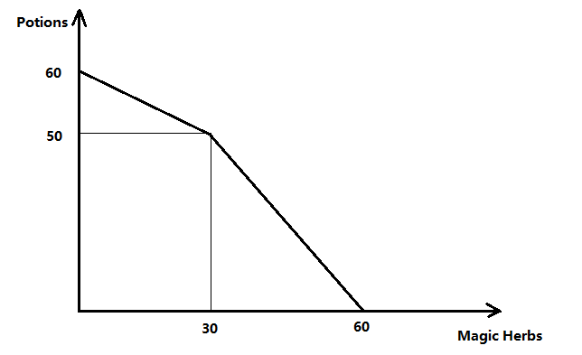
  - Between 1/3 herb and 3 herbs
  - Between 1/3 herb and 5/3 herbs
  - Between 3/5 herb and 3 herbs
  - Between 30 and 60 herbs

Use the following information to answer the next TWO (2) questions.

The market demand and supply in the market of cheese is given by the following equations where P is the price per pound of cheese and q is the quantity of cheese measured in pounds:
$$Demand for Cheese: P=60-2q$$
$$Supply of Cheese: P=q$$

- Holding everything else constant, if the government decides to set a price floor of $30 in the cheese market, the consumer surplus will decrease by approximately:
  - 50%
  - 45%
  - 55%
  - 35%

- Suppose that the government decides to impose a new price floor, and as a result the excess supply has increased by 20% relative to the excess supply in the market with the original price floor ($30). What is the new price floor?
  - $35
  - $32
  - $33
  - $34
(This page is intentionally left blank as an extra work sheet.)
DO NOT DETACH THIS SHEET FROM THIS EXAM BOOKLET!

- The former Soviet Union (U.S.S.R.) economy was based on a system of state ownership of all forms of production with centralized administrative planning determining the types and quantities of goods produced. Centralized planners determined prices in this system. Assume that the following equations describe the market demand and market supply in the USSR shoe market where P is the market price in Rubles per pair of shoes and Q is the quantity of pairs of shoes:
Market demand for shoes in the USSR: P=100-Q
Market supply of shoes in the USSR: P= Q/3
Assume that the centralized committee set an effective price ceiling of 20 Rubles for each pair of shoes. This price ceiling resulted in excess demand for shoes at this price.
Now suppose that some people in the USSR travel to Yugoslavia and buy 40 pairs of shoes to bring back and sell in the USSR. Given this information and holding everything else constant, is the price ceiling still effective and what is the price of a pair of shoes in the USSR?
  - The price ceiling was still effective and the price of a pair of shoes was $15.
  - The price ceiling was no longer effective and the price of a pair of shoes was $20.
  - The price ceiling was still effective and the price of a pair of shoes was $20.
  - The price ceiling was no longer effective and the price of a pair of shoes was $15.

(This page is intentionally left blank as an extra work sheet.)
DO NOT DETACH THIS SHEET FROM THIS EXAM BOOKLET!

Use the following information to answer the next TWO (2) questions.

Consider the market for tomato in the US. The market demand and supply are given by the following equations where P is the price per unit of tomatoes and q is the number of units of tomatoes:
$$Demand for tomatoes: p=10-\frac{1}{100}q$$
$$Supply of tomatoes: p=-2+\frac{1}{100}q$$

- Suppose the government wants to implement a price guarantee (a subsidy) program. With this program the government promises the farmers will get $6 per unit of tomatoes. Given this information and holding everything else constant, how much will the subsidy per unit be with this program?
  - $3 per unit of tomatoes
  - $2 per unit of tomatoes
  - $4 per unit of tomatoes
  - $5 per unit of tomatoes

- Given the program described in the previous question and holding everything else constant, the government expenditure on this subsidy program will be:
  - $3200
  - $1600
  - $1200
  - $2400

(This page is intentionally left blank as an extra work sheet.)
DO NOT DETACH THIS SHEET FROM THIS EXAM BOOKLET!

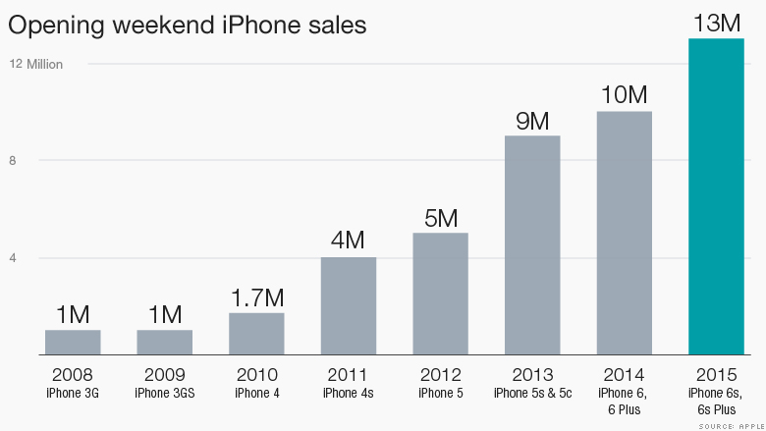
- The figure above is the opening weekend iPhone sales in millions of units between the years 2008 and 2015. According to this figure, the largest percentage increase in opening weekend iPhone sales (in units) is between the years ____________
  - 2009 and 2010
  - 2010 and 2011
  - 2012 and 2013
  - 2013 and 2015

- The market for Ramen noodles, an inferior good, is currently in equilibrium. Suppose that the Ramen noodles consumers' incomes have increased by 20%. Keeping everything else constant, what would we expect to happen to the equilibrium price and quantity?

  - Equilibrium price decreases and equilibrium quantity decreases
  - Equilibrium price decreases and equilibrium quantity increases
  - Equilibrium price increases and equilibrium quantity decreases
  - Equilibrium price increases and equilibrium quantity increases

- Suppose that the crude oil market is initially in equilibrium. Then suppose that there has been a technological breakthrough in shale drilling that allows oil producers to drill for oil faster and more cheaply. What would we expect to happen to the equilibrium price and quantity in the market for crude oil given this information and holding everything else constant?

  - Equilibrium price increases and equilibrium quantity increases
  - Equilibrium price decreases and equilibrium quantity decreases
  - Equilibrium price decreases and equilibrium quantity increases
  - Equilibrium price increases and equilibrium quantity decreases

29. Atlantis and Mu are two countries that produce both swimming goggles (G) and fishing rods (R). The individual PPF curves for these two countries are given by:
Atlantis: R=12-3G
Mu: R=10-G
Which of the following is an efficient combination of swimming goggles and fishing rods, when the two countries are producing jointly?
  - G=15, R=1
  - G=12, R=5
- G=10, R=14
- G=5, R=17

END OF EXAM!

