Economics 101
Spring 2020
Homework #5
Due April 30, 2020

Directions: Please take a photo of every page of your homework. Convert it into pdf file using websites outlines in the “Q&A” file. Go on Canvas “Homework 5 Submission” assignment, press “submit assignment” and upload your pdf files.

Please realize that you are essentially creating “your brand” when you submit this homework. Do you want your homework to convey that you are competent, careful, professional? Or, do you want to convey the image that you are careless, sloppy, and less than professional. For the rest of your life you will be creating your brand: please think about what you are saying about yourself when you do any work for someone else!

1. Consider a monopoly that produces widgets. Suppose you are told that the monopoly has the following cost curves where TC is total cost measured in dollars, Q is the quantity of widgets, and P is the price per widget in dollars:

Total Cost: TC = 18 + 5Q + (1/2)Q2 Marginal Cost: MC = 5 + Q

Suppose you also know that the market demand curve is given by the following equation:

Market Demand: P = 95 - Q

- Given the above information, what is this monopolist’s equation for MR?
- Determine the profit maximizing level of production for this monopolist as well as the price that will be charged for each unit of the good. Assume that this is a single price monopolist, i.e. the monopolist cannot engage in price discrimination. Explain how you found your answer.

- Given the above information and your answer in (b) calculate the level of profit in the short- run for this monopolist. Explain how you found your answer.

- Given your answer in (c), what do you predict will happen to this monopolist in the long-run?

- Calculate the deadweight loss that results from this market being served by a monopolist. Show how you found your answer. Provide a graph that is well labeled to illustrate your answer.

- Use the following graph of a natural monopolist to answer this next question. The graph depicts the market for a monopolist where ATC is the long-run average total cost curve, MC is the marginal cost curve, and Demand is the market demand for the product. You are also told that the reciprocal of the slope of the market demand curve is -500.

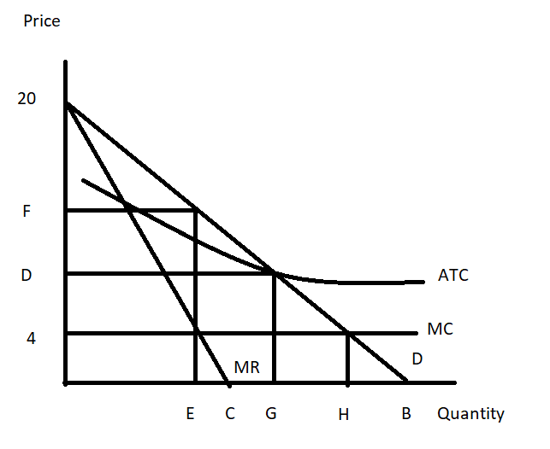

- Given the above information and the graph, write the equation for the market demand curve in slope intercept form. Explain how you found your answer. You will need to provide a numeric value for “B” in the above graph.

b) Suppose that this monopolist is not regulated. Explain how this monopolist will determine its profit maximizing output and price. Assume that the monopolist is a single price monopolist. After explaining the process, identify the value of E and F on the above graph.

c) Will the monopolist described in (b) earn positive, negative, or zero economic profits? Explain your answer. Calculate the monopolist’s Total revenue and then, on the graph indicate what the monopolist’s total costs are.

d) Suppose that this monopolist is regulated with a MC pricing regulation. This insures that the monopolist produces the socially optimal amount of the good, but will require a subsidy for the producer since economic profits will be negative. From the graph and your prior work, identify (that is, provide a numeric value) the socially optimal amount of the good. Then amend the graph to show the amount of total subsidy this monopolist will need to receive if they are to produce the socially optimal amount of the good.

e) Suppose that this monopolist is regulated with AC pricing regulation. This insures that the monopolist produces the level of output where its economic profit is equal to zero. You are also told that at this quantity the monopolist has total revenue equal to $42,000. From the graph and your prior work, identify (that is, provide a numeric value) of the price the monopolist will charge if it is regulated to produce that level of output where the monopolist breaks even. Amend the graph to provide this numeric value.

- Consider a market that is served by a single producer. This market has significant barriers to entry so the single producer has market power and is not likely to face any competition due to these barriers of entry. You are given the following information about this market:

Market Demand: Q = 600 – 40P
MC = 5
Fixed Cost for the Producer: FC = 4

- Given the above information, if this producer acts as a single price monopolist, calculate the following:

Profit maximizing quantity = Profit maximizing price = Level of profits =
Consumer Surplus = CS =
Producer Surplus (remember you will need to adjust this to take into account FC) = PS =

Deadweight Loss =

Show your work and provide a graph to illustrate your answer.

b) Suppose that this monopolist decides to practice second degree price discrimination. The monopolist decides that it will sell its first 100 units of the good produced for a price of $12.50 per unit, its next hundred units for a price of $10 per unit, and its next hundred units for a price of $7.50 per unit. Given this information and the initial information, calculate the following for the monopolist who practices this second degree price discrimination:

Total quantity produced by the second degree price discriminator = Prices charged by the second degree price discriminator = Level of profits for the second degree price discriminator =
Consumer Surplus in this case of second degree price discrimination = CS’ =

Producer Surplus (remember you will need to adjust this to take into account FC) in this
case of second degree price discrimination = PS’ = Deadweight Loss in this case of second degree price discrimination =

Show your work and provide a graph to illustrate your answer.

c) Compare your answers in (a) and (b). Does second degree price discrimination benefit consumers in this case? Explain your answer here and provide evidence to support your answer. Does second degree price discrimination benefit the producer? Explain your answer here and provide evidence to support your answer.
d) Suppose this monopolist practices first degree price discrimination in this market. Compute the following if this monopolist successfully implements first degree price discrimination.

Total amount of the good produced in the market = _____
PS” with perfect price discrimination = _______
CS” with perfect price discrimination = _______
Profit with perfect price discrimination = ______
DWL with perfect price discrimination = _______
Show your work and provide a graph to illustrate your answer.

- Marcia is a supplier of dry cleaning services in her small town. She operates the only dry cleaning service and therefore has significant market power. She knows that she has two types of clients: business clients who come in regularly to have their clothing cleaned and non-business clients who have occasional garments to clean. She knows the following information where Q is the quantity of dry cleaning units and P is the price per unit of dry cleaning:

Demand for dry cleaning services from business clients: Q = 20 – (1/2)P
Demand for dry cleaning services from non-business clients: Q = 30 - P
MC of providing dry cleaning services: MC = 4
Fixed Costs of providing dry cleaning services: FC = 10

Suppose that Marcia decides to treat her dry cleaning business as two separate monopolies: one providing dry cleaning services to business clients and one providing dry cleaning services to non-business clients. She can readily identify the status of each of her clients since she has been in business in this small town for a long, long time and she knows her customers well.

- Given that Marcia is going to treat these two types of customers as separate entities, what will be the profit maximizing price and quantity of the good for each type of customer? And, what will total profits be equal to? Show how you found your answers to this set of questions clearly and logically! Provide a set of graphs to illustrate your answer.

- Now, suppose Marcia would like to verify that this two pricing scheme idea in (a) actually results in her earning greater profits than if she were to simply follow a single pricing monopoly model. So, find the market demand curve. Then determine the profit maximizing quantity and price if Marcia treats this market as a single market with one price for dry cleaning. What happens to the level of profits Marcia earns under this pricing decision? Provide numeric values for all your work and clearly and logically explain how you found your answers. Also, provide a graph to illustrate your answer.

5. Suppose Mary and Peter are running for an elected position and are busy Jeanniepaigning against one another. Two issues are being debated in this election: free college education and comprehensive public healthcare for everyone. Mary realizes that both of these programs are expensive and she advocates for a need based approach for both financing college education as well as universal health care. If Peter elects to not address these two issues in his Jeanniepaign, Mary’s election team estimates that she will get 52% of the vote if she adheres to her program to provide these goods based upon financial need and 47% of the vote if she decides to instead not provide these two goods. If Peter adopts a program of universal healthcare as well as universal college education, then Mary’s Jeanniepaign team estimates that she will earn 49% of the vote if she does not provide these two goods and 50% of the vote if she decides to provide these goods based upon financial need. Over at Peter’s Jeanniepaign headquarters his team finds that no matter what stance he takes on this issue he will get 49% of the vote irrespective of the stance that Mary takes. Understand that there is some rounding going on with these projected percentages: they may sum to just a bit more than 100% of the vote!

a) Given the above information fill in the following payoff matrix. In each cell put Mary’s vote percentage first, followed by Peter’s vote percentage.
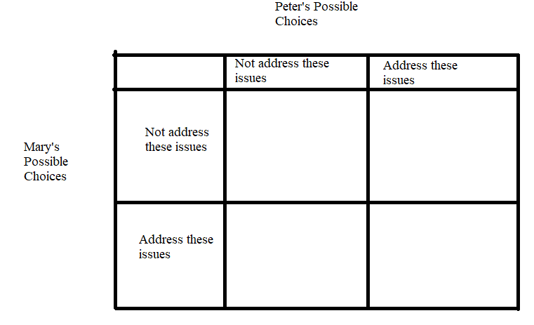
b) Examine the payoff matrix you created in (a). Does Mary have a dominant strategy? Explain your answer.

c) Examine the payoff matrix you created in (a). Does Peter have a dominant strategy? Explain your answer.

d) Suppose Mary follows her dominant strategy, can you predict what Peter will do given the above information? Explain your answer.

e) You plan to watch Mary and Peter debate each other this weekend. Describe the debate you anticipate seeing. What do you think the two candidates platforms will be at the debate?

6. Consider two firms in an industry consisting solely of these two firms. Giant Industries and Mega Products produce identical products. Both firms are trying to decide whether they want to offer coupons or not offer coupons. They know that when they offer coupons the other firm is hurt by this policy since they are selling identical products.

Giant Industries knows that if Mega Products offers coupons then Giant Industries will earn a profit of $60,000 for the year if it also offers coupons and a profit of $70,000 for the year if it does not offer coupons. Giant Industries knows that if Mega Products does not offer coupons then Giant Industries will earn a profit of $75,000 for the year if it offers coupons and a profit of $80,000 for the year if it does not offer coupons.

Mega Products knows that if Giant Industries offers coupons then Mega Products will earn a profit of $48,000 for the year if it also offers coupons and a profit of $50,000 for the year if it does not offer coupons. Mega Products knows that if Giant Industries does not offer coupons then Mega Products will earn a profit of $60,000 for the year if it offers coupons and a profit of $64,000 for the year if it does not offer coupons.

a) Given the above information, construct a payoff matrix for this situation. Put Giant Industries on the left hand side of the payoff matrix and Mega Products on the top of the matrix. Make sure your payoff matrix identifies the strategies that each firm faces as well as the payoff from each combination of strategies.

b) Identify if these two firms have the dominant strategies and, if so, what these dominant strategies are. Explain your answer.

c) Given the above information, can you predict what these two firms will do? Explain your answer.

7. Suppose there are two firms in a market and these two firms agree to form a cartel and divide up the market evenly. The two firms know the following:

Market Demand for the Product: P = 2000 – 2Q
Marginal Cost of producing the good: MC = 400
Fixed Cost of production: FC = 0

a) What is the profit maximizing quantity and price for the cartel? Explain your answer and provide a graph of this market to illustrate your answer.

b) What are the industry profits given your answer in (a)? Show your work.

c) What is the level of production for each firm if both firms adhere to the cartel agreement? What are the profits for each firm? Explain your answer.

d) Suppose one of the firms decides to cheat on the cartel agreement and sell the product for $1100 per unit. How many units can this firm sell at this price and what will be its profits when it follows this pricing strategy? Assume that the other firm does not drop its price and consumers know all prices, so the other firm sells zero units.

e) Suppose that one of the firms drops its price as described in (d), but now the other firm matches this price decrease. If the two firms continue to split the market evenly, what will the profit for each firm equal now that both firms are selling the good for $1100 per unit? Explain your answer.

f) Make a payoff matrix for these two firms with each firm having a choice of charging the profit maximizing price (see (a)) or the “cheating on cartel” price of $1100. Put Firm A on the left hand side of the payoff matrix and Firm B at the top of the matrix.

g) Does each firm have a dominant strategy? Explain your answer.

h) What do you predict will be the outcome of this game? Explain your answer.

i) If you apply the above logic many times to successively lower prices (e.g. $1050, $1000, …), what will the price eventually be?

8. Tom, Kem, and Jeannie live in the same community (they are the only residents) and they are debating installing some lighthouses. Thankfully each of these individuals is willing to reveal their preferences and demand for lighthouses, but the community is still trying to decide how many lighthouses they should buy. Here is the relevant information that they have gathered:

Tom’s demand for lighthouses: Q = 20 – 4P
Kem’s demand for lighthouses: Q = 40 – 4P
Jeannie’s demand for lighthouses: Q = 10 – P
Marginal social cost of a lighthouse: MSC = $16

a) Given the above information draw an illustration of these three demand curves plus the market demand curve for lighthouses. In your illustration provide four different graphs that are vertically stacked with the market demand curve the bottom graph in the stack. Make sure all your graphs are clearly and completely labeled. Describe verbally how you found the market demand curve.

b) Write the equation(s) for the market demand curve and provide a range or domain for any segments of the demand curve. Show how you found these equations.

c) What is the socially optimal amount of lighthouses for this community? Explain how you found your answer. How much will Tom pay per lighthouse? How much will Kem pay per lighthouse? How much will Jeannie pay per lighthouse?

9. Consider the market for college education in the economy of Statesville. The market demand curve for a year of college education is given by P = 80,000 – 2Q where P is the price per year of college and Q is the quantity of students attending college per year. This market demand curve expresses the marginal private benefit of going to college but does not include the social benefits derived from this education. The market supply curve for a year of college education is given by P = 2000 + 2Q. This market supply curve expresses the marginal social cost of going to college. The social benefit of going to college for a year is equal to $10,000 per year per student, in addition to the private benefit that goes to the student directly.

a) Given the above description is there a negative or positive externality in this market? Explain your answer.

b) Given the above description, is this a consumption or a production externality? Explain your answer.

c) What quantity of students will attend college this year and what price will they pay given the above information? Show your work.

d) Suppose that the described externality is internalized in this market. Write the new equations we will need in order to find the socially optimal amount of college education to provide this year. Explain how you got these equations.

e) What is the socially optimal amount of college education to provide this year given the above information? What is the “right” (the one that corresponds to the socially optimal amount of the good) price for a year of college? Explain your answer.

f) What is the deadweight loss that occurs when the externality is not internalized in this market? Show your work.

