Economics 101 | Name _____________________________
Spring 2020 | TA Name __________________________
February 25, 2019 | Discussion Section # _________________
Midterm Exam 1 | Student ID # ________________________

VERSION 1

DO NOT BEGIN WORKING UNTIL THE INSTRUCTOR TELLS YOU TO DO SO.
READ THESE INSTRUCTIONS FIRST.

You have 75 minutes to complete the exam, including filling in your scantron. The exam consists of 30 multiple choice questions worth 3 points each for a total of 90 points. The last 10 points are administrative and earned by accurately and completely providing your name, ID number, discussion section number, version number, and TA name on the scantron sheet and the exam booklet. Answer all questions on the scantron sheet with a #2 pencil. There are 23 printed pages in this exam, including this cover sheet. Do not pull the exam apart or remove the staple.

WARNING: NO COMMUNICATION OR CALCULATING DEVICES, OR FORMULA SHEETS ARE ALLOWED. NO CONSULTATION AND CONVERSATION WITH OTHERS ARE ALLOWED WHILE YOU ARE TAKING THE EXAM OR IN THE EXAM ROOM. ACADEMIC MISCONDUCT IS A SERIOUS OFFENSE AND PUNISHABLE TO THE FULLEST EXTENT.
PICK THE BEST ANSWER FOR EACH QUESTION.

How to fill in the scantron sheet and other information:
- Print your last name and first name in the spaces marked "Last Name," and "First Name". Fill in the corresponding bubbles below.
- Print your student ID number in the space marked "Identification Number." Fill in the bubbles.
- Write the number of the discussion section you’ve been attending under "Special Codes" spaces ABC, and fill in the bubbles. The discussion numbers can be found at the bottom of this page.
- Write the version number of your exam booklet under "Special Codes" space D, and fill in the bubble. The version number is at the top of this page.
Example: If you are registered for section 361 and it says “VERSION 2” at the top of this page, your “Special Codes” should read 3612.
- If there is an error on the exam or you do not understand something, make a note on your exam booklet and the issue will be addressed AFTER the examination is complete. No questions regarding the exam can be addressed while the exam is being administered.
- When you are finished, please get up quietly and bring your scantron sheet and this exam booklet to the place indicated by the instructors.

Zaure Aitkulova | Philip Coyle | Mengqi Wang
363 F 12:05 – 12:55 pm  Soc Sci 6232 | 360 F 2:25 – 3: 15 pm  Ingraham 214 | 364 F 1:20 – 2:10 pm  Soc Sci 5231
368 F 8:50 -9:40 am  Ingraham 222 | 361 F 9:55 – 10:45 am  Sterling 2333 | 366 F 11:00 – 11:50 am  Van Hise 591
 | 362 Th 4:35 – 5:25 pm  Soc Sci 6224 | 367 F 9:55 – 10:45 am  Van Hise 219
 | 365 F 11:00 – 11:50 am  Van Hise 590 | 369 F 12:05 – 12:55 pm  Van Hise 240

WORKSHEET – DO NOT REMOVE!

EXAM CONTINUES – THERE ARE 23 PAGES!
I, ______________________________, agree to neither give nor receive any help on this exam from other students. Furthermore, I understand that use of a calculator on this exam is an academic misconduct violation. I also understand that failure to cover my answers is academic misconduct: it is important that I maintain the integrity of my work and that I do not make it available to other students.
Signed ___________________________________

Multiple Choice Questions (30 questions each worth 3 points)

1. Maria is considering how many hours she should study. She has the following information:

Hours of Study | Marginal Benefit from an additional hour of study | Marginal Cost of an additional hour of study
First Hour | $50 | $4
Second Hour | $38 | $9
Third Hour | $28 | $15
Fourth Hour | $10 | $22
Fifth Hour | $3 | $25

Given the above table and holding everything else constant, Maria should:

a. Study more than two hours but less than three hours.
b. Study more than four hours but less than five hours.
c. Study more than three hours but less than four hours.
d. Study five hours since her marginal benefit for an additional hour of study is a positive number for five hours of study.

Use the following graph of a PPF for a café to answer the next three (3) questions.

The PPF for this café consists of two linear segments as provided in the graph.
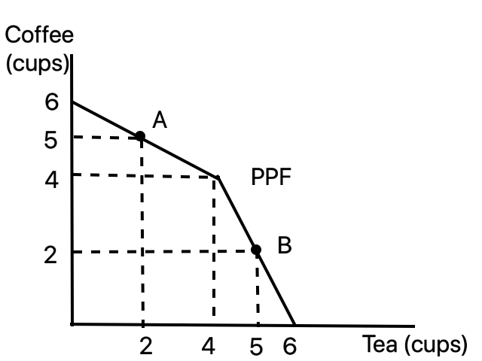

2. What is the opportunity cost of tea going from point A (2, 5) to point B (5, 2)?

a. 3 cups of tea
b. 3 cups of coffee
c. 1 cup of coffee
d. 6 cups of coffee

3. Given the above graph and holding everything else constant, which one of the following points (Tea, Coffee) is feasible, but inefficient?

a. (Tea, Coffee) = (6, 0)
b. (Tea, Coffee) = (5, 5)
c. (Tea, Coffee) = (4, 4)
d. (Tea, Coffee) = (3, 3)

4. Consider the two points in the above graph: point A (2, 5) and B (5, 2). Given the above graph and holding everything else constant, which of the following statements is correct?

a. The opportunity cost of an additional unit of coffee at A is higher than the opportunity cost of an additional unit of coffee at B.
b. The opportunity cost of an additional unit of coffee at A is lower than the opportunity cost of an additional unit of coffee at B.
c. The opportunity cost of an additional unit of coffee at A is 0.5 cups of tea.
d. The opportunity cost of an additional unit of coffee at B is 1 cup of tea.

WORKSHEET – DO NOT REMOVE!

5. At the end of the football game there is a crucial play where our team needs to make a big play (a play that will alter the outcome of the game). The stadium is crowded and when the play begins Joe stands up reasoning that he will be able to see the play better if he is not sitting in his seat. If the rest of his section of the stadium simultaneously stands up with Joe then Joe finds that his idea does not result in a good view of the action. This is an example of:

a. scarcity of resources.
b. the fallacy of composition.
c. the paradox of thrift.
d. poor economic reasoning on Joe’s part.

6. Consider the market for widgets that is initially in equilibrium. You are told that there is an increase in incomes for consumers in this market at the same time there is an increase in the price of metal, an important input in the production of widgets. You are also told that widgets are an inferior good. Given this information and holding everything else constant:

a. The demand curve shifts to the left and the supply curve shifts to the right relative to their initial positions and the new equilibrium price is indeterminate.
b. The new equilibrium quantity is smaller than the initial equilibrium quantity, the supply curve shifts to the left relative to the initial supply curve, and the demand curve shifts to the right relative to the initial demand curve.
c. Both the demand curve and the supply curve shift to the right relative to the initial curves and the new equilibrium quantity is indeterminate while the new equilibrium price increases relative to the initial levels.
d. Both the demand curve and the supply curve shift to the left relative to the initial curves and the new equilibrium price is indeterminate while the new equilibrium quantity decreases relative to the initial levels.

7. Why is the joint PPF for any society bowed outwards and why does it have a negative slope?

a. The PPF is bowed outwards because of specialization according to comparative advantage and the PPF has a negative slope because economic resources are limited.
b. The PPF is bowed outwards because economic resources are limited and the PPF has a negative slope because of specialization according to comparative advantage.
c. The PPF is bowed outwards because of specialization according to absolute advantage and the PPF has a negative slope because economic resources are limited.
d. The PPF is bowed outwards because of the law of increasing opportunity cost and the PPF has a negative slope because economic growth is costly.

8. Suppose you are told that the market demand curve for a good shifts to the right at every price. Given this information and holding everything else constant, which of the following statements provides a possible explanation for why this shift occurred?

a. There was an increase in the number of producers in this market and that resulted in a greater quantity of the good at every price.
b. Future prices were expected to decrease in the future and that resulted in the quantity demanded today being greater at every price.
c. There was a decrease in incomes in this economy and since this good is an inferior good this resulted in a greater demand for this good at every price.
d. There was an increase in the price of a complementary good in this economy and this resulted in greater demand at every price for this good.

9. The study of economic decision making by households is a topic primarily covered in ____ and the determination of the unemployment rate is a topic typically covered in _______:

a. macroeconomics; macroeconomics
b. microeconomics; microeconomics
c. macroeconomics; microeconomics
d. microeconomics; macroeconomics

Use the following information to answer the next two (2) questions.

A market is composed of five demanders and five suppliers. Each demander has the same demand curve and each firm has the same individual supply curve. These curves are given as follows where Q is the quantity of the good and P is the price of the good:

Individual Consumer Demand Curve: P = 100 – 5Q
Individual Producer Supply Curve: P = 4 + 3Q

10. Given the above information and holding everything else constant, the market supply curve is given as:

a. P = 20 + 15Q
b. P = 4 + (3/5)Q
c. P = 4 + (5/3)Q
d. P = 4 + 15Q

11. Given the above information and holding everything else constant, when this market is in equilibrium the value of consumer surplus (CS) and the value of producer surplus (PS) are:

a. CS = (1/2)(100 – 15)(17); PS = (1/2)(15 – 4)(17)
b. CS = (1/2)(100 – 60)(40); PS = (1/2)(60 – 4)(40)
c. CS = (1/2)(100 – 40)(60); PS = (1/2)(40 – 4)(60)
d. CS = (1/2)(100 – 35)(65); PS = (1/2)(35 – 4)(65)

WORKSHEET – DO NOT REMOVE!

12. Consider a market for gadgets in a small, closed economy. If this economy opens the gadget market to trade and the domestic closed market price for gadgets is greater than the world price for gadgets, we can predict that this economy will:

a. import gadgets and producer surplus with trade will increase relative to producer surplus without trade.
b. export gadgets and producer surplus with trade will increase relative to producer surplus without trade.
c. import gadgets and consumer surplus with trade will increase relative to consumer surplus without trade.
d. export gadgets and consumer surplus with trade will increase relative to consumer surplus without trade.

13. The individual “mandate” that required individuals to purchases health insurance in the Affordable Care Act was designed to prevent the:

a. poor from not being able to afford health insurance.
b. insurance death spiral.
c. pool of insured individuals from being a highly diversified pool with respect to potential health outcomes.
d. government from needing to pay subsidies to the poor so that they could afford health insurance.

14. Which of the following statements describes the subject of economics the best?

a. Economists study the how people can make optimal decisions given their tastes and subject to the constraint they face with regard to the scarcity of their time and/or income.
b. The primary question economists try to answer is how to increase people’s wealth as measured by the amount of money they have.
c. Wealthy people such as Bill Gates do not fit into the subject of economics since they do not face scarcity.
d. Economics’ main purpose is to make sense of mathematical expressions.

Use the following information to answer the next two (2) questions.

Phil’s demand for hamburgers is given by the equation where Q is the quantity of hamburgers and P is the price per hamburger:

Phil’s Demand for Hamburgers: Q = 140 – 5P

15. Given this information and holding everything else constant, how many of the following statements are true?

Phil will demand 15 hamburgers if the price is $25.
Phil will demand 40 hamburgers if the price is $20.
Phil will demand 65 hamburgers if the price is $16.

a. One statement is true.
b. Two statements are true.
c. Three statements are true.
d. All three statements are false.

16. A research study at the University of Wisconsin recently concluded that there are negative health effects to consuming red meat. This study causes a shift in Phil’s demand curve, so that for every quantity demanded of burgers, the price changes by $10. Given this information and holding everything else constant, what is the new equation for Phil’s demand curve?

a. P = -1/5Q + 38
b. P = -1/5Q + 28
c. P = -1/5Q + 18
d. P = -1/5Q + 8

Use the following information to answer the next four (4) questions.

Pedro and Ming have linear production possibility frontiers for sandwiches (S) and cookies (C). These PPFs are depicted in the graphs below.

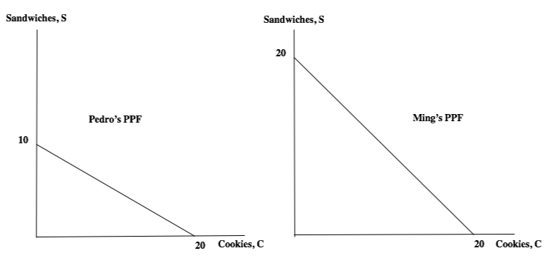

17. Based on the above graphs, how many of the following statements are true?

- Ming has the absolute advantage in the production of sandwiches: that is, Ming can absolutely produce more sandwiches than Pedro.
- Pedro has the comparative advantage in the production of cookies.
- For every sandwich that Pedro produces he must give up ½ cookie.
- It is feasible for Pedro to produce the combination (C, S) = (8, 7).

a. One statement is true.
b. Two statements are true.
c. Three statements are true.
d. Four statements are true.

18. Based on the above graphs, the set of equations that describes the joint PPF for Pedro and Ming is:

a. S = 30 – C for 10 ≤ S ≤ 30
S = 20 – C for 0 ≤ S ≤ 10

b. S = 30 – C for 20 ≤ S ≤ 30
S = 20 – C for 0 ≤ S ≤ 20

c. S = 30 – (1/2)C for 10 ≤ S ≤ 30
S = 40 – C for 0 ≤ S ≤ 10

d. S = 30 – (1/2)C for 20 ≤ S ≤ 30
S = 40 – C for 0 ≤ S ≤ 20

19. Consider Pedro and Ming’s joint PPF. Suppose a total of 30 cookies are currently being produced by Pedro and Ming. Furthermore, assume that they are efficiently operating on the frontier of their joint PPF. Given this information you conclude that:

a. Pedro is producing 20 cookies and Ming is producing five sandwiches.
b. Pedro is producing 10 sandwiches and Ming is producing 20 cookies.
c. Pedro is producing ONLY the maximum number of cookies he can produce, and Ming is producing both sandwiches and cookies.
d. Ming is producing ONLY the maximum number of cookies he can produce, and Pedro is producing both sandwiches and cookies.

20. Pedro and Ming decide to specialize according to their comparative advantage and then trade with one another. Based on the above information, which of the following statements is true?

a. Ming is willing to sell 10 sandwiches provided he gets at least 8 cookies.
b. Pedro is willing to buy 10 sandwiches provided the price is less than 22 cookies.
c. Ming and Pedro decide to trade 10 sandwiches for 10 cookies: this trade arrangement could be interpreted as Pedro being a better negotiator than Ming.
d. Pedro offers Ming 8 cookies for the 10 sandwiches and Ming accepts this offer.

Use the following information to answer the next two (2) questions.

The graph below depicts a graph of an agricultural market.

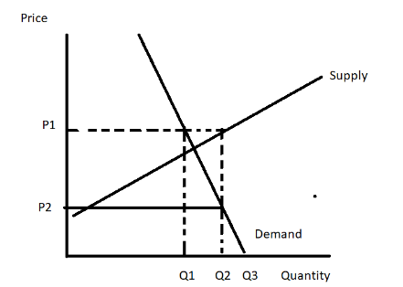

21. Suppose the government implements an effective agricultural price support equal to P1 in this market. The direct cost of this program to the government of purchasing the surplus (and not including any storage costs should they occur) is:

a. (P1 – P2)(Q2)
b. (P1)(Q2 – Q1)
c. P1Q2 – P1(Q2 – Q1)
d. P1Q1

22. Suppose the government implements an effective subsidy program in this market with the government guaranteeing producers a price of P1 in this market. Given this information and holding everything else constant, consumer (non-government) expenditure on this good is equal to:

a. (P1)(Q1)
b. (P2)(Q2)
c. P1Q2 – P1(Q2 – Q1)
d. (P1 – P2)(Q2)

WORKSHEET – DO NOT REMOVE!

Use the following information to answer the next two (2) questions.

Assume that Ann, Bob and Clare all have linear production possibility frontiers (PPFs) and that the values in the table below provide the maximum amount of each good the individual can produce given their resources, technology and time period. Thus, based on the table above, Ann can make either 12 erasers or 3 pencils, Bob can make either 18 erasers or 6 pencils and Clare can make 12 erasers or 12 pencils within the same time period.

 | Erasers | Pencils
Ann | 12 | 3
Bob | 18 | 6
Clare | 12 | 12

23. Given the above information and holding everything else constant, which of the following statements and graphs represent their joint PPF and points of specialization?

a. point A is where Clare specializes in pencils and point B is where Ann specializes in erasers
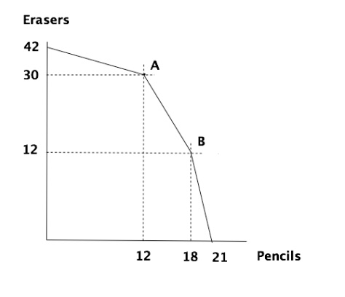
b. point A is where Clare specializes in pencils and point B is where Bob specializes in erasers
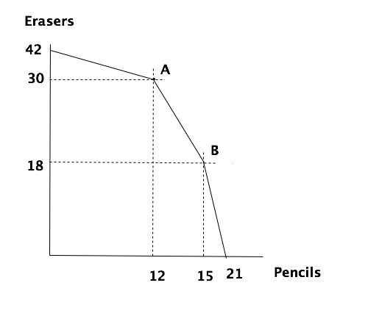

c. point A is where Ann specializes in pencils and point B is where Clare specializes in erasers
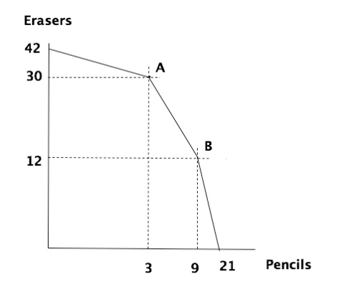
d. point A is where Bob specializes in pencils and point B is where Ann specializes in erasers
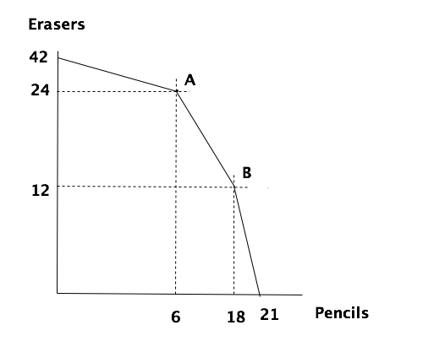

24. Which of the following statements are true about the acceptable range of trading prices?

a. If the price of 1 pencil is 3.5 erasers then Bob and Clare will sell pencils and Ann will buy pencils.
b. If the price of 1 eraser is 0.5 pencils then Ann and Clare will sell erasers and Bob will buy erasers.
c. If the price of 1 pencil is 0.5 erasers then Bob will sell pencils and Clare and Ann will buy pencils.
d. If the price of 1 eraser is 2 pencils then Ann, Bob and Clare will all buy erasers.

Use the following information to answer the next two (2) questions.

Consider the following market for printers. The graph below illustrates this market: assume that both the demand curve and the supply curve are linear in this market.

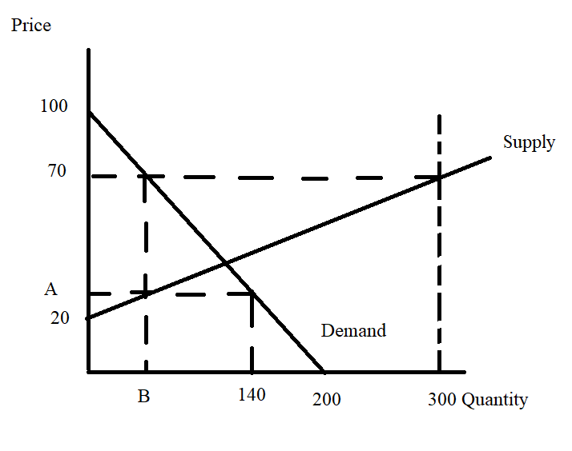
25. For a price floor set by the government to be effective in this market, the price floor must be:

a. Set at a price less than or equal to $30 per unit.
b. Set at a price no less than $70 per unit.
c. Set at a price greater than $40 per unit.
d. Set at a price no less than $50 per unit.

26. Given the above information, suppose the government imposes a price ceiling that results in a shortage of 80 units. Holding everything else constant, the value of “A” is ___________ and the value of “B” is ___________.

a. A = 60 units; B = $30 per unit
b. A = 30 units; B = $60 per unit
c. A = $60 per unit; B = 30 units
d. A = $30 per unit; B = 60 units

WORKSHEET – DO NOT REMOVE!

Use the following information to answer the next two (2) questions.

The domestic market for limes in Smallville, a small closed economy, can be described by the following demand and supply curves where Q is the quantity of limes and P is the price per lime:

Domestic Market Demand for Limes in Smallville: P = 10 – (1/10)Q
Domestic Market Supply of Limes in Smallville: P = 2 + (1/10)Q

The world price of a lime is $3 per lime.

27. Suppose the government of Smallville opens this market for limes to trade and, at the same time, implements a tariff in this market for limes. The tariff results in the price of limes being $4 per lime. Given this information and holding everything else constant, how many of the following statements are true?

- At the world price of $3 per lime, imports are equal to 70 limes.
- At the tariff price of $4 per lime, imports are equal to 40 limes.
- At the tariff price, domestic producers will produce ten more limes than they would have if the lime market was simply opened to trade.
- Relative to the open market, the open market with a tariff increases domestic producer surplus and increases domestic consumer surplus.

a. One statement is true.
b. Two statements are true.
c. Three statements are true.
d. Four statements are true.

28. Consider the tariff described in the last question. Given this information and holding everything else constant, compare the value of consumer surplus with an open economy with the value of consumer surplus when this tariff is implemented.

a. The open economy has a greater area of consumer surplus than the open economy with this tariff. The difference in the values of these two surpluses is $245.
b. The open economy has a smaller area of consumer surplus than the open economy with this tariff. The difference in the values of these two surpluses is $75.
c. The open economy has a greater area of consumer surplus than the open economy with this tariff. The difference in the values of these two surpluses is $65.
d. The open economy has a smaller area of consumer surplus than the open economy with this tariff. The difference in the values of these two surpluses is $180.

WORKSHEET – DO NOT REMOVE!

Use the following information to answer the next two (2) questions.

The market for cigarettes in Country X can be described by the following two equations where Q is the quantity of packages of cigarettes and P is the price per package of cigarettes:

Market Demand for Cigarettes: Q = 1000 – 50P
Market Supply of Cigarettes: Q = (50/3)P

Initially this market is in equilibrium and then the government of Country X decides to impose an excise tax of $8 per package of cigarettes.

29. Given this information and holding everything else constant:

a. People in Country X will consume 100 fewer packages of cigarettes and they will pay $8 per package of cigarettes more than they did before the imposition of the excise tax.
b. People in Country X will continue to consume 250 packages of cigarettes but the price per package of cigarettes will rise from $15 per package to $23 per package.
c. People in Country X will consume 150 fewer packages of cigarettes with the imposition of the tax and the tax incidence of this excise tax will fall more heavily on consumers of cigarettes than on producers of cigarettes.
d. People in Country X will consume 100 fewer packages of cigarettes with the imposition of the tax and the tax incidence of this excise tax will fall more heavily on producers of cigarettes than on consumers of cigarettes.

30. Given this information and holding everything else constant, the deadweight loss (DWL) from the implementation of this excise tax will equal _____ and the tax revenue from the imposition of this excise tax will equal _______.

a. DWL = $400; Tax Revenue = $300
b. DWL = $800; Tax Revenue = $1200
c. DWL = $400; Tax Revenue = $1200
d. DWL = $800; Tax Revenue = $300

WORKSHEET – DO NOT REMOVE!

END OF EXAM!

