Economics 101 Name ____________________________________________
Summer 2012
Answers to Quiz #4
6/20/12

Please answer all questions neatly and legibly. Your TA will not want to spend her time hunting for your answers or trying to decipher difficult handwriting.

1. This set of questions compares a single price monopoly to a first degree price discriminating monopoly. Suppose that the market demand curve for this monopoly is given by the equation
P = 10 – (1/2)Q
while the firm’s marginal cost of production is given by the equation
MC = 1
Assume for this problem that the firm has no fixed costs.

a. (5 points) In the space below draw a graph of the firm’s demand curve and its marginal cost curve. Label this graph clearly and completely.

Answer:
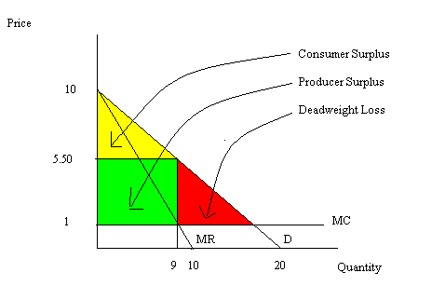

b. (8 points) Suppose this firm acts as a single price monopoly. In the space below show your work in determining the quantity of the good the firm will produce (Qm), the price the firm will charge (Pm), total revenue (TRm) for the firm, total cost (TCm) for the firm, and profits (Πm) for the firm. Finally, calculate producer surplus (PSm) for the firm, consumer surplus (CSm) for the firm, and deadweight loss (DWLm) for the firm. Indicate in the graph in (a) where Qm, Pm, CSm, PSm and DWLm are located. Show your work, but place your answers in the following table:

Qm
Pm
TRm
TCm
Πm
PSm
CSm
DWLm

Answer:
To answer this question you first need to find the firm’s MR equation:
MR = 10 – Q
Then MR = MC gives you Qm:
10 – Q = 1
Qm = 9
Then use the demand curve to find Pm:
Pm = 10 – (1/2)Qm
Pm = 10 – (1/2)(9)
Pm = $5.50
TRm = Pm * Qm = ($5.50 per unit)(9 units) = $49.50
TCm = ATCm * Qm
Recall that ATC = MC if MC is a horizontal line and FC = 0
Thus, TCm = ($1 per unit)(9 units) = $9
Πm = TRm – TCm = $49.50 - $9 = $40.50
CSm = (1/2)($4.50 per unit)(9 units) = $20.25
PSm = ($4.50 per unit)(9 units) = $40.50
DWLm = (1/2)($4.50 per unit)(9 units) = $20.25

Qm | 9
Pm | $5.50
TRm | $49.50
TCm | $9
Πm | $40.50
PSm | $40.50
CSm | $20.25
DWLm | $20.25

c. (5 points) Redraw the graph you had in (a) so that you can use it to guide your work in (d).

Answer:
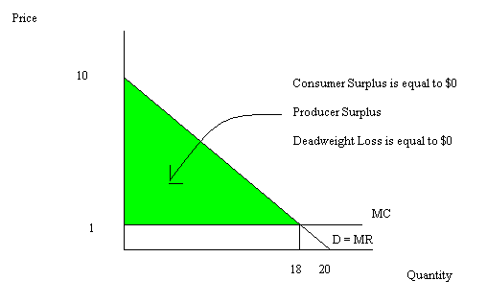

d. (7 points) Suppose this firm acts as a perfect price discriminating monopolist (ppd). In the space below show your work in determining the quantity of the good the firm will produce (Qppd), total revenue (TRppd) for the firm, total cost (TCppd) for the firm, and profits (Πppd) for the firm. Finally, calculate producer surplus (PSppd) for the firm, consumer surplus (CSppd) for the firm, and deadweight loss (DWLppd) for the firm. Indicate in the graph in (c) where Qppd, CSppd, PSppd and DWLppd are located. Show your work, but place your answers in the following table:

Qppd
TRppd
TCppd
Πppd
PSppd
CSppd
DWLppd

Answer:
MR for the perfect price discriminating monopolist is equal to
MR = 10 – (1/2)Q
So, MR = MC
10 – (1/2)Q = 1
Qppd = 18
Pppd will vary since the firm will follow its demand curve and charge each consumer a different price for the quantity they consume
TRppd = ($1 per unit)(18 units) + (1/2)($9 per unit)(18 units) = $99
TCppd = ($1 per unit)(18 units) = $18
Πppd = $81
PSppd = (1/2)($9 per unit)(18 units) = $81
CSppd = $0
DWLppd = $0

Qppd | 18 units
TRppd | $99
TCppd | $18
Πppd | $81
PSppd | $81
CSppd | $0
DWLppd | $0

