Econ 101 Name _________________________________
Summer 2014
Answers to Quiz #3

Please write all answers neatly and legibly.

1. (2 points) Suppose you know that prices in Grayland have risen 10% in 2012, 20% in 2013, and 50% in 2014. If 2012 is used as the base year for calculating the CPI on a 100 point scale, what is the value of the CPI in 2014? Show your work.

Answer:
To answer this problem it will be helpful to have a table to contain our calculated values.
Year | CPI
2012 | 100
2013 | 110
2014 | 132
2015 | 198

If the CPI is 100 in the base year of 2012 and the price level has risen 10% between 2012 and 2013, that implies that the CPI in 2013 should be 10% higher than the CPI in 2012. Thus, 100(1 + .10) = 110.

If the CPI is 110 in 2013 and the price level has risen 20% between 2013 and 2014, that implies that the CPI in 2014 should be 20% higher than the CPI in 2013. Thus, 110(1 + .20) = 133.

If the CPI is 133 in 2014 and the price level has risen 50% between 2014 and 2015, that implies that the CPI in 2015 should be 50% higher than the CPI in 2014. Thus, 133(1 + .5) = 199.5.

2. Suppose that the market basket underlying the CPI in Grayland is composed of 2 loaves of bread and 5 cans of tuna. You are given the following information about prices of these items over the three year period 2010-2012.

 | 2010 | 2011 | 2012
Price of a loaf of bread | $0.50 | $2.50 | $2
Price of a can of tuna | $4 | $5 | $2.20

a. (2 points) Given this information, calculate the CPI on a 100 point scale for 2010, 2011, and 2012 using 2011 as the base year. Show all your work in a logical, organized manner. Put your index numbers in the following table after you do your calculations (you must show the steps you took to get the index numbers in order to get full credit on this question).

Year | CPI
2010
2011
2012

Answer:
1) To answer this question you will first need to calculate the cost of the market basket in each of the three years:
Cost of market basket in 2010 = (2)(0.50) + (5)(4) = $21
Cost of market basket in 2011 = (2)(2.50) + (5)(5) = $30
Cost of market basket in 2012 = (2)(2) + (5)(2.20) = $15
2) To find the CPI index numbers use the following formula:
CPI for year n = [(Cost of market basket in year n)/(Cost of market basket in base year)]*(scale factor)
CPI for 2010 = [(21)/(30)]*100 = 70
CPI for 2011 = [(30)/(30)]*100 = 100
CPI for 20012= [(15)/(30)]*100 = 50

Here is the completed table of values:
Year | CPI
2010 | 70
2011 | 100
2012 | 50

b. (2 point) Calculate the annual rate of inflation between 2010 and 2011, and the annual rate of inflation between 2011 and 2012. Show any formulas used and the work you did to get this inflation rate. After computing your answers put them in the following table (you must show the steps you took to get the rate of inflation in order to get full credit on this question). Round your answer to the nearest tenth of a percent.

Period | Rate of Inflation
2010 to 2011
2011 to 2012

Answer:
To find the rate of inflation use the percentage change formula:
Percentage change in a variable = {[(Value of variable in current year) – (Value of variable in previous year)]/(Value of variable in previous year)} * (100%)
Percentage change in the CPI from 2010 to 2011 = [(100 – 70)/70] * 100 = 42.9%
Percentage change in the CPI from 2011 to 2012 = [(50 – 100)/100] * 100 = -50%

Here is the completed table:

Period | Rate of Inflation
2010 to 2011 | 42.9%
2011 to 2012 | -50%

3. (1 point) (Circle the correct response) Judy is considering raising the price she charges for her accounting services. She currently is selling 100 units of accounting services for $100 a unit. She estimates that she can sell 120 units of accounting services if she drops her price to $90 a unit. From this information you can conclude that
a. The price elasticity of demand for Judy’s accounting services is elastic over this price range.
b. The price elasticity of demand for Judy’s accounting services is inelastic over this price range.

Answer:
When Judy prices her services at $100 a unit, her total revenue is $10,000. She estimates that her total revenue if she drops her price to $90 a unit will be $10,800. If price decreases result in total revenue increases we can conclude that demand is in the elastic region of the demand curve. The answer is (a).

4. (1 point) (Circle the correct response) Jacob estimates that the cross price elasticity of demand between pretzels and sandals is -0.25. This tells us that pretzels and sandals are
a. Complements since as the price of sandals decreases the quantity of pretzels demanded increases.
b. Substitutes since as the price of sandals increases the quantity of pretzels demanded decreases.

Answer:
If the cross price elasticity of demand between two goods is a negative number this implies that as the price of one of the goods increases, the quantity demanded of the other good decreases. This signifies that the two goods must be complements. The answer is (a).

5. Use the following graph to answer this next set of questions.

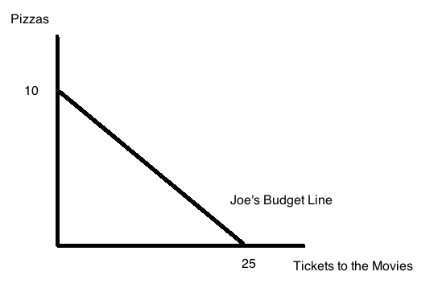

The above graph depicts Joe’s budget line. You are also told that the price of a movie ticket is $10.

a. (1 point) From this information determine Joe’s income as well as the price of a pizza. Show how you found your answer.

Answer:
Given that Joe can afford 25 movie tickets if he only buys movie tickets we can deduce that his income must be equal to 25 movie tickets times $10 per movie ticket or $250. Since he can afford 10 pizzas, this implies that the price of a pizza is $250 divided by 10 or $25 per pizza. So, Joe’s income is $250 dollars and the price of a pizza is $25.

b. (1 point) Suppose you are told that Joe maximizes his utility when he purchases 15 movie tickets. How many pizzas will Joe consume when he maximizes his utility? Show how you found your answer.

Answer:
If Joe buys 15 movie tickets he will have spent $150 of his income. That leaves him with $100 in income to spend on pizza. Since each pizza costs $25, this implies that Joe will purchase 4 pizzas when he maximizes his satisfaction given his income and the prices of the two goods.

