Econ 101 Name _________________________________
Summer 2013
Answers to Quiz #2

Please write all answers neatly and legibly.

1. (2 points) Consider the market for bicycles which is initially in equilibrium. Suppose that the Surgeon General releases a report that indicates the bicycle riding helps prevent serious disease. Given this information and holding everything else constant, what do you predict will happen to the equilibrium quantity and price of bicycles? In your answer provide a well-labeled diagram to depict this market and the changes that occur in this market.

Answer:

The demand curve for bicycles will shift to the right after the Surgeon General’s report: this will result in the price of bicycles and the quantity of bicycles increasing. Here is the diagram:
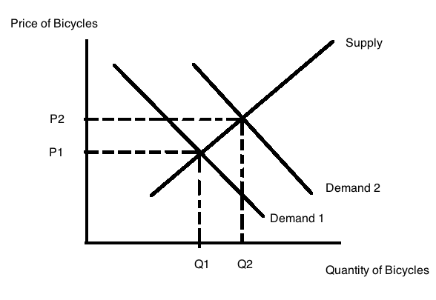

2. (2 points) Consider the market for milk which is initially in equilibrium. Recent reports link the consumption of milk with obesity concerns. At the same time the cost of pasture for dairy cows has risen substantially. Holding everything else constant, what do you predict will happen to the equilibrium price and quantity in the market for milk given this new information? If any curves shift, be sure to identify these shifts and the direction of these shifts in your answer. In your answer provide a well-labeled diagram to depict this market and the changes that occur in this market.

Answer:

Both the demand curve and the supply curve for milk will shift to the left. Since we do not know the magnitude of these shifts we will have a situation of indeterminancy: we can know with certainty that the equilibrium quantity of milk is lower than the initial equilibrium quantity, but we do not knowwhether the new equilibrium price is equal to, greater than, or less than the initial equilibrium price. Here is a diagram to represent the situation (note I am showing the diagram with three possible supply curve shifts, you might show it with three possible demand curve shifts-either depiction would be accurate).
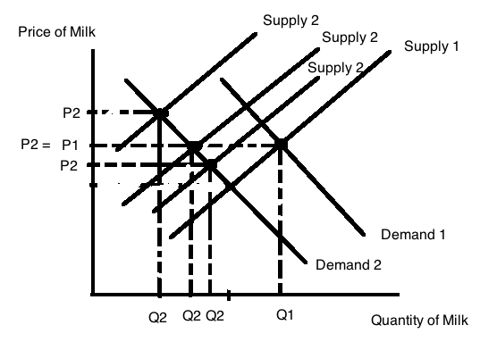

3. (2 points) Suppose the market for bananas is described by the following equations where P is the price per unit of bananas and Q is the quantity of units of bananas:
Demand: Q = 100 – 2P
Supply: Q = P + 25
What is the value of producer surplus in the market for bananas when this market is in equilibrium? Show how you calculated this value. Make sure you provide a unit of measurement for your final answer.

Answer:

PS in this example is a trapezoid. So you will need to calculate the area of PS by finding the area of a rectangle plus the area of a triangle.
PS = ($25 per unit of bananas)(25 units of bananas) + (1/2)($25 per unit of bananas)(50 units of bananas – 25 units of bananas) = $937.50

A figure will help you see these areas: note that PS in this example is a trapezoid. Here is the figure illustrating these concepts:
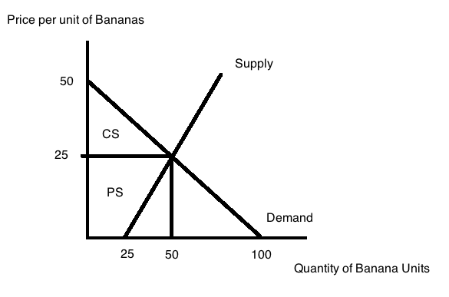

4. (2 points) Suppose that in the market for bananas described in the last question that the government decides they would like to increase the number of bananas sold to 80 units of bananas. The government decides to reach this goal by implementing a subsidy per unit of bananas provided in the market. How big a subsidy would the government need to implement to reach this goal if nothing else changed in the market? Explain how you found your answer.

Answer:

At a quantity of 80 units of bananas demanders are willing to pay $10 per unit of bananas and suppliers must receive $55 per unit of bananas. To get these prices simply substitute Q = 80 in the demand curve (80 = 100 – 2P or P = $10 per unit of bananas) and in the supply curve (80 = P + 25 or P = $55 per unit of bananas). The subsidy from the government would need to be the difference between these two prices or $45 per unit of bananas.

5. (2 points) Suppose that the banana market described in problem 3 is a closed market in a small economy. Furthermore, suppose that the world price of a unit of bananas is $30 per unit of bananas. Suppose this market opens to trade. Describe verbally the quantity of bananas produced domestically in this economy, the quantity of bananas consumed domestically, and the level of imports or exports of bananas for this economy. Explain your answer.

Answer:

If this economy opens to trade, bananas from this economy’s perspective will sell at the world price. Since the world price is greater than the closed domestic price we know with certainty that this economy will export bananas once the market is open to trade. At $30 per unit of bananas, the quantity demanded domestically will be 40 units of bananas and the quantity supplied domestically will be 55 units of bananas. The difference, or 15 units of bananas, will be exported to the world market.

