Econ 101 Name _________________________________
Summer 2013
Answers to Quiz #2

Please write all answers neatly and legibly.

1. (2 points) Consider the market for coffee which is initially in equilibrium. Suppose that bad weather hurts the coffee crop this year at the same time that a research study finds that drinking coffee offers major health benefits. What do you predict will happen to the equilibrium price and quantity of coffee relative to their initial levels given this information and holding everything else constant? If the demand or supply curves shift, be explicit in describing these shifts.

Answer:
The bad weather will shift the supply of coffee to the left while the research study will result in the demand curve shifting to the right. Since we do not know the magnitude of these two shifts we know that this situation will be indeterminate. With certainty we know that the new equilibrium price will be higher than the initial equilibrium price, but the new equilibrium quantity may be greater than, less than, or equal to the initial equilibrium quantity.

2. (2 points) Consider the market for leather belts. Recent fashion trends suggest that belt wearing is decidedly not fashionable. At the same time, animal rights activist groups protest against those wearing animal products. What do you predict will happen to the equilibrium price and quantity of leather belts relative to their initial levels given this information and holding everything else constant? If the demand or supply curves shift, be explicit in describing these shifts.

Answer:
The change in fashion trends will cause the demand for leather belts to shift to the left: at every price the quantity of leather belts demanded will be smaller. In addition the activities of the animal rights activists will affect the tastes and preferences for leather belts: it is most likely that the demand for leather belts will shift to the left. Both changes in the market impact the demand curve and they both result in a leftward shift: thus, we should expect the equilibrium price of leather belts to fall relative to its initial level and the equilibrium quantity of leather belts to fall relative to its initial level.

3. (2 points) Suppose the market for lipstick in Utopia is described by the following demand and supply curves:
Demand: P = 100 – Q
Supply: P = 2Q – 50
What is the value of total surplus in this market when the market is in equilibrium? Show how you calculated this value.

Answer:
TS = CS + PS
TS = (1/2)($100 per unit - $50 per unit)(50 units) + ($50 per unit)(25 units) + (1/2)($50 per unit - $0 per unit)(50 units – 25 units)
TS = $3125

A figure will help you see these areas: note that PS in this example is a trapezoid. Here is the figure illustrating these concepts:
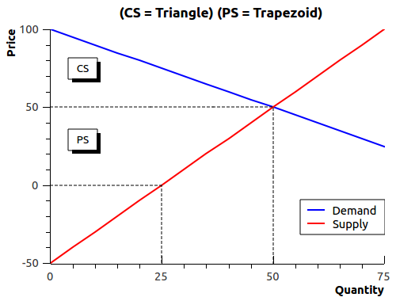

4. (2 points) Suppose that in the market for lipstick in Utopia described in the last question that the government decides they would like to limit the number of lipsticks sold in Utopia to 40 units. The government decides to reach this goal by implementing a tax per unit of lipstick sold (this is an excise tax). How big an excise tax will the government need to implement to reach this goal?

Answer:
At a quantity of 40 units the price suppliers must receive in order to supply this quantity is equal to P = 2Q – 50 = 2(40) – 50 = $30. The price at which consumers demand 40 units of lipstick is equal to P = 100 – Q = 100 – 40 = $60. The difference in these two prices, $60 - $30, is the amount of excise tax that should be levied to reach this goal. That is, an excise tax of $30 per unit will result in only 40 lipsticks being sold in this market.

5. (2 points) Suppose that the market for microwaves in Microland, a small closed economy, is described by the following domestic demand and supply equations:
Domestic Demand: Q = 100 – (1/2)P
Domestic Supply: Q = (1/2)P – 10
The world price of microwaves is $60. Suppose that the government of Microland decides to open the microwave market to trade while simultaneously implementing a tariff that results in the price of microwaves in Microland being $80. How many microwaves will be imported into this market given this information and holding everything else constant? Show how you got your answer.

Answer:
At a price of $80 per microwave we know that the quantity demanded domestically is equal to 60 units. To see this, put $80 into the domestic demand curve as the price and then solve for the quantity: thus, Qd = 100 – (1/2)(80) = 60 units. At a price of $80 per microwave we know that the quantity supplied domestically is equal to 30 units. To see this, put $80 into the domestic supply curve as the price and then solve for the quantity: thus, Qs = (1/2)(80) – 10 = 30 units. The amount of imports into this market is equal to the quantity demanded domestically minus the quantity supplied domestically: in this case, the levels of imports would therefore be 60 units – 30 units for a total of 30 imported units.

