Economics 101
Summer 2013
Answers to Homework #4
Due Thursday, June 13, 2013

Directions: The homework will be collected in a box before the lecture. Please place your name, TA name and section number on top of the homework (legibly). Make sure you write your name as it appears on your ID so that you can receive the correct grade. Late homework will not be accepted so make plans ahead of time. Please show your work. Good luck!

Please realize that you are essentially creating “your brand” when you submit this homework. Do you want your homework to convey that you are competent, careful, professional? Or, do you want to convey the image that you are careless, sloppy, and less than professional. For the rest of your life you will be creating your brand: please think about what you are saying about yourself when you do any work for someone else!

1. Use the graph below of a perfectly competitive firm’s cost functions to answer this set of questions.
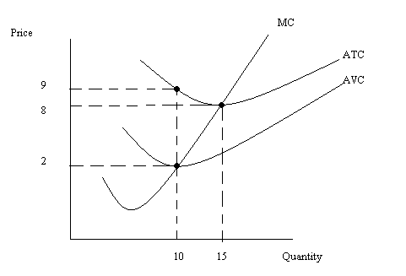
a. In the short run, what is the fixed cost for this firm? Explain your answer fully.
b. Suppose this firm produces 15 units of output. What is the variable cost of producing this level of output? What is the firm’s AVC of production when it produces 15 units of output. Explain your answer fully.
c. Suppose the market price of the good in the short-run is $9 per unit. What do you know about this firm’s short-run profits, TR, TC, FC, VC, and level of production given this information? What do you predict will happen in the long-run in this market? (Hint: describe verbally, with numerical reference points, what you know about these different measures.)

Answer:
a. We know ATC = AVC + AFC. From the graph we can see that when Q is equal to 10 units, ATC = $9 per unit and AVC = $2 per unit. Thus, AFC = ATC – AVC = $9 per unit - $2 per unit = $7 per unit. To find FC recall that AFC = FC/Q. Rearranging this we get FC = AFC*Q or ($7 Per unit)(10 Units) = $70.
b. We know that the ATC of producing 15 units of output is $8 per unit. We can use this information to calculate the TC of producing 15 units of output: ATC = TC/Q or TC = ATC*Q. Thus, TC = ($8 per unit)(15 units) = $120. From (a) we know that the firm’s FC is equal to $70. This implies that VC = $50 since TC = FC + VC. AVC = VC/Q = ($50 per unit)(15 units) = $3.33 per unit of output.
c. In the short run if price is $9 per unit you know that the firm is earning positive economic profits since the price is greater than the breakeven price (Breakeven price is $8 per unit or the minimum point of the ATC curve). This implies that TR is greater than TC. We know that TC is greater than $120 since when price is $9 per unit the firm is producing more than 15 units and the average cost of producing these units is greater than $8 per unit. We know that FC is still equal to $70. Since TC is greater than $120 and FC is equal to $70, this implies that VC is greater than $50.

The long-run prediction is entry of firms into this industry since short-run economic profits are positive.

2. Use the graph below of a perfectly competitive market and a representative firm in this market to answer this set of questions. Assume all firms in the market are identical.
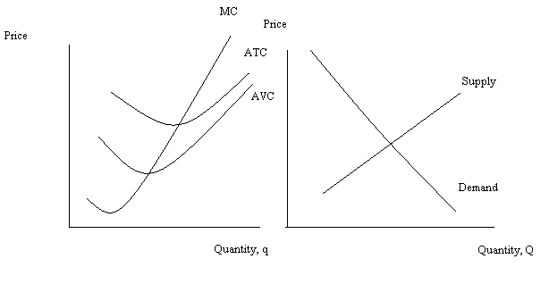
a. Given the above graphs, identify on the graphs the short-run equilibrium price, P1; the short-run equilibrium market quantity, Q1; and the short-run firm quantity, q1. On the graph indicate the average total cost for the firm of producing its level of output; also shade in the area that represents profits and determine whether these profits are positive or negative.
b. From your work in (a), fill in the following statements with either “=”, “>”, or “<”.
i. P _______ AFC
ii. TR _____VC
iii. TR _____TC
iv. Profit ______0
c. In the long run, holding everything else constant, what do you predict will happen in this industry?
d. Redraw the above graph and in this new graph show the long run adjustment of the market. Assume that market demand and the cost curves for the firms do not change. Label any shifting curves completely. Also label the new long run equilibrium price, P2; the new long run equilibrium market quantity, Q2; and the new long run equilibrium quantity for the firm, q2. Explain in words this long run adjustment process.

Answer:
a.
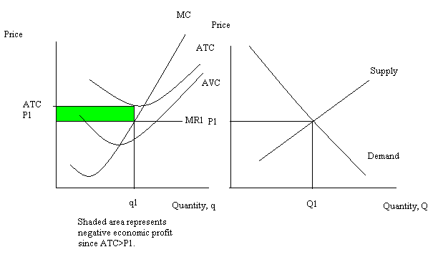
b.
i. P ___>____ AFC
ii. TR __>___VC
iii. TR __<___TC
iv. Profit ___<___0
c. In the long run there will be exit of firms from this industry until economic profits are equal to zero. Since firms are earning negative economic profit in the short run this indicates that P1 is less than the breakeven price. This tells us that exit of firms will occur in the long run until the market price increases to the price associated with the breakeven point.
d. As firms exit the market this will cause the market supply curve to shift to the left at every price: the long run price will rise to P2; the long run market quantity will decrease to Q2; and the firms that remain in the market will adjust their output to q2. Each firm left in the market will produce at their breakeven point: long run economic profits for each firm left in the market will equal zero.
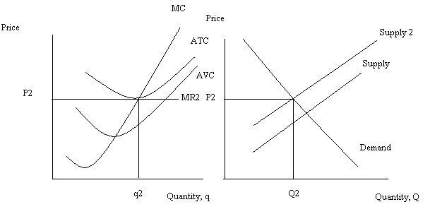
3. The profit maximization rule for a perfectly competitive firm states that the perfectly competitive firm will maximize its profits when it produces that quantity where marginal revenue equals marginal cost for the last unit produced and sold. In your own words explain why the firm is better off producing that quantity where MR = MC rather than that quantity where MR > MC or that quantity where MR < MC.

Answer:
Let’s start by considering the situation where MR > MC for the last unit produced and sold: when the firm considers the last unit it produces it finds that the addition to total revenue from producing and selling this unit is greater than the addition to total cost from producing this unit. The firm definitely wants to produce and sell this unit. But, if the MR > MC is true for the next unit, then the argument is still true. So, the firm should always increase its production when MR > MC.

Consider the situation where MR < MC for the last unit produced and sold: when the firm considers the last unit it produces it finds that the addition to total revenue from producing and selling this unit is less than the addition to total cost from producing this unit. The firm definitely does not want to produce and sell this unit. But, if the MR < MC is true for the next unit, then the argument is still true. So, the firm should always decrease its production when MR < MC.

Thus, by logic the firm must end up at that quantity where MR = MC if the firm wants to profit maximize.

4. A perfectly competitive market has market demand that can be represented by the equation P = 200 – 2Q. Furthermore, you are told that all firms in the market are identical and that the total cost function and the marginal cost function for a representative firm are given by the following equations: TC = 32 + 20q + 8q² and MC = 20 + 16q. There are 10 firms initially in this market.
  - Given the above information, what is the fixed cost for the representative firm? Explain your answer.
  - Find the market supply curve given the above information.
  - Given the above information and the market supply curve you found in (b), calculate the equilibrium price and quantity in this market in the short run.
  - If each firm is identical, how many units of output will each firm produce in the short run?
  - Calculate the representative firm’s short run profits.
  - Given your calculation in (e), what do you predict will happen in the long run? Explain your answer.
  - Calculate the long run equilibrium price in this market. Then, assuming market demand does not change, calculate the long run equilibrium market quantity as well as the level of output for a representative firm. Finally, calculate the number of firms in this industry in the long run.

Answer:
a. You know that TC = FC + VC and you also know that when q = 0 for a firm, then TC = FC since the firm will not have any variable costs of production if it decides to produce no output. So, if q = 0, then TC = 32. Therefore, FC = $32.
b. For the individual firm we can use its MC curve as its supply curve. But, there are 10 firms so we need to horizontally sum these individual marginal cost curves together. A table will provide us with some points that lie on the industry supply curve.
Price | Quantity Produced by a single firm | Quantity produced by 10 firms
20 | 0 | 0
40 | 1.25 | 12.5
60 | 2.5 | 25
80 | 3.75 | 37.5
100 | 5 | 50
Working with any two coordinates (Q, P) from this table we can find the market supply curve. Using (Q, P) = (0, $20) and (50, $100) we can write the market supply curve as P = 20 + (8/5)Q.
c. To find the equilibrium price and quantity in the market, you need to find where the market demand curve intersects the market supply curve. Thus, 200 – 2Q = 20 + (8/5)Q or Q = 50. Then, using the market demand curve or the market supply curve, substitute in Q = 50 to find the equilibrium price. Thus, P = 200 – 2Q or P = 200 – 2(50) = $100 per unit.
d. There are 10 firms in the market initially and total market quantity is 50 units of output. If each firm is identical then each firm produces 50/10 or 5 units of output per firm.
e. Profit = TR – TC. So, TR = P*q or TR = ($100 per unit)(5 units) = $500. TC = 32 + 20q + 8q². Or, TC = 32 + 20(5) + 8(25). TC = $332. Profit = TR – TC or Profit = $500 - $332 = $168.
f. Since economic profit is greater than zero in the short run, this implies that there will be entry of firms into the market in the long run until economic profit for each firm is zero. The entry of firms will shift the market supply curve to the right and result in a lower price in the market. The price will fall until it reaches the breakeven point: all firms in the market will breakeven and that implies that each firm’s TR will equal its TC.
g. The long run equilibrium price occurs where MC = min ATC. So, let’s find ATC and set it equal to MC. ATC = 32/q + 20 + 8q and MC = 20 + 16q. So, 32/q + 20 + 8q = 20 + 16q or 32/q =8q and solving this equation we get q = 2. So, when the firm produces 2 units of output, MC = ATC. But, we also know that MC = MR = P, so we can use this quantity to solve for the price associated with this quantity. Thus, MC = 20 + 16q = 20 + 16(2) = $52 per unit. The long run price must be equal to $52 per unit for the firm to be producing at its breakeven point (where ATC = MC). [Hint: I took a moment to verify this is where profit = 0. When q = 2 and P = $52 per unit, the firm’s TR = $104 and its TC = $104!] Using this price and the market demand curve, we can solve for the long run market quantity: P = 200 – 2Q or 52 = 200 – 2Q or Q = 74 units of output. Dividing Q/q will give us the number of firms in the market: 74/2 = 37 firms in the market in the long run.

5. Suppose the market demand curve for a monopolist is given as P = 200 – 2Q. Furthermore, suppose the MC curve for the firm can be written as MC = 20 + 2Q. The firm’s TC can be expressed as TC = 20Q + Q² + 100. Use this information to answer this set of questions.
- What is the profit maximizing price and quantity for this monopolist given the above information? Calculate the monopolist’s profit.
- Calculate the monopolist’s consumer surplus (CS), producer surplus (PS), and deadweight loss (DWL).
- Suppose demand increases by 90 units at every price. Find the equation for the monopolist’s new demand curve. Then, calculate the new profit maximizing price and quantity for this monopolist given the new demand curve. Calculate the new level of monopoly profits.
- Calculate the value of consumer surplus (CS’), producer surplus (PS’), and deadweight loss (DWL’) for this monopolist given the information in (c).

Answer:
a. To find the profit maximizing quantity for the monopolist we need the firm’s MR curve. Remember that for a linear downward sloping demand curve, the MR has the same y-intercept and twice the slope of this demand curve. Thus, MR = 200 – 4Q. Set MR = MC to find the profit maximizing quantity for the monopolist: 200 – 4Q = 20 + 2Q. Or, Q = 30 units. Use this quantity and the demand curve to find the monopolist’s profit maximizing price: P = 200 – 2Q or P = $140 per unit. Profit is equal to TR – TC: so Profit = ($140 per unit)(30 units) – [(20)(30) + (30)(30) + 100] = $2600.
b. CS = (1/2)($200 per unit - $140 per unit)(30 units) = $900
PS = (1/2)($80 per unit - $20 per unit)(30 units) + ($140 per unit - $80 per unit)(30 units) = $2700
DWL = (1/2)($140 per unit - $80 per unit)(45 units – 30 units) = $450
c. The slope of the demand curve is unchanged but at each price the quantity is now 90 units greater than the original quantity at that price. So, for instance, when P = $100 per unit, the quantity initially was 50 units and now it is 140 units. Use these new (Q, P) coordinates to find the new demand curve: P = b + mQ but the slope of the new demand curve is the same as the slope of the initial demand curve. So, P = b – 2Q. Then, plugging in (Q, P) = (140, $100) into this equation we get 100 = b – 2(140) or b = 380. Thus, the new market demand curve is P = 380 – 2Q.

To find the profit maximizing quantity for the monopolist we need the firm’s MR’ curve. Remember that for a linear downward sloping demand curve, the MR has the same y-intercept and twice the slope of this demand curve. Thus, MR’ = 380 – 4Q. Set MR’ = MC to find the profit maximizing quantity for the monopolist: 380 – 4Q = 20 + 2Q, Or, Q’ = 60 units. Use this quantity and the new demand curve to find the monopolist’s profit maximizing price: P’ = 380 – 2Q or P’ = $260. Profit is equal to TR – TC: so Profit = ($260 per unit)(60 units) – [20(60) + (60)(60) + 100] or Profit = $15,600 - $4900 = $10,700.

d. CS’ = (1/2)($380 per unit - $260 per unit)(60 units) = $3600
PS’ = (1/2)($140 per unit - $20 per unit)(60 units) + ($260 per unit - $140 per unit)(60 units) = $10,800
DWL’ = (1/2)($260 per unit - $140 per unit)(90 units – 60 units) = $1800

6. Consider a natural monopoly with market demand
P = 100 – 10Q
and whose total cost curve and marginal cost curve can be expressed as
TC = 100 + 20Q + Q²
MC = 20 + 2Q
a. Write an equation for this natural monopoly’s average total cost (ATC) curve?
b. Using the equation you wrote in (a) fill in the following table.
Q | ATC
1
2
4
5
10
20
c. Draw a graph of this firm’s demand curve, ATC curve, and MC curve. At what (Q, P) do MC and ATC intersect one another? Show how you found there coordinates. Is this (Q, P) pair a likely equilibrium in this market? Explain your answer fully.
d. Suppose this monopolist acts as a single price profit maximizing monopolist. Determine the monopolist’s price, quantity, and profit with this scenario. Round your answers to the nearest hundredth.
e. Suppose this monopolist is regulated to produce the socially optimal amount of output (where P = MC for the last unit produced and sold). Given this regulatory decision, determine the monopolist’s price, quantity, and profit. Round your answers to the nearest hundredth.
f. Suppose this monopolist is regulated to produce that quantity where profit is equal to zero. Given this regulatory decision, determine the monopolist’s price, quantity, and profit. Round your answers to the nearest hundredth. HINT: TO FIND THE Q IN THIS QUESTION YOU WILL NEED TO MAKE USE OF THE QUADRATIC FORMULA!
Here’s a quick review of the quadratic equation and the quadratic formula!
A quadratic equation can be written as
ax² + bx + c = 0
In this question “x” will be “Q”, the variable whose value we are trying to find.
Once you have an equation written in the above form, you will need to use the quadratic formula to solve for the value of x since the quadratic equation you will have found cannot be easily factored. So, here is the quadratic formula:
x = [- b ± (b² – 4ac)^{1/2}]/(2a)
This formula when used will give you two solutions: one of these solutions represents where ATC crosses the demand curve at a very high price and a very low price (this is not the point you are looking for)-discard this solution and use the other solution.
Answers:
a. ATC = (100/Q) + 20 + Q
b.
Q | ATC
1 | $121 per unit
2 | 72
4 | 49
5 | 45
10 | 40
20 | 45

c. ATC = MC
(100/Q) + 20 + Q = 20 + 2Q
(100/Q) = Q
Q = 10 units of output
MC = 20 + 2Q
MC = 20 + 2(10) = 40
P = $40 per unit of output
(Q, P) = (10 units of output, $40 per unit of output)
This point lies to the right of the demand curve and will therefore not be a likely (Q, P) equilibrium in this market since at a price of $40 per unit, there is only demand for 6 units of output. Or, at a quantity of 10 units, demanders willingness to pay can be calculated as $0 per unit of output.
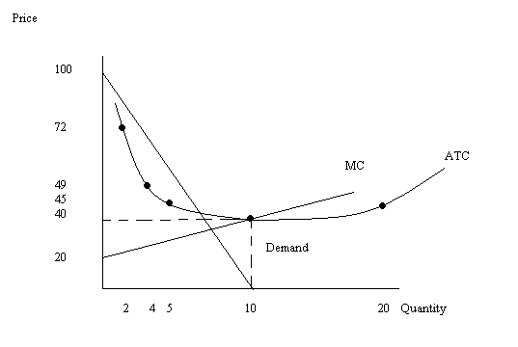
d. MR = 100 – 20Q
MC = 20 + 2Q
MR = MC determines the single price monopolist’s optimal quantity. So,
100 – 20Q = 20 + 2Q or Q = 3.64 units of output
Use the demand curve to find the price the monopolist should charge for this level of output: P = 100 – 10Q = 100 – 10(3.64) = $63.60 per unit of output
Profit = TR – TC
TR = P*Q = ($63.60 per unit of output)(3.64 units of output) = $231.50
TC = 100 + 20Q + Q²
TC = 100 + 20(3.64) + (3.64)(3.64)
TC = $186.05
Profit = $231.50 - $186.05
Profit = $45.45

e. The socially optimal amount of good in this market is that quantity where MC intersects the demand curve. So, MC = 20 + 2Q and demand can be written as P = 100 – 10Q. Thus, 20 + 2Q = 100 – 10Q or Q socially optimal = 6.67 units of output. (This is an increase in the level of output you found in (d): remember that the monopolist left to their own devices will constrict output.) Use either the demand curve or the MC curve to find the price: P = 100 – 10Q = 100 – 10(6.67) = $33.30 per unit of output. (Again, compare the price you found in (d) to this price: remember that the monopolist left to their own devices will charge a higher price than would a market that operated as a perfectly competitive market.) Profit = TR – TC. TR = P*Q = ($33.30 per unit of output)(6.67 units of output = $222.11. TC = 100 + 20Q + Q² . TC = 100 + 20(6.67) + (6.67)(6.67) = $277.89. Profit = $222.11 - $277.89 = -$55.78.

f. If the monopolist is regulated to produce where P = ATC, then we know that the firm will earn zero economic profits (but we will confirm this once we get underway). Use the demand curve and the ATC curve to solve for the quantity the firm will produce. Thus,
100 – 10Q = (100/Q) + 20 + Q or 0 = 11Q² + (-80)Q + 100. Now, you have the quadratic equation and will need to use the quadratic formula to solve for a solution.

So, Q = 80 ± [(80)(80) – (4)(11)(100)]^{1/2}/[(2)(11)]
Q = (80 + 44.8)/22 or Q = (80 – 44.8)/22 (this second solution is the one that you need to discard-look at your graph and see if you can find which (Q, P) this second solution corresponds to).
Q = 5.67 units of output
To find P, use the demand curve and this quantity: P = 100 – 10(Q) = 100 – 10(5.67) = $43.30 per unit of output.
Now, check that the firm earns zero economic profit when it produces 5.67 units of output and sells this output at $43.30 per unit of output. TR = P*Q = ($43.30 per unit of output)(5.67 units of output) = $245.51. TC = 100 + 20Q + Q² . TC = 100 + 20(5.67) + (5.67)(5.67) = $245.55. We have TC slightly greater than TR and this is due to rounding error.

7. Consider a monopoly where the market demand curve is given by the equation
Q = 40 – 2P
To simplify the math of this problem let’s assume this firm has fixed cost of $10 and that the firm’s MC can be written as
MC = $2 per unit of output
a. Suppose this profit-maximizing monopolist acts as a single price monopolist. Determine the price the monopolist will charge, the level of output it will produce, the level of profits it will earn (be careful here-don’t forget to incorporate those fixed costs!), the level of consumer surplus (CS), the level of producer surplus (PS), and the deadweight loss (DWL) in this market. (Hint: you may find it helpful to sketch a graph to guide your work. Also, don’t forget to incorporate the fixed costs when calculating PS.)
b. Let’s do a check on your calculations in (a). In this problem suppose the firm produced and sold the socially optimal amount of the good while practicing perfect price discrimination.
i. If the firm did this, what would the firm’s total revenue equal? To calculate this answer you will need to think about what the socially optimal amount of the good is and what price(s) the firm would need to charge to sell this amount of the good assuming the firm was a perfectly price discriminating firm.
ii. If the firm did this, what would the firm’s TC equal?
iii. Recall that total surplus (TS) is the area below the supply curve and above the demand curve. In this example to find TS we will also need to remember to include the fixed costs. If the firm produces the socially optimal amount of the good, what will TS equal?
iv. Go back to your answers in (a) and calculate the sum of (CS + PS + DWL). Does this sum equal the TS value you calculated in (iii)? If not, you have made an error in your calculations or in your logic! And, this implies you need to continue to think and work on this problem.
c. Compare the profits this monopolist earns as a single price monopolist versus a perfect price discriminating monopolist.
d. Does it benefit the monopolist to perfectly price discriminate? Explain your answer.
Answer:
a. To answer this question you will first need to find MR for the monopolist. We know the demand curve is Q = 40 – 2P, but this demand curve is not written in slope-intercept form. So, rearranging this equation into slope-intercept form gives us P = 20 – (1/2)Q. The MR will have the same y-intercept as the demand curve and twice its slope: MR = 20 – Q.
To find the profit maximizing quantity for a single price monopolist we need to equate MR to MC. Hence, 20 – Q = 2 or Q = 18 units of output. Use the demand curve to find the profit maximizing price: P = 20 – (1/2)Q = 20 – (1/2)(18) = $11 per unit of output.
Profit = TR – TC. TR = P*Q = ($11 per unit)(18 units of output) = $198. TC = FC + VC and we know FC = $10. VC = AVC*Q but since MC is constant this implies MC = AVC. So, VC = ($2 per unit of output)(18 units of output) = $36. TC = $10 + $36 = $46. Profit = $198 - $46 = $152.
CS = (1/2)($20 per unit of output - $11 per unit of output)(18 units of output) = $81
PS = ($11 per unit of output - $2 per unit of output)(18 units of output) - $10 = $152
DWL = (1/2)($11 per unit of output - $2 per unit of output)(36 units of output – 18 units of output) = $81
Check out the graph below to see the areas of CS, PS, and DWL.
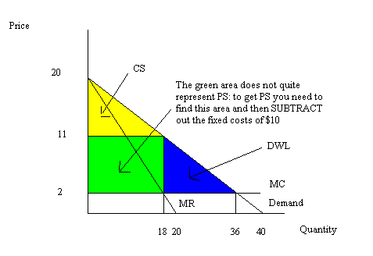
b.
i. The socially optimal amount of the goo dis where MC = P for the last unit produced. To find this quantity set MC equal to demand: 2 = 20 – (1/2)Q or Qsocially optimal = 36 units of output.
If the firm is a perfect price discriminating monopolist it will charge a different price for each unit of the good: its MR curve will be its demand curve and its TR will be the area under the demand curve over the socially optimum range of output. The shaded area in the graph below indicates the area of TR.
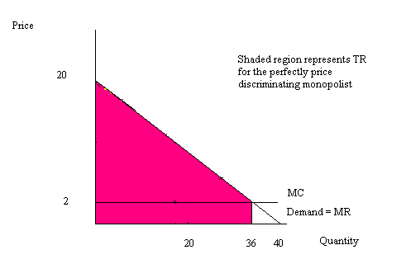
TR = (1/2)($20 per unit of output - $2 per unit of output)(36 units of output) + ($2 per unit of output)(36 units of output) = $396
ii. TC = FC + VC. Hence, TC = $10 + ($2 per unit of output)(36 units of output) = $82
iii. TS = CS + PS – FC in this example. In this problem, FC = $10, CS = $0 since the perfect price discriminating monopolist captures all of the CS. Thus, TS = (1/2)($20 per unit of output - $2 per unit of output)(36 units of output) - $10 = $314
iv. (CS + PS + DWL – FC) from (a) is equal to (81 + 152 + 81 – 10) = $314 and this is equal to the value of TS in (iii) when the firm acts as a perfect price discriminating monopolist.
c. Single price monopolist’s profit = $152 while the perfect price discriminating monopolist’s profit = $314.
d. Yes, the monopolist’s profits increase substantially when it chooses to perfectly price discriminate.

8. Let’s return to the same monopolist we considered in the last problem. Recall this monopolist’s demand curve is given by the equation:
Q = 40 – 2P
Also, recall that this firm’s fixed cost of production is $10 and that the firm’s MC can be written as
MC = $2 per unit of output
a. Quickly refer back to your earlier work and record the profit maximizing quantity, price and profits of this monopolist if the monopolist acts as a single price monopolist.
b. Now, suppose this monopolist decides to practice second degree price discrimination. It plans to continue to sell the original level of output at the initial price, but it now wants to offer more of the good at two other pricing levels. Suppose it decides to offer at the first new pricing level 10 additional units and at the second new pricing level 4 more units.
i. Draw a graph representing this new pricing arrangement where P1 is the first new pricing level and p2 is the second new pricing level. In your graph identify numerically the total level of output that corresponds to these new prices.
ii. Calculate the numerical values of P1 and P2.
c. Suppose the firm now charges three prices: the initial price it charged as a single price monopolist, P1, and P2. Calculate the firm’s TR under this pricing scheme. Calculate the firm’s TC given this pricing arrangement (don’t forget those fixed costs!). Then, calculate the firm’s profits.
d. Is it profitable for this firm to practice second degree price discrimination? Explain your answer.

Answer:
a. Q = 18 units of output; P = $11 per unit of output; Profit = $152
b.
i.
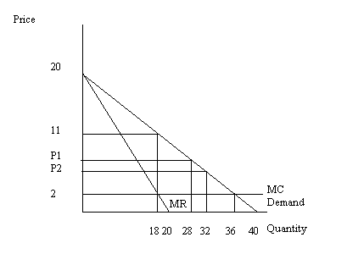
ii. P1 is that price on the demand curve when quantity is equal to 28: thus, P1 = 20 – (1/2)(28) = $6 per unit of output
P2 is that price on the demand curve when quantity is equal to 32: thus, P2 = 20 – (1/2)(32) = $4
c. TR = ($11 per unit of output)(18 units of output) + (P1)(10 units of output) + (P2)(4 units of output). TR = $198 + ($6 per unit of output)(10 units of output) + ($4 per unit of output)(4 units of output) or TR = $274.
TC = VC + FC or TC = ($2 per unit of output) (32 units of output) = $74
Profit = $200
d. Yes, this firm’s profits increase when it practices second degree price discrimination.

