Economics 101
Spring 2020
Answers to Homework#4
Due 4/2/20

Directions: The homework will be collected in a box before the lecture. Please place your name, TA name and section number on top of the homework (legibly). Make sure you write your name as it appears on your ID so that you can receive the correct grade. Late homework will not be accepted so make plans ahead of time. Please show your work. Good luck!
Please realize that you are essentially creating “your brand” when you submit this homework. Do you want your homework to convey that you are competent, careful, professional? Or, do you want to convey the image that you are careless, sloppy, and less than professional. For the rest of your life you will be creating your brand: please think about what you are saying about yourself when you do any work for someone else!

1. Suppose the nominal prices over time for the following goods in some fictional city are given by the following table:

Year | Price per Cup of Diet | Price per Pizza | Price per TV
 | Drinks
2014 | $1.75 | $10.00 | $165
2015 | $1.50 | $10.50 | $170
2016 | $1.65 | $11.00 | $155
2017 | $2.00 | $11.50 | $150

Suppose a typical consumer basket throughout the year consists of 200 cups of diet drinks, 25 Pizzas, and 1 TV.

a. Using the above information to calculate the cost of the market basket for each of the years and present your calculations in the table below:

Year | Cost of Market Basket
2014
2015
2016
2017

b. Let 2014 be the base year, calculate the CPI for each year using a 100-point scale. Then, for 2015 to 2017, calculate the annual inflation rate. Calculate your answers to two places past the decimal.

Year | CPI | Inflation Rate
2014 |  | -
2015
2016
2017

c. 2014 is still the base year. Calculate the real price of pizza in each year. Again, calculate your answers to two places past the decimal.

Answer:
a) Cost of Market Basket in Year n = (Price of diet drink in Year n) *(200 cups of diet drinks) + (Price of pizza in Year n) *(25 Pizzas) + (Price of TV in Year n) *(1 TV)

Year | Cost of Market Basket
2014 | $765
2015 | $732.5
2016 | $760
2017 | $837.5

b) CPI for year n = (Price of basket in year n / Price of basket in base year) *100 % Inflation = (CPI this year – CPI last year)/ (CPI last year)

Year | CPI | Inflation Rate
2014 | 100 | -
2015 | 95.75 | -4.25%
2016 | 99.35 | 3.76%
2017 | 109.48 | 10.20%

c) Real price = (Nominal Price / CPI) * 100

Year | Real price of pizza
2014 | $10.00
2015 | $10.97
2016 | $11.07
2017 | $10.50

2. a) John, a seller of hamburgers, sells hamburgers to Howard for $6 per hamburger. John has observed that Howard’s demand for hamburgers decreases from 8 hamburgers to 5 hamburgers when the price of sandwiches decreases from $5 per sandwich to $4 per sandwich. What is his cross-price elasticity of hamburgers for sandwiches? Use the arc elasticity formula concept when calculating this cross-price elasticity. Based upon your value for the cross-price elasticity of demand of hamburgers for sandwiches, are these two goods substitutes or complements? Explain your answer.

b) Suppose at $6 per hamburger, John can supply an infinite quantity of hamburgers but he will supply none at a price below $6. What do you know about his supply when price rises above $6? What is John’s price elasticity of supply?

c) When the price of hamburgers is $8 per hamburger, John can sell 45 hamburgers in a day. We know when the price of hamburgers decreases to $6 per hamburger, John’s total revenue remains unchanged. Given this information and assuming that John’s demand curve for hamburgers is linear, what do we know about the price elasticity of demand for his hamburgers? Use the standard formula for the percentage change to calculate this elasticity value. Given this information write an equation for this demand curve in slope-intercept form. Once you find the demand curve provide an explanation for why John’s total revenue is not changing as the price of hamburgers falls from $8 per hamburger to $6 per hamburger.

Answer:
a) The arc elasticity of demand formula is: e = [(Q2 – Q1) / (Q1 + Q2)] / [(P2 – P1) / (P1 + P2)]

Then we get:

Cross-price elasticity of demand = [(5 – 8) / (5+ 8)] / [(4 – 5) / (5 + 4)]

- (-3 /13) / (-1 / 9)

- 27/13

Since the cross-price elasticity of demand of hamburgers for sandwiches is positive this tells us that these two goods are substitutes: when the price of sandwiches falls, Howard substitutes away from hamburgers: the quantity of hamburgers he demands at every price decreases relative to his initial demand.

b) At any price above $6 per hamburger, the quantity that John supplies is extremely large.

Then we know John’s price elasticity of supply equals ∞, which means he has a perfectly elastic supply. When even a tiny increase or reduction in the price will lead to very large changes in the quantity he supplied, so that the price elasticity of supply is infinite.

c) Since John’s total revenue remains unchanged, we know the demand for his hamburger at P = 6 must equals 45*8/6 = 60 hamburgers

Regular percentage elasticity of demand formula is:

e = | (% change in demand / % change in price) | = | ((60 – 45) / 45) / ((6 – 8) / 8) | = 4/3

We now know two points on the demand curve that John faces: (Q, P) = (45, 8) and (60, 6).

From these two points, we can calculate the slope of the demand curve: slope = (8 – 6)/ (45 – 60)

- -2/15. Then use the standard y-intercept form: y = mx + b to find the demand curve. Thus, Y = mX + b

P = (-2/15) Q + b

Plug in one of our known points to find the value of b:

6 = (-2/15) (60) + b

14 = b

Equation for the demand curve: P = 14 – (2/15) Q

When the price of hamburgers falls from $8 per hamburger to $6 per hamburger John’s revenue does not fall because we are moving symmetrically around the unit elastic point on this linear demand curve. With a linear demand curve, we know that total revenue is maximized at the midpoint: in this example, the midpoint is at (Q, P) = (52.5, 7) and John’s maximum total revenue is $367.50. Our two known points are equally distant from this midpoint.

3. A Wisconsin resident Alice only consumes two goods: bread (B) and rice (R). Her budget constraint and utility are given by the formula:

Y = P_{B}B + P_{R}R U= BR

Given her current consumption bundle (B, R), her marginal utility from consuming bread is given by ${MU}_{B}$= R and her marginal utility from consuming rice is given by ${MU}_{R}$= B

a) Suppose Alice’s income is Y=$40, and the prices for bread and rice are P_{B} = $4, P_{R} = $1. What is her optimal consumption bundle? What is the value of Alice’s utility at this consumer optimization point? Show how you found this value.

b) Fill out all the missing information in the table.

Quantity of Bread | Quantity of Rice | Utility
1 |  | 100
5 |  | 100
10 | 10
20 |  | 100
 | 4 | 100

c) Graph the optimal consumption bundle in (a), with bread on the horizontal axis and rice on the vertical axis. Also graph the indifference curve, IC1, for U = 100 using the values you found in part (b).

d) Draw the indifference curve, IC2, for U = 400 in this same graph. You might find it helpful to construct a similar table to part (b) with U = 400.

e) Now suppose the price level is P_{B} = 1, P_{R} = 1 and Alice’s income is now equal to $20. Suppose Alice wants to achieve a utility level of U=100. Given this information and holding everything else constant, what should be her optimal consumption bundle?

Answer:

a) If (B, R) is the optimal consumption bundle for Alice, the it must satisfy that $\frac{{MU}_{B}}{{MU}_{R}}= \frac{P_{B}}{P_{R}}$ and $Y= P_{B}B+ P_{R}R$ , so we have 40 = 40B + R and R/B = 4/1. The we can solve that B = 5, R = 20, so her optimal consumption bundle is (B, R) = (5, 20). Her utility is U = BR = 5*20 = 100.

b)

Quantity of Bread | Quantity of Rice | Utility
1 | 100 | 100
5 | 20 | 100
10 | 10 | 100
20 | 5 | 100
25 | 4 | 100

c)see the graph in (d).

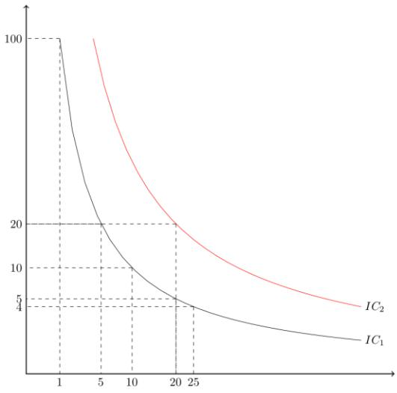
d)

e) Again, if (B, R) is the optimal consumption bundle for Alice, then it must satisfy that $\frac{{MU}_{B}}{{MU}_{R}}= \frac{P_{B}}{P_{R}}$ , which is equivalent to R/B = 1/1. Since she wants to achieve U = 100, then we have that BR = 100. The solution is B = 10, R = 10. Therefore, her optimal consumption bundle will be (10, 10).

4. Consider an aggregate production function

Q = 6K1/2L1/2

where Q is the number of widgets, K is the number of units of capital, and L is the number of units of labor. For this question assume K is initially fixed at 25 units. You also know that total cost, TC, is given as

TC = Pk*K + PL*L

where Pk is the price of capital and Pl is the price of labor. Assume that the price of labor and the price of capital are both constant.

- Fill in the missing cells of the table below based on the above information. (Hint: you might find it fun to do this with Excel: practice your spreadsheet skills and generate the numbers fast!). Calculate your answers to two places past the decimal. Note: the numbers you get may not generate U-shaped curves.
L | K | Q | VC | FC | TC | AVC | AFC | ATC | MC
0 |  |  |  | $50 |  | --- | --- | --- | ---
1
4 |  |  | $60
9
16
25
36
49

- What is the price of capital? Explain how you got this answer.

- What is the price of labor? Explain how you got this answer.

- Given the above information and your work in (a), fill in the following table. Round your answers to two places past the decimal. (Hint: if you used Excel earlier, you can continue to use Excel in this part of the exercise-just a great way to keep building your spreadsheet skills!)

L | Q | MPL
0 |  | ---
1
4
9
16
25
36
49

- Given your work, does the production of this good show diminishing marginal returns to labor? Explain your answer.

- Suppose that K doubles and L doubles. Without using numeric values, can you prove this production function has constant returns to scale? That is, can you show that if K and L both double that output, Q, will also double?

Answers:
a)
L | K | Q | VC | FC | TC | AVC | AFC | ATC | MC
0.00 | 25.00 | 0.00 | 0.00 | 50.00 | 50.00 | --- | --- | --- | ---
1.00 | 25.00 | 30.00 | 15.00 | 50.00 | 65.00 | 0.50 | 1.67 | 2.17 | 0.50
4.00 | 25.00 | 60.00 | 60.00 | 50.00 | 110.00 | 1.00 | 0.83 | 1.83 | 1.50
9.00 | 25.00 | 90.00 | 135.00 | 50.00 | 185.00 | 1.50 | 0.56 | 2.06 | 2.50
16.00 | 25.00 | 120.00 | 240.00 | 50.00 | 290.00 | 2.00 | 0.42 | 2.42 | 3.50
25.00 | 25.00 | 150.00 | 375.00 | 50.00 | 425.00 | 2.50 | 0.33 | 2.83 | 4.50
36.00 | 25.00 | 180.00 | 540.00 | 50.00 | 590.00 | 3.00 | 0.28 | 3.28 | 5.50
49.00 | 25.00 | 210.00 | 735.00 | 50.00 | 785.00 | 3.50 | 0.24 | 3.74 | 6.50

- The price of capital can be found by recognizing that FC = PkK and from the table we see that FC = $50, we are told that K = 25 and therefore 50 = Pk(25) or the Pk = $2 per unit of capital.

- The price of labor can be found by using the provided information in the table: when L = 4 we see that VC = $60. We know that VC = PlL and so 60 = Pl (4) or Pl = $15 per unit of labor.
d)
L | Q | MPL
0 | 0.00 | ---
1 | 30.00 | 30.00
4 | 60.00 | 10.00
9 | 90.00 | 6.00
16 | 120.00 | 4.29
25 | 150.00 | 3.33
36 | 180.00 | 2.73
49 | 210.00 | 2.31

e) Yes. To see this calculate the MPL and see what happens to this measure as you increase your hiring of the variable input (in this case, labor) while holding constant your fixed input. From (d) we can see that the value of the MPL decreases as L increases: this indicates that the change in total product from hiring another unit of labor falls: this is diminishing marginal returns to labor.
f) Q = 6K1/2L1/2
Then K increases to 2K and L increases to 2L. So, Q’ = 6(2K)1/2 (2L)1/2
Q’ = 6(2)K1/2L1/2
Q’ =12K1/2L1/2 which is twice the original production function! This production function exhibits constant returns to scale.
5. Consider a perfectly competitive industry composed of ten identical firms that produce widgets. Suppose you are told that the representative firm has the following cost curves where TC is total cost measured in dollars and q is units of widgets produced by a particular firm:

Total Cost: $TC=18+5q+(1/2)q^{2}$

Marginal Cost: MC = 5 + q

Suppose you also know that the market demand curve is given by the following equation where P is the market price in dollars and Q is the market quantity of widgets:

Market Demand: P = 93 – Q

Q represents market quantity and q represents firm quantity.

- Given the above information write an equation for the market supply curve. Explain how you found this equation.

- Given the market supply curve you found in (a), calculate the short run market equilibrium quantity and price in this market. How many units of output will the representative firm produce in the short run? Calculate the short-run profits for the representative firm. Explain your work.

- Given your calculations in (b), will the representative firm produce in the short-run? Explain your answer.

- Given your answer in (b), what do you predict will happen in the long-run in this industry?

- Given no changes in the firm’s cost curve or the market demand curve, calculate the following and explain how you found your answers:
Long-run equilibrium market price =
Long-run equilibrium market quantity = Level of production by the representative firm = _ Approximate number of firms in industry in the long-run (this will not be a whole number) =

Answer:
- We know that the firm’s MC curve is its supply curve: technically speaking the firm’s MC above its AVC curve is its supply curve, but for this exercise we can just take the MC curve as the firm’s supply curve (this is because AVC and MC only intersect when q = 0, so the shutdown point is also where P = MC gives zero quantity anyway). We also know that there are ten firms in the industry. So, let’s put this together graphically to illustrate the connection between these two ideas:
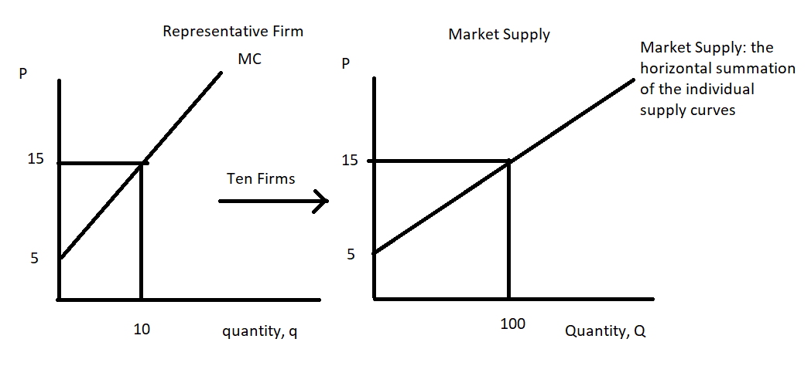
Graphing the representative firm’s MC curve we can see that the y-intercept is 5 and then choosing some cost per unit (in the graph I chose $15 per unit) we can see that the representative firm is willing to supply 10 units of output at this cost per unit. Since there are ten identical firms we can deduce that the total amount produced in the market when the cost for the additional unit is $15 per unit will be 100 units. The market supply curve can therefore be written as P = 5 + (1/10)Q.

- We know that the market demand and market supply curves are as follows: Market Demand: P = 93 – Q
Market Supply: P = 5 + (1/10)Q
Set these two equations equal to one another: 93 – Q = 5 + (1/10)Q
88 = (11/10)Q
880/11 = Q
Q = 80 widgets
P = 93 – Q = 93 - (80) = 93 - 80 = $13 per widget
Or, P = 5 + (1/10)Q = 5 + (1/10)(80) = $ 13per widget
The representative firm is a price-taking firm, so it will charge $13 per widget and it will view this market price as equivalent to its MR curve. Thus, MR = 13. The representative firm will equate MR to MC to decide its profit maximizing output. The firm does this because it wants to equate the addition to total cost from producing the last unit of the good (the MC) to the addition to total revenue from selling the last unit of the good (the MR): when the firm produces that quantity where MR = MC the firm knows that it is profit maximizing. Thus,
13 = 5 + q
8 = q
q = 8 widgets
In the short run the firm will produce 8 widgets and charge $13 per widget.

Short-run profit for the firm can be computed as TR – TC. For the representative firm: TR = P*q = ($13 per widget)(8 widgets) = $104
TC = 18 + 5q + (1/2)q2 = 18 + 5(8) + (1/2)(8)(8) = 18 + 40 + 32 = $90
Profit in the Short-run for the firm = $104 - $90 = $14.00

- The firm will produce in the short-run since its total revenue of $104 is greater than its variable costs of $72. The firm’s profit in the short run is sufficient to cover its variable costs of production in the short run.

- Since short-run profits are positive, you can predict that firms will enter the industry in the long-run. This will cause the market supply curve to shift to the right and result in a decrease in the market price, an increase in the market quantity, and a decrease in the level of production by firms remaining in the industry.

- In the long-run ATC = MC for the representative firm since the representative firm earns zero economic profit in the long-run. Thus,
(18/q) + 5 + (1/2)q = 5 + 2q
18/q = (1/2)q
36 = (q)(q)
q = 6 widgets
We also know that in the long-run, the firm continues to profit maximize by producing where MR = MC and we can use this idea to find the long-run market price. Thus,
MR = MC MR = 5 + q
MR = 5 + 6 = $11 per widget = Long-run market price
We can use this market price (the price that will result in all firms left in the industry earning zero economic profit) and the market demand curve to calculate the long-run market equilibrium quantity. Thus,
P = 93 – Q
11 = 93 – Q
Q = 82 widgets
To find the number of firms in the industry in the long-run we can divide the market quantity, Q, by the representative firm’s production, q: thus,
Q/q = (82 widgets)/(6 widgets per firm) = 13.67 firms in the industry

To sum up:
Long-run equilibrium market price = $11
Long-run equilibrium market quantity = 82 widgets Level of production by representative firm = 6 widgets Number of firms in industry in the long-run = 13.67 firms

