Economics 101
Fall 2014
Answers to Homework #4
Due 11/13/14
Directions: The homework will be collected in a box before the lecture. Please place your name, TA name and section number on top of the homework (legibly). Make sure you write your name as it appears on your ID so that you can receive the correct grade. Late homework will not be accepted so make plans ahead of time. Please show your work. Good luck!
Please realize that you are essentially creating “your brand” when you submit this homework. Do you want your homework to convey that you are competent, careful, professional? Or, do you want to convey the image that you are careless, sloppy, and less than professional? For the rest of your life you will be creating your brand: please think about what you are saying about yourself when you do any work for someone else!

More Real and Nominal prices

1) Last week we had you research careers and directed you to a data set that contained information about salaries, including a breakdown of salaries by state. However, just as the purchasing power of a dollar varies over time, so too does purchasing power vary across state. The table below contains median salary data on an occupation from 2013, along with some fictitious data on the cost of a basket of goods and services in each state. Use the data to compute a price index and a real salary for each state, using Wisconsin as the base location (this means that the Wisconsin base index will be 100 if we measure the price index on a 100 point scale). The same technique you use for data over time will work here as well! Does adjusting for cost of living matter?

 | Median salary in 2013 | Cost of basket in 2013 | Price Index in 2013 with Wisconsin the base location | Real Salary (measured in Wisconsin $)
Hawaii | $87,000 | 1000
Idaho | $70,000 | 500
New York | $105,000 | 1000
Wisconsin | $90,000 | 600

Answer: The table below contains the answers and indicates the work that was done to generate the answers. Once we adjust for differences in the cost of living the salaries in New York and Hawaii look much less attractive and the salary in Idaho looks much more attractive. Of course this is still missing a lot of information (e.g. weather!) that would factor in to where you want to work, but it does illustrate that one should take cost of living into account when comparing salaries.

Salary data was taken from http://www.onetonline.org/ for the occupation “Economics Teachers, Postsecondary”. Cost of basket data was based off CNN’s cost of living calculator: http://money.cnn.com/calculator/pf/cost-of-living/

 | Median salary in 2013 | Cost of basket in 2013 | Price Index in 2013 with Madison the base location | Real Salary in 2013 (measured in Wisconsin $)
Hawaii | $87,000 | 1000 | 1000/600*100 =1000/6 | 87000*100/(1000/6) =  $52,200
Idaho | $70,000 | 500 | 500/600*100 =500/6 | 70000*100/(500/6) =  $84,000
New York | $105,000 | 1000 | 1000/600*100 =1000/6 | 105000*100/(1000/6) =  $63,000
Wisconsin | $90,000 | 600 | 600/600*100 = 100 | $90,000

2) The Bureau of Labor Statistics (BLS) is the US government agency that compiles CPI data. They provide an inflation calculator at http://www.bls.gov/data/inflation_calculator.htm that performs inflation adjustments automatically. Use this to perform an interesting comparison. For instance, you could ask someone much older than you how much they were paid during their first job and convert that to 2014 dollars.

Answer: “Interesting” is somewhat subjective and will vary person to person. One example is this: the Apple II computer was one of the world’s first successful home computers and started selling in 1977 at a price of $1298 (for a version with a whopping 4kB of RAM!). That is $5,098.42 in 2014 dollars, though every computer today is more capable than the Apple II and most of them cost much less than $5,000!

Consumer Theory

3) Nick earns $20,000 every year, and he spends his money on golf (g) and water-skiing (w). The price of playing golf and water-skiing are $100 and $200, respectively.

a. Given this information, what is the equation for Nick’s budget line? Graph it with the number of times he plays golf on the x axis. Label this budget line BL1.

Answer: Nick’s budget line has the equation 100g + 200w = 20000, where w and g are the number of times Nick goes water-skiing and golfing respectively. Rearranging into slope intercept form we have w = 100 – (1/2)g. The relevant graph is below.

b. Suppose Nick’s income increases to $30,000 a year. Draw his new budget line and label it BL2.

Answer: this is shifts the budget line out with no change in slope, since the prices did not change.

c. Suppose Nick’s income is $30,000 per year and the price of water-skiing falls to $150. Draw his new budget line in your graph and label it BL3.

Answer: The maximum number of times Nick can go golfing does not change but now he can go water-skiing more if he wants to, so the budget line becomes steeper (since water-skiing is on the y axis).

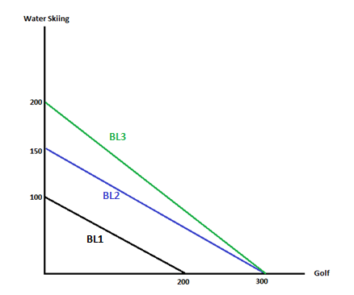

d. Go back to the starting situation (income of $20,000 per year, prices of $100 and $200 for golf and water-skiing respectively). To attract Nick to play golf more frequently, the manager offers him a new price package (the Mid-night VIP Package). For the first 100 units of golf-playing he purchases, the price is only $40 per game of golf, and for the extra units the price is $160 per game of golf. Draw a graph that illustrates Nick’s new budget line given this information. (Hint: this budget line will definitely not be one linear segment: you will need to think about this carefully!) Label this budget line BL4. Will he be worse off under this new pricing arrangement than he was initially? Explain your answer.

Answer: Firstly note that the maximum number of Nick can go water-skiing is still 20000/200 = 100, since the price of water-skiing is as before. If Nick goes golfing 100 times he has $16,000 left over, with which he could go water-skiing 16000/200 = 80 times. Thus the budget line has a kink point at (100 g, 80w). If instead of water-skiing Nick spent his remaining $16,000 on golfing he could golf another 100 times (since 16000/160 = 100), so the maximum number of times he can golf is still 200. Thus his budget line has a kinked shape with the same maximums as in (a):

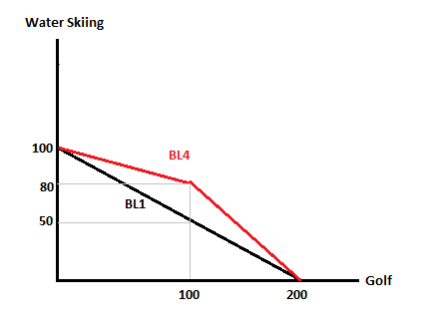
Since everything Nick could do previously he can still do and there are some new options available, Nick is definitely not worse off with the new package.

4) Bob is organizing a large camping expedition and needs to acquire some flashlights. Each flashlight requires two batteries in order to work: without batteries a flashlight is useless and batteries are useless unless put inside a flashlight. Thus a flashlight and two batteries are perfect complements. Suppose a flashlight costs $15 and each battery costs $2.50 (so 2 batteries costs $5).

a. If Bob is trying to maximize the number of working flashlights for the trip, what has to be true about the number of flashlights and the number of batteries he buys? Express this in words. Also, if F is the number of flashlights and B is the number of batteries, give an equation relating F and B if Bob is maximizing the number of flashlights with batteries in them. We call this an “optimality condition”.

Answer: Since each flashlight requires two batteries, the number of batteries must be twice the number of flashlights. As an equation that means B = 2F.

b. Bob has a budget of $300 to spend on flashlights and batteries. What has to be true about the amount of money Bob spends on flashlights and batteries compared to his budget? Express this in words and as an equation.

Answer: The amount of money Bob spends on flashlights must equal his budget. As an equation we have 15F + 2.5B = 300.

c. We will now find the optimal number of flashlights and batteries for Bob to buy. Since we are after two numbers (number of flashlights and number of batteries) we require two pieces of information. Use the optimality condition from (a) and the budget constraint from (b) to calculate Bob’s optimal purchasing plan.

Answer: substituting B = 2F into the budget constraint gives 20F = 300, so F = 15. Then B = 30.

d. Now suppose that flashlights are on sale this week and the price is actually $10. What is Bob’s new optimal consumption bundle?

Answer: note that this affects Bob’s budget constraint but not his optimality condition. Thus we can substitute B = 2F into the new budget constraint (which is 10F + 2.5B = 300). This gives 15F = 300, so F = 20 and B = 40.

e. Fill in the following table. Is Bob’s decision making consistent with the law of demand?
Price of flashlights | Number of flashlights purchased
$15
$10

Answer: Yes, as price drops from 15 to 10 Bob’s quantity demanded of flashlights rises from 15 to 20, so a decrease in price resulted in an increase in quantity demanded, which is exactly what the law of demand states should happen.
Price of flashlights | Number of flashlights purchased
$15 | 15
$10 | 20

f. Illustrate parts a-d on a diagram with the number of flashlights on the x axis. That is, show the indifference curves and budget lines that lead to Bob choosing the bundles in (c) and (d). Did we use the tangency condition given in lectures?

Answer: see below. Note the kinked indifference curve since we are dealing with perfect complements. Since the indifference curve has a kink we did not use the condition that the slope of the indifference curve equals the slope of the budget line at an optimum.
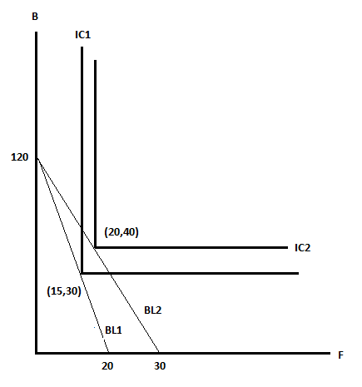

5) Jeff Albertson enjoys consuming comic books (C) and DVD’s (D). His total utility depends on the product of the number of comic books and number of DVD’s he owns. For instance, if he owns 4 comic books and 3 DVD’s his total utility is 3 x 4 = 12. Mathematically we can write this as u(C,D) = CD. His marginal utility from an additional comic book depends on the number of DVD’s he owns and is given by MU_{C} = D. For instance, if he owns 3 DVD’s then an extra comic book improves his utility by 3, whereas if he has 5 DVD’s an extra comic book improves his utility by 5. This captures the fact that Jeff likes reading comic books that involve characters he has seen in a DVD: if he recognizes someone in a comic book from a DVD then that comic book is extra awesome! Similarly his marginal utility from an extra DVD depends on the number of comic books he owns, so MU_{D} = C. Suppose comic books cost $2.50 each and DVD’s cost $10 each.
a. Given the above equation (u = CD) we know that 2 comic books and 5 DVD’s gives Jeff a total utility of 10. Plot Jeff’s indifference curve at this utility level, i.e. a curve representing all bundles that give him a utility of 10. In your graph measure comic books on the x axis. (Hint: when in doubt, plot some points! For instance, if Jeff has 10 comic books, how many DVD’s does he need to give him a utility of 10? Try some numbers and see what happens!)
Answer:
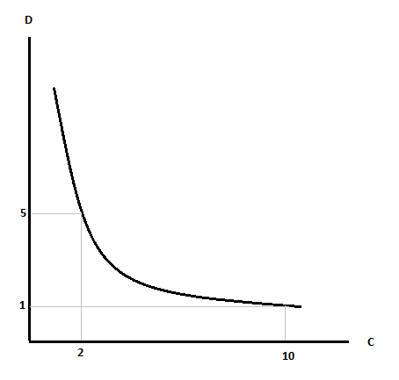
b. In the previous question the optimality rule Bob followed was very simple. In this case the indifference curves are smooth, so we need to use the tangency result given in lectures. What has to be true about the slope of Jeff’s indifference curve and the slope of Jeff’s budget line at the optimal bundle of comic books and DVD’s? State this in words and express it as an equation involving C and D.
Answer: In words the slope of Jeff’s indifference curve must equal the slope of his budget line. The slope of Jeff’s indifference curve represents the rate at which he is willing to give up DVD’s for a small increase in comic books. The slope of the budget line represents the rate at which he must give up DVD’s to buy comic books (just as with PPF’s, the slope of the budget line is the opportunity cost of the good on the x axis). Thus in order for Jeff to be optimizing, the rate at which he is willing to give up DVD’s for comic books must be the same as the rate he is able to trade off DVD’s for comic books.

Mathematically we must have MU_{C}/MU_{D} = P_{C}/P_{D}. Substituting in the formulae for marginal utility and the numbers given for prices we have
D/C = 2.5/10
4D = C

c. Suppose Jeff has a budget of $400 to spend on DVD’s and comic books. Write down the equation of his budget constraint given this information.

Answer: 2.5C + 10D = 400

d. As in part (c) of the previous question, use Jeff’s optimality condition and his budget constraint to calculate his optimal consumption bundle of comic books and DVD’s. How much utility does he obtain?

Substituting C = 4D into the budget constraint gives
10D + 10D = 400
20 D = 400
D = 20
C = 4D = 80
Thus Jeff consumes 80 comic books and 20 DVD’s, which gives him a utility of 80x20 = 1600.

e. Suppose a natural disaster greatly reduces the supply of comic books, sharply driving up the price of comic books to $10 per comic book, while the price of DVD’s remains unchanged. Find Jeff’s new optimal consumption bundle and new utility. (Hint: you will have to adjust both Jeff’s optimality condition and his budget constraint.)

Jeff’s optimality condition is now D/C = 10/10 = 1, so we have C = D. Jeff’s budget constraint becomes
10C + 10D = 400
Combining these gives 20D = 400, so D = 20 and C = 20. Jeff’s new utility is 20 x 20 = 400.

f. Illustrate parts (b)-(e) on a well labelled diagram. As in lectures label the point found under the original prices A and the point under the new prices B, etc.
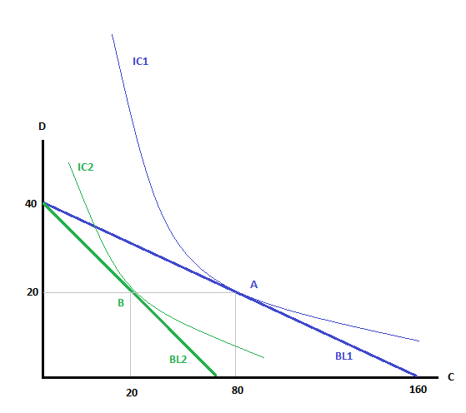
g. We now want to compute the income and substitution effects of the price change in part (e). To do this we must compute the point “C” that lies on an “imaginary” budget line. There are two features of point C: (i) it gives the same utility as the bundle chosen under the original prices, so it lies on the same indifference curve as point A; (ii) the imaginary budget line has the same slope as the second budget line, so the slope of the indifference curve at point C is equal to the slope of budget line 2. Importantly that means that the imaginary budget line does not pass through point A! Indeed, we do not know the income of the imaginary budget line, though we do know its slope. This information about slope gives you an optimality condition and the second equation you need is that the utility from the bundle at C is the same as the utility from the bundle at A. Use these two equations to find point C and illustrate on a diagram. Once you find the coordinates of bundle C, calculate the income of this imaginary budget line.

Answer: At point C the prices are the same as at point B, so we again have MU_{C}/MU_{D} = 10/10 = 1. Thus at point C we must have C = D, as at point B. The information about total utility tells us that at point C, CD = 1600. Combining these gives D² = 1600, so C = D = 40 at point C. Since the price of a comic book is $10 and the price of a DVD is $10, we can compute that the income for the imaginary budget line is ($10 per comic book)(40 comic books) + ($10 per DVD)(40 DVDs) = $800 (since this is the amount of money Jeff is spending at point C under the new prices, which must be equal to his income on the imaginary budget line).

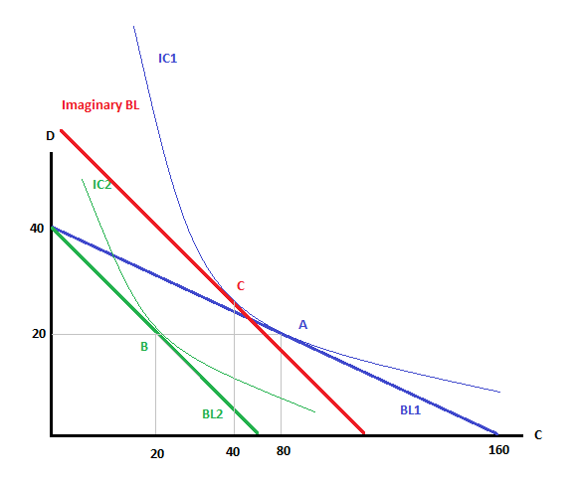
h. Use point C to calculate the income and substitution effects of the increase in comic book prices (in terms of the change in the quantity of comic books consumed).

Answer: The substitution effect is the movement from A to C, which is 80 – 40 = 40 comic books. The income effect was the movement from C to B, which was 40 – 20 = 20 comic books.

i. Jeff is understandably annoyed by the increase in comic book prices. How much money would he need to be paid to return him to his old level of utility under the new prices? That is, by how much would his income have to change to be able to afford the bundle at point C?

Answer: From (g) we know that at point C under the new prices Jeff is spending $800. Since Jeff’s income is only $400, he would require an additional $400 to be able to afford the bundle at point C.

Production and Costs

6) (Hint: on this question you will likely want to use a calculator!) Alice owns and runs a factory that creates widgets using capital and labor. The table below summarizes the production and cost functions of Alice’s factory, where q, K and L respectively represent the quantity of widgets, capital and labor, and costs are given in dollars. Before starting this question it would be a good idea to compile all the relevant formulae on a single piece of paper!

K | L | q | FC | VC | TC | AFC | AVC | ATC | MC | MPL
2 | 0 | 0 |  |  | $18
2 |  | 1 |  |  |  |  |  |  | $2/unit of output | 0.25 units of output/unit of labor
2 | 6 | 2
2 | 9 | 3
2 |  | 4 |  |  |  |  |  |  | 2.5
2 | 22 | 5 |  |  | 29
2 |  |  |  |  | 44 |  |  |  | 5
2 | 63 | 9 |  |  |  |  |  |  |  | 0.091
2 | 75 | 10 |  |  |  |  |  |  |  | 0.083

a. Given the above information, what is the cost of one unit of capital to Alice?

Answer: at q=0 no workers are employed, so the total costs are just the cost of capital. Thus each unit of capital costs $18/2 = $9.

b. How much labor is required to produce the first unit of output? What is the cost of a unit of labor? (Hint: you can figure this out using marginal cost and the marginal product of labor.)

Answer: at q=1 the marginal product of labor is 0.25, so (change in q)/(change in L) = ¼. Thus 4 workers were required. Since total cost increases by $2, each unit of labor costs $2/4=$0.50.

c. Fill in the blank cells in the table. Check to make sure that your numbers are consistent with each other!

Answer: The table is below.
K | L | q | FC | VC | TC | AFC | AVC | ATC | MC | MPL
2 | 0 | 0 | 18 | 0 | 18 | - | - | - | - | -
2 | 4 | 1 | 18 | 2 | 20 | 18 | 2 | 20 | 2 | 0.25
2 | 6 | 2 | 18 | 3 | 21 | 9 | 1.5 | 10.5 | 1 | 0.5
2 | 9 | 3 | 18 | 4.5 | 22.5 | 6 | 1.5 | 7.5 | 1.5 | 0.333
2 | 14 | 4 | 18 | 7 | 25 | 4.5 | 1.75 | 6.25 | 2.5 | 0.2
2 | 22 | 5 | 18 | 11 | 29 | 3.6 | 2.2 | 5.8 | 4 | 0.125
2 | 52 | 8 | 18 | 26 | 44 | 2.25 | 3.25 | 5.5 | 5 | 0.1
2 | 63 | 9 | 18 | 31.5 | 49.5 | 2 | 3.5 | 5.5 | 5.5 | 0.091
2 | 75 | 10 | 18 | 37.5 | 55.5 | 1.8 | 3.75 | 5.55 | 6 | 0.083

For most rows you can find total cost by adding together the cost of capital (which is always $18 here) and the cost of labor ($0.50 times the quantity of labor employed). At q=4 you can use marginal cost divided by the wage to see that 5 extra workers were employed. At q=8 you can use marginal cost and the change in total cost to see that quantity must have increased by 3. Then since costs went up by $15, 30 more workers must have been employed. The rest is a matter of using formulae given in lectures.

d. Does Alice’s factory exhibit diminishing marginal productivity of labor? How do you know?

Answer: Yes, since the marginal product of labor (calculated in the table above) falls as quantity increases.

e. Is Alice’s factory operating in the short run or the long run? How do you know?

Answer: In the short run, since capital is being held fixed.

f. If the price of a widget was $2.50, what quantity of widgets would Alice’s factory produce (assuming that Alice’s decisions do not affect the market price)? How large would her profit or loss be?

Answer: Since Alice is a price taker, she chooses a quantity such that price equals marginal cost. Thus she produces a quantity of 4 units, giving revenue of 4x$2.50 = $10. Since her total costs at q=4 are $25, she makes a loss of $15. Note, however, that she covers her variable costs, so she will still operate in the short run.

g. What price is the shutdown price for Alice’s factory? (Hint: it is not $2!)

Answer: recall that the shutdown price (where Alice stops producing in the short run) is where total revenue equals total variable costs, or where AVC = P = MC. This occurs at a price of $1.50, where q = 3. Note that at a price of $2 Alice could produce q = 2, which would give revenue of $4, which exceeds her variable costs.

h. If the above costs were also true in the long run, what price would widgets have to be sold for in order for Alice to break even?

Answer: The breakeven point is where ATC = P = MC, which happens at a price of $5.50.

i. What quantity minimizes Alice’s average total costs?
Answer: The quantity at the breakeven price, q = 9.

Perfect Competition

7) Black Swan Clothing is a firm producing costumes for residents in Econ Town. The total cost of the firm is given by TC = 0.5q² + q + 2 where q is the number of costumes produced by Black Swan Clothing. You are also told that the marginal cost curve (MC) for Black Swan Clothing is given by the equation MC = q + 1. Furthermore, assume Black Swan Clothing takes prices as given when choosing the quantity it will produce.

a. How many costumes will the firm produce when price, P, is given as P = $2? How many costumes will the firm produce is P = $1?

Answer: Since the firm is a price taker, the firm will choose to produce that quantity where P = MC. In general that means we must have P = q + 1, so q = P-1, which is 1 when P = $2 and 0 when P = $1.

b. Draw a graph that represents Black Swan Clothing’s marginal cost curve (MC), average variable cost (AVC) and average total cost (ATC) curves. Measure marginal cost, average variable cost, and average total cost on the vertical axis (all three of these cost curves are measured as “$ per unit”). Measure the quantity of costumes on the horizontal axis. Label your graph carefully and completely.

Answer: Remember that ATC = TC/q = 0.5q + 1 + 2/q
Also recall that TC = FC when q = 0. So, if TC = 0.5q² + q + 2 and q is equal to 0, then FC = 2. Thus, AFC = FC/q = 2/g. VC can be written as VC = 0.5q² + q and AVC = 0.5q + 1.
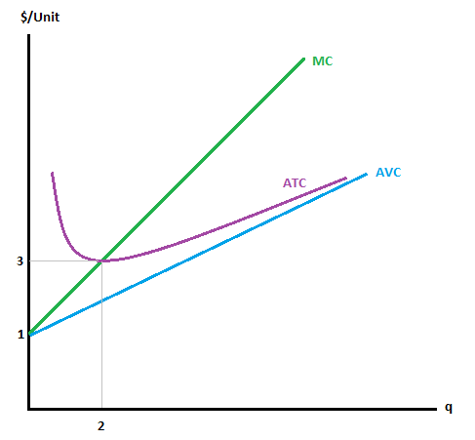
c. What is the firm’s breakeven point? Mark it on your diagram from (b).

Answer: at the breakeven point MC = P = ATC, so:
q + 1 = (0.5q² + q + 2)/q
q² + q = 0.5q² + q + 2
0.5q² = 2
q = 2
P = MC = q + 1 = 3
Thus the breakeven point is at q = 2, P = $3

d. Suppose there are 10 firms in the market, including Black Swan Clothing, which all have the same cost curves. Assume that this market is perfectly competitive. What is the market supply curve given this information? (Hint: first find Black Swan Clothing’s supply curve, then think about the market supply curve.)

Answer: To find the market supply curve we need to horizontally sum the 10 individual supply curves (recall from lecture that the individual firm’s supply curve is equal to its MC curve). Thus, if MC = q + 1 for one firm, then the market supply curve will consist of adding up the 10 individual MC curves horizontally. Thus, the market supply curve will be P = 1 + (1/10)Q where P is the price per costume and Q is the market quantity of costumes supplied by the ten firms. (Note: to find this answer you will need to consider two different quantities-I chose q = 0 and q = 1 and for both quantities I then calculated the respective price. From there I could combine each firm’s production at that price with the production from the other nine firms.)

Alternatively, from (a) we know that for any particular price Black Swan Clothing produces q = P – 1 units. Since all firms are identical the market quantity will just be 10 times this, so:
Q^{s} = 10q = 10(P – 1) = 10P – 10 or Q^{s} = 10P – 10 or P = (1/10) Q^{s} + 1.

e. Suppose demand is given by the equation Q^{d} = 50 - 10P. Calculate the equilibrium price and quantity. Is the market in long run equilibrium at this price and quantity? Explain your answer.

Answer: Setting supply equal to demand (yet again!) gives P = $3 per costume, Q = 20 costumes. When P = $3 per costume, each firm produces 2 costumes. We can calculate the individual firm’s profits as total revenue minus total cost. Thus,
Total revenue = TR = P*q = ($3 per costume)(2 costumes) = $6
Total cost = TC = .5(2)(2) + 2 + 2 = $6
Profits = TR- TC = $6 - $6 = $0
Since profits for the individual firm are equal to $0 when P = $3 per costume, this tells us that this price and quantity are the long-run equilibrium quantity. You can also see this directly since the market price is the break-even price, i.e. you know from (c) that at a price of $3 firms make zero profits.

f. Suppose demand increases to Q^{d}=90-10P. What is the new market equilibrium price and quantity in the short-run?

Answer: P = $5 per costume, Q = 40 costumes

g. Given the situation in (f), how much profit in the short-run does Black Swan Clothing make now? What do you predict will happen to the number of firms in the long run? Explain your prediction.

Answer: Black Swan Clothing produces 4 costumes at a price of $5 per costume: thus, Black Swan’s total revenue (TR) is $20 and total costs (TC) are 0.5(4)² + 4 + 2 = $14. Thus Black Swan Clothing makes a profit of $6 in the short-run. Since profits for this representative firm are positive in the short-run we can predict that these positive profits will act as an incentive for new firms to enter this industry in the long run. This entry will continue until long-run profits for the representative firm are driven to $0.

h. If demand is as is given in (f), how many firms will be in the market in the long run, assuming all firms still have the same cost curves as Black Swan Clothing? (Hint: what does the price have to be if the market is in a long run equilibrium?)

In the long run we know the break-even price must be $3 per costume since this is the price where P = MC = ATC for the representative firm. If price is greater than $3 per costume holding everything else equal this will result in firms earning a positive economic profit and we can expect that firms will enter this industry. If price is less than $3 per costume holding everything else equal this will result in firms earning a negative economic profit and we can expect that firms will exit this industry. Thus the price is pinned down entirely by supply in this case! We also know that each firm will produce 2 units. Substituting P = $3 per costume into the market demand equation gives Q = 60. Since each firm makes 2 units in the long run, there must be 60/2 = 30 firms if this market is in long-run equilibrium.

