Economics 101
Fall 2014
Answers to Homework #3
Due 10/30/14

Directions: The homework will be collected in a box before the lecture. Please place your name, TA name and section number on top of the homework. Write legibly throughout the whole homework. Make sure you write your name as it appears on your ID so that you can receive the correct grade. Please remember the section number for the section for which you are registered, because you will need that number when you submit exams and homework. Late homework will not be accepted so make plans ahead of time to insure that your homework is submitted. Good luck!

Your homework reflects you: please make sure that you submit a neat, organized, and legible set of answers!

Remember to show all your work. Also remember that calculators are not permitted on the exam, so you should try these manually.

Part I: Excise Tax

1. Consider the ice cream market in Madison. In July, the ice cream market demand and supply curves are given by the following equations where Q is the quantity to ice cream units and P is the price in dollars per unit of ice cream:
Demand: Q = 14000 – 10P
Supply: Q = 2000 + 20P
a) Find the equilibrium price and quantity of ice cream in July.

In equilibrium, we know that the quantity demanded = quantity supplied. Thus, by solving the two equations, we have the equilibrium price = $400 per unit of ice cream and the equilibrium quantity = 10,000 units of ice cream.

b) Calculate the price elasticity of demand and supply at the equilibrium price in July. Use the point elasticity formula to compute these two values of these elasticities.

Answer:
The point elasticity of demand formula is
Elasticity of Demand = (-1/slope)(P/Qd)
and the point elasticity of supply formula is
Elasticity of Supply = (1/slope)(P/Qs)
At the equilibrium quantity and price we know (Q, P) = (10000, 400). We also have the demand and supply equations, but they are not in slope-intercept form. So, rewriting the two equations in slope-intercept form we have:
Demand Equation: P = 1400 – (1/10)Qd
Supply Equation: P = (1/20)Qd – 100
Now, we are ready to use the point elasticity formulas:
Point Elasticity of Demand = [-1/(-1/10)][400/10000] = .4 (hence, demand is inelastic at the point of equilibrium in this market)
Point Elasticity of Supply = [1/(1/20)][400/10000] = .8

In October, ice cream demand in Madison decreases. So, the new demand curve is given by
Demand: Q = 7000 – 30P
Assume the supply curve doesn’t change.

c) Find the equilibrium price and equilibrium quantity in October, and calculate the price elasticity of demand and supply at this new equilibrium price. Use the point elasticity formula in calculating these values.

Answer:
By solving the two equations, we obtain the equilibrium price of $100 per unit of ice cream and quantity of 4,000 units.

To find the price elasticity of demand using the point elasticity formula:
Price elasticity of demand = [(-1)/(-1/30)][100/4000] = (30)(1/40) = .75

To find the price elasticity of supply using the point elasticity formula:
Price elasticity of supply = [(1)/(1/20)][100/4000] = (20)(1/40) = .5

Let’s return to the July. Suppose that the city of Madison imposes on producers an excise tax of $15 per unit of ice cream.

d) For part (d), answer this set of questions based upon this new tax and the demand and supply curves you have been given in this problem.
- How does this excise tax affect the supply curve for ice cream producers in Madison? Explain your answers in words as well as in an equation.
- Then, calculate the new equilibrium price and quantity in July for this ice cream market.
- Then, calculate the new equilibrium price and quantity in October for this ice cream market.

Answers:
- The imposition of the excise tax on producers effectively increases the costs of production for the ice cream producers since they now must also include paying the government an excise tax of $15 per unit of ice cream they produce. We can model this in two different ways: as done in class, this excise tax will shift the supply curve up so that the new y-intercept of the supply curve with the tax will now be the old y-intercept plus 15 (this “plus 15” reflects the idea that the producers now have a new cost that they must cover). Thus, if the supply curve was Q = 2000 + 20P, then we could rewrite the supply curve in slope intercept form as P = (1/20)Q – 100. Therefore the new supply curve that includes the tax would be P = (1/20)Q – 85.

Alternatively, you could take the existent supply curve in July written in x intercept form and view the tax as effectively decreasing the amount per unit that the producer receives by 15. Thus, instead of P in this original supply curve, the tax results in the new price with the tax being “P – 15”. If, we plug that into the original supply curve equation this is what we get:
Q = 2000 + 20(P – 15)
Q = 2000 + 20P – 300
Q = 1700 + 20P, the new supply curve in JULY written in x intercept form.
Let’s check that this new supply equation is the same as we found in the first method: that is, is P = (1/20)Q – 85 the same as Q = 1700 + 20P?
20P = Q – 1700
P = (1/20)Q – 1700/20
P = (1/20)Q – 85
Yes, these two approaches give us the same new supply equation with the excise tax.

- In July the relevant demand equation is Q = 14000 – 10P and the relevant supply equation is Q = 1700 + 20P (see explanation in the answer to #1 of part (d)). Solving for equilibrium with these two equations we get:
14000 – 10P = 1700 + 20P
30P = 12300
P in July = $410 per unit of ice cream
Q = 1700 + 20(410)
Q in July = 9900 units

- In October the relevant demand equation is Q = 7000 – 30P and the relevant supply equation is Q = 1700 + 20P (see explanation in the answer to #1 of part (d)). Solving for equilibrium with these two equations we get:
7000 – 30P = 1700 + 20P
50P = 5300
P in October = $106 per unit of ice cream
Q = 7000 – 30(106)
Q in October = 3820 units

e) Calculate the consumers’ tax burden ratio in July and in October given your answers in (d) and then analyze the answers you get for these two calculations by filling out the table provided and then writing a verbal explanation of the difference you find with regard to the two consumers’ tax burden ratios. Your explanation should include the impact of demand and supply elasticities on these calculations. The tax burden ratio can be found by using the following equation:

Consumers’ tax burden ratio = (consumers’ tax incidence)/(total tax revenue)

Here is a table that will help you organize your data:
July |  |  | October
 | No Tax | Tax | No Tax | Tax
Price
Quantity
Price Elasticity of Demand |  | --- |  | ---
Price Elasticity of Supply |  | --- |  | ---

Answers:
Total tax revenue in July is (tax per unit)(number of units sold with the tax) = ($15 per unit)(9900 units) , and consumers’ tax incidence is (equilibrium price with the excise tax – the old equilibrium price)(number of units sold with the tax) = ($410 per unit – $400 per unit)(9900) = ($10 per unit)(9900 units). Thus, consumers’ tax burden ratio in July is 2/3 (that is, consumers end up paying 67% of the excise tax on ice cream in July.

Tax revenue in October is ($15 per unit)(3820 units), and consumers’ tax incidence is (equilibrium price with the excise tax – the old equilibrium price)(number of units sold with the tax) = ($106 per unit - $100 per unit)(3820 units) = ($6 per unit)(3820 units). Thus, consumers’ tax burden ratio in October is 2/5 (that is, consumers end up paying 40% of the excise tax on ice cream in October).

July |  |  | October
 | No Tax | Tax | No Tax | Tax
Price | $400 per unit | $410 per unit | $100 per unit | $106 per unit
Quantity | 10,000 units | 9900 units | 4000 units | 3820 units
Price Elasticity of Demand | .4 | --- | .75 | ---
Price Elasticity of Supply | .8 | --- | .5 | ---

In July, the price elasticity of demand is smaller than the price elasticity of supply. As a result, consumers pay more than half of the excise tax in July. Equivalently, producers pay less than half of the tax in July. On the other hand, in October, the price elasticity of demand is greater than the price elasticity of supply, and thus consumers pay less than half of the excise tax in October. In general, the less elastic side of the market pays more of any given excise tax.

Part II: International Trade

2. Suppose the domestic demand in the United States for glow-in-the-dark golf balls can be represented by the following domestic demand curve and domestic supply curve equations where P is the price per glow-in-the-dark golf balls and Q is the quantity of glow-in-the-dark golf balls”

Domestic Demand Curve: Q = 40 – 5P for 0 ≤ P ≤ 8 ; Q = 0 for 8 ≤ P
Domestic Supply Curve: Q = 10P – 20 for 2 ≤ P ; Q = 0 for P ≤ 2

a) Calculate the equilibrium price, quantity, consumer surplus and producer surplus for the domestic market for glow-in-the-dark golf balls when the United States is in autarky (i.e. the market is closed to trade). Illustrate your answer graphically.

To find the equilibrium price and quantity set the domestic supply equation equal to the domestic demand equation and then solve. P* = $4 per flow-in-the-dark golf ball, Q* = 20 glow-in-the-dark golf balls. Consumer surplus is the area of the triangle above P = $4and below the demand curve. Thus Consumer Surplus = (1/2)($8 per golf ball - $4 per golf ball)(20 golf balls) = $40. Producer surplus is the area of the triangle below P = $4 and above the supply curve. Thus Producer Surplus = (1/2)($4 per golf ball - $2 per golf ball)(20 golf balls) = $20.

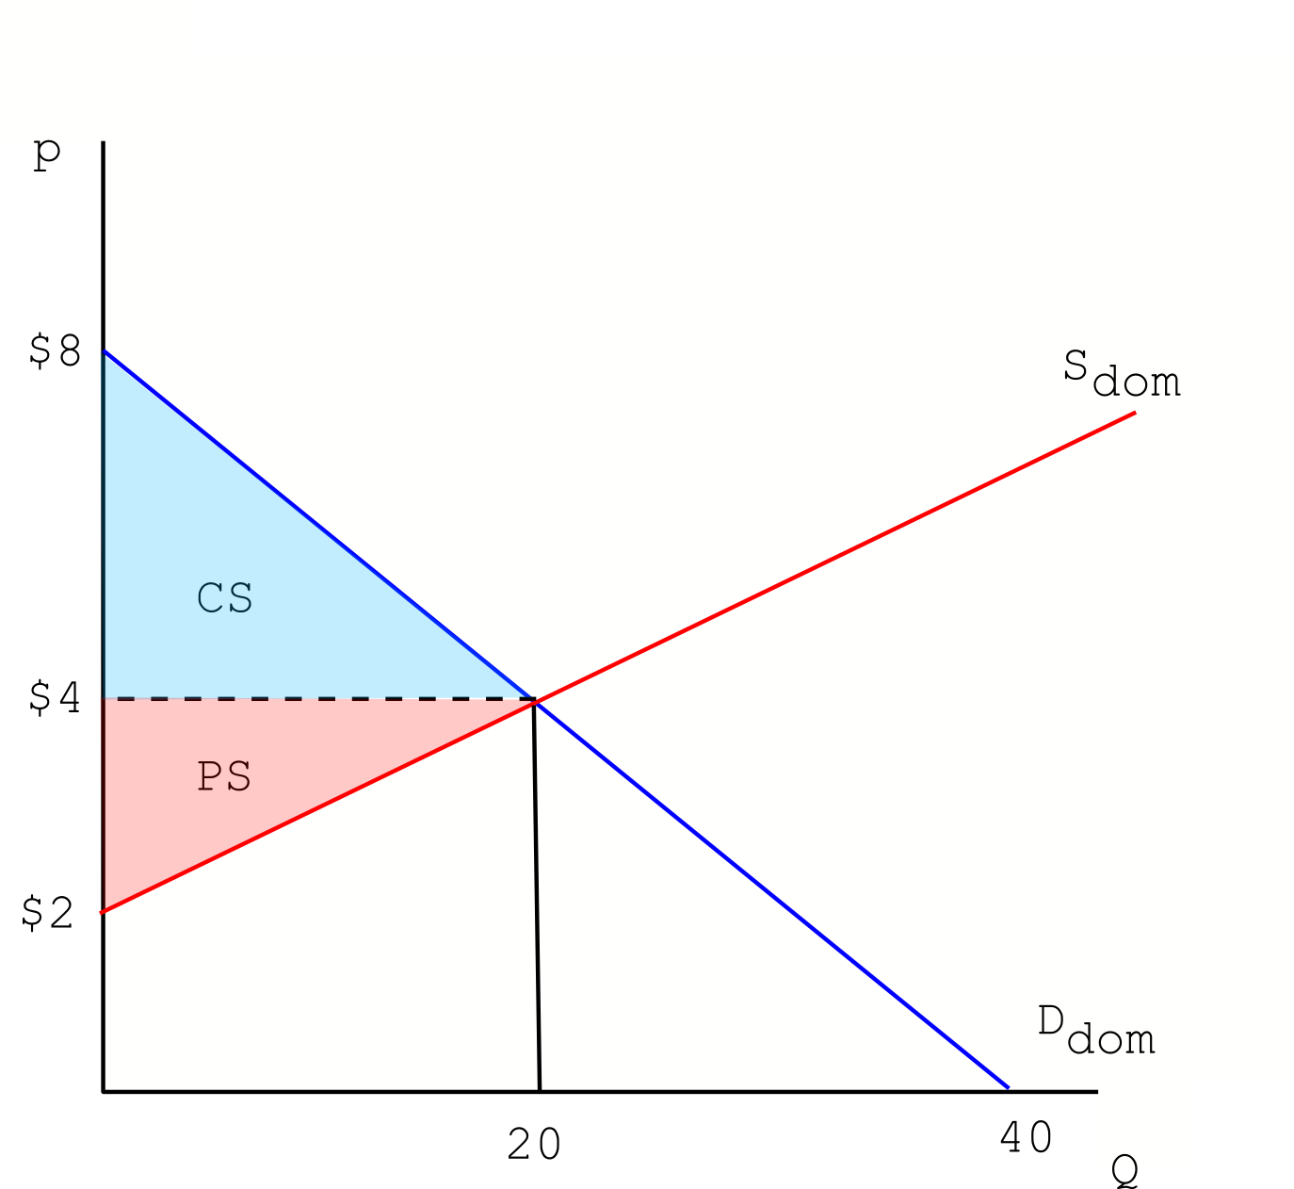

b) Suppose now that the United States opens the market to international trade and that the world price for glow-in-the-dark golf balls is $2 per golf ball. Further, suppose the United States market for such golf balls is small relative to the global market. Given this information, what will be the new price of glow-in-the-dark golf balls in the US market? How many glow-in-the-dark golf balls will be consumed domestically? How many glow-in-the-dark golf balls will be produced domestically? How many glow-in-the-dark golf balls will be imported/exported? Calculate the new consumer and producer surplus. Illustrate your answers graphically.

The new price in the domestic market (the US market) will be the world price. Domestically supplied golf balls will be Q = 10*2 – 20 = 0 golf balls. Domestically consumed golf balls will be Q = 40 – 5*2 = 30 golf balls. Imports = Number of golf balls domestically demanded – number of golf balls domestically supplied = 30 golf balls – 0 golf balls or 30 golf balls will be imported. Consumer surplus is the area above the price consumers pay for golf balls ($2 per golf ball) and below the demand curve: thus CS = (1/2)($8 per golf ball - $2 per golf ball)(30 golf balls) = $90. Domestic producers sell no golf balls, so Producer Surplus = $0. The graph below depicts these results.

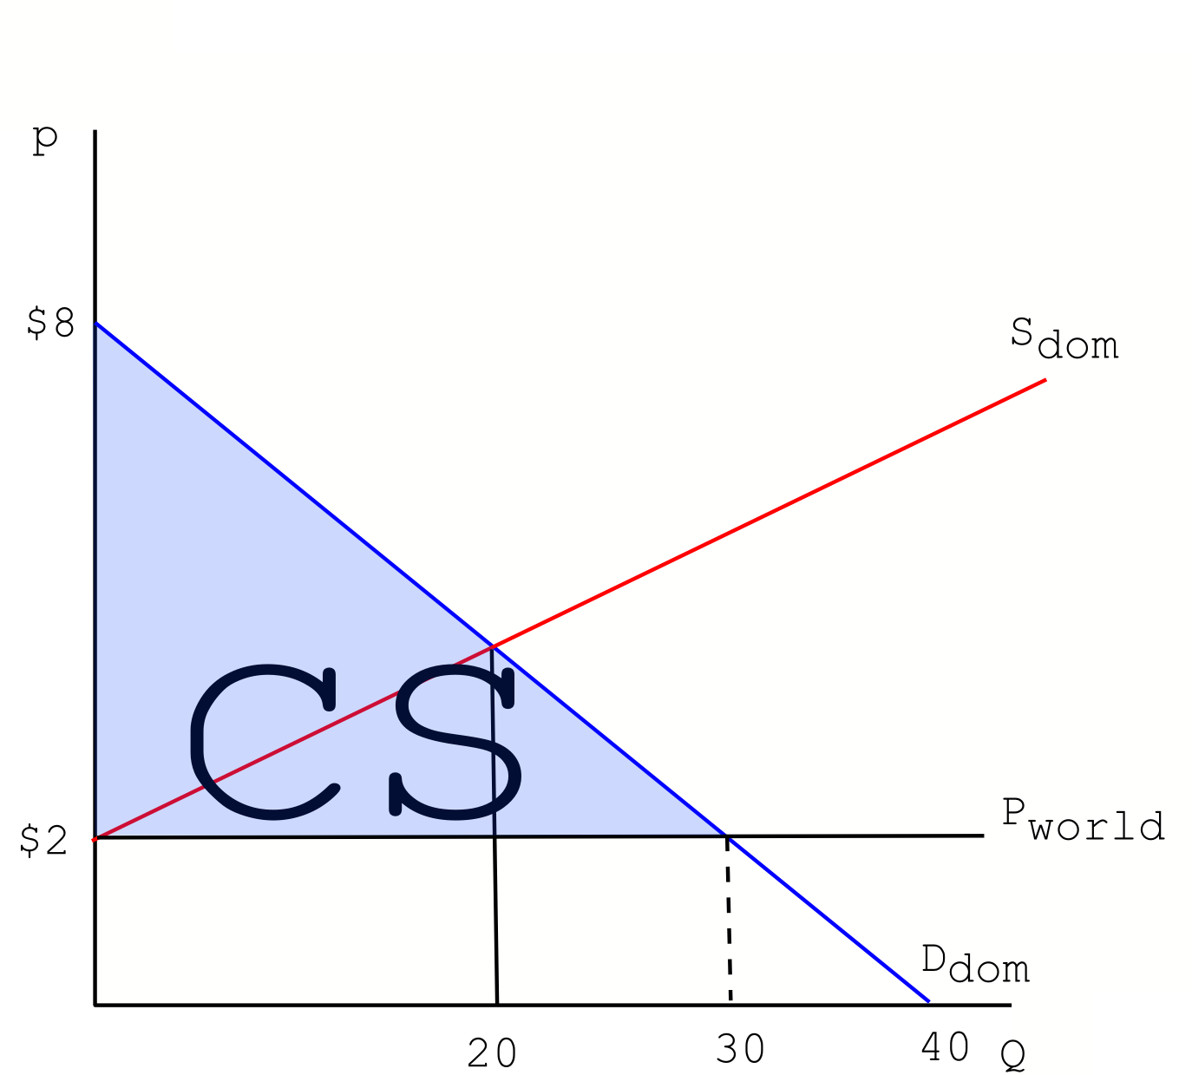

c) Suppose the United States government decides to attempt to support domestic producers of glow-in-the-dark golf balls by implementing a tariff of $1 per imported glow-in-the-dark golf balls. What will be the new price of glow-in-the-dark golf balls in the US when this tariff is implemented? How many glow-in-the-dark golf balls will be consumed domestically? How many glow-in-the-dark golf balls will be produced domestically? How many glow-in-the-dark golf balls will be imported/exported given this tariff? Calculate the new consumer and producer surplus, government revenue, and deadweight loss, if any, from the imposition of this tariff. Illustrate your answer graphically.

The new price in the US with this quota will be the world price plus the tariff (because the world price plus the tariff is still below the original equilibrium price when this market was closed to trade), that is, $3 per golf ball. Domestically supplied golf balls will be Q = 10*3 – 20 = 10 golf balls. Domestically consumed golf balls will be Q = 40 – 5*3 = 25 golf balls. Imports = number of golf balls consumed – number of golf balls domestically supplied, thus 15 golf balls will be imported with the imposition of the tariff. Consumer surplus is the area above this new price with the tariff and below the demand curve: thus, Consumer Surplus = (1/2)($8 per golf ball - $3 per golf ball)(25 golf balls) = $62.50. Producer surplus is the area of the triangle below P = $3 and above the supply curve; thus, Producer Surplus = (1/2)($3 per golf ball - $2 per golf ball)(10 golf balls) = $5. Government Revenue is the rectangle between the Q = 10 and Q = 25, and between P = $2 and P = $3. Thus Government Revenue = (15 golf balls)($3 per golf ball - $2 per golf ball) = $15. Deadweight Loss is represented by the area of the two small triangles on either side of the Government Revenue rectangle. Note, total surplus without the tariff was $90 and total surplus with the tariff (including Government Revenue) is $ 15 + $62.5 + $5 = $82.50. Deadweight loss is simply the difference,that is $7.50. But, you can also calculate the area of these two triangles: DWL = (1/2)($3 per golf ball - $2 per golf ball)(10 golf balls – 0 golf balls) + (1/2)($3 per golf ball - $2 per golf ball)(30 golf balls – 25 golf balls) = $5 + $2.50 = $7.50.
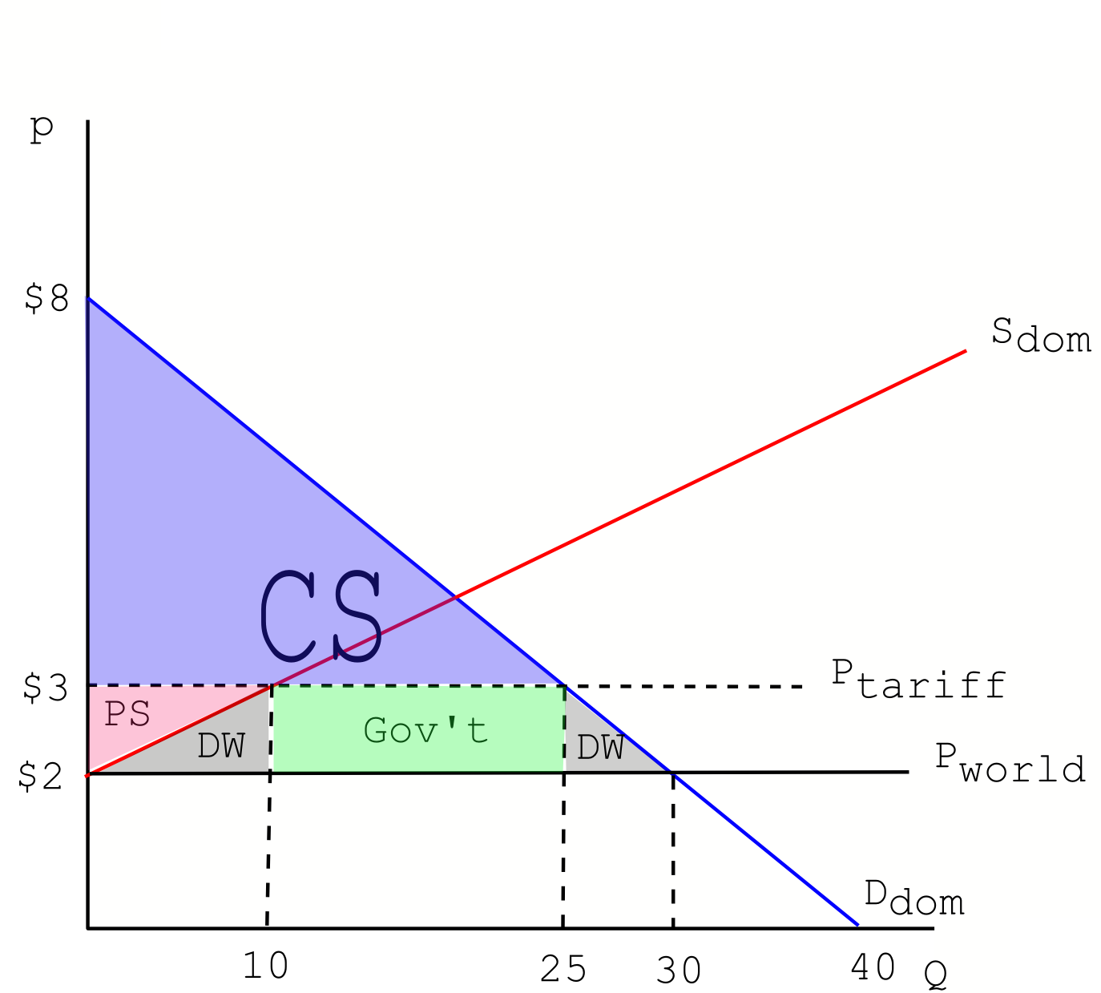

d) Suppose instead of a tariff, the US government decides to implement an import quota of 15 glow-in-the-dark golf balls. What will be the new price of glow-in-the-dark golf balls? How many glow-in-the-dark golf balls will be consumed domestically? How many glow-in-the-dark golf balls will be produced domestically? How many will be imported/exported? Calculate the new consumer and producer surplus, government revenue, license-holder revenue, and deadweight loss, if any. Illustrate your answer graphically.

All answers are the same as from part (c), except that Government Revenue is now $0, and what was previously Government Revenue is now Revenue to License-holders.

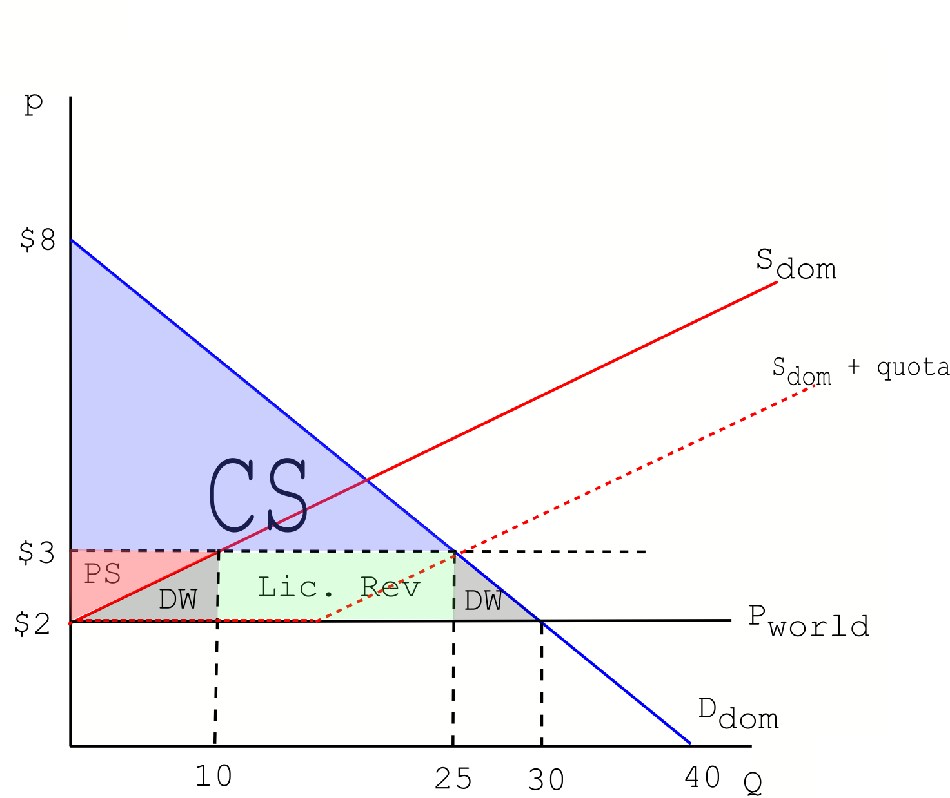

e) Suppose the US government decides to sell a single license to an importer granting the right to import and sell all the imported glow-in-dark golf balls up to the import quota of 15 golf balls. At most how much would a seller be willing to pay in order to purchase the license to sell glow-in-dark golf balls? Explain your answer.

An importer would be willing to pay no more than the revenue gained from selling the imported golf balls, that is, $15.

3. You are not required to illustrate your answers to this question, but it is never a bad idea. Suppose, circa 4th century BCE, the domestic demand in Macedon, for spears (specifically, sarisas) can be expressed by

Domestic Demand: Q = 10000 – 20P for 0 ≤ P ≤ 500; 0 for 500 ≤ P
Domestic Supply: Q = 25P – 1250 for 50 ≤ P; 0 for P ≤ 50

where Q is the number of spears, and P is the price of a spears in dollars (imagine for the moment that 4th century BCE Macedon used dollars as a currency).

a) Calculate the equilibrium price, quantity, consumer surplus and producer surplus for the domestic market for spears when Macedon is a closed economy (an autarky).

To find the equilibrium in the closed economy set domestic supply equal to domestic demand and solve. P* = $250 per spear, Q* = 5000 spears. Consumer surplus is the area under the demand curve and above the equilibrium price, or P = $250. Thus CS = (1/2)($500 per spear - $250 per spear)(250 spears) = $625,000. Producer surplus is the area of the triangle below P = $250 and above the supply curve. Thus PS = (1/2)($250 per spear - $50 per spear)(5000 spears) = $500,000.

b) Suppose Phillip II (the king) decides to open the market for spears in Macedon. Suppose the world price for a spear is $300. What will be the new price of spears? How many spears will be consumed domestically? How many spears will be produced domestically? How many spears will be imported/exported? Calculate the new consumer and producer surplus given this information.

The domestic price is now the world price, that is, $300 per spear. The Quantity demanded domestically is thus given by Q = 10000 – 20*300 = 4000 spears. The quantity supplied domestically is given by Q = 25*300 - 1250 = 6250 spears. Exports are given by the difference between the quantity supplied domestically and the quantity demanded domestically: thus, 2250 spears are exported by Macedon. Consumer surplus is the area of the triangle above P = $300 and below the demand curve. Thus Consumer Surplus = (1/2)($500 per spear - $300 per spear)(4000 spears) = $400,000. Producer surplus is the area of the triangle below P = $300 and above the supply curve. Thus, Producer Surplus = (1/2)($300 per spear - $50 per spear)(6250 spears) = $781,250.

Part III: Elasticity

4. This set of questions focuses on percentages and elasticity.
a) Suppose your hourly wage decreases from $25 to $20. What is the regular percentage decrease in your wage given this information?

The regular percentage decrease is equal to [(New Value – Initial Value)/(Initial Value)]*100 % or [(20 – 25)/25]*100 % = -20%

b) Suppose your hourly wage increases from $20 to $25. What is the regular percentage increase in your wage given this information?

The regular percentage increase is equal to [(New Value – Initial Value)/(Initial Value)]*100% or [(25 – 20)/20]*100 % = 25%

c) Suppose Mr R’s demand for pizza decreases from 10 pizzas to 7 pizzas when the price increases from $5 per pizza to $6 per pizza. What is his price elasticity of demand for pizza? Use the arc elasticity of demand formula to calculate this price elasticity of demand.

The arc elasticity of demand formula is:
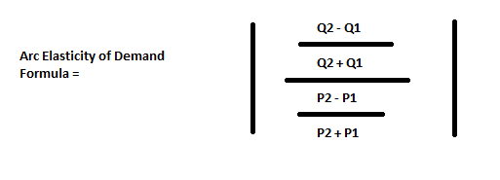
The given information allows us to identify (Q1, P1) = (10, 5) and (Q2, P2) = (7, 6). Plugging these values into the above formula, we get:
Arc Elasticity of Demand = │{[(7 – 10)/(7 + 10)]/[(6 – 5)/(6 + 5)]}│= [(3/17)/(1/11)] = 33/17 which is greater than 1 and therefore the price elasticity of demand for this example tells us that demand is elastic between these two points.

d) Mr R’s demand for sandwiches increases from 15sandwiches to 18 sandwiches when the price of pizza increases from $5 to $6. What is his cross price elasticity of sandwiches for pizza? Are these two goods complements or substitutes? Use the standard formula for percentage change to calculate this cross price elasticity value.

The cross price elasticity of demand formula is given by the following equation:

Cross price elasticity of demand = [(percentage change in the quantity demanded of good X)/(percentage change in the price of good Y)]

In this example good X are the sandwiches and good Y are the pizzas. Here is the calculation:

Cross price elasticity of demand = [(18 – 15)/15]/[(6 – 5)/5] = [(1/5)/(1/5)] = 1

This cross price elasticity of demand indicates that these two goods are substitutes.

e) In 2001 France uses the franc as national currency. The demand for cheese in France is 100 units of cheese when the price is 20 francs per unit of cheese and the demand for cheese is 130 units of cheese when the price of cheese decreases to 15 francs. What is the price elasticity of demand for cheese given this information? Use the arc elasticity formula to calculate this value.

The price elasticity of demand for cheese using the arc elasticity formula is given as
Price Elasticity of Demand for Cheese = {[(130 – 100)/(130 + 100)]/[(15 -20)/(15 + 20)]}│ = 21/23
Since the price elasticity of demand for cheese between these two points has a value less than one, this tells us that demand between these two points is inelastic.

f) In 2002, France starts using the euro as its currency. The exchange rate for francs to euro is 5 francs = 1 euro. So, in terms of euro, the demand for cheese is 100 when the price is 4 euros, and the demand becomes 130 when the price decreases to 3 euros. What is the price elasticity of demand for cheese given these new prices? Compare your results to part (e). Use the arc elasticity formula to calculate the price elasticity of demand.

The price elasticity of demand for cheese using the arc elasticity formula is given as
Price Elasticity of Demand for Cheese = {[(130 – 100)/(130 + 100)]/[(3 - 4)/(3 + 4)]}│ = 21/23
Since the price elasticity of demand for cheese between these two points has a value less than one, this tells us that demand between these two points is inelastic. In comparing our answers in (e) and (f) we find that the price elasticity of demand is the same despite changing from francs to euros. In general, price elasticity is invariant to currency.

g) Suppose you are a producer who knows with certainty that the demand for your product is given by the following linear demand curve equation where P is the price per unit and Q is the number of units demanded:
Demand: Q = 1000 – 10P
If maximizing revenue is your sole goal, what is the best price to charge demanders for this good? What quantity will be demanded at this price? And, what will be your total revenue?

Answer:
To maximize revenue, the producer who faces a downward sloping linear demand curve for her product should charge that price that corresponds to the midpoint on that demand curve. In this example that price would be $50 per unit and the quantity demanded at this price would be 500 units. Total revenue at this price and quantity would equal $25,000.

You might want to verify what happens to total revenue if the producer charges $40 or $60: at a price of $40 per unit, the quantity demanded is 600 units and therefore the total revenue is equal to $24,000; and, at a price of $60 per unit, the quantity demanded is 400 units and therefore the total revenue is equal to $24,000. This indicates that the producer will increase his revenue if he raises his price above $40 per unit and he will increase his revenue if he lowers his price below $60 per unit: he will maximize his revenue by charging $50 per unit.

Part IV: Real vs. Nominal Quantities

5. Consider the following table of nominal prices in a fictional version of Madison over time:

Year | Shirts | Bread | Diamonds
2009 | $25.00 | $5.00 | $100.00
2010 | $22.00 | $5.50 | $90.00
2011 | $22.50 | $6.00 | $92.00
2012 | $24.00 | $6.00 | $120.00
2013 | $23.00 | $6.50 | $115.00

S
uppose a typical consumer basket throughout the year consists of 5 shirts, 55 loaves of bread, and 1 diamond.

a) Using the above information, calculate the cost of the market basket for each of the given years and enter your calculations in the table below:
Year | Cost of Market Basket

Answer:
Cost of Market Basket in Year n = (Price of Shirt in Year n)(5 shirts) + (Price of loaf of bread in Year n)(55 loaves of bread) + (Price of Diamond in Year n)(1 diamond)

Year | Cost of Market Basket
2009 | $500
2010 | $502.50
2011 | $534.50
2012 | $570
2013 | $587.50

b) Using 2009 as the base year, calculate the CPI for each year using a 100 point scale.

CPI for year n = (Price of basket in year n / Price of basket in base year)*100

Year | CPI with base year 2009
2009 | 100
2010 | 100.5
2011 | 106.9
2012 | 114
2013 | 117.5

c) Using the CPI calculated in part (b), calculate the annual rate of inflation starting with the annual rate from 2009 to 2010.

% Inflation = (CPI this year – CPI last year)/(CPI last year)

Year | Inflation
2009 | -
2010 | 0.50%
2011 | 6.37%
2012 | 6.64%
2013 | 3.07%

d) Using the CPI calculated in part (b), calculate the real price of diamonds in 2012 (out to two places past the decimal) using 2009 dollars (that is, you are converting the 2012 price of diamonds measured in 2012 dollars into the 2012 price of diamonds measured in 2009 dollars).

Answer:
Recall from the class lecture that real price = (Nominal Price/Inflation Index) * 100 where the CPI is an example of an Inflation Index. Thus,
Real Price = (Nominal Price /CPI)*100 = (120/114)*100 = $105.63

e) Suppose we do not know the nominal price of shirts in 2008, but we do know that a loaf of bread cost $4.00 and a diamond cost $60.00. Additionally, we know that the rate of inflation from 2008 to 2009 was 25%. What was the cost of a shirt in 2008? To answer this question you should assume that the defined market basket has not changed and that you have access to all the data provided or calculated in the problem thus far.

Let C denote the CPI in 2008. We know the rate of inflation from 2008 to 2009 was 25% and that the CPI in 2009 was 100. Thus we can say

1.25C = 100
C = 80

Let P denote the price of a shirt. Then we have

(5*P + 55*4 + 60)/500 = C/100 = 0.8
P = $24 per shirt

f) Describe a procedure to compare the cost of living in Madison to the cost of living in Chicago for a given year.

Define a typical market basket for both cities. Then take the ratio

Price in Chicago / Price in Madison = R

If R > 1, we can say that the costs of living in Chicago are higher; if R < 1, then we can say that the costs of living are higher in Madison; if R = 1, the costs of living are essentially equal in the two cities based on the chosen market basket.

V. Surfing the Web, Data Sets, and Occupational Choice:

6. Professor Kelly and her husband are working on a new blog for people interested in economics but who are not career economists. So, for this question we have you going to the web and doing a bit of reading and then some research. Here are the directions:

Go on the web and google “Life’s Curiosities: An Economist’s Perspective”.

Once you are on this page click on “Careers” and read “Is There Data Available to Help You Evaluate Occupational Choices?”

Once you have read this entry in its entirety go to the websites that are mentioned and research a potential career of interest to you. Then, answer the following questions.

a) What career did you pick? Why did you pick it?

b) What was the “outlook” for the career you picked? What does this “outlook” mean? Were you aware of this “outlook” for the career you selected?

c) Determine the level of income earned in this occupation in a particular state (tell us what state you are choosing) by the bottom 10% of the people working in this occupation, the median income, and the income earned by the 90 percentile. Put this information into a nice organized table.

d) Write a paragraph about what you learned by doing this reading and this research.

e) Was this a helpful exercise for you-that is, did you find it interesting, revealing, and helpful? Explain your answer beyond a simple “Yes”, “No”, or “Whatever”.

Note: it would be really surprising if everyone in the class research an occupation starting with the letter “A”; it would be really strange if the same occupation kept coming up on every student’s paper…so, you can work with a friend, but you better pick a separate, and different, occupation to research!

Note: if you found this interesting and fun, let Prof. Kelly know: she would like to use all 800 of you as a kind of “focus group” in what she hopes is a good experience for people who are thinking about their career paths!

Answer:
There is no one answer to this question. This question is meant to introduce you to some existent data that has been collected and that is potentially helpful to people who are in the midst of planning their career paths.

