Economics 101
Summer 2013
Answers to Homework #2
Due Tuesday, June 4, 2013

Directions: The homework will be collected in a box before the lecture. Please place your name, TA name and section number on top of the homework (legibly). Make sure you write your name as it appears on your ID so that you can receive the correct grade. Late homework will not be accepted so make plans ahead of time. Please show your work. Good luck!

Please realize that you are essentially creating “your brand” when you submit this homework. Do you want your homework to convey that you are competent, careful, professional? Or, do you want to convey the image that you are careless, sloppy, and less than professional. For the rest of your life you will be creating your brand: please think about what you are saying about yourself when you do any work for someone else!

- Each of the following situations is independent of the other situations. For each draw a graph illustrating the situation and do the requested analysis.
  - Consider the market for soft drinks that is initially in equilibrium with a market price of P1 and a market quantity of Q1. Suppose there is a successful campaign to educate the public about the caloric values in soft drinks and their contribution to obesity. At the same time suppose that the price of corn syrup, a key ingredient in many soft drinks, rises. Draw a graph illustrating the initial equilibrium and the new equilibrium after these described changes. Provide a verbal description of the outcome in this market due to these changes.
  - Consider the market for mass transit that is initially in equilibrium with a market price of P1 and a market quantity of Q1. Suppose that after Hurricane Sandy swept through the Atlantic states that New York City officials mandated that all cars coming into New York City must have at least three occupants at all times, otherwise individuals wishing to travel in New York City would need to take mass transit during the weeks of clean-up from this storm. Analyze the impact of this edict from city officials on the market for mass transit. Provide a graph of your analysis and also a verbal description of how the equilibrium price and equilibrium quantity responded to this edict.
  - Consider the market for gasoline that is initially in equilibrium with a market price of P1 and a market quantity of Q1. Suppose that there is a war in the Middle East that disrupts petroleum production (petroleum is a major input to the production of gasoline) while at the same time people’s incomes in the United States increases. Assume gasoline is a normal good. Draw a graph illustrating the initial equilibrium and the new equilibrium after these described changes. Provide a verbal description of the outcome in this market due to these changes.
  - Consider the market for noodles that is initially in equilibrium with a market price of P1 and a market quantity of Q1. Noodles are an inferior good. Suppose that people’s incomes fall due to the financial crisis. Draw a graph illustrating the initial equilibrium and the new equilibrium after the described changes. Provide a verbal description of the outcome in this market due to these changes.
Answers:
- The market demand curve for soft drinks will shift to the left and the market supply curve will shift to the left as well: equilibrium quantity will decrease and the equilibrium price may rise, fall, or remain the same. The graphs below illustrate this idea.
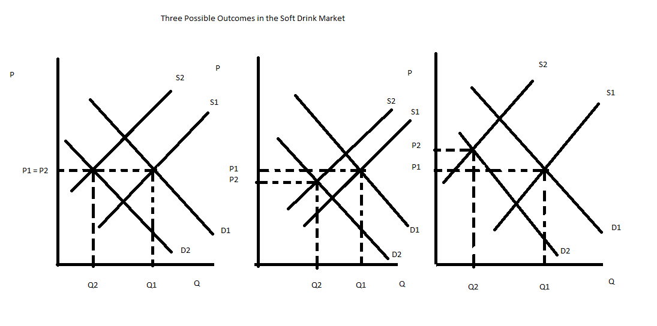
- The market demand curve for mass transit will shift to the right and the market supply will be unchanged: equilibrium quantity will increase and the equilibrium price will increase. The graph below illustrates this idea.
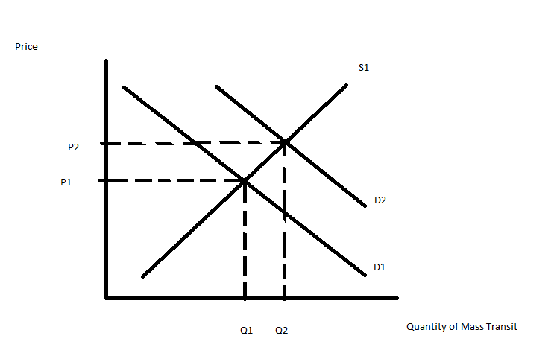
- The market demand curve for gasoline will shift to the right while the market supply curve for gasoline will shift to the left: the equilibrium quantity may rise, fall or stay the same while the equilibrium price will increase. The graphs below illustrate this idea.
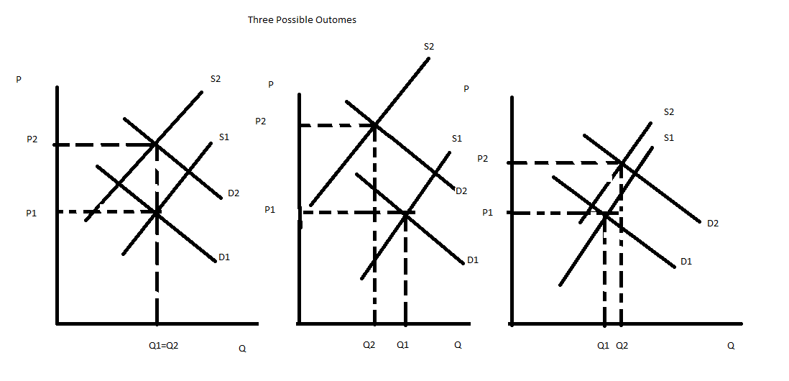
- The market demand curve will shift to the right and the market supply curve will be unchanged. The equilibrium price of noodles will increase as will the equilibrium quantity of noodles. The graph below illustrates this example.
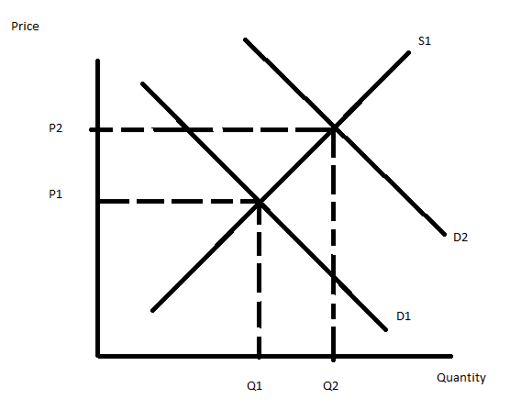

- Problem 2 consists of two different scenarios requiring you to find the market demand curve.
  - Joe, Mary, and Ellen all have the same individual demand curve for peanuts. This demand curve is P = 10 - Q. They are the only consumers of peanuts in the market.
    - Draw four graphs horizontally lined up with one another. In the first graph draw Joe’s demand curve, in the second graph draw Mary’s demand curve, in the third graph draw Ellen’s demand curve, and in the fourth graph draw the market demand curve. Be sure to identify any intercept values as well as any “kink” values in the four graphs.
    - From the graphs in (i) write an equation in slope intercept form for the market demand curve.
    - Show algebraically how you could find the market demand curve.

  - Paul, Chris and Jon have different demand curves for popcorn. Paul’s demand curve is P = 10 – Q; Chris’ demand curve is P = 8 – Q; and Jon’s demand curve is P = 6 – Q. They are the only consumers of popcorn in the market.
    - Draw four graphs horizontally lined up with one another. In the first graph draw Paul’s demand curve, in the second graph draw Chris’ demand curve, in the third graph draw Jon’s demand curve, and in the fourth graph draw the market demand curve. Be sure to identify any intercept values as well as any “kink” values in the four graphs.
    - From the graphs in (i) write an equation in slope intercept form for the market demand curve.
    - Show algebraically how you could find the market demand curve.

Answer:

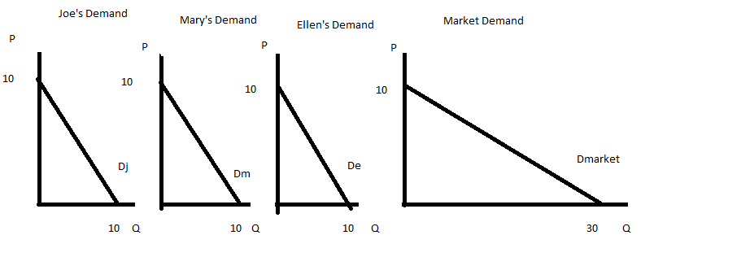
  - P = 10 – (1/3)Q
  - To find the equation algebraically, rewrite each market demand curve in x-intercept form: Q = 10 – P for Joe, Ellen and Mary. Then, add the quantities together to get the market quantity: Qj + Qm + Qe = Qmarket. Or, Qmarket = 10 – P + 10 – P + 10 – P. This gives us Qmarket = 30 – 3P and solving for P we get P = 10 – (1/3)Qmarket as our market demand curve.

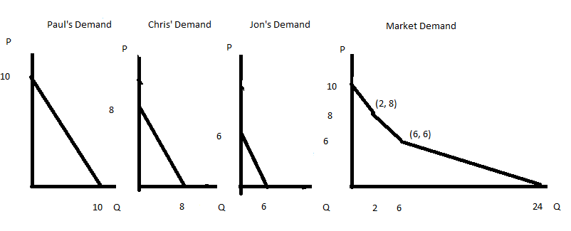
  - The market demand curve this time is composed of three different segments. For prices between 8 and 10, the demand curve is P = 10 – Q; for prices between 6 and 8, the demand curve is P = 9 – (1/2)Q; and for prices between 0 and 6, the demand curve is P = 8 – (1/3)Q.
  - To find the demand curve algebraically first rewrite each individual demand curve is x-intercept form: Paul’s demand is Qp = 10 – P; Chris’ demand is Qc = 8 – P; and Jon’s demand is Qj = 6 – P. The market demand for prices between 8 and 10 consists only of Paul’s demand curve: so Qmarket = Qp = 10 – P or the market demand is P = 10 – Q. The market demand for prices between 6 and 8 consists of Paul’s demand curve and Chris’ demand curve: so Qmarket = Qp + Qc. Or, Qmarket = 10 – P + 8 – P = 18 – 2P. Rewriting this we get P = 9 – (1/2)Qmarket. The market demand for prices between 0 and 6 consists of Paul’s demand curve, Chris’ demand curve and Jon’s demand curve: so Qmarket = Qp + Qc + Qj. Or, Qmarket = 10 – P + 8 – P + 6 – P = 24 – 3P. Rewriting this we get P = 8 – (1/3)Qmarket.

- Problem 3 consists of two different scenarios requiring you to find the market supply curve.
  - The market supply curve is given as P = 100 + 2Q. Several new firms enter this market and now you are told that at each price there are now 50 more units of the good available. What is the equation for the new market supply curve?
  - Firm A’s supply curve is P = 2Q and Firm B’s supply curve is P = 10 + 2Q. There are only these two firms in the market.
    - Draw three graphs horizontally lined up with one another. In the first graph draw Firm A’s supply curve, in the second graph draw Firm B’s supply curve, and in the third graph draw the market supply curve. Be sure to identify any intercept values as well as any “kink” values in the three graphs.
    - From the graphs in (i) write an equation in slope intercept form for the market supply curve.
    - Show algebraically how you could find the market supply curve.
Answer:
- From the information given we know the market supply curve initially and can easily find two points that sit on this curve: for example, (0, 100) and (50, 200) both sit on this supply curve. The new supply curve has shifted to the right by 50 units: this implies that the new supply curve is parallel to the initial supply curve and therefore has the same slope. The new supply curve would therefore contain the points (50, 100) and (100, 200). So, the new supply curve is P’ = b’ + 2Q’ where b’ is the new y-intercept for this supply curve. To find the value of b’, use one of the points you know that sit on the new supply curve and this equation: thus, 100 = b’ + 2(50) or b’ = 0. The new supply curve is P’ = 2Q’.

  - Qw
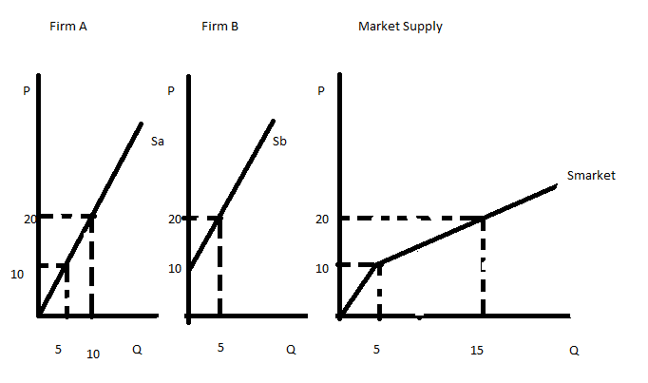
  - For prices between 0 and 10, the market supply curve is P = 2Q. For prices equal to and greater than 10, the market supply curve is P = 5 + Q.
  - To find the market supply algebraically first rewrite the two firm supply curves in x-intercept form: Qa = (1/2)P and Qb = (1/2)P – 5. Then, for prices less than 10, the market supply curve is just firm A’s supply curve: thus, the market supply is P = 2Q. But for prices equal to or greater than 10, Qmarket = Qa + Qb since both firms are willing to supply the good to the market if the price is equal to $10 or greater than $10. Thus, Qmarket = (1/2)P + (1/2)P – 5. Or, Qmarket = P – 5. Rearranging this in y-intercept form we have P = Q + 5 as the market supply curve.

- Consider the market for smart phones. Initially the market demand for these phones is given as P = 500 – .005Q and the market supply for these phones is given as P = .005Q. For all questions in this problem make sure you show your work and not just your final answer.
  - Given this information, what is the equilibrium price and equilibrium quantity of smart phones in this market?
  - What is the value of consumer expenditure on smart phones given this initial information?
  - What is the value of consumer surplus in the market for smart phones?
  - What is the value of producer surplus in the market for smart phones?
Now, suppose that tastes and preferences for smart phones changes so that at every price an additional 20,000 phones are demanded. There are no changes in the market supply curve.
  - Given this information, what is the new equilibrium price and equilibrium quantity of smart phones in this market?
  - Given this new information, what is the value of consumer expenditure on smart phones in this market?
  - What is the new value of consumer surplus in the market for smart phones given this change in tastes and preferences?
  - What is the new value of producer surplus in the market for smart phones given this change in tastes and preferences?

Answers:
- To find the equilibrium quantity set the market demand curve equal to the market supply curve: 500 - .005Q = .005Q or Q = 50,000. Use this quantity in either the demand or supply curve to find the equilibrium price: P = 500 - .005(50,000) = $250.
- Consumer expenditure in this problem will be equivalent to total revenue. This implies that consumer expenditure can be found by multiplying the equilibrium price times the equilibrium quantity. Thus, consumer expenditure = ($250 per smart phone)(50,000 smart phones) = $12,500,000.
- Consumer surplus = CS = (1/2)($500 per smart phone - $250 per smart phone)(50,000 smart phones) = $6,250,000.
- Producer surplus = PS = (1/2)($250 per smart phone - $0 per smart phone)(50,000 smart phones) = $6, 250,000.
- To find the new equilibrium price and equilibrium quantity of smart phones you need to first find the new demand curve. You know from the given information that the demand curve has shifted to the right by 20,000 units at every price: the new demand curve is therefore parallel to the initial demand curve. This implies that the two demand curves have the same slope. You also know that the point (120,000 smart phones, $0 per smart phone) sits on the new market demand curve. Use this point and the slope of the original demand curve to find the new demand curve: P = 600 - .005Q. Once you have the new marked demand curve use this demand curve and the supply curve to find the new equilibrium price and equilibrium quantity in the market. Thus, 600 - .005Q = .005Q or Q = 60,000 smart phones. Plug this quantity back into the new market demand curve or the supply curve to find the equilibrium price: P = 600 - .005(60,000) = $300 per smart phone.
- Consumer expenditure in this problem will be equivalent to total revenue. This implies that consumer expenditure can be found by multiplying the equilibrium price times the equilibrium quantity. Thus, consumer expenditure = ($300 per smart phone)(60,000 smart phones) = $18,000,000.
- Consumer surplus = CS = (1/2)($600 per smart phone - $300 per smart phone)(60,000 smart phones) = $9,000,000.
- Producer surplus = PS = (1/2)($300 per smart phone - $0 per smart phone)(60,000 smart phones) = $9,000,000.

- Consider the market for soybeans in Smallia. The market demand is given as P = 1000 – 2Q while the market supply is given as P = 200 + 6Q. Assume that the market for soybeans in Smallia is closed to international trade. For each of the following questions please show your work and not just your final answer.
  - Given the above information, what is the equilibrium price and equilibrium quantity in this market?
  - What is the value of consumer surplus in this market given the above information?
  - What is the value of producer surplus in this market given the above information?
Now suppose that the government of Smallia implements a price floor in the market for soybeans and this price floor is set at $500 per unit of soybeans.
  - Describe the impact of this price floor on the market for soybeans and in your answer explain why this is the impact.
The government decides to institute a price ceiling in this market for soybeans instead of the price floor. The government sets this price ceiling at $400.
  - Describe verbally (no numbers needed here) the impact of this price ceiling on the market for soybeans and in your answer explain why this is the impact.
  - Now determine how many units of soybeans will actually be traded in this market given this price ceiling.
  - What is the value of consumer surplus given this price ceiling?
  - What is the value of producer surplus given this price ceiling?

Answer:
- 1000 – 2Q = 200 + 6Q or 800 = 8Q and therefore Q = 100 units of soybeans. P = 1000 – 2(100) = $800 per unit of soybeans.
- CS = (1/2)($1000 per unit of soybeans - $800 per unit of soybeans)(100 units of soybeans) = $10,000
- PS = (1/2)($800 per unit of soybeans - $200 per unit of soybeans)(100 units of soybeans) = $30,000
- This price floor will have no impact on this market. For a price floor to be effective it must be set at a level that is greater than the equilibrium price in the market since a price floor is a minimum price that can be charged for the good. If the price floor is set at a level below the equilibrium price then consumers will continue to pay this equilibrium price and producers will continue to charge this equilibrium price and the price floor will not have any impact on the market.
- A price ceiling represents a maximum price that can be charged for a good. For a price ceiling to be effective it must be set below the equilibrium price in the market. In this example the price ceiling is effective since its level ($400 per unit of soybeans) is less than the equilibrium price of $800 in this market. When a price ceiling is effective there will be excess demand at the price ceiling price since suppliers will supply fewer units than the number of units demanded by consumers.
- With a price ceiling of $400 per unit of soybeans suppliers will be willing to supply 33.3 units of soybeans while consumers will demand 300 units of soybeans. There will be an excess demand of 266.7 units. The market will only supply 33.3 units of soybeans given this price ceiling.
- Note this CS has a different shape than the usual CS: it is composed of a triangle plus a rectangle. You will see this if you take the time to sketch a graph of the price ceiling and the market demand and market supply curves. CS with price ceiling = (1/2)($1000 per unit of soybeans - $933.40 per unit of soybeans)(33.3 units of soybeans) + ($933.40 per unit of soybeans - $400 per unit of soybeans)(33.3 units of soybeans) = $18,871.11.
- PS = (1/2)($400 per unit of soybeans - $200 per unit of soybeans)(33.3 units of soybeans) = $3330.

- Suppose the market for corn in Utopia has market demand of P = 1000 – 2Q and market supply of P = 200 + 6Q. Assume the market for corn in Utopia is a closed market. Use this information to answer this set of questions. Make sure you show all of your work and do not just provide your final answer.
  - Given the above information, what is the equilibrium price and equilibrium quantity in this market? What is total farmer revenue in this market?

Suppose the government implements a price floor of $900 per unit of corn in this market where the government agrees to maintain this price floor by purchasing any excess supply at the price floor price.

  - Given this price floor, how many units of corn will be purchased by consumers? How many units of corn will be supplied by farmers in Utopia? How many units of corn will be purchased by the government?
  - Given this price floor what will be the direct cost to the government of implementing this price floor?
Suppose that the cost of storing each unit of corn is $100 per unit for the year.
  - Given this information and the described price floor what will be the total cost to the government of implementing this price floor?
  - Given the price floor what is total farmer revenue from selling corn in this market?
Now, suppose the government replaces the price floor program with a subsidy or price guarantee program. Furthermore, suppose that the price guarantee is $900 per unit of corn.
  - Given this information and the price guarantee program, how many units of corn will consumers purchase? What price will consumers pay for this corn?
  - Given this information and the price guarantee program, how many units of corn will be purchased by the government?
  - Given this information and the price guarantee program, what will be the cost to the government of this program?
  - Comparing the two different policies, the price floor or the price guarantee, which of these two programs will corn farmers in Utopia prefer and why will they prefer it?
  - Comparing the two different policies, the price floor or the price guarantee, which of these two programs will the government of Utopia prefer and why will they prefer it?

Answers:
- The equilibrium price in this market will be $800 per unit of corn and the equilibrium quantity in this market will be 100 units of corn. Farm revenue is equal to ($800 per unit of corn)(100 units of corn) = $80,000.
- Given the price floor, we can determine the number of units of corn purchased by consumers by using the market demand curve and the price floor price: 900 = 1000 – 2Q or Q = 50 units of corn. We can determine the number of units of corn supplied by farmers by using the market supply curve and the price floor price: 900 = 200 + 6Q or Q = 116.67 units of corn. We can determine the number of units of corn purchased by the government by recognizing that the government will purchase the excess supply when the price is $900: thus, Excess Supply = Q supplied by farmers – Q demanded by consumers = 116.67 – 50 = 66.67 units of corn.
- The direct cost to the government of implementing this price floor will equal (the price floor price)(number of units of corn purchased by the government) = $900 per unit of corn)(66.67 units of corn) = $60,030.
- The total cost to the government of implementing this price floor will equal the sum of the direct costs ($60,030) and the storage costs ((storage cost per unit)(number of units of corn stored) = ($100 per unit of corn)(66.67 units of corn)). Or, $60,030 + $6667 = $66,697.
- Farm revenue from the price floor will be equal to ($900 per unit of corn)(116.67 units of corn) or $105,003. This is clearly more farm revenue than farmers got prior to the government’s intervention in the market: farmers sell more units of the good at a higher price per unit.
- Given the price guarantee program, consumers will purchase the number of units of corn that suppliers are willing to provide when they are guaranteed a price of $900 per unit of corn. Using the market supply curve, we find that consumers will purchase 900 = 200 + 6Q or Q = 116.67 units of corn. To find the price consumers will pay for the corn, use the market demand curve. This will enable you to find out what price consumers are willing to pay per unit when they consume 116.67 units of corn. Thus, P = 1000 – 2Q = 1000 – 233.34 = $766.66 per unit of corn.
- Under a price guarantee program the government does not buy any of the product. Instead the price guarantee program guarantees the producers a certain price but then tells them to sell the product at whatever price they must in order to get rid of the product.
- The government will pay a subsidy per unit of corn consumed: this subsidy per unit will equal the difference between the guaranteed price and the price consumers are willing to pay when they consume 116.67 units of corn. Thus, ($900 per unit of corn - $766.66 per unit of corn) is the subsidy per unit of corn. To find the total cost to the government of this program you need to multiple the subsidy per unit of corn times the number of units of corn produced by farmers. Thus, ($900 per unit of corn - $766.66 per unit of corn)(116.67 units of corn) = $15,556.78.
- Total farm revenue under the price guarantee is ($900 per unit of corn)(116.67 units of corn) = $105,003 while total farm revenue under the price floor is $105,003. The two programs are equivalent from the farmers’ perspective.
- The government will prefer the price guarantee program in this example since the cost to the government of this program is $15,556.78 while the cost of the price floor program is $66,697. This is not always the outcome with these two programs, but is does illustrate that the cost to the government for two different programs may not be the same.

- Romia is a small, closed economy that produces pianos. Currently the domestic demand for pianos in Romia is given by the equation P = 2000 – 2Q while the domestic supply for pianos in Romia is given by the equation P = 200 + 4Q.
  - Given the above information calculate the equilibrium price and equilibrium quantity in the market for pianos in Romia. Then, calculate the value of consumer surplus (CS) and producer surplus (PS).

Suppose that Romia is considering opening its piano market to trade and that the world price of pianos is $1500.

  - Given this information, analyze the effect on Romia of opening its piano market to trade. In your answer be sure to comment on how this decision will impact imports or exports of pianos in Romia while also commenting on how many pianos domestic consumers will purchase if the market opens to trade and how many pianos domestic producers will produce if the market opens to trade. In addition, calculate the values of CS with trade and PS with trade.
  - Is opening this market to trade beneficial for Romia? Fully explain your answer to this question.

Suppose that Romia is considering opening its piano market to trade and that the world price of pianos is $800.

  - Given this information, analyze the effect on Romia of opening its piano market to trade. In your answer be sure to comment on how this decision will impact imports or exports of pianos in Romia while also commenting on how many pianos domestic consumers will purchase if the market opens to trade and how many pianos domestic producers will produce if the market opens to trade. In addition, calculate the values of CS with trade and PS with trade.
  - Is opening this market to trade beneficial for Romia? Fully explain your answer to this question.

Now, suppose the market for pianos in Romia is opened to trade and the world price is $800 per piano. Use this information and the equations for the domestic demand and domestic supply curves to answer the net set of questions.

  - Given this information, suppose you are told that the government has enacted a tariff that resulted in the government receiving $60,000 in tariff revenue. By how much did the tariff raise the price of pianos given this information? Hint: if you do this correctly you should find that there are two different tariffs that Romia could apply in this market to get this level of tariff revenue.
  - Given your two answers in (f) go back and calculate the value of imports under each tariff price and then prove numerically that both tariffs result in tariff revenue of $60,000.

Answer:
- The equilibrium price in the market for pianos in Romia is $1400 while the equilibrium quantity is 300 pianos. To find these equilibrium values use the given domestic demand and domestic supply curves. The value of CS = (1/2)($2000 per piano - $1400 per piano)(300 pianos) = $90,000. The value of PS = (1/2)($1400 per piano - $200 per piano)(300 pianos) = $180,000.
- If this market opens to trade and the world price of pianos is $1500, then domestic consumers will demand 250 pianos at this price (P = 2000 – 2Q and then 1500 = 2000 – 2Q and therefore the quantity demanded domestically is 250 pianos) and domestic producers will supply 325 pianos at this price (P = 200 + 4Q and then 1500 = 200 + 4Q and therefore the quantity supplied domestically is 325 pianos). Since the quantity supplied domestically is greater than the quantity demanded domestically, Romia will have an excess supply of pianos at a price of $1500 per piano. The excess supply of 75 pianos (325 pianos – 250 pianos or 75 pianos) will be exported and sold to buyers elsewhere in the world for a price of $1500 per piano. CS with trade will now equal (1/2)($2000 per piano - $1500 per piano)(250 pianos) = $62,500. PS with trade will now equal (1/2)($1500 per piano - $200 per piano)(325 pianos) = $211,250.
- Yes, opening this market to trade is beneficial since total surplus (TS) increases from $270,000 to $273,750 when this market is opened to trade. However, there are winners and losers when this market opens to trade: domestic consumers will find that they are buying fewer pianos and paying a higher price for each piano while domestic producers will find that they are selling more pianos and receiving a higher price for each piano. Domestic consumers will find that their consumer surplus is lower with trade while domestic producers will find that their producer surplus is higher with trade.
- If this market opens to trade and the world price of pianos is $800, then domestic consumers will demand 600 pianos at this price (P = 2000 – 2Q and then 800 = 2000 – 2Q and therefore the quantity demanded domestically is 600 pianos) and domestic producers will supply 150 pianos at this price (P = 200 + 4Q and then 800 = 200 + 4Q and therefore the quantity supplied domestically is 150 pianos). Since the quantity supplied domestically is less than the quantity demanded domestically, Romia will have an excess demand for pianos at a price of $800 per piano. The excess demand of 450 pianos (600 pianos – 150 pianos or 450 pianos) will be imported and sold to domestic buyers in Romia for a price of $800 per piano. CS with trade will now equal (1/2)($2000 per piano - $800 per piano)(600 pianos) = $360,000. PS with trade will now equal (1/2)($800 per piano - $200 per piano)(150 pianos) = $45,000.
- Yes, opening this market to trade is beneficial since total surplus (TS) increases from $270,000 to $405,000 when this market is opened to trade. However, there are winners and losers when this market opens to trade: domestic consumers will find that they are buying more pianos and paying a lower price for each piano while domestic producers will find that they are selling fewer pianos and receiving a lower price for each piano. Domestic consumers will find that their consumer surplus is greater with trade while domestic producers will find that their producer surplus is lower with trade.
- To find the price with the tariff in this question is a really bit hard. Let’s first start by rewriting the domestic demand curve in x-intercept form: P = 2000 – 2Q can be rewritten as Q domestic demand = 1000 – (1/2)P. Let’s also rewrite the domestic supply curve in x-intercept form: P = 200 + 4Q can be rewritten as Q domestic supply = (1/4)P – 50. Then, think about the relationship between the tariff revenue, the world price, the price with the tariff, the quantity demanded domestically and the quantity supplied domestically. We could write this as Tariff Revenue = (Q demanded domestically – Q supplied domestically)(Price with the tariff – World Price). Then, let’s plug in the values or relationships we know: $60,000 = (Q demanded domestically – Q supplied domestically)(Price with the tariff – 800). But, we also know Q demanded domestically and Qsupplied domestically from our domestic demand and domestic supply equations respectively. So, 60,000 ={[ (1000 – (1/2)P] – [(1/4)P – 50]}( P – 800). Now, the math gets a little bit tedious and so let’s switch to a line per math manipulation.
60,000 = (1050 – (3/4)P)(P – 800)
60,000 = 1050P – (3/4)P² - 1050(800) + (3/4)P(800)
60,000 = 1650P – (3/4)P² – (1050)(800)
0 = (3/4)P² – 1650P – 900,000
0 = P² – 2200P + 1,200,000
Now, let’s factor this equation to find the two roots that will solve the equation:
0 = (P – 1200)(P – 1000)
Or, 0 = P – 1200 implies that P = 1200 or 0 = P – 1000 implies that P = 1000. So, when the tariff increases the world price to $1200 per piano or when the tariff increases the world price to $1000, the government will collect $60,000 in tariff revenue.
- Let’s start with a tariff that raises the price of pianos to $1200 in Romia. At a price of $1200, domestic demand will equal 400 pianos while domestic supply will equal 250 pianos and therefore Romia will import 150 pianos. Each of these imported pianos will pay the tariff of $400 per piano (the difference between the tariff price of $1200 per piano and the world price of pianos of $800). Tariff revenue will therefore equal ($400 per piano)(150 pianos) = $60,000.
Now, let’s try the same thing with a tariff that raises the price of pianos to $1000 in Romia. At a price of $1000, domestic demand will equal 500 pianos while domestic supply will equal 200 pianos and therefore Romia will import 300 pianos. Each of these imported pianos will pay the tariff of $200 per piano (the difference between the tariff price of $1000 per piano and the world price of pianos of $800). Tariff revenue will therefore equal ($200 per piano)(300 pianos) = $60,000.
- Consider the small, closed economy of Exurbia. Exurbia produces mittens and the domestic market demand and domestic market supply curves for mittens in Exurbia are as follows where Q is pairs of mittens and P is the price per pair of mittens:
Domestic Demand: Q = 20,000 – 2000P
Domestic Supply: Q = 2000P – 4000
  - For the closed economy of Exurbia calculate the equilibrium price and equilibrium quantity of mittens, as well as the value of consumer surplus (CS) and producer surplus (PS). Then draw and label a graph depicting the closed market for mittens in Exurbia.
  - Now, suppose that the economy of Exurbia opens its mittens market to trade. Furthermore suppose that the world price of mittens is $3 per pair of mittens. Find the level of imports when Exurbia opens this market to trade. In addition find the quantity demanded domestically, the quantity supplied domestically, the value of CS with trade, and the value of PS with trade. Then draw and label a graph depicting the open market for mittens in Exurbia. Is opening this market to trade beneficial for Exurbia? Explain your answer.
  - Now, after opening this market to trade, the government of Exurbia decides to implement a quota in this market. They decide to impose a quota of 2000 pairs of mittens in this market. Find the level of imports when Exurbia opens this market to trade and imposes this quota. In addition find the quantity demanded domestically, the quantity supplied domestically, the value of CS with the quota, the value of PS with the quota, the license holder revenue due to the quota, and the deadweight loss associated with the quota. Then draw and label a graph depicting this quota in the market for mittens in Exurbia.

Answer:
- To find the equilibrium price and equilibrium quantity of mittens in Exurbia use the provided domestic demand and domestic supply curves. Thus,
20,000 – 2000P = 2000P – 4000
24,000 = 4000P
P = $6 per pair of mittens
Q = 20,000 – 2000(6) = 8,000 pairs of mittens
CS with a closed economy = (1/2)($10 per pair of mittens - $6 per pair of mittens)(8000 pairs of mittens) = $16,000
PS with closed economy = (1/2)($6 per pair of mittens - $2 per pair of mittens)(8000 pairs of mittens) = $16,000
The graph below represents this closed economy.
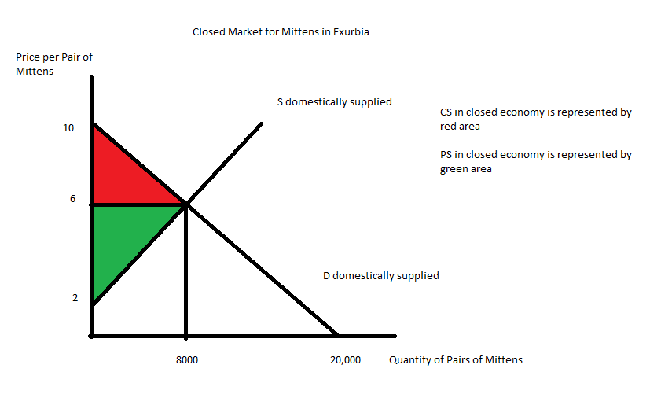
- Now the mitten market is open to trade with the world price of $3 per pair of mittens. When the price is $3 per pair of mittens, the quantity demanded domestically is equal to:
Q demanded domestically = 20,000 – 2000(3) = 14,000 pairs of mittens
When the price is $3 per pair of mittens, the quantity supplied domestically is equal to:
Q supplied domestically = 2000(3) – 4000 = 2000 pairs of mittens
Exurbia will import the difference between the quantity demanded domestically and the quantity supplied domestically or
Imports = 14,000 – 2,000 = 12,000
CS with trade = (1/2)($10 per pair of mittens - $3 per pair of mittens)(14,000 pairs of mittens) = $49,000
PS with trade = (1/2)($3 per pair of mittens - $2 per pair of mittens)(2000 pairs of mittens) = $1000
Opening this market to trade is beneficial since the area of total surplus (CS with trade + PS with trade) is greater than the area of total surplus (CS + PS) when the economy is a closed economy. Domestic consumers consume more of the good and purchase it at a lower price when the market is open to trade: opening this market to trade provides positive distributional consequences to domestic consumers. Domestic producers sell fewer units of the good and sell it at a lower price when the market is open to trade: opening this market to trade provides negative distributional consequences to domestic producers.
Here is a graph representing this market when it opens to trade:
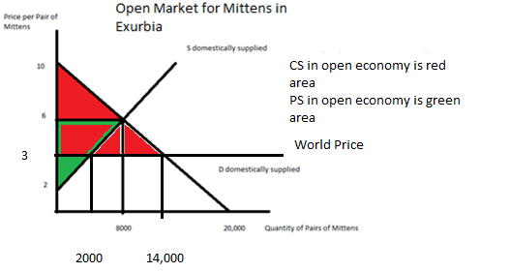
- Now the market is open to trade but with a quota of 2000 units. So, we know that the quantity supplied domestically plus the quota is equal to the quantity demanded domestically. Or,
Q _{supply domestic} + quota = Q _{demand domestic}
Or, 2000P – 4000 + 2000 = 20,000 – 2000P
4000P = 22,000
P = $5.50 per pair of mittens
Q _{supply domestic} = 2000P – 4000 = 2000(5.50) – 4000 = 7,000 pairs of mittens
Q _{demand domestic} = 20,000 – 2000P = 20,000 – 2000(5.5) = 9,000 pairs of mittens
Imports = Quantity demanded domestically with the quota – Quantity supplied domestically with the quota = 9,000 – 7,000 = 2,000 = amount of the quota
CS with quota = (1/2)($10 per pair of mittens - $5.50 per pair of mittens)(9,000 pairs of mittens) = $20,250
PS with quota = (1/2)($5.50 per pair of mittens - $2 per pair of mittens)(7,000 pairs of mittens) = $12,250
License Holder Revenue = ($5.50 per pair of mittens - $3 per pair of mittens)(2000 pairs of mittens) = $5000
Deadweight Loss due to the quota = DWL = (1/2)($5.50 per pair of mittens - $3 per pair of mittens)(7000 pairs of mittens – 2000 pairs of mittens) + (1/2)($5.50 per pair of mittens - $3 per pair of mittens)(14,000 pairs of mittens – 9,000 pairs of mittens) = $12,500
Here is a graph representing this quota:
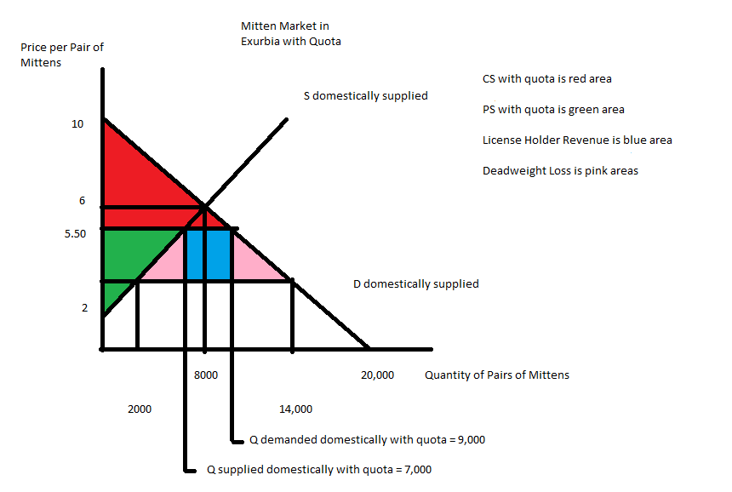
- In Boomtown government officials are considering implementing an excise tax on the producers of tennis balls. They have called you in to analyze the impact of this proposed tax. Currently (before the excise tax) market demand and market supply of tennis balls is given in Boomtown are given by the following equations where P is the price per case of tennis balls and Q is the quantity of cases of tennis balls:
Market Demand: P = 90 – (3/2)Q
Market Supply: P = 20 + (1/4)Q
The government officials propose implementing an excise tax of $7 per case of tennis balls on producers. Use this information to answer the following set of questions. Be sure to show how you got your answers.
  - Intuitively, implementation of this tax will cause which curve in our demand and supply graph to shift? Explain the direction of this shift and how this shift will impact equilibrium price and equilibrium quantity in this market once the excise tax is imposed.
  - With the imposition of this excise tax, how much tax revenue will be collected by the government in Boomtown?
  - With the imposition of this excise tax, what will be the change in consumer surplus relative to the initial level of consumer surplus?
  - With the imposition of this excise tax, what will be the change in producer surplus relative to the initial level of producer surplus?
  - What is the deadweight loss due to this excise tax? Verify that the sum of (CS with the tax + PS with the tax + Tax revenue + Deadweight Loss) is equal to the value of total surplus prior to the imposition of the excise tax. (If it is not, then you have made a math error and you need to redo the problem to correct this error.)
  - Calculate the consumer tax incidence (CTI) and the producer tax incidence of this excise tax. Who bears the greater economic burden of this excise tax? Explain your answer.
  - Suppose the government would like to decrease consumption of tennis balls to 28 cases. How big an excise tax would the government need to implement to reach this goal?

Answer:
- When the government implements an excise tax on producers of tennis balls this will cause the supply curve to shift to the left: the excise tax effectively increases the cost of producing tennis balls since producers must now pay the government the excise tax on each case of tennis balls that they sell. The equilibrium price in the market for tennis balls will increase while the equilibrium quantity of cases of tennis balls will decrease with the imposition of this excise tax.
- To find the tax revenue from the excise tax we must first find the new equilibrium price and new equilibrium quantity in this market once the excise tax is implemented. First, find the new supply curve with the excise tax: the new supply curve will shift to the left and the y-intercept of this new supply curve will be equal to the initial y-intercept plus the amount of the excise tax per unit. The y-intercept of the original supply curve is 20, so the new y-intercept of the supply curve with the excise tax will be 20 + 7 or 27. The new supply curve with the excise tax will therefore be equal to P = 27 + (1/4)Q. Use this new supply curve and the original demand curve to solve for the equilibrium price and quantity in the market for cases of tennis balls once the excise tax is implemented. Thus,
90 – (3/2)Q = 27 + (1/4)Q
63 = (7/4)Q
Qe with the excise tax = 36 cases of tennis balls
Pe with the excise tax = 90 – (3/2)Q = 90 – (3/2)(36) = $33 per case of tennis balls
To find the tax revenue, recognize that tax revenue = (tax per case of tennis balls)(number of cases of tennis balls sold) = ($7 per case of tennis balls)(36 cases of tennis balls) = $252
- To answer this question you must first calculate the value of consumer surplus before the imposition of the excise tax; then you must calculate the value of consumer surplus once the excise tax is implemented; and then you must compare these two values. You will find it necessary to find the equilibrium price and quantity in this market prior to the implementation of the excise tax; you will also find it necessary to know the y-intercept of both the demand and supply of cases of tennis balls in this market. The value of consumer surplus before the excise tax is equal to (1/2)($90 per case of tennis balls - $30 per case of tennis balls)(40 cases of tennis balls) = $1200. (Note: the equilibrium price and equilibrium quantity in this market prior to the tax is $30 per case of tennis balls with 40 cases of tennis balls being purchased.) The value of consumer surplus after the imposition of the excise tax will equal (1/2)($90 per case of tennis balls - $36 per case of tennis balls)(36 cases of tennis balls) = $972. When the excise tax is implemented consumer surplus decreases by $228.
- To answer this question you must first calculate the value of producer surplus before the imposition of the excise tax; then you must calculate the value of producer surplus once the excise tax is implemented; and then you must compare these two values. The value of producer surplus before the excise tax is equal to (1/2)($30 per case of tennis balls - $20 per case of tennis balls)(40 cases of tennis balls) = $200. The value of producer surplus after the imposition of the excise tax will equal (1/2)($29 per case of tennis balls - $20 per case of tennis balls)(36 cases of tennis balls) = $162. Produce surplus decreases by $38 with the imposition of the excise tax.
- The deadweight loss due to the imposition of the excise tax can be calculated as DWL = (1/2)($7 per case of tennis balls)(40 cases of tennis balls – 36 cases of tennis balls)
DWL = $14
Total surplus before the imposition of the tax = CS + PS = $1400
The sum of (CS with the excise tax + PS with the excise tax + Tax Revenue + Deadweight Loss) = $972 + $162 + $252 + $14 = $1400
- CTI = (Price with the tax – Initial equilibrium price)(Quantity with the tax) = ($36 per case of tennis balls - $30 per case of tennis balls)(36 cases of tennis balls) = $216
PTI = (Initial equilibrium price – Net price with the tax)(Quantity with the tax) = ($30 per case of tennis balls - $29 per case of tennis balls)(36 cases of tennis balls) = $36
Consumers of tennis balls bear the greater economic burden of this tax since consumers end up paying an excise tax of $6 per case of tennis balls consumed while producers only pay an excise tax of $1 per case of tennis balls produced.
- The government would like the equilibrium quantity in the market for tennis balls to be 28 cases of tennis balls. Use this quantity to find out what price producers must get in order to supply only 28 cases of tennis balls: P = 20 + (1/4)(Q) = 20 + (1/4)(28) = $27 per case of tennis balls. Use this quantity to find out what price consumers must pay in order to demand only 28 cases of tennis balls: P = 90 – (3/2)Q = 90 – (3/2)(28) = $48 per case of tennis balls. The excise tax will be the difference between these two prices: the excise tax should be equal to $48 per case of tennis balls - $27 per case of tennis balls or $21 per case of tennis balls.

