Economics 101
Spring 2020
Answers to Homework #2
Due 2/20/2020

Directions: The homework will be collected in a box before the lecture. Please place your name, TA name and section number on top of the homework (legibly). Make sure you write your name as it appears on your ID so that you can receive the correct grade. Late homework will not be accepted so make plans ahead of time. Please show your work. Good luck!
Please realize that you are essentially creating “your brand” when you submit this homework. Do you want your homework to convey that you are competent, careful, professional? Or, do you want to convey the image that you are careless, sloppy, and less than professional. For the rest of your life you will be creating your brand: please think about what you are saying about yourself when you do any work for someone else!

1. Answer each of the following questions by drawing a graph that represents the initial situation and the new situation. Label these graphs completely and carefully. Provide a verbal explanation as well.

a. Consider the market for thermal travel mugs that is initially in equilibrium. Suppose that metal, a key input into the production of these travel mugs, is now cheaper due to new trade policies that have been implemented. Given this information what do you predict will happen to the equilibrium price and quantity in the market for thermal travel mugs? Explain your answer fully and completely and use a graph to illustrate this answer.

b. Consider the market for plain yogurt that is initially in equilibrium. Suppose that a report finds that eating ice cream, a substitute for plain yogurt, is bad for one’s health. At the same time, the price of dairy workers rises due to a tightening labor market. What do you predict will happen to the equilibrium price and quantity in the market for plain yogurt? Explain your answer fully and completely and use a graph to illustrate this answer.

c. Consider the market for bicycles in Madison that is initially in equilibrium. Suppose that a new study is published showing that bicycling has the potential to significantly impact the environment in positive ways and that bicycling on a regular basis proves to have significant health benefits. Given this information what do you predict will happen to the equilibrium price and quantity in the market for bicycles in Madison? Explain your answer fully and completely and use a graph to illustrate this answer.

d. Suppose that there are two manufacturers of smartphones initially and that this market is in equilibrium. Then, suppose that two new firms enter this market while, at the same time, new technology for producing smartphones is discovered. This new technology decreases the cost of producing smartphones. What do you predict will happen to the equilibrium price and quantity in the market for smartphones given this information? Explain your answer fully and completely and use a graph to illustrate this answer.

e. Consider the market for bikini swimsuits that is initially in equilibrium. Suppose that there is an increase in the number of people of interested in wearing bikinis and, at the same time, while at the same time people’s incomes fall. Assume that bikinis are a normal good. Given this information what do you predict will happen to the equilibrium price and quantity in the market for bikini swimsuits? Explain your answer fully and completely and use a graph to illustrate this answer.

Answer:

a. When the metal used in the production of thermal travel mugs becomes cheaper this will cause the supply curve for these mugs to shift to the right. This shift in the supply curve will cause a movement along the demand curve. We can expect the new equilibrium price to be lower than the initial equilibrium price while the new equilibrium quantity will be greater than the initial equilibrium quantity. Here's a graph:
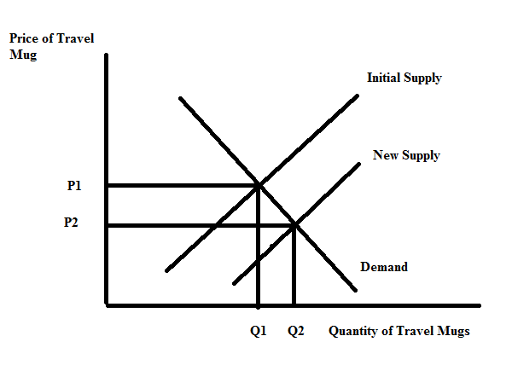

b. In the market for plain yogurt this report on the detrimental impact of consuming ice cream will cause the demand curve for plain yogurt to shift to the right since yogurt and ice cream are substitutes. At the same time, the increase in the price of dairy labor, an input in making plain yogurt, will cause the supply curve to shift to the left. With these two shifts we can predict that one of our variables will be indeterminate since we do not know the magnitude of the shift. With certainty we can predict that the equilibrium price will increase relative to its initial level, but the new equilibrium quantity may increase, decrease, or remain the same as the initial equilibrium quantity. Here is a graph to illustrate this outcome.

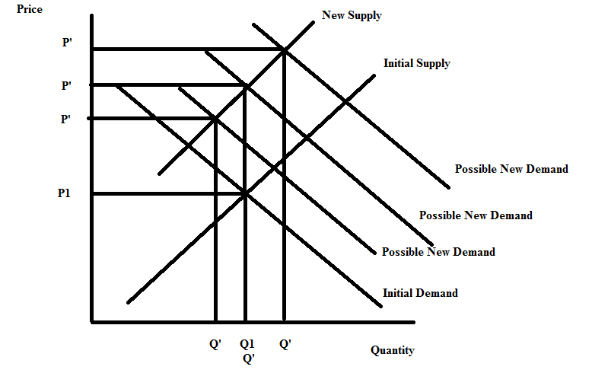

c. This published study will shift the demand for bicycles to the right because of the reputed health benefits as well as environmental benefits that arise from bicycling. This rightward shift in the demand for bicycles will cause a movement along the supply curve: the new equilibrium price of bicycles will be higher than the initial equilibrium price and the new equilibrium quantity of bicycles will be greater than the initial equilibrium quantity of bicycles. Here's a graph:
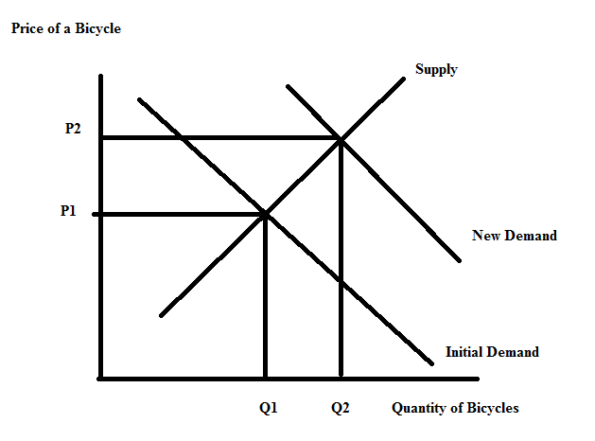

d. The entry of two firms into the market for smartphones will cause the supply curve to shift to the right. The discovery of new technology that reduces the cost of producing smartphones will also cause the supply curve to shift to the right. This will result in a movement along the market demand curve and we can predict that the equilibrium price of a smartphone will decrease while the equilibrium quantity of smartphones increases. Here is a graph to illustrate this market:
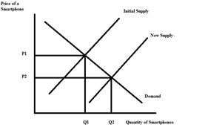

e. There are two changes to analyze in this market and that may have you anticipating an answer that includes indeterminancy. But, let me forewarn you to be careful here since these two changes are going to only shift the demand curve while leaving the supply curve unaffected (so we might or we might not have indeterminancy!). The decrease in income will cause the demand curve to shift to the left, but the increase in the number of consumers will cause the demand curve to shift to the right. If the rightward shift is bigger than the leftward shift, then we can expect both the equilibrium price and quantity to increase relative to their initial levels. If the rightward shift is smaller than the leftward shift, then we can expect both the equilibrium price and quantity to decrease relative to their initial levels. So, the answer is that both the new equilibrium price relative to the initial equilibrium price and the new equilibrium quantity relative to the initial equilibrium quantity are indeterminate. Here are two graphs to illustrate:
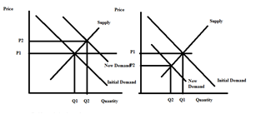

2. Consider the market for fountain pens. The market demand and supply curves are given by the following equations where Q is the quantity of fountain pens and P is the price per fountain pen:

Demand: Q = 200 – (1/2)P
Supply: Q = (15/8)P – (37.5)

a. Given the above information, find the equilibrium quantity of fountain pens and the equilibrium price for a fountain pen. Show your work.

b. Given the above information, find the value of consumer surplus (CS), producer surplus (PS), and total surplus (TS). Show your work.

c. Draw a well labeled graph of the market for fountain pens. In your graph indicate the equilibrium price and the equilibrium quantity. Also, identify the area that corresponds to CS and the area that corresponds to PS.

d. Suppose that the market supply curve changes to the following:

New Market Demand: P = 20 + (26/25)Q

Given this new market demand curve and holding everything else constant, fill in the following table with your prediction of what will happen to each of the items listed in the table. Then provide a verbal explanation for your predictions.
Item | Prediction of direction of change relative to initial values that were calculated (predictions should be no change, increase or decrease)
New equilibrium price, Pe’
New equilibrium quantity, Qe’
New CS’
New PS’
New TS’

e. Calculate the values of Pe’, Qe’, CS’, PS’, and TS’. Show your work.

Answer:
a. To find the equilibrium price and equilibrium quantity, set the demand equation equal to the supply equation: thus,
200 – (1/2)P = (15/8)P – (37.5)
200*8 – 8(1/2)P = 8(15/8)P – (37.5)(8)
1600 – 4P = 15P – 300
1900 = 19P
P = $100 per fountain pen (this may seem high, but fine artist fountain pens can easily cost this much or more!)
Then, use the demand or the supply curve to find the equilibrium quantity:
Q = 200 – (1/2)(100) = 150 fountain pens
Or, Q = (15/8)(100) – 37.5 = 375/2 – 37.5 = 150 fountain pens

b. You may find it helpful to draw a graph of this market before you do the calculations, but here are the calculations and answer (c) will provide the graph.
CS = (1/2)($400/unit - $100/unit)(150 units) = $22,500
PS = (1/2)($100/unit - $20/unit)(150 units) = $6,000
TS = CS + PS = $22,500 + $6,000 = $28,500

c. Here’s the graph:
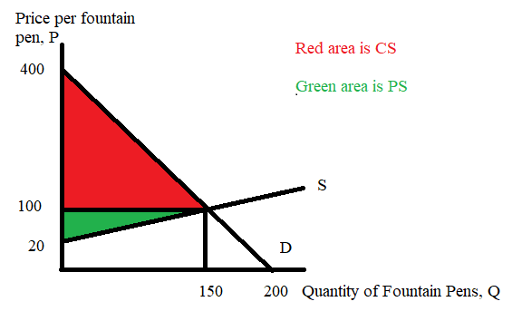

d.
Item | Prediction of direction of change relative to initial values that were calculated (predictions should be no change, increase or decrease)
New equilibrium price, Pe’ | Increase
New equilibrium quantity, Qe’ | Decrease
New CS’ | Decrease
New PS’ | Increase
New TS’ | Decrease

The new supply curve is steeper than the initial supply curve but has the same y-intercept. So, if we were to sketch a graph of this new supply curve it would have pivoted up relative to the initial supply curve. Here's the sketch:
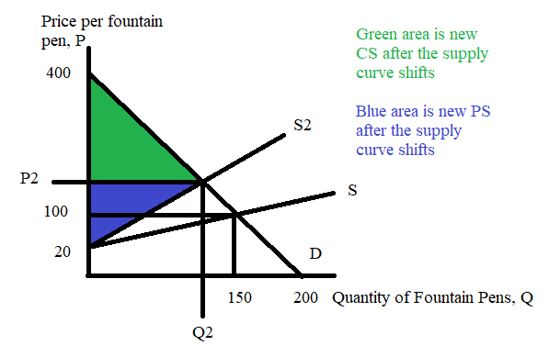
From the sketch it is easy to see that P2 must be greater than the original Pe and Q2 must be lower than the initial Qe. The CS triangle is also obviously smaller; the PS may actually take a calculation for all of us to be certain about what has happened to it. Note: this graph has not been drawn to scale, so the areas, in particular, may be misleading in terms of their sizes.

Let's look at that PS issue a bit more closely: you could envision this question using the following graph:
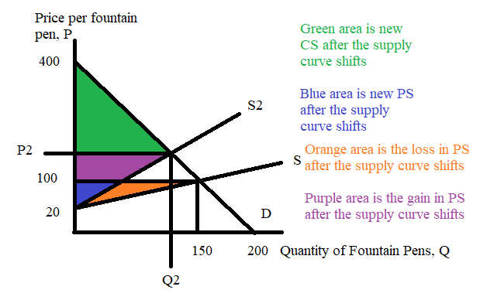
If you calculate the value of the purple area you will get:
Area of purple area = (1/2)($150 per unit - $100 per unit)(125 units – 112.5 units) + ($150 per unit - $100 per unit)(112.5 units) = $312.50 + $5625 = $5937.50 = gain in PS when the supply curve shifts from S to S2.

Area of orange area = (1/2)($100 per unit - $20 per unit)(150 units – 0 units) – (1/2)($100 per unit - $20 per unit)(112.5 units – 0 units) = $1500 = loss in PS when the supply curve shifts from S to S2.

The area of the purple area is greater than the area of the orange area: therefore PS increases when the supply curve shifts from S to S2.

e. Start by finding the equilibrium price and quantity but this time set the market demand curve equal to the new supply curve (note: you will need to get the two curves into the same form-either y-intercept or x-intercept): thus,
400 – 2Q = 20 + (26/25)Q
Note that I rewrote the demand curve as P = 400 - 2Q
25(400) – 50Q = 25(20) + 26Q
10,000 – 500 = 76Q
9500 = 76Q
Q = 125 units = 125 fountain pens

P = 400 – 2(125) = 400 – 250 = $150 per fountain pen
CS’ = (1/2)($400 per fountain pen - $150 per fountain pen)(125 fountain pens) = $15,625
PS’ = (1/2)($150 per fountain pen - $20 per fountain pen)(125 fountain pens) = $8125
TS’ = $23,750

Here’s the graph:
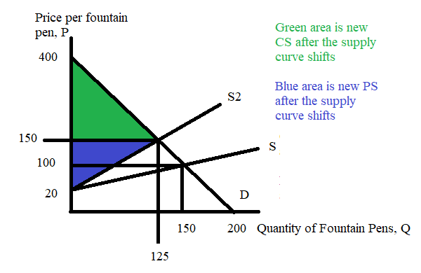

3. Suppose there are two consumers in the market for muffins and their individual demand curves are given by the following equations where P is the price per muffin and Q is the quantity of muffins:

Mark’s demand for muffins: P = 20 – 2Q
Beth’s demand for muffins: P = 30 – (1/2)Q

a. Draw two different graphs: in the first graph draw Mark’s demand for muffins and in the second graph draw Beth’s demand for muffins. Make sure you label all axes and all intercepts clearly.

b. In a third graph draw the market demand curve for muffins. Make sure you label this demand curve carefully and completely; if there is a “kink” point label the coordinates of this point.

c. Based on your graph in (b), write the equation(s) for the market demand curve. Provide a range of price for any demand curve equation you provide. When writing these equations, use the slope-intercept form and also retain fractions rather than decimals if necessary.

Suppose that Matt, a third consumer, enters this market and has the following demand for muffins:

Matt’s demand for muffins: P = 10 - Q

d. Draw a fourth graph that represents the market demand curve for muffins when the market includes Mark, Beth, and Matt. Label all intercepts, all axes, and all “kink” points clearly and carefully.

e. Based on your graph in (d), write the equation(s) for the market demand curve. Provide a range of prices for any demand curve equation you provide. When writing these equations, use the slope-intercept form and also retain fractions rather than decimals when necessary. Check that your answers are correct and that your math is accurate!!

Answer:

a. and b.
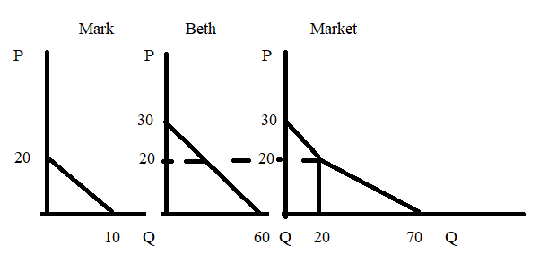

c. There are two segments to the market demand curve:
i) For prices greater than or equal to 20, the market demand curve can be written as P = 30 – (1/2)Q. That is, the market demand curve if the price is greater than or equal to 20 is simply Beth's demand curve.
ii) For prices less than or equal to 20, the market demand curve is a harder equation to write. Here is the explanation: you know that the points (20, 20) and (70, 0) are on this line and you also can compute the slope = rise/run = -20/50 = -2/5. So, then take the slope-intercept form: y = mx + b and start plugging in what you know:
y = mx + b
P = (-2/5)Q + b and (Q, P) = (20, 20) is on the line
20 = (-2/5)(20) + b or b = 28
The equation for the lower segment of the market demand curve is therefore: P = (-2/5)Q + 28

d. Adding in Matt’s demand (the graph to the left of Mark’s graph):
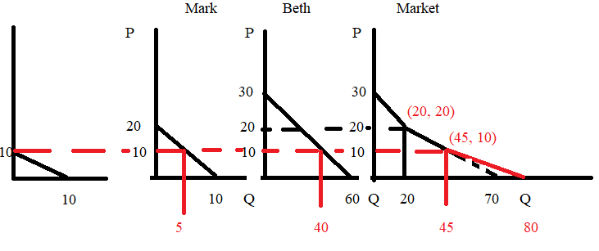

e. The market demand curve has three segments now:
i) For prices greater than or equal to 20, the market demand curve can be written as P = 30 – (1/2)Q. That is, the market demand curve if the price is greater than or equal to 30 is simply Mark's demand curve.
ii) For prices less than or equal to 30 and greater than or equal to 10, the market demand curve is a harder equation to write. Here is the explanation: you know that the points (20, 20) and (45, 10) are on this line and you also can compute the slope = rise/run = -10/25 = -2/5. So, then take the slope-intercept form: y = mx + b and start plugging in what you know:
y = mx + b
P = (-2/5)Q + b and (Q, P) = (20, 20) is on the line
20 = (-2/5)(20) + b or b = 28
The equation for the middle segment of the market demand curve is therefore: P = (-2/5)Q + 28
NOTE: THAT THE EQUATIONS FOR THESE FIRST TWO SEGMENTS ARE THE SAME AS WHAT YOU FOUND IN (C), ALTHOUGH THE RANGE HAS CHANGED FOR THE SECOND EQUATION.
iii) We now just need to find the equation for the lowest segment of the demand curve: we know that the points (45, 10) and (80, 0) sit on this segment. To make sure you see this: hold price constant at 10 and ask what quantity Mark, Beth and Matt will demand: Mark will want 5 units (use his demand curve to get this quantity at this price), Beth will want 40 units (use her demand curve to get this quantity at this price), and Matt will demand zero units. Then similar work to the work you did for answer (c) will give P = (160/7) – (2/7)Q for prices equal to or less than 10. This equation seems so strange that I wanted to check my work:

For (Q, P) = (80, 0) is this a true equation? Yes,
P = (160/7) – (2/7)Q
0 = (160/7) – (2/7)(80)

For (Q, P) = (45, 10) is this a true equation? Yes,
P = (160/7) – (2/7)Q
10 = (160/7) – (2/7)(45)
10 = 70/7!

4. Suppose that there are two firms that produce muffins and their individual firm supply curves are given as follows where P is the price per muffin and Q is the quantity of muffins:

Supply curve for Firm A: P = (4/25)Q
Supply curve for Firm B: P = (2/25)Q

HINT: In this problem you will find it helpful to retain your fractions as fractions. You will also find it helpful to use a calculator for some of the multiplication and division that is required. Do NOT despair-you can do this set of problems!

a. If there are just these two firms in the market, what is the market supply curve? Show how you found this answer.

b. Given the market demand curve you found in question 3e, and this new information about the firms that produce muffins, calculate the equilibrium price and quantity in the market for muffins.

c. Given your answer in (b), how many muffins will Mark consume? How many muffins will Beth consume? How many muffins will Matt consume? Show how you found your answer.

Answer:

a. To find the market supply curve we need to add the two individual supply curves together horizontally. We know that when the price is equal to 0, neither firm produces any muffins. Hence, the point (0, 0) is on each firm’s supply curve, but it is also on the market supply curve. To find the market supply curve we need to find one more point on this curve: so, pick a quantity and then compute the price that the firm will sell this many muffins for. So, for example if the quantity is 25 muffins produced by Firm A, we know that firm A will be willing to sell those 25 muffins for $4 per muffin. Similarly, if the quantity is 25 muffins produced by Firm B, we know that firm A will be willing to sell those 25 muffins for $2 per muffin. Thus, we have (75, 4) as another point on our market supply curve. [Note: picking a "good quantity" for this analysis makes the analysis easier to do.] So, now you have two points on the market supply curve: (Q, P) = (0, 0) and (75, 4). Use these two points to write the equation:
Y = mX + b
P = (4/75)Q + b
Use one of the known points to find the value of the y-intercept, b:
0 = (4/75)(0) + b
b = 0
Equation for the market supply curve in y-intercept form: P = (4/75)Q

Alternatively, you could get the market supply curve by first writing the two firm supply curves in x-intercept form and then adding these two equations together to find the total quantity supplied in the market. You want the equations in x-intercept form since you are summing these equations horizontally. So, using this method you have:
Supply of Firm A: Qa = (25/4)P
Supply of Firm B: Qb = (25/2)P
Total Supplied by the two firms = Qt = Qa + Qb
Qt = [(25/4) + (25/2)]P = (75/4)P
Qt = (75/4)P this is the market supply curve in X-intercept form
P = (4/75))Qt …this is the market supply curve in Y-intercept form

b. Here the issue is trying to decide where the market supply curve intersects the market demand curve. We know that from 3e there are three segments to the market demand curve. Which is the right segment to use? One way to think about this it to consider each of the kink points on that demand curve relative to the supply curve:
i) Kink point (20, 20) sits on the market demand curve. If the quantity is 20, what price do you get from the market supply curve? So, P = (4/75)(20) = 80/75: a number that is smaller than 2 (no need to do the math calculation if you are comfortable with the underlying logic). This tells us that the supply curve must cross the market demand curve below this first kink point.
ii) Kink point (45, 10) sits on the market demand curve. If the quantity is 45, what price do you get from the market supply curve? So, P = (4/75)(45) = 180/75: a number that is smaller than 4 (no need to do the math calculation if you are comfortable with the underlying logic). This tells us that the supply curve must cross the market demand curve below this second kink point.
The logic of the above “thought experiment” tells us that we need to use the market demand equation for the range of prices between 0 and 10 to find the equilibrium price and quantity in this market. Thus, the market demand curve segment we need is P = 160/7 – (2/7)Q – rewritten in Q-intercept form: Q = 80 -7P/2 – and the market supply equation is P = (4/75)Q. Using these two equations we can find that the equilibrium quantity is (75*80/89) muffins and the equilibrium price is $(4*80/89) per muffins. Here's the work:
80 -7P/2 = 75/4P
7P/2 + 75P/4 = 80
14P/4 + 75P/4 = 80
89P/4 = 80
P = 4*80/89

Then, use this price in either the market demand or market supply equation to find the equilibrium quantity:
Market Supply: Q = (75/4)( 4*80/89) = 75*80/89 muffins transacted
Market Demand: Q = 80 – 7*( 4*80/89)/2 = 75*80/89 muffins transacted

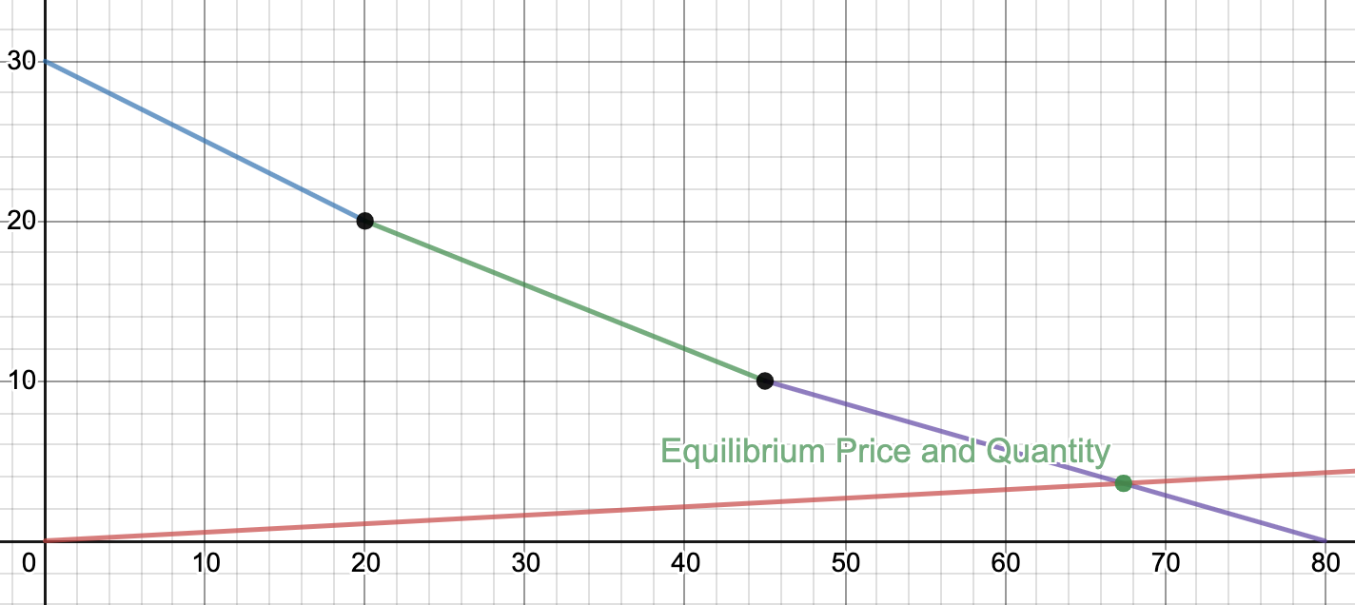
c. Given Mark’s demand is P = 20 - 2Q and the equilibrium price in the muffin market is $4*80/89, we can calculate Mark’s number of muffins as 4*80/89 = 20 – 2Q or QMark = 10-2*80/89 muffins.

Given Beth’s demand is P = 30 – (1/2)Q and the equilibrium price in the muffin market is $4*80/89, we can calculate Beth’s number of muffins as 4*80/89 = 30 – (1/2)Q or QBeth = 60 – 8*80/89 muffins. (She does love her muffins.)

Given Matt’s demand is P = 10 - Q and the equilibrium price in the muffin market is $4*80/89, we can calculate Matt’s number of muffins as 4*80/89 = 10 - Q or QMatt = 10 - 4*80/89 muffins.

Notice: that the sum of muffins consumed by Mark, Beth and Matt does equal the equilibrium quantity of muffins provided by the market: 10-2*80/89 + 60 – 8*80/89 + 10 - 4*80/89 does equal the 75*80/89 muffins that were provided.

5. Suppose the market for walnuts is described by the following market demand and supply curves where P is the price per unit of walnuts and Q is the quantity of units of walnuts:

Demand: P = 500 – 2Q
Supply: P = 20 + 8Q

a. Suppose a price floor of $90 per unit of walnuts is implemented in the almond market. Describe the impact of this price floor on this market.

b. Suppose a price floor of $420 per unit of walnuts is implemented in the almond market. Describe the impact of this price floor on this market. Which side of the market is the “short” side of the market?

c. Given the price floor described in (b), calculate the value of consumer surplus (CS), producer surplus (PS), total surplus (TS), and deadweight loss (DWL). Show your work. Include a graph depicting this market, the price floor and the various areas mentioned.

Answer:

a. Setting demand equal to supply, we find that the equilibrium price and equilibrium quantity in this market can be calculated as follows:
500 – 2Q = 20 + 8Q
10Q = 480
Qe = 48 units of walnuts
Pe = 500 – 2(48) = $404 per unit of walnuts or P = 20 + 8(48) = $404 per unit of walnuts
Thus, a price floor of $90 will have no impact in this market since the price floor represents a minimum price that can be charged for the good. Since the equilibrium price is greater than the proposed price floor, the price floor will not be effective in this market.

b. With a price floor of $420 per unit of walnuts, we can calculate the quantity demanded at that price as 420 = 500 – 2Qd or Qd = 40 units of walnuts and the quantity supplied at that price as 420 = 20 + 8Qs or Qs = 50 units of walnuts. With a price floor of $420 there will be an excess supply of 10 units of walnuts. The short side of the market is the demand side since at a price of $420 per unit of walnuts, the quantity demanded is less than the quantity supplied: the demand side of the market will determine the number of units sold and consumed in this market.

c. Here is the graph of this market:
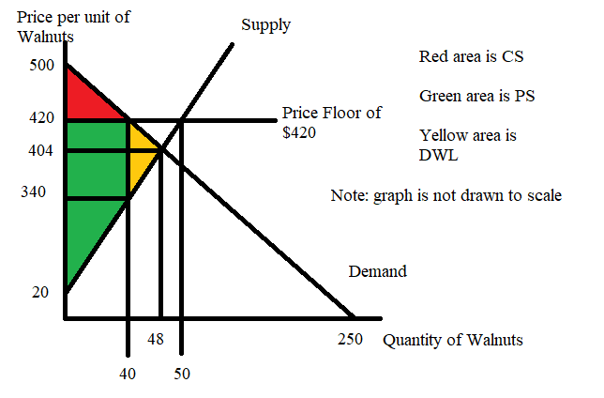
CS = (1/2)($500 per unit - $420 per unit) (40 units) = $1600
PS = (1/2) ($340 per unit - $20 per unit)(40 units) + ($420 per unit - $340 per unit)(40 units) = $9600
TS = CS + PS = $1600 + $9600 = $11,200
DWL = (1/2)($420 per unit - $340 per unit)(48 units – 40 units) = $320

6. Suppose the market for gasoline in Websterville, a small economy is described by the following two equations where P is measured in dollars per gallon and Q is measured in gallons per month:

Market demand for gasoline: P = 20 – (1/50)Q
Market supply of gasoline: P = (1/150)Q

a. Given this information, determine the equilibrium price and quantity in this market. Show your work.

b. Suppose that the government of Websterville decides that gasoline is too expensive and they decide there should be a price ceiling on gasoline. What must be true about this price ceiling in Websterville if it is to be effective? Explain your answer carefully and with complete sentences.

c. Suppose that the government of Websterville decides that too much gasoline is being consumed in Websterville and they decide to remedy the situation by imposing a price floor that results in 300 gallons of gasoline being consumed each month. Determine the price floor price that the government has imposed given this information. Explain how you got your answer.

Answer:
a. To find the equilibrium price and quantity in this market, set demand equal to supply. Thus,
20 – (1/50)Q = (1/150)Q
Q = 750 gallons per month
The equilibrium price can be found by substituting Q = 750 into either the demand or the supply equation: thus, P = 20 – (1/50)(750) = $5 per gallon or P = (1/150)(750) = $5 per gallon.

b. For a price ceiling to be effective it must be set by the government at a level that is lower than the equilibrium price in the market. In this case the price ceiling must be set at a price less than $5 per gallon in order for it to be effective. Recall that a price ceiling represents a maximum price that can be charged: for the price ceiling to be effective it must set a maximum limit on the price that is less than the equilibrium price.

c. The government sets a price floor so that consumers consume 300 gallons of gasoline a month instead of 750 gallons of gasoline a month. We can plug Q = 300 into the demand curve to see what the price must be in order for demanders to only want to consume this amount. Thus, P = 20 – (1/50)(300) = $14 per gallon. If the government sets the price ceiling to $14 per gallon then they will reach their goal of reducing gasoline consumption to 300 gallons per month. Notice that at $14 per gallon there will be an excess supply of gasoline each month (suppliers will be willing to supply 2100 gallons of gasoline per month while demanders will only demand 300 gallons of gasoline per month): the short side of the market will be the demand side and it is the demand side that will determine the level of gasoline consumption once this price floor is imposed.

7. Suppose that the market for wheat can be described by the following equations where P is the price per bushel and Q is the quantity of bushels:

Market Demand: P = 200 – (1/100)Q
Market Supply: P = 60 + (1/600)Q

a. Suppose that the government implements a price floor program in this market and sets the price floor at $85 per bushel. Describe the effect of this price floor on this market: where possible make numerical calculations of the impact. Assume that the government purchases any surplus that is produced in this market given this price floor. Will this price floor be effective?

b. Given the price floor described in (a), what is the direct cost to the government of this price floor? Assume that the government is willing to buy up any surplus in the market and store this surplus indefinitely. Show how you calculated this cost to the government.

c. Given the price floor described in (a), what is the amount that consumers expend in buying this good? Show how you calculated this cost to the consumers.

d. Given the information you have been given, draw a graph of this market clearly labeling all intercepts, axis, and intersection points. Also, include the price floor, the area that represents the direct cost to consumers of this price floor, and the area that represents the direct cost to the government of this price floor.

e. Suppose that you are told that the storage costs for the government are equal to $4 per bushel per year. What is the total annual cost of this program to the government including the cost of storage? Show how you computed your answer.

Answer:

a. If the government sets the price floor at $85 per bushel this will be an effective price floor in this market. We can see that by taking the time to calculate the equilibrium price in this market if there is no price floor: the equilibrium price would be $80 per bushel. So, the price floor (a minimum price that can be charged for the good) will be effective since it is set above the equilibrium price. At a price floor of $85 per bushel, consumers will demand 11,500 bushels of wheat while suppliers will be willing to supply 15,000 bushels: there will be an excess supply of wheat at this price floor price. The government will need to buy this excess supply: answer (b) provides this calculation.

b. The government will buy the surplus of 15,000 bushels – 11,500 bushels or 3,500 bushels at the price floor of $85 per bushel. That is, the direct cost to the government will be equal to (15,000 bushels – 11,500 bushels)($85 per bushel) = $297,500.

c. Consumers will purchase 11,500 bushels at a price of $85 per bushel: the expenditure by consumers will equal (11,500 bushels)($85 per bushel) = $977,500.

d.
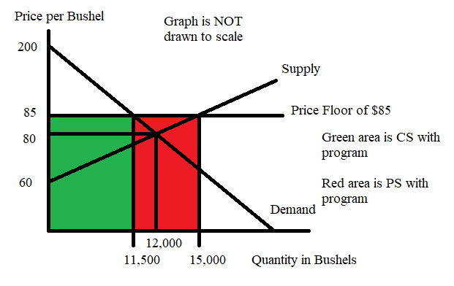

e. Total cost of the price floor program including storage costs for the year = (15,000 bushels – 11,500 bushels)($85 per bushel) + ($4 per bushel storage cost)(3,500 bushels) = $2,337,500 + $110,000 = $311,500.

8. Suppose that you have the same market as in (7), but instead of a price floor the government implements a price guarantee of $90 per bushel.

a. Given this price guarantee, how many bushels of wheat will consumers purchase? What will the price per bushel be for the consumer given this price guarantee? Explain how you got your answers.

b. Given this price guarantee, how many bushels of wheat will the government purchase? Explain your answer.

c. What will the cost per bushel to the government of this price guarantee program? Explain your answer.

d. What will be the total cost to the government of this price guarantee program? Explain your answer.

Answer:

a. With a price guarantee of $90 per bushel, producers will be willing to supply 18,000 bushels. To see this, use the supply equation and the guaranteed price of $90 per bushel: 90 = 60 + (1/600)Qs or Qs = 18,000 bushels. Demanders are willing to consume this many bushels at a price of $20 per bushel. To see this use Q = 18,000 and the demand equation to solve for the price that consumers are willing to pay per bushel if they consume 18,000 bushels. Thus, P = 200 – (1/100)(18,000) = $20 per bushel.

b. With the price guarantee program the government will not buy any of the good: the price guarantee program simply tells producers what price is going to be guaranteed, the producers decide how much they want to produce at this price, and then they sell if for whatever price consumers are willing to pay for this quantity.

c. The cost per bushel of wheat produced to the government will be the difference between the guaranteed price of $90 per bushel and the price consumers are willing to pay of $20 per bushel. Thus, the cost per bushel for the government will be $70 per bushel.

d. The total cost to the government of this price guarantee program will be (18,000 bushels)($70 per bushel) or $1,260,000.

